Caleb White

CIDM 4310

Jeffry Babb

6/29/21

BI and DSS are two systems, or portions of a system in data engineering and data analytics. BI, or business intelligence is often composed of a dashboard displaying data to users in a specific layout or format that “tells a story” to the user. DSS, or decision support systems go hand in hand with a BI dashboard. A DSS helps companies make business decisions, based off of some previously gathered data. An example of a complete BI/DSS setup would be a BI dashboard displaying metrics from a mass email campaign, versus metrics from a mass snail-mail campaign. The DSS system would aid the Chief Marketing Officer in decided which method to continue employing.

Many Texan’s are still in shock after ERCOT’s (Electric Reliability Council of Texas) fumble of the power grid in February. Lack of preparation led to death for several Texan’s, and left others with sky-high electric bills. If Texas joined the national power grid, it would ease the responsibility of ERCOT, and when one state had a higher usage (ie, Texas in Feburary), the impact would not nearly be as great with generators and power stations across the country. This BI dashboard would compare power rates across the nation to help standardize the power grid and set a rate appropriate for each state and utility. This dashboard will also show the change in cost between 2011, and 2019 which would help the national grid operator adjust prices for inflation.

Data will be stored in a MySQL database, managed by phpMyAdmin on a Linux web server. Additional data may be accessed directly via API, or may be stored directly in the database via API.

I currently have 2 tables which detail the zip code, provider name, and average rate in cents for that zip code. The tables have the same columns, except one is comprised of 2011 data, and another of 2019 data (fig 1). To make my dashboard more useful, I would also like to obtain additional data, such as number of customers each provider served, and the average monthly use in kwh (kilowatt-hours) (fig 2). This would allow me to create a system that is far more versatile and will help decision makers make an informed decision.

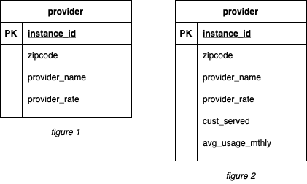

I currently have data which can substantiate the current rates that consumers are willing to pay, which will help the new national grid operator to design a system and a rate that works for all consumers. But, to help them make the most informed decision on a pricing scheme, we would need to know the current utilization of that provider too. We can measure utilization with a function of both the number of customers served, and the average amount of power in kwh they deliver each month. For example, if Booneyville power company is charging 2 cents per kwh but only has 2 customers, but Lytle Lakes power company is charging 1 cent and has 300 customers, then we would disregard the info from the first company. If Booneyville had more customers, it might make sense to charge the higher rate in this area.

I would utilize various forms of graphs and charts to provide all of the necessary data to decision makers. I would further my dashboard by adding pieces of data such as standard deviation between providers in each zip code, ability to filter out providers with less than a certain subscriber count, etc.