Introduction

A Portuguese bank conducted seventeen telephone marketing campaigns between May 2008 and November 2010. The bank recorded client contacts information for each telephone call. Client characteristics include demographic factors: age, job type, marital status, and education. The client’s previous use of banking services is also noted. Current contact information shows the date of the telephone call and the duration of the call. There is also information about the call immediately preceding the current call, as well as summary information about all calls with the client.

summary and problem definition for management

***The bank wants its clients to invest in term deposits***. A term deposit is an investment such as a certiﬁcate of deposit. The interest rate and duration of the deposit are set in advance. A term deposit is distinct from a demand deposit. The bank is interested in identifying factors that affect client responses to new term deposit offerings, which are the focus of the marketing campaigns. What kinds of clients are most likely to subscribe to new term deposits? What marketing approaches are most effective in encouraging clients to subscribe.

measurement and statistical methods

The data used in this evaluation was obtained from a previous telephone marketing campaign.

The dataset consists of 4521 respondent’s answers (rows) to 17 marketing questions (columns).

**dataset dimensions (4521, 17)**

Non-values were dropped if present in data. However, removal has not change the dataset dimensions.

**dataset shape after dropna (4521, 17)**

Model data consists of three explanatory variables -**default, housing, and loan**, were used and one **response** variable

The response is binary variable and the research two classification models – Naïve Bias and Logistic Regression have been utilized for the training and prediction.

**Linear logistic regression** is solved by maximizing the conditional likelihood of G given X: Pr(G = k | X = x), while LDA maximizes the joint likelihood of G and X: Pr(X = x, G = k).

**Naive Bias** is very simple, easy to implement and fast. If the NB conditional independence assumption holds, then it will converge quicker than discriminative models like logistic regression. Even if the NB assumption doesn’t hold, it works great in practice. Need less training data. Highly scalable. It scales linearly with the number of predictors and data points. Can be used for both binary and mult-iclass classification problems. Can make probabilistic predictions. Handles continuous and discrete data.

Exploratory Data Analysis Methods

**Dimensions**

The dataset consists of 4521 respondent’s answers (rows) to 17 marketing questions (columns).

**dataset dimensions (4521, 17)**

**Dataset Basic Descriptive Statistics**

|  | **age** | **balance** | **day** | **duration** | **campaign** | **pdays** | **previous** |
| --- | --- | --- | --- | --- | --- | --- | --- |
| **count** | 4521.000000 | 4521.000000 | 4521.000000 | 4521.000000 | 4521.000000 | 4521.000000 | 4521.000000 |
| **mean** | 41.170095 | 1422.657819 | 15.915284 | 263.961292 | 2.793630 | 39.766645 | 0.542579 |
| **std** | 10.576211 | 3009.638142 | 8.247667 | 259.856633 | 3.109807 | 100.121124 | 1.693562 |
| **min** | 19.000000 | -3313.000000 | 1.000000 | 4.000000 | 1.000000 | -1.000000 | 0.000000 |
| **25%** | 33.000000 | 69.000000 | 9.000000 | 104.000000 | 1.000000 | -1.000000 | 0.000000 |
| **50%** | 39.000000 | 444.000000 | 16.000000 | 185.000000 | 2.000000 | -1.000000 | 0.000000 |
| **75%** | 49.000000 | 1480.000000 | 21.000000 | 329.000000 | 3.000000 | -1.000000 | 0.000000 |
| **max** | 87.000000 | 71188.000000 | 31.000000 | 3025.000000 | 50.000000 | 871.000000 | 25.000000 |

**Correlation**

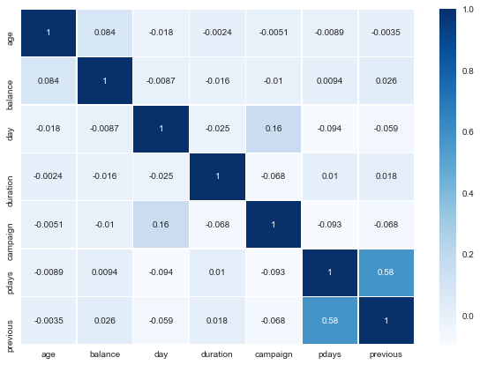

**Transformation**

In order to apply classification model, the categorical variable should be converted to their binary representation

1. bank['response_ind'] = le.fit_transform(bank['response'].astype(str))
2. bank['default_ind'] = le.fit_transform(bank['default'].astype(str))
3. bank['loan_ind'] = le.fit_transform(bank['loan'].astype(str))
4. bank['housing_ind'] = le.fit_transform(bank['housing'].astype(str))

Double check that response, default, loan, housing are binary

1. response (array([0, 0, 0, ..., 0, 0, 0], dtype=int64), array(['no', 'yes'], dtype=object))
2. default (array([0, 0, 0, ..., 0, 0, 0], dtype=int64), array(['no', 'yes'], dtype=object))
3. loan (array([0, 1, 0, ..., 0, 0, 1], dtype=int64), array(['no', 'yes'], dtype=object))
4. housing (array([0, 1, 1, ..., 0, 0, 1], dtype=int64), array(['no', 'yes'], dtype=object))

Head of the research dataset

|  | **default_ind** | **loan_ind** | **housing_ind** |
| --- | --- | --- | --- |
| **4383** | 0 | 0 | 0 |
| **502** | 0 | 0 | 0 |
| **4052** | 0 | 0 | 1 |
| **3634** | 0 | 1 | 1 |
| **3088** | 0 | 0 |  |

Overview of Programming Work

Python was used exclusively for the analysis of the telephone direct marketing data, including

the use of the following packages: Pandas and Numpy for data handling, and Scikit Learn for

machine learning and model evaluation metrics. Telephone direct marketing campaign data was

presented to us as a CSV file and loaded into the program using Pandas. K fold cross

validation design, with ten folds using the AUROC as index for classification performance, was

used for both logistic regression and naives Bayes classification machine learning models and

was implemented using the Python Scikit Learn environment.

Results and Recommendations

|  |  |  |
| --- | --- | --- |
|  | **Logistics Regression** | **Naïves Bias** |
| **score** | 0.886891 | 0.879977876 |
| **Accuracy** | 0.876243 | 0.8629834 |
| **Training accuracy** | 87.6243 % | 86.2983 % |
| **Training AUC** | 58.4517 % | 0.5001 % |
| **Confusion matrix** | [[793 0]  [112 0]] | [[779 14]  [110 2]] |

Examining the average AUROC for the Logistic Regression classification method 58.4%, and the

Naives Bayes classification method, 50%, the Logistic Regression model performs

better for predicting customers that will participate in term deposits when using three

explanatory variables, default, loan, and housing. Those most likely to participate also have no

defaults. The recommendation is the Logistic Regression method to direct t marketing

campaigns towards those with no defaults.