**Tutorial Aplikasi QasBot**

1. Pastikan laptop sudah terinstal telegram dan phyton 3 dan ada koneksi internet
2. Lakukan instalasi program dengan cara

* Buka terminal phyton 3
* Masuk kedalam directory QasBot
* pip install -r requirements.txt
* import nltk
* nltk.download('stopwords')
* import nltk
* nltk.download('punkt')
* import nltk
* nltk.download('averaged_perceptron_tagger')
* python QasBot.py

1. Buka Telegram
2. Cari @BotFather

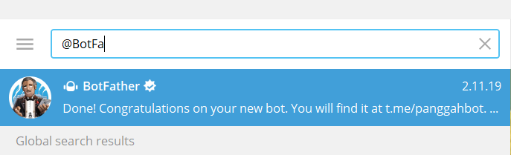

1. Klik start
2. Ketikan “/newbot”

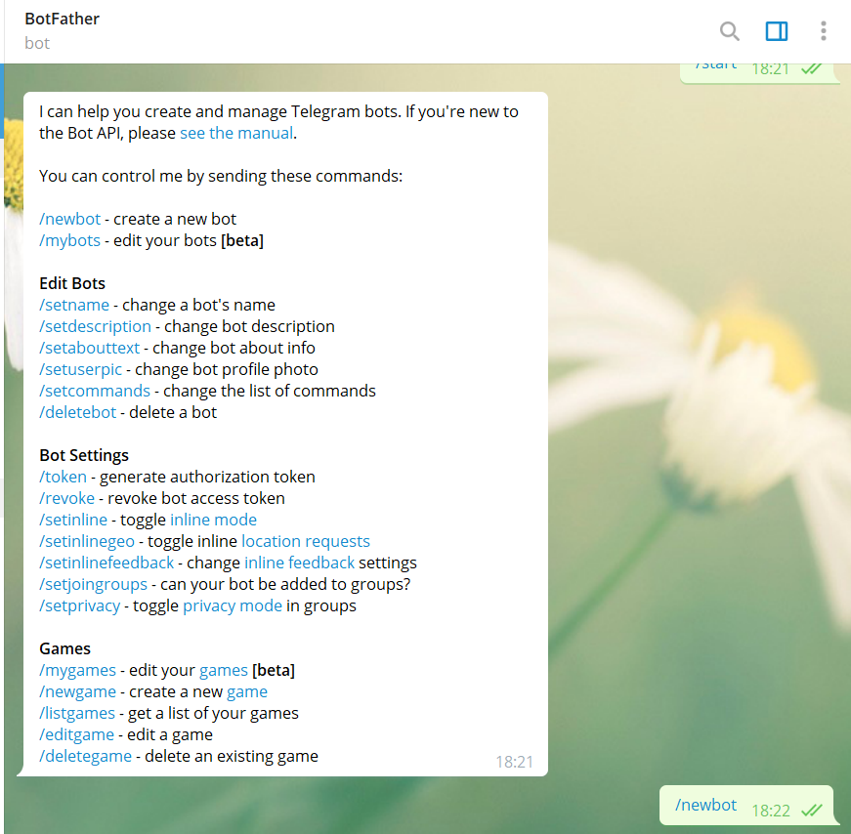

1. Setelah muncul balasan “Alright, a new bot. How are we going to call it? Please choose a name for your bot.” Masukkan nama bot sesuai yang diinginkan

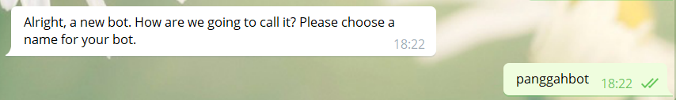[1]

1. Setelah muncul balasan “Good. Now let's choose a username for your bot. It must end in `bot`. Like this, for example: TetrisBot or tetris_bot.” Masukkan nama bot yang telah dibuat

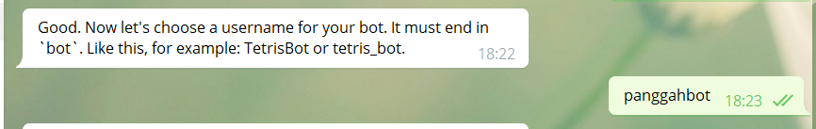

1. Setelah muncul balasan

===========================================================================

“Done! Congratulations on your new bot. You will find it at t.me/panggahbot. You can now add a description, about section and profile picture for your bot, see /help for a list of commands. By the way, when you've finished creating your cool bot, ping our Bot Support if you want a better username for it. Just make sure the bot is fully operational before you do this.

Use this token to access the HTTP API:

1019998009:AAH3IUHEHniBg4I60SW5xiljztJzzOjKnls

Keep your token secure and store it safely, it can be used by anyone to control your bot.

For a description of the Bot API, see this page: <https://core.telegram.org/bots/api>”

===========================================================================

Copy token yang berarna merah pada HTTP API tersebut.

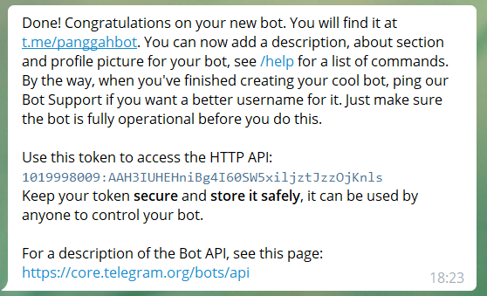

1. Buka QasBot.py dengan menggunakan text editor
2. Cari “def main(): “
3. Lalu ganti pada baris

===========================================================================

“updater = Updater('1019998009:AAH3IUHEHniBg4I60SW5xiljztJzzOjKnls')”

===========================================================================

ganti token merah tersebut dengan token yang telah dicopy pada langkah sebelumnya.

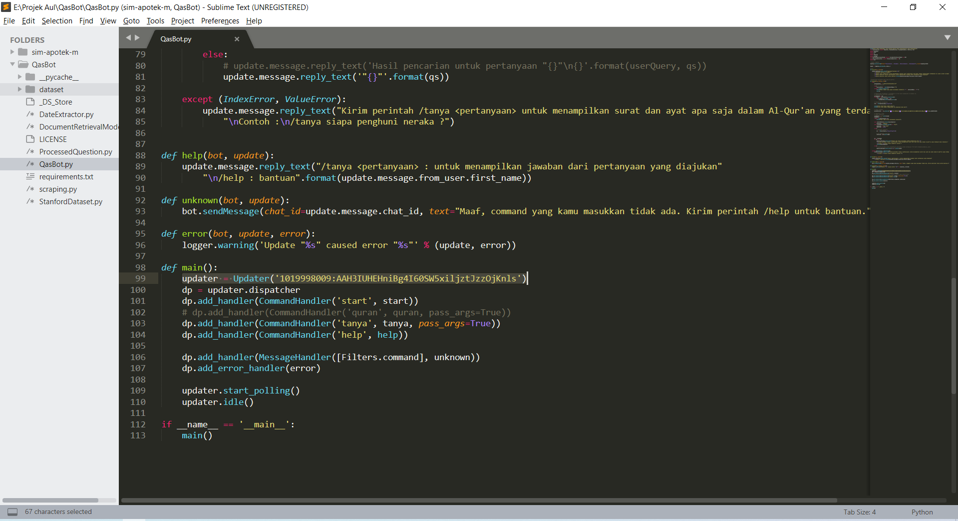

1. Cari bot yang telah dibuat.
2. Uji coba pertanyaan “/tanya siapa penghuni neraka ?”

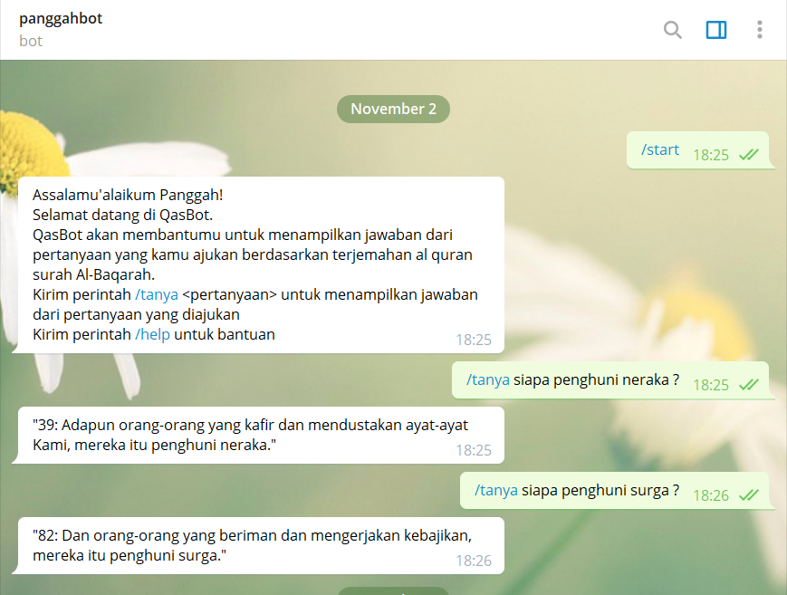

1.