* **How many organisations in total?**

Query - SELECT count(1) FROM organisations

Result - 100

Run time - 87ms

* **How many organisations do not have offer_requests?**

Query - **select** **count**(**distinct** o.id) **from** organisations o **left** **join** offer_requests or2 **on** o.id =or2.organisation_id **where** or2.organisation_id **is** **null**

Result - 0

Run time - 118ms

* **How many organisations have offer_requests?**

Query - **select** **count**(**distinct** o.id) **from** organisations o **inner** **join** offer_requests or2 **on** o.id =or2.organisation_id

Result - 100

Run time - 238ms

* **How many organisations have no offers?**

Query - **select** **count**(**distinct** o.id) **from** organisations o **left** **join** offers o2 **on** o.id =o2.organisation_id **where** o2.organisation_id **is** **null**

Result - 0

Run time - 90ms

* **Which organisation has maximum offers and how many offers?**

Query - **select** o.org_name ,**count**(o.id) **from** organisations o **inner** **join** offers o2 **on** o.id =o2.organisation_id **group** **by** o.id,o.org_name **order** **by** **count**(o.id) **desc** **limit** 1

Result –



Run time - 201ms

* **Which organisation has minimum offers and how many offers?**

Query - **select** o.org_name ,**count**(o.id) **from** organisations o **inner** **join** offers o2 **on** o.id =o2.organisation_id **group** **by** o.id,o.org_name **order** **by** **count**(o.id) **asc** **limit** 1

Result –



Run time - 280ms

* **Which organisation has maximum orders and how many orders?**

Query - **select** o.org_name ,**count**(o.id) **from** organisations o **inner** **join** orders o3 **on** o.id =o3.organisation_id **group** **by** o.id,o.org_name **order** **by** **count**(o.id) **desc** **limit** 1

Result –

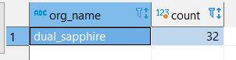

Run time - 200ms

* **Which organisation has minimum orders and how many orders?**

Query - **select** o.org_name ,**count**(o.id) **from** organisations o **inner** **join** orders o3 **on** o.id =o3.organisation_id **group** **by** o.id,o.org_name **order** **by** **count**(o.id) **asc** **limit** 1

Result –

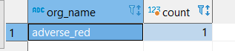

Run time - 81ms

* **Which organisation has the maximum total amount of offers and what is the amount?**

Query - **select** o.org_name,**sum**(o2.total_amount) total_amount **from** organisations o **inner** **join** offers o2 **on** o.id =o2.organisation_id **group** **by** o.org_name **order** **by** 2 **desc** **limit** 1

Result –

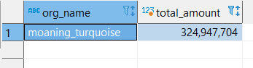

Run time - 237ms

* **Which organisation has the maximum total amount of orders and what is the amount?**

Query - **select** o.org_name,**sum**(o2.total_amount) total_amount **from** organisations o **inner** **join** orders o2 **on** o.id =o2.organisation_id **group** **by** o.org_name **order** **by** 2 **desc** **limit** 1

Result –

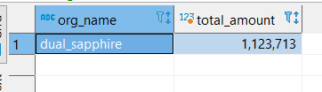

Run time - 138ms