Data Types:

|  |  |  |
| --- | --- | --- |
| Employee |  |  |
| **Attribute** | **Date type** | **Nullable** |
| name | String | Not Null |
| email | String | Not Null |
| position | String | Not Null |
| phone_number | String | Not Null |
|  |  |  |
| Group |  |  |
| **Attribute** | **Date type** | **Nullable** |
| groupName | String | Not Null |
|  |  |  |
| Foup |  |  |
| **Attribute** | **Date type** | **Nullable** |
| foupName | String | Not Null |
|  |  |  |
| Slot |  |  |
| **Attribute** | **Date type** | **Nullable** |
| slotNumber | Integer | Not Null |
|  |  |  |
| Wafer |  |  |
| **Attribute** | **Date type** | **Nullable** |
| waferID | Integer | Not Null |
| waferType | String | Not Null |
| isUsed | Boolean | Not Null |
|  |  |  |
| ProcessRecipe |  |  |
| **Attribute** | **Date type** | **Nullable** |
| recipeName | String | Not Null |
| recipeFile | File | Not Null |
|  |  |  |
| Chamber |  |  |
| **Attribute** | **Date type** | **Nullable** |
| chamberName | String | Not Null |
| chamberPosition | String | Not Null |
|  |  |  |
| ChamberConfiguration | |  |
| **Attribute** | **Date type** | **Nullable** |
| configurationID | Integer | Not Null |
| configurationFile | File | Not Null |
|  |  |  |
| Metrology |  |  |
| **Attribute** | **Date type** | **Nullable** |
| metrologyName | String | Not Null |
| measurementType | String | Not Null |
|  |  |  |
| MeasurementRecipe | |  |
| **Attribute** | **Date type** | **Nullable** |
| recipeFolder | String | Not Null |
| recipeName | String | Not Null |
|  |  |  |
| MeasurementResult |  |  |
| **Attribute** | **Date type** | **Nullable** |
| datetime | DateTime | Not Null |
| foup | String | Not Null |
| startingSlot | Integer | Not Null |
| endingSlot | Integer | Not Null |
| rawDataFile | File | Not Null |
|  |  |  |
| Project |  |  |
| **Attribute** | **Date type** | **Nullable** |
| projectName | String | Not Null |
| projectDescription | String | Not Null |
|  |  |  |
| Split |  |  |
| **Attribute** | **Date type** | **Nullable** |
| splitID | Integer | Not Null |
| note | String | Not Null |

Business Logic Constraints:

# Task Decomposition

## Login

### Task Decomposition:

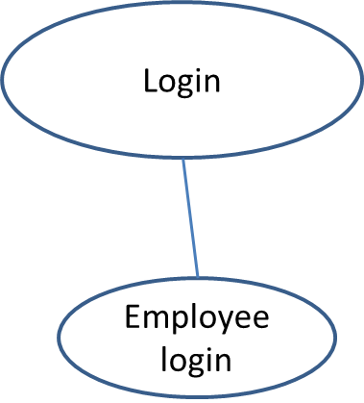

Lock Types: Read-only for “Employee login” on Employee.

Enabling Conditions: None.

Frequency: Frequent.

Consistency: Not critical.

Subtask: All tasks must be done, but can be in parallel.

#### Abstract Code:

* In the login screen, the user inputs “employeeID” and “password”, in 2 text boxes.
* The software saves the input as $employeeID, and $password.
* Query in the database for the user according to the $employeeID.
  + If the returned entry has the same password as $password, the user logged in.
  + Otherwise, reset the $employeeID and $password, and give an error message “Your EmployeeID or password is not correct”. Return to the login screen for the next input.
* Once the user logged in, show the main menu:
  + On the top is a band of different tabs:
    - The first tab shows the group name the user belongs to, which is also the main menu button if the user browses to other sections.
    - The second tab is link to current projects that’s presently active that is assigned to the $employeeID.
    - The third tab is “Splits” which links to the page showing the most recent 75 splits that the $employeeID runs. Based on the need, these splits are further divided into sections. For example, for Staircase ON group, the splits are divided into “Ox”, “Nit” and “Stack” sections.
    - The fourth tab is “Process Recipe”, which links to the page showing the most recent 75 process recipes that the $employeeID used. Based on the need, these process recipes are further divided into sections. For example, for Staircase ON group, the recipes are divided into “Ox”, “Nit” and “Stack” sections.
    - The fifth tab is “Chamber Configuration”, which links to the page showing the configurations for the chambers that belongs to the $employeeID.
    - The sixth tab is “Foup Status”, which links to the foup/wafer management page.
    - The seventh tab is “Metrology”, which links to the metrology management part.

## View/edit/add Splits

### Task Decomposition:

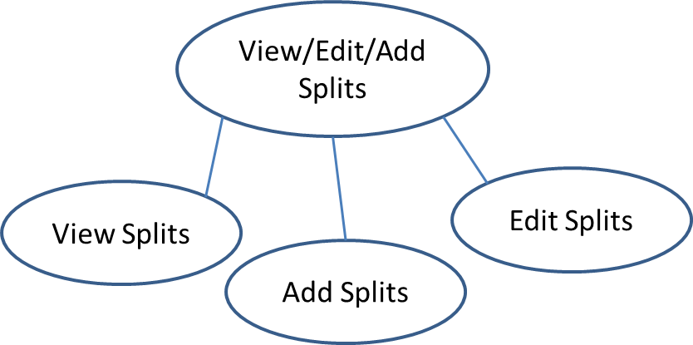

Lock Types: Read-only for “View Splits” on Splits. Write for “Add Splits” and “Edit Splits” on Splits.

Enabling Conditions: None.

Frequency: Frequent.

Consistency: Not critical.

Subtask: All tasks must be done, but can be in parallel.

#### Abstract Code:

* User clicks on “Split” tab on top ribbon, and the “Split” page shows up and “View Splits” action is executed:
  + In the middle shows the most recent 100 splits, which includes the columns of “SplitID”, “Date”, “FoupName”, “Slot”, “RecipeName”, “Chamber”, a block of process conditions, under the title “Process Condition Details”, that are extracted from the raw process recipe files, “Note”, “Metrology”, and then a block of statistical summaries from metrology result raw data files, under the title “Results”.
  + On each row, the “SplitID” shows a link to editing that certain split.
  + The top titles “Process Condition Details” and “Results” shows links to “Edit Split” to edit the selected items that shows in the split table.
  + On the left pane, there is search part, which enables to search by “Project”, “Date”, “Foup”, “Chamber”, etc.
  + At the bottom of the left pane, there is button “Add Split”, which leads to the “Add Split” page.
* With “Edit Split”, the user can change the related info for split.
* With “Add Split”, the user can add new split.

## View/edit Employee

### Task Decomposition:

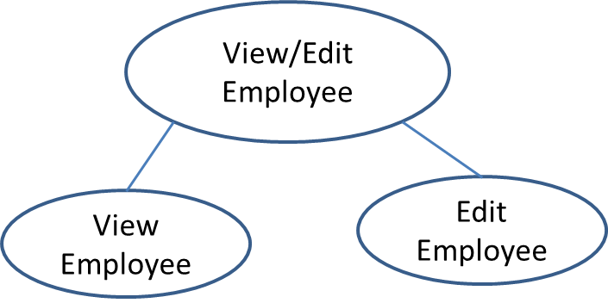

Lock Types: Read-only for “View Splits” on Splits. Write for “Add Splits” and “Edit Splits” on Splits.

Enabling Conditions: None.

Frequency: Frequent.

Consistency: Not critical.

Subtask: All tasks must be done, but can be in parallel.

#### Abstract Code: