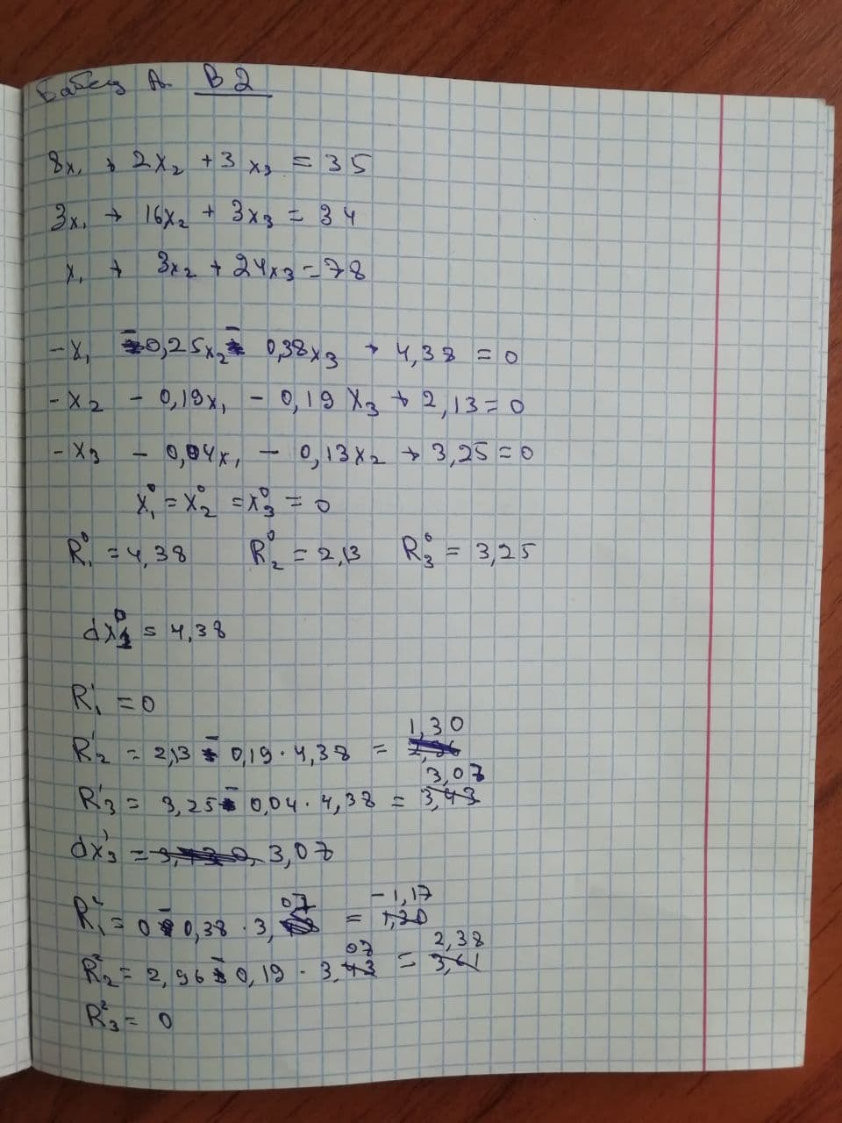

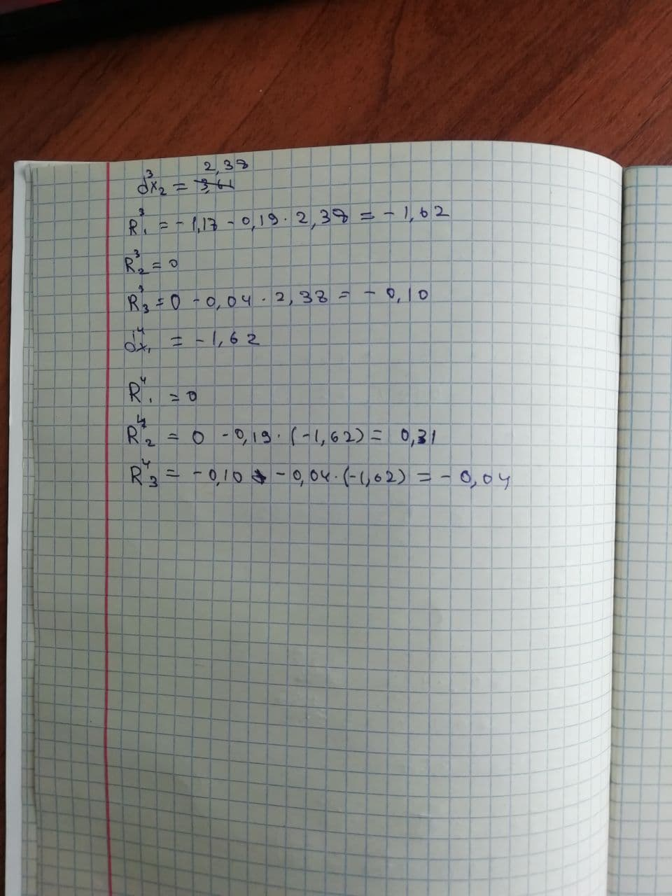

|  |  |  |  |  |  |
| --- | --- | --- | --- | --- | --- |
| **X1** | **R1** | **X2** | **R2** | **X3** | **R3** |
| 0  4.38 | 4.38 | 0 | 2.13 | 0 | 3.25 |
|  | 0 |  | 1.30 | 3.07 | 3.07 |
|  | -1.17 | 2.38 | 2.38 |  | 0 |
| -1.62 | -1.62 |  | 0 |  | -0.10 |
|  | 0 | 0.31 | 0.31 |  | -0.04 |
| Итого:  2.76 |  | 2.69 |  | 3.07 |  |