CALIFORNIA STATE UNIVERSITY, LONG BEACH
IS 640 – Business Applications Programming
Fall 2019 Term – Session 01 (#12021) – Final Project

Due: December 12, 2019

Individual Class Project
This is an individual class project, not a group project. You may discuss items with colleagues, but you may not share code.

BACKGROUND
You have been working as a Sales Manager for the Western Division (California, Arizona, and Nevada) of Awesome Automation Sales. A company that provides mailing lists to customers.

You track your own customers list manually on index cards. You often need to run reports on your customers’ total sales by state to determine where to concentrate your efforts. Recently, you took a Python course where you learned web application development and decide to put those skills to use by writing a Python web application using the Flask framework to track your customers list and provide summary reports.

PROGRAM VISION

You envision that when you start the program you will have a menu similar to the one below:

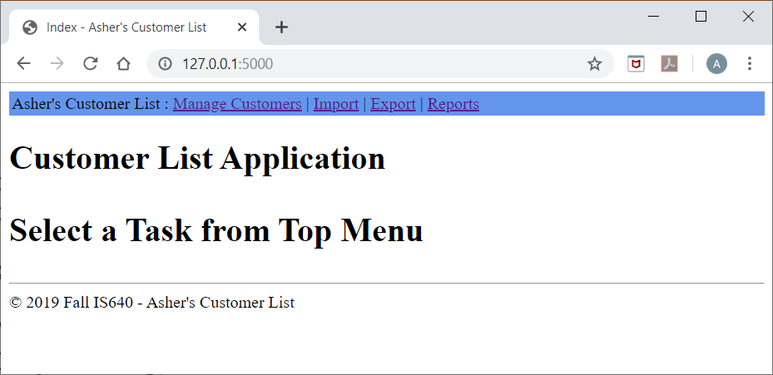

Use your own last name for the Title, Footer, and Application Name.

A. Manage Customers
Often you need to find information regarding a specific customer or list of customers. You may then want to edit or delete the customers from the list. Also, you have instances when you need to add a single customer and do not want to import an entire file. Therefore, you decide to build a view as follows to complete these tasks. Note that the total number of records are displayed.

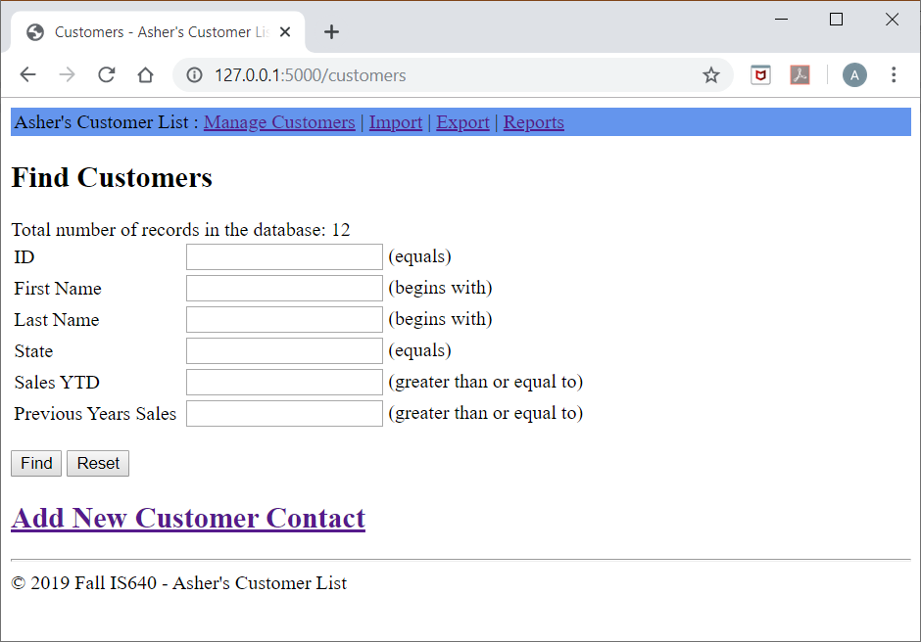

Find Records

All the fields are optional. If no criterion is entered, all the records are returned.

If no records are found, a message is sent back to the user. For example (search for First Name begins with abc):
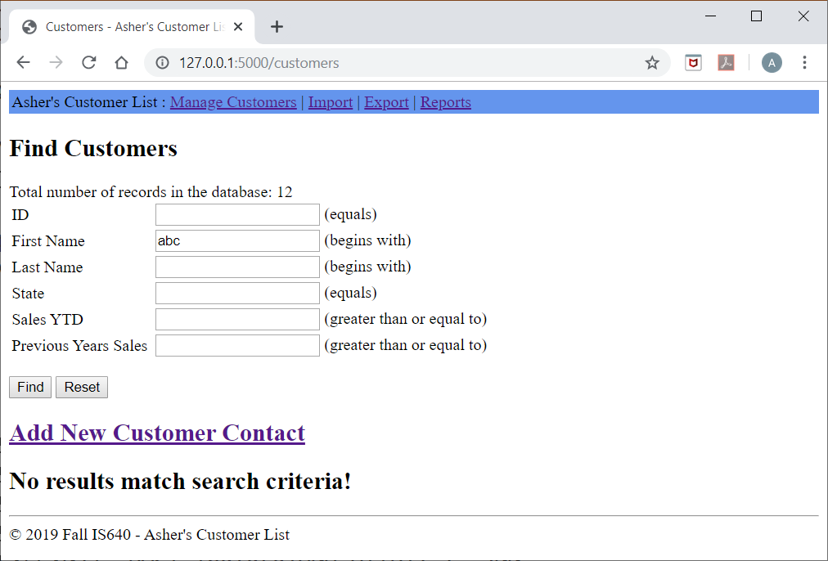

When results are found, they are displayed with hyperlinks to “Edit | Delete” the records. See below.
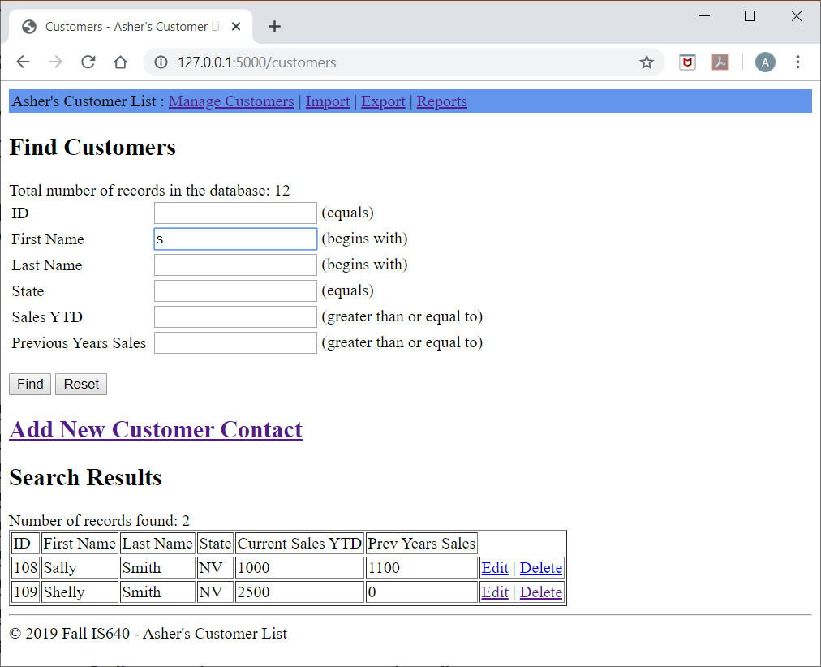

Other
Searches are NOT case sensitive.

Add New Customer Contact
When the hyperlink is clicked, a form is displayed for the user to enter customer information. The user must populate ID, First Name, and Last Name or an error message is given. If all the data is acceptable, the record is entered into the database and the user is notified of success.
Note:
- For this class, entering the Id is fine. You can auto-populate this. However, make sure that you can turn the auto-populate off for importing archived records.
- We did not cover client-side validation.
  - You can validate for user entry of ID, First Name, and Last name prior to attempting an insert.
  - If data is provided, attempt an insert. If the insert fails, you will display the error to the user.

Initial Create Screen
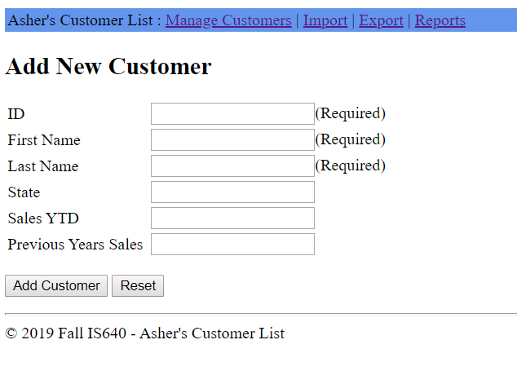

No Data Entered Error (can use the same error if any of the three required fields are not entered):
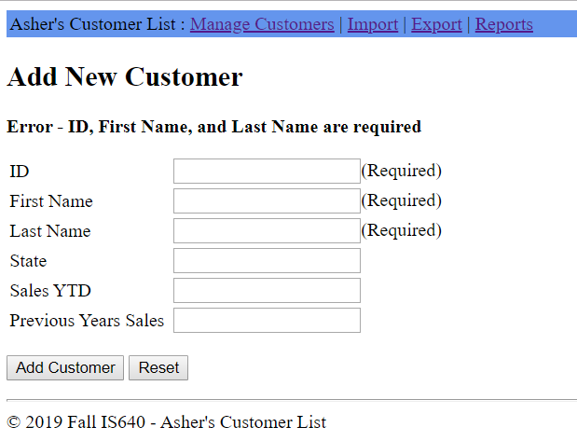

Duplicate ID Entered:
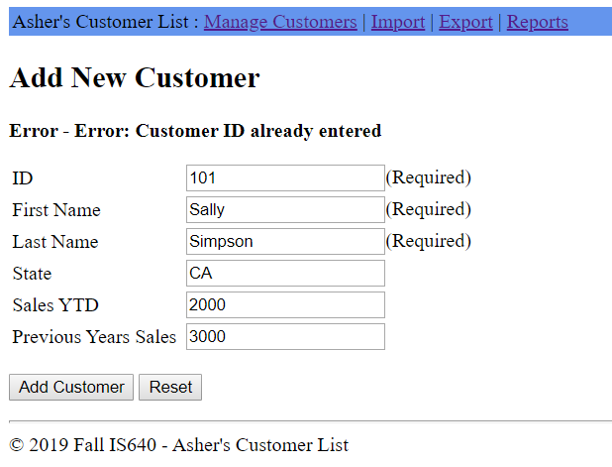

Successful Insert
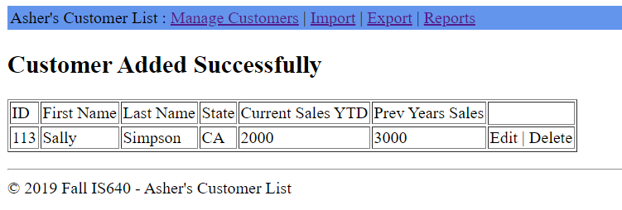

Delete Customer
When the delete hyperlink is selected, the user is shown the record and asked for confirmation. Upon confirmation, the record is deleted and the user is notified of success (see below).

Confirmation Request
Note: Fields are READ ONLY.
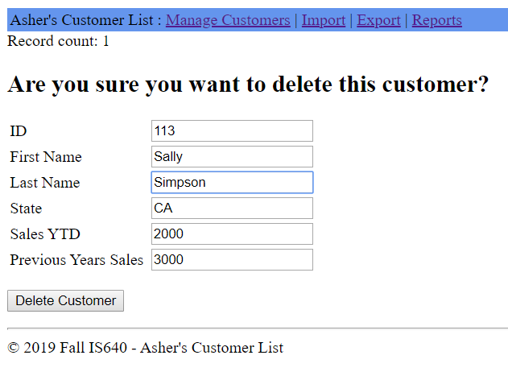

Status After Confirmation
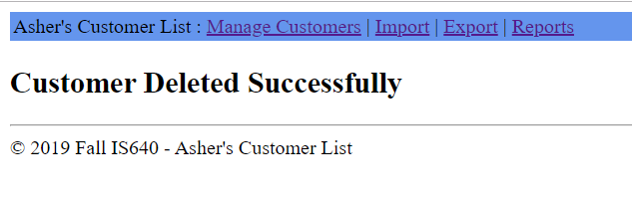

Update Record
When the Edit hyperlink is selected, the user is shown the record and given the opportunity to make changes. The ID is READ ONLY. If any data is invalid, the user is shown an error message. When the user clicks Save and there are no issues, the user is presented with a confirmation.

Initial Edit View
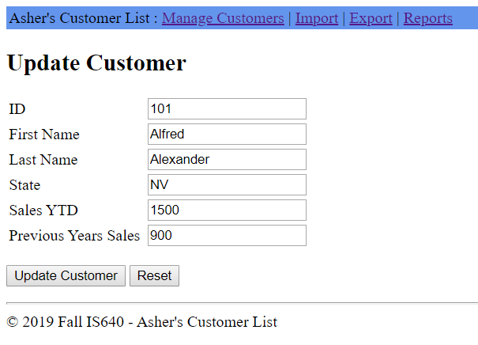
Invalid Data (Last Sales YTD is text)
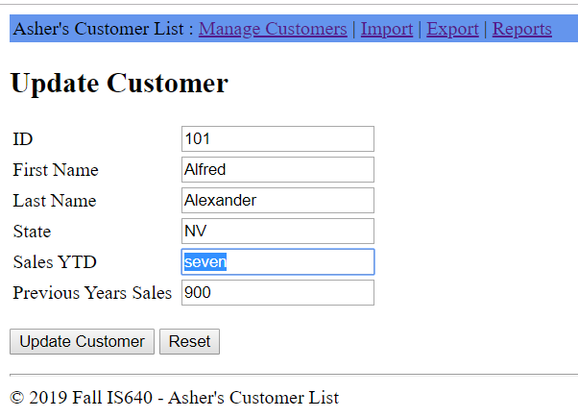

ERROR
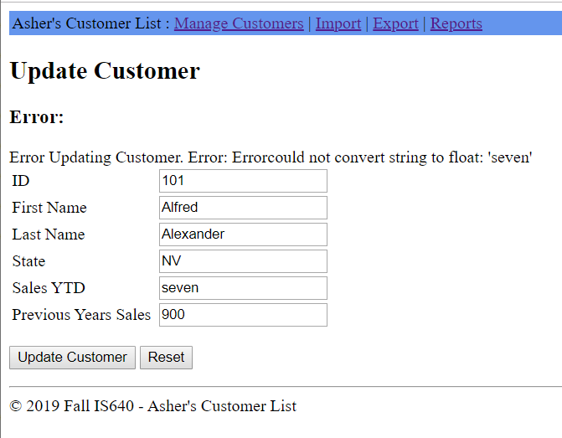

Confirmation After Update
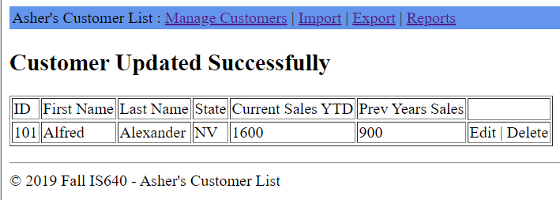

B. Import Files
You receive potential customer listings electronically. You want to be able to insert these customers to your program. You create the view that follows.
Assumption: Can assume that files are located in the current working directory as discussed in class.

Initial View
Note: Total number of records displayed
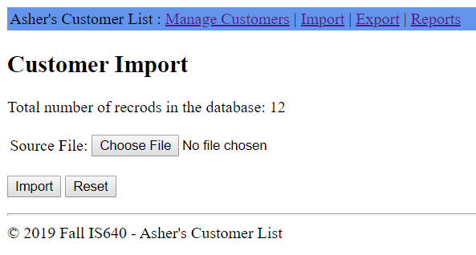

Processing a File
When Import is clicked, the data will be inserted into the database. Recall that the Id is the Primary Key and may not be duplicated in two records. If an attempt is made to insert duplicate Ids, create an error file as follows:
Filename: origFilename_errors_YYYYMMDDHHMMSS.txt
Note:
YYMMDDHHMMSS is the date stamp: Year, Month, Day, Hours, Minutes, Second.

For example:
File to be imported: Input1.txt (it has duplicate names). Then,
Error file name is: Input1_errors_20191117_103025.txt
The error file will contain the duplicate record

Assumption: Can assume that error files will be writing to the application working directory (as discussed in class).

Display a summary of the files that processed. See below for processing Input2.txt
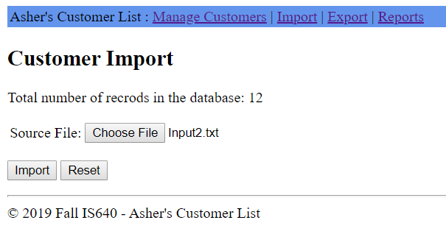
Summary results:
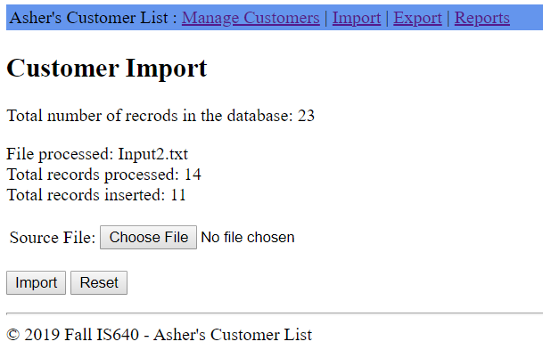

B. Export Files
Additionally, you want the ability to back up and archive your data. You envision the following view.

Initial View
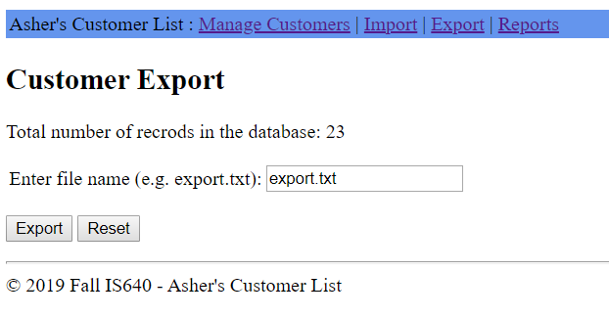

Processing
When backing up or archiving data, write it to a sequential file so it can be loaded again in the future. Same format as your input file.

E. Reports
You have a need for numerous reports. You want to be able to easily choose which report to run. Therefore you design the following.
Initial View
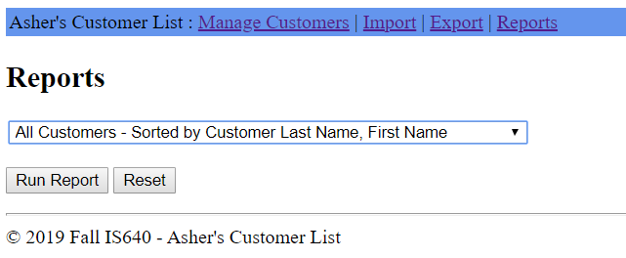

The drop down list shows the reports to be executed.
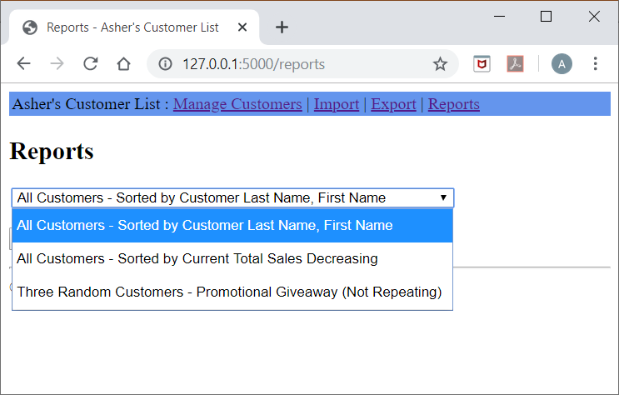

Report Types
- All Customers - Sorted by Customer Last Name, First Name
- All Customers - Sorted by Current Total Sales Decreasing
- Three Random Customers - Promotional Giveaway (Not Repeating) –
From the list of customers, select and display three random customers. Make sure not to display the same customer twice and make sure that at least three customers exist.

SAMPLE PROGRAM DATA
Attached are three files with sample input data. A customer record in contained in each line delimited by a space. Assume input files are accurate (don’t have to check for bad input files)

WHAT YOU NEED TO DO
- Database File Location. Use your current working directory and include your database as part of your submission.
- Create the program for the above requirements.
- Make sure to TEST the program to make sure it functions properly.
- Document your code well.
- Use naming conventions discussed in class.
- Don’t assume perfect data entry (except for given input files), test for data when appropriate (wrong date type, missing data, etc.).

Note:
Program interface is not perfect, just an interface for you to demonstrate your knowledge. You may enhance the interface and program shown, but don’t omit requirements.

WHAT TO TURN IN

Submit via BeachBoard Dropbox
Create a directory to store your files/subdirectories (.py, .db, .html, etc.).
Zip the entire directory use the following name:
yourLastNameFinalProject.zip (use your last name: e.g. AsherFinalProject).

Example:
Application directory:
c:\users\username\is640proj\
This directory has the .py files, .db file, templates subdirectory (with .html files). Zip the entire directory and submit via Drop Box.

Note: If you created additional input files and/or any other documents that you feel are relevant; include them in the zipped file.

