**Tremain mannion – lab 3 semester 2**

1. 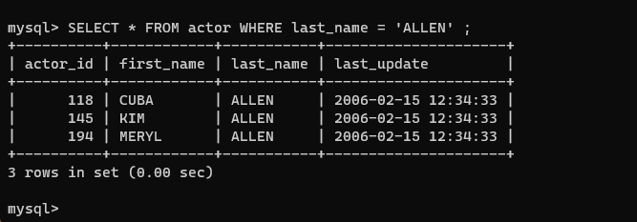
2. 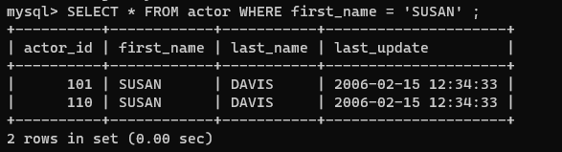
3. 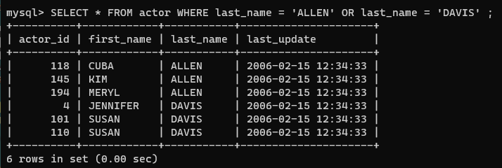
4. 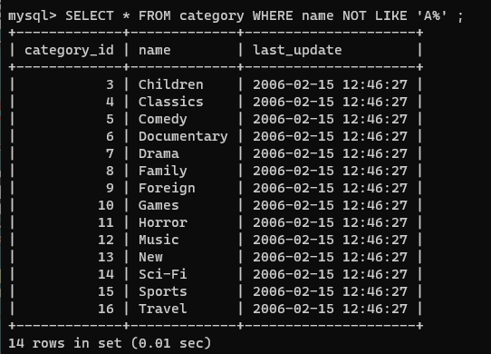
5. 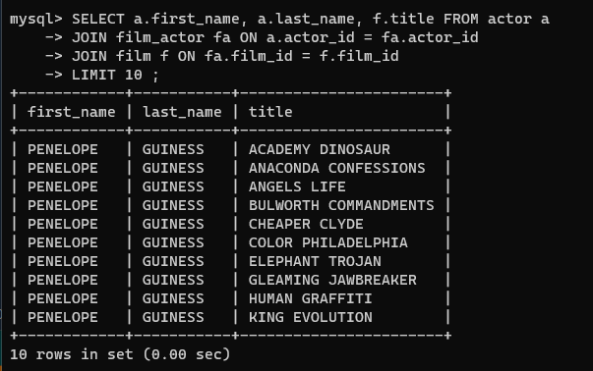
6. 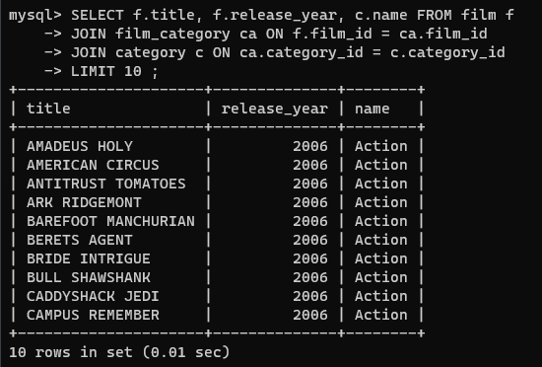
7. 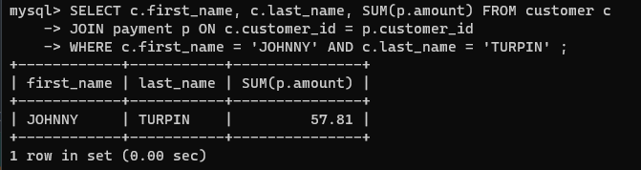
8. 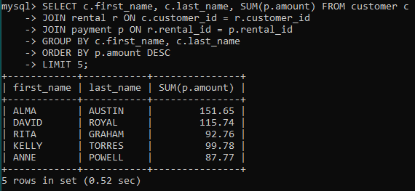
9. 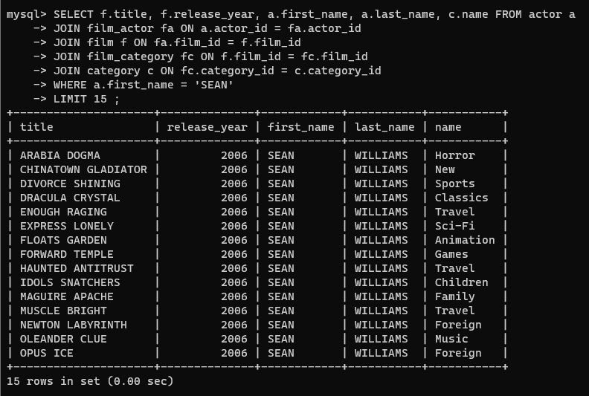
10. Return how much ANNE POWELL has spent on movie rentals.

Return the name of the customer that has spent the least on movie rentals.

Return the countries where SUSAN DAVIS has appeared in films

return the postal code of all customers

return the name of staff members and their store locations

return the rating of all films and their categorys

return the date that KELLY TORRES returned her last rental

return the country where all customers are from

return all films and categorys that KIM ALLEN is in

return the name all of actors, film title, rating and category

