GR
GYULROSE CAKES
Cake Manager Playbook
How to add, publish, remove and restore cakes from your phone

PRIVATE OWNER TOOL
Manager: https://gyulrose-cake-manager.vercel.app
Use the password supplied to you separately. Do not share the manager link or password publicly.
Prepared for Gyulten | August 2026
Your five-step quick start
You can publish a new cake without opening GitHub or contacting Gyunay. The manager prepares the photograph, saves the cake and updates the website automatically.
1 | Open the private manager  Visit the manager link on your phone and enter the password supplied separately.

2 | Choose one clear cake photograph  Use a bright, sharp image that shows the whole cake. The manager optimizes the image automatically.

3 | Complete the cake information  Add the cake name, starting price, category, flavour, description, ingredients and photo description.

4 | Check everything once  Make sure the price says the correct starting price and the description matches the photograph.

5 | Publish once and wait  Press Publish cake to website once. The website normally updates within about two minutes.

IMPORTANT
Do not close the page while it says Publishing. Do not press the publish button twice. Wait for the success message.
1. Sign in
Open https://gyulrose-cake-manager.vercel.app on your phone. Enter the private password supplied to you, then press Open cake manager.
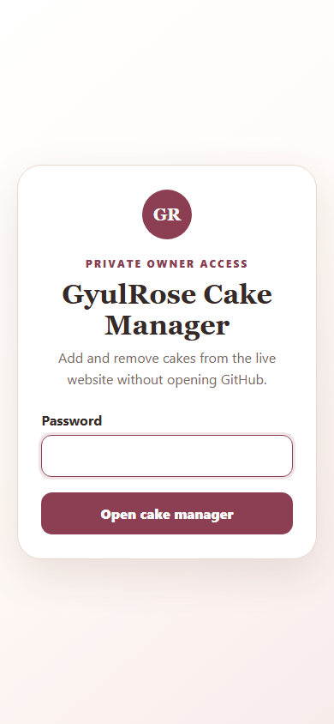
The private sign-in page. Your password will appear as hidden dots while typing.
If the password is rejected
Check for an accidental space before or after the password and try again carefully. If it still fails, send Gyunay a screenshot of the error message. Do not send the password in the screenshot.
2. Start a new cake
The Add new cake tab opens automatically. Press Choose File and select the cake photograph from your phone.
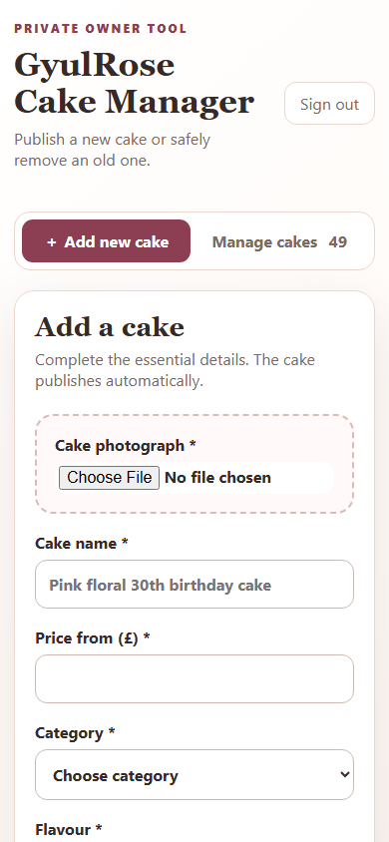
The beginning of the Add a cake form.
Choose the best photograph
Use one image with good light, a tidy background and the full cake visible. JPEG, PNG and WebP photographs are accepted. The manager resizes and compresses the image automatically.
3. Complete every required field
Fields marked with an asterisk (*) are required. The example below shows the level of detail needed.
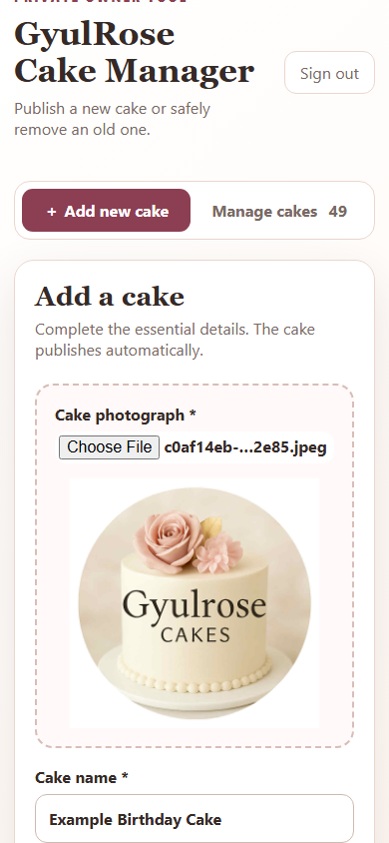
Example information only. Use the real information for the cake you are publishing.
Field | What to enter
Cake name | A clear name customers understand.
Price from | The minimum starting price in pounds, using numbers only.
Category | Birthday, children and themed, celebration, or corporate.
Flavour | The sponge and filling flavour.
Short description | Design, colours, decorations and occasion.
Ingredients shown | Sponge, filling, buttercream and decorations shown.
Photo description | A simple description of what is visible in the photo.
4. Review and publish
Before publishing, check the photograph, spelling, flavour and starting price. Tick Feature this cake only when you want the cake promoted near the top of the homepage.
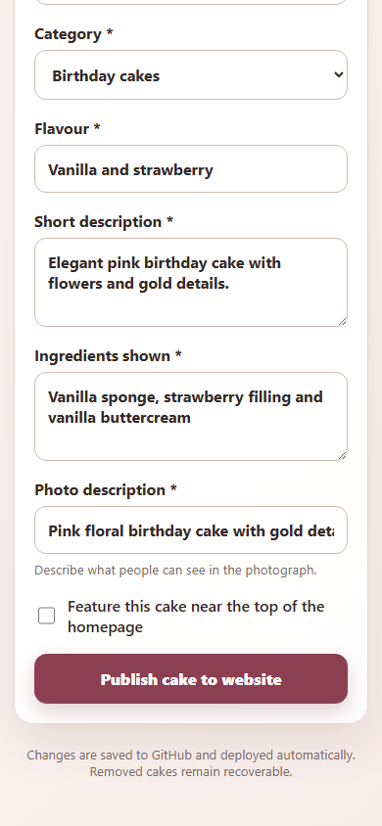
The final fields, optional Featured checkbox and Publish button.
1 | Press Publish cake to website once  The button changes while the manager prepares and uploads the cake.

2 | Wait for the success message  Keep the page open. A successful message confirms that the live website is rebuilding.

3 | Allow about two minutes  The cake will appear after the automatic website deployment finishes.

4 | Check the public website  Open gyulrosecakes.com and confirm the cake image, information and price are correct.

5. Remove or restore a cake
Open the Manage cakes tab to see the current cake list. Use the search box when you know the cake name.
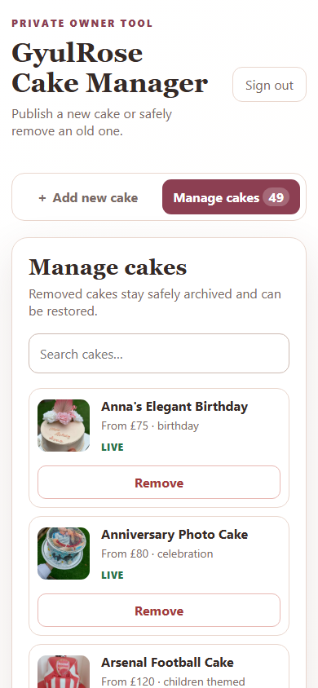
Each live cake has a Remove button. Removed cakes remain recoverable.
To remove a cake
Press Remove beside the correct cake, then confirm. The cake will disappear from the public website after the automatic rebuild. It is archived, not permanently deleted.
To restore a cake
Find the cake marked Removed and press Restore. After the website rebuild finishes, the cake becomes public again.
CHECK THE CAKE NAME
Always confirm you selected the correct cake before pressing Remove. If you remove the wrong cake, use Restore.
If something does not work
1 | The manager will not open  Check your internet connection, then reopen the manager link in Chrome or Safari.

2 | The password is not accepted  Retype it carefully without spaces. If it still fails, send Gyunay a screenshot of the error, without showing the password.

3 | The photograph will not upload  Try a normal JPEG or PNG from your phone. If needed, take a screenshot of the photograph and upload that copy.

4 | The cake name already exists  Use a more specific unique name, for example include the theme, flavour or occasion.

5 | The manager says published but the cake is not visible  Wait two full minutes and refresh the public website. If it is still missing, send Gyunay the cake name and a screenshot of the success message.

6 | Information is wrong after publishing  Do not publish the same cake again. Send Gyunay the cake name and the exact correction needed.

WHAT TO SEND WHEN ASKING FOR HELP
Send the cake name, what you pressed, what you expected, what happened, and one screenshot showing the problem. Never include the password in a screenshot or message.
Final publishing checklist
Use this quick check before pressing Publish:
[ ] The photograph is clear and shows the whole cake.
[ ] The cake name is unique and easy for customers to understand.
[ ] The starting price is correct.
[ ] The category matches the cake.
[ ] The flavour is correct.
[ ] The description matches the cake in the photograph.
[ ] The ingredients shown are correct.
[ ] The photo description explains what is visible.
[ ] Featured is selected only if I want homepage promotion.
[ ] I will press Publish once and wait for the success message.

YOU ARE READY
The Cake Manager is designed for you to use independently. Upload carefully, check once and let the automation complete the website update.

