Trent Ziemer

Dr. Newman

EECS 397

September 20, 2016

Homework 2: Sine Controller Services

On the left screen is some of my source code. On the right we see, from top to bottom: my catkin_make terminal, the user inputting a sine command into the sin_command_client (which is then sent out to sin_command), the sin_command node sending out vel_cmd data based on the client data through a client/service interaction, and then minimal controller node terminal, and the minimal simulator node terminal. The user can repeatedly send out new commands to the sin_command node which sends out the most up-to-date commanded sine wave data to the controller.

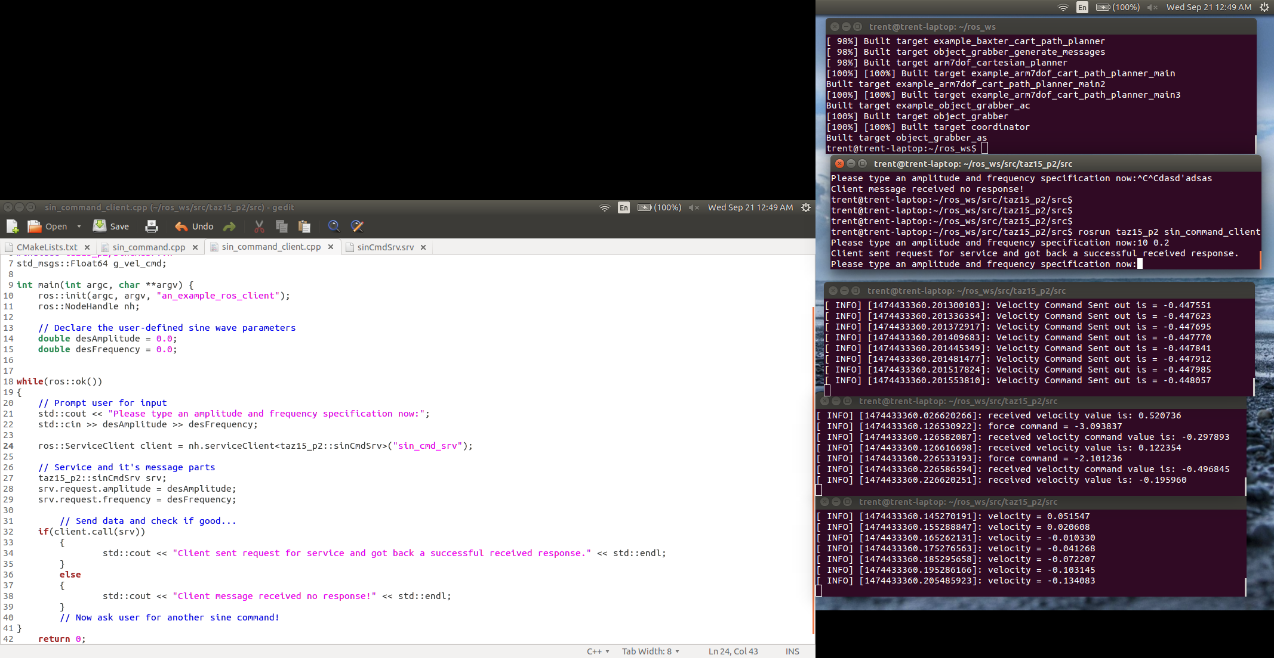

Here is a copy of my source code for the server node:

// SIN COMMANDER NODE MODIFIED TO BE A SERVER FOR HW2 - TRENT ZIEMER 9/20/2016

#include<ros/ros.h>

#include<std_msgs/Float64.h>

#include<taz15_p2/sinCmdSrv.h>

//global variables for callback functions to populate for use in main program

std_msgs::Float64 g_vel_cmd;

// Global pointers so that the callback and int main() can both access the publisher

ros::NodeHandle * g_nh;

ros::Publisher * g_pub;

double g_client_command_amplitude;

double g_client_command_frequency;

bool callback(taz15_p2::sinCmdSrvRequest& request, taz15_p2::sinCmdSrvResponse& response)

{

ROS_INFO("Server received a client request command.");

// Set global variables here based on received request data

g_client_command_amplitude = request.amplitude;

g_client_command_frequency = request.frequency;

// Junk ---->

response.received = true;

return true;

}

int main(int argc, char **argv) {

ros::init(argc, argv, "sin_command");

ros::NodeHandle nh;

// Declare variables, with global pointers for use by callbacks

g_nh = &nh;

ros::Publisher pub = g_nh->advertise<std_msgs::Float64>("vel_cmd", 1);

g_pub = &pub;

ros::start();

ros::ServiceServer service = nh.advertiseService("sin_cmd_srv", callback);

// Continually update vel_cmd, spinning once to potentially update from callback action

while(ros::ok())

{

double vel_cmd = g_client_command_amplitude*sin(g_client_command_frequency*ros::Time::now().toSec());

// Assign vel command to publishable object

g_vel_cmd.data = vel_cmd;

// Now publish

g_pub->publish(g_vel_cmd);

// Log info for user to cout

ROS_INFO("Velocity Command Sent out is = %f", g_vel_cmd.data);

ros::spinOnce();

}

return 0; // Should never get here, unless roscore dies!

}

And here is a copy of my source code for the client node:

// SIN COMMANDER CLIENT NODE - TRENT ZIEMER 9/20/2016

#include<ros/ros.h>

#include<std_msgs/Float64.h>

#include<taz15_p2/sinCmdSrv.h>

std_msgs::Float64 g_vel_cmd;

int main(int argc, char **argv) {

ros::init(argc, argv, "an_example_ros_client");

ros::NodeHandle nh;

// Declare the user-defined sine wave parameters

double desAmplitude = 0.0;

double desFrequency = 0.0;

while(ros::ok())

{

// Prompt user for input

std::cout << "Please type an amplitude and frequency specification now:";

std::cin >> desAmplitude >> desFrequency;

ros::ServiceClient client = nh.serviceClient<taz15_p2::sinCmdSrv>("sin_cmd_srv");

// Service and it's message parts

taz15_p2::sinCmdSrv srv;

srv.request.amplitude = desAmplitude;

srv.request.frequency = desFrequency;

// Send data and check if good...

if(client.call(srv))

{

std::cout << "Client sent request for service and got back a successful received response." << std::endl;

}

else

{

std::cout << "Client message received no response!" << std::endl;

}

// Now ask user for another sine command!

}

return 0;

}