Trenton Hohle

Assignment 3

2/28/18

CS 3354

Use Cases

Access Website

The Access Website use case is initiated when the user goes to the store's website. Once on the website they will be able to do things such as:

1. Display Inventory

2. Add/modifying their account with the store

3. Make any purchase online

4. Contact the store

Once they select any of the options it will redirect them accordingly.

Display Inventory

The Display Inventory use case is initiated when the user selects option number 1 from the menu. It then accessed the store's inventory and displays it in a formatted chat for the customer to look through. Redisplays the menu options afterward.

Add or Modify Account

The Add or Modify Account use case is initiated when the user selects option number 2 from the menu. Once they enter this setting they will be prompted if they want to make an account or modify an currently existing account. If they go to add an account they will be prompted to input information such as their first and last name, address, and phone number, then an ID will be created for them. If they want to modify an existing account, they will be asked for their ID number, there ID will be validated in the system, if not found an error will be shown, if found it will asked if they want to modify their address or their phone number, then gather the necessary information to make the change.

Make Purchase

The Make Purchase use case is initiated when the user selects option number 3 from the menu, or when they Come into the Store. It asks the user which item they would like to purchase (asks for the ID of the item), it then validates that it is an valid ID for the item, if it doesn't exist it send an error, but if it does it moves on. After which it prompts the user for the quantity they wish to buy, and validates that there is enough on hand. If there isn't enough on hand it sends an error message, if there is enough it gathers payment and finishes the transaction, sending the order on to the store, if it was online, if it was in person at the store then it just completes the transaction and prints a receipt. The order stores the customer ID, Item ID, quantity, and price, while if an online order it leave the Employee ID blank, and setting the transaction status to pending, but if it's at the store it fills in the Employee ID and marks the transactions status to completed.

Contact Store

The Contact Store use case is initiated when the user selects option number 4 from the menu. It asks the customer for their Customer ID, and validates that it is a valid ID, if not it gives an error message, if it is, it proceeds on. It then asks the user for the message they would like to send the store. Saves the message into the system for the store to view. Displays a message saying the store will call them in regard to their message when they get the chance.

Come into Store

The Come into Store use case is initiated when the customer comes into the store. From there they can get with an employee into order to:

1. Add or Modify Account

2. Make a Purchase

3. Pick up an order

Pick Up Order

The Pick Up Order use case is initiated when the customer asks an employee to pick up their order. The employee then asks for the Customer's ID, and checks if the customer has an order on hold, if they don't they get an error, if they do then they input their own Employee ID into the Order, mark the transaction status to complete, and give the customer their product.

Verify Information

The Verify Information use case is initiated when either the Customer info is being modified, the customer goes to make a purchase, when an employee's information is being modified, or an administrator's information is being modified. The other cases that call it pass the ID that needs to be checked, it is checked against the list, and if it's there, true is returned and if not, false is returned.

Modify User

The Modify User use case isn't initiated but is an abstract case that the customer, employee and admin use cases all are based from.

Customer

The Customer modify use case is initiated when the customer selects it on the website or when the customer is in store and asks the employee to update their information for them. When they are updating their info, the system will ask for their ID, and then validate that it is actually in the system. If it isn't in the system it will give an error message. If it is in the system it will ask if they want to modify their address or phone number. If the user is just making an account, it will ask for their first name, last name, phone number and address, then the system will auto generate an ID for them.

Employee

The Employee use case is initiated when the Admin selects to modify it in the stores computer system. When the admin is in it, the system will prompt for the Employees ID, once provided the system will validate the ID, if not found it will provide an error message, if found it will ask if the admin would like to adjust the employee's SSN or their salary.

Administrator

The Administrator use case is initiated when the Admin selects to modify it in the stores computer system. The system will then prompt the Admin if he would like to modify an employee or another admin. It will gather the ID of the employee or the admin, and validate the input, giving the appropriate error message if needed. Then will ask if the admin wants to modify the salary, SSN or admin status of the given employee/admin in the system.

Not Found Error Extension

The Not Found Error Extension use case is initiated when the input ID is checked in the system, and is not found in the system. It then prints out an error message to the user.

Accounting

The Accounting use case is initiated when the Admin selects the menu option and logs in with their pin number. The pin gets validated to make sure that it is allowed to access the Accounting aspect as well as even in the system. If it isn't in the system an error is output, if it is they get a menu asking what they would like to do including tracking income, expenses and profit, as well as printing financial documents like balance sheets, statements of cash flow and invoices.

Use Case Diagram

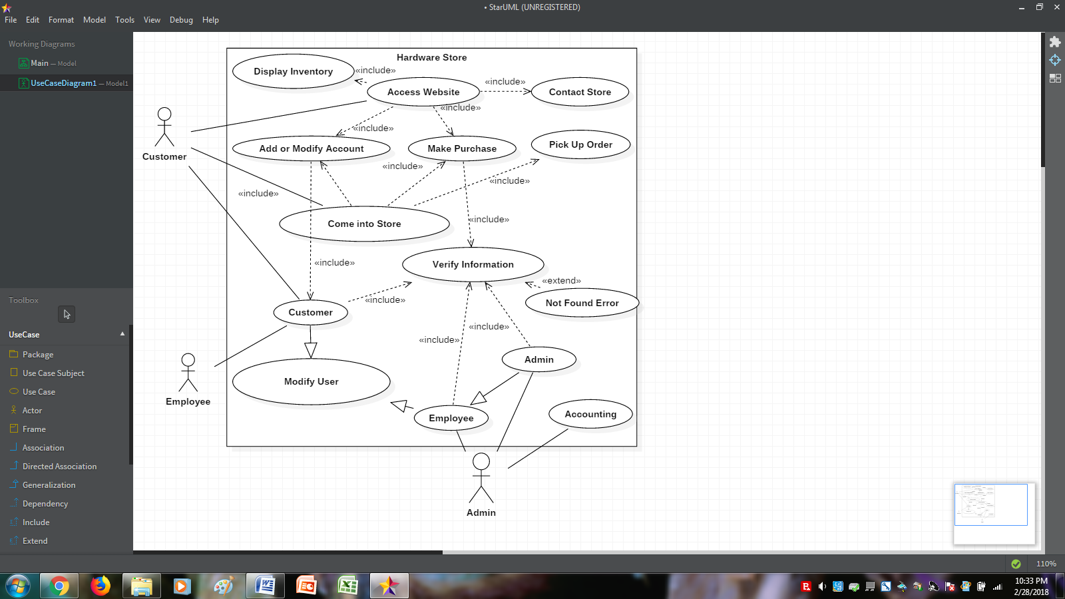

CRC cards

|  |  |
| --- | --- |
| Driver | |
| -Read in the 4 databases (Users, inventory, transactions, and accounting)  -Display Existing items in Inventory  -Add new items to the Inventory  -Delete items from the inventory  -Search for items in the inventory  -Display list of users in the database  -Add new users to the database  -Update information on users in database  -Complete a sales transaction in store  -Release ordered item to customer  -Display transactions  -Tracking income, expenses, and profits  -Printing Financial Documents  -*Customer orders product online*  -Read out the 4 databases (Users, inventory, transactions, and Accounting) | -Users, Inventory, Transactions, Accounting  -Inventory  -Inventory  -Inventory  -Inventory  -Users  -Users  -Users  -Transactions  -Transactions  -Transactions  -Accounting  -Accounting  -Website  -Users, Inventory, Transactions, Accounting |

|  |  |
| --- | --- |
| Inventory | |
| -Add or remove Items from the inventory  -Storing ItemID, Name, Quantity, and price | -Small Hardware / Appliances / Driver  -Small Hardware / Appliances |

|  |  |
| --- | --- |
| Small Hardware | |
| -Storing Categorical information for items | -Inventory |

|  |  |
| --- | --- |
| Appliances | |
| -Storing type and brand information for items | - Inventory |

|  |  |
| --- | --- |
| User | |
| -Adding and removing people from Users  -Storing Id, first and last name of users | -Customer / Employee / Driver  -Customer / Employee |

|  |  |
| --- | --- |
| Customer | |
| -Storing Address and phone number | -User |

|  |  |
| --- | --- |
| Employee | |
| -Storing Salary, SSN, Active Status, and Pin | -User / Admin |

|  |  |
| --- | --- |
| Admin | |
| -Adding and removing Admins / Employees  -Accessing Accounting | - Employees  - Accounting |

|  |  |
| --- | --- |
| Transaction | |
| -Adding sales transactions to a database  -Processing Online sales  -Processing Store sales  -Storing ItemID, Date, Quantity, Customer ID, Employee ID and transaction status | -Online / In Store / Driver  - Online  -In Store  -Online / In Store / Driver |

|  |  |
| --- | --- |
| Online | |
| -Marks transaction status as pending until picked up  -passes ItemID, date, quantity, customer ID to Transaction | -Transaction  -Transaction |

|  |  |
| --- | --- |
| In Store | |
| -Sells the product right there in person  -passes itemID, date, quantity, customer ID, and employee ID to Transaction, while marking Transaction status as complete | -Transaction  -Transaction |

|  |  |
| --- | --- |
| Accounting | |
| -Accessed only by Admins, verifies it's an admin before allowing access  -Allows user to track income, expenses, and profit  -Allows user to print financial documents like:  i. Balance Sheets  ii. Statements of Cash flow  iii. Invoices | -Admin  -Driver  -Driver |

|  |  |
| --- | --- |
| Website | |
| -Lets customers create a new account  -Lets customers edit an existing account  -Lets customers create a purchase order  -Lets customers contact the hardware store customer service | -Customer (User)  -Customer (User)  -Online(Transactions)  -Customer Service |

Class Diagram

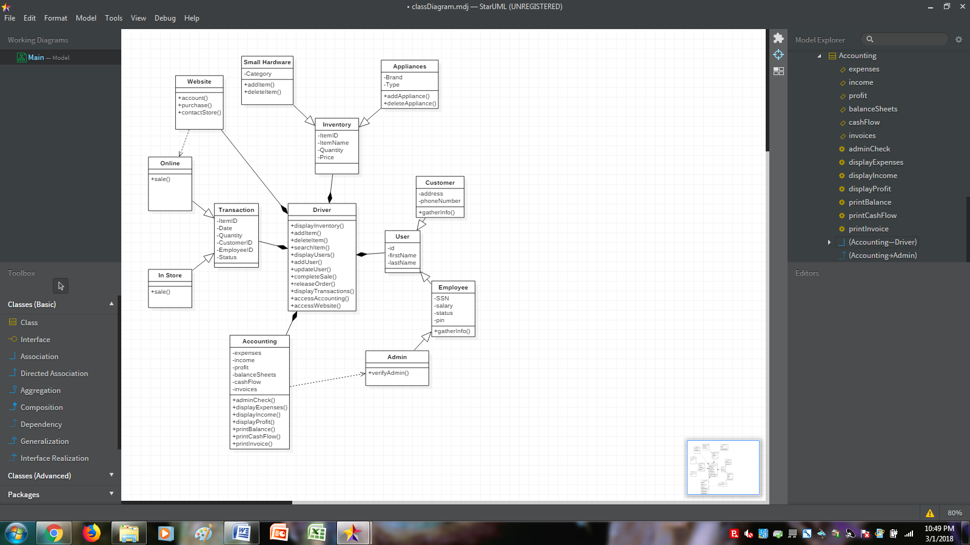

(couldn't figure out how to add multiplicities or set User/Transaction/Inventory as abstract data types)

(but for multiplicities... for 1 instances in drive, there are * instances of Transaction/User/Inventory)

Sequence Diagram

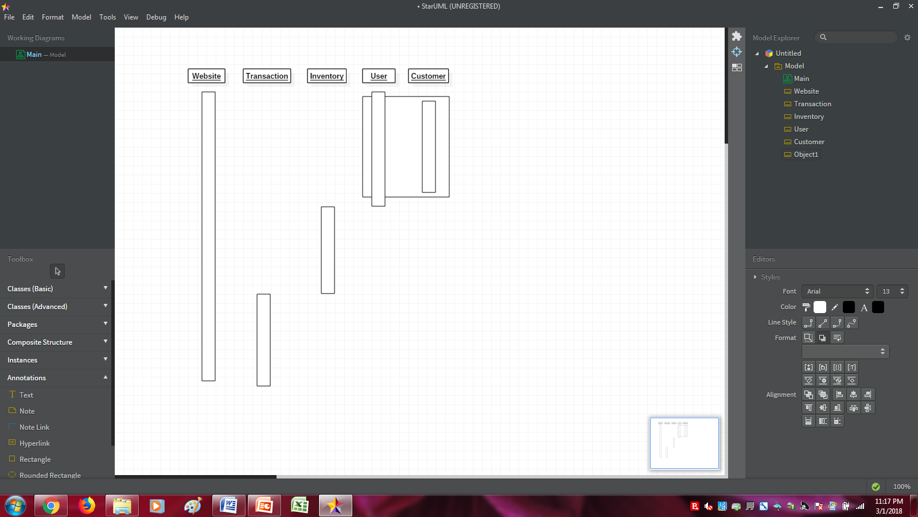

pickUpOrder()

placeOrder()

checkQuantity()

checkItemID()

**Make Account**

setPhoneNumber()

setAddress()

generateID()

setLastName()

setFirstName()

verifyAccount()

(dashed lines going to the left don't exist in word apparently (couldn't find them)) (nor could I find them in starUML, so all lines and text boxes were made in word...)