Does it rain more in Seattle or New York City? To answer this question, rainfall data from weather stations in both cities was gathered, cleaned, and analyzed. The NOAA National Centers for Environmental Information website was used to request records of daily precipitation/rainfall from Seattle and New York for the 3 year period from January 2020 to January 2024. The data was cleaned, resulting in a data set where each city has a daily average precipitation. Note that a few days were missing for Seattle.The data was analyzed using a variety of methods, such as comparing the overall average rainfall of each city over various time periods like monthly, quarterly, etc. Furthermore, the intensity of the rain was considered.

A sensible way to answer the question “Does it rain more in Seattle or New York City?” is to compare the cities to find which has the larger average daily rainfall, shown in figure 1. Clearly, New York City has the larger overall average daily precipitation. So that’s the answer, right? Not exactly. It is true that NYC received more rain on average than Seattle over 3 years, but there’s more to the story when investigated further.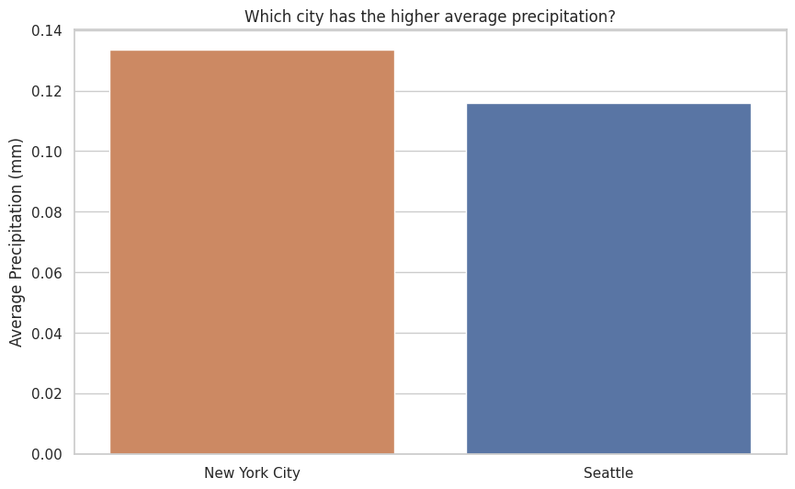

Figure 1

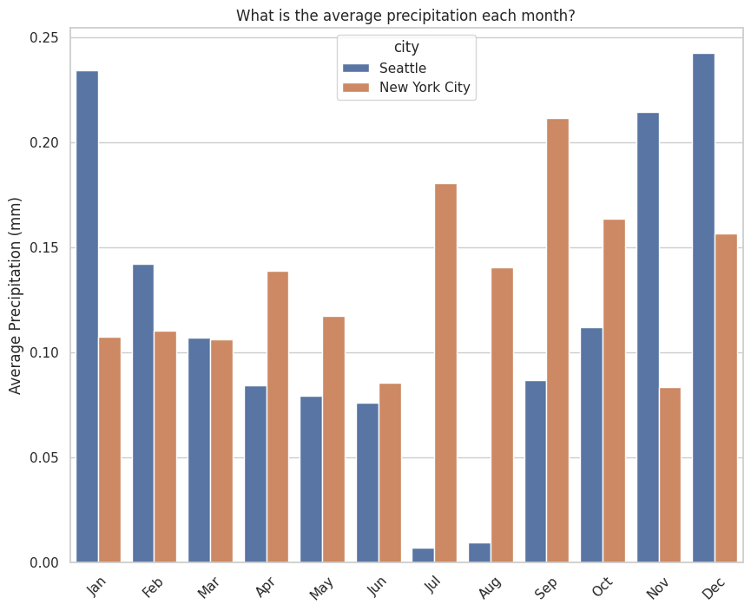

Figure 2

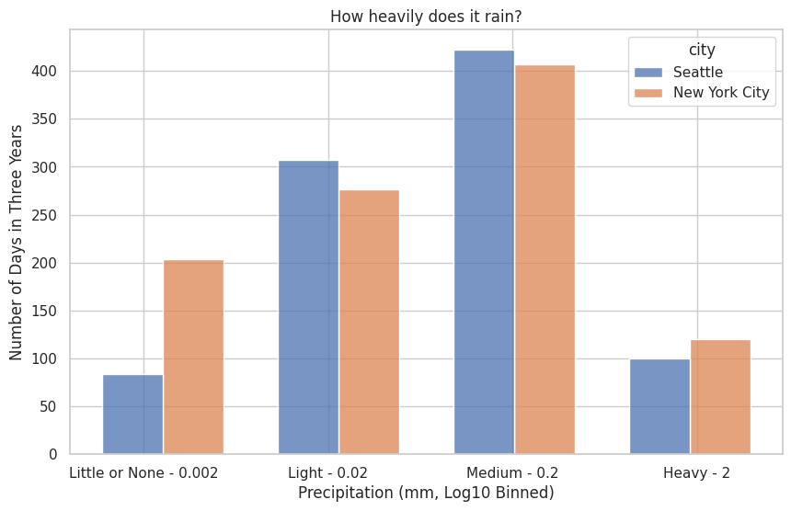

Figure 3

In figure 2, there are 5 months out of the year where Seattle rains more than NYC. In January, November, and December, it rains much more in Seattle than NYC. NYC appears to have a monthly average precipitation of at least 0.075 mm every month, with larger rainfall occurring in July and September. Seattle similarly has a monthly average precipitation of at least 0.075 mm, but only in most months. July and August in Seattle see virtually no rain, meanwhile January, November, and December are the 3 months with the most monthly average precipitation out of both cities. It appears it is more rainy (one might say “rainier”) in Seattle from November to March, and more rainy in NYC from April to October. In figure 3, the number of days out of the three years of data has been grouped by intensity of rain denoted by four categories: Little or None, Light, Medium, and Heavy rainfall. Each category is 10 times the intensity of the previous. The city of Seattle has more days of light and medium precipitation, even more than New York City. NYC also has mostly days of light and medium precipitation, but has many days with little to no rain in comparison to Seattle. NYC has more days of no rain than heavy rain, but Seattle has more days of heavy rain than no rain.

In conclusion, New York City gets slightly more rainfall than Seattle on average. Both cities rain a light or medium amount most days, but NYC boasts more dry days while also claiming more days of heavy rainfall than Seattle. Seattle, on the other hand, gets more rain than New York in the winter months, but is in comparison quite dry during July and August. As such, there are many times where either city is experiencing more rainfall than the other.