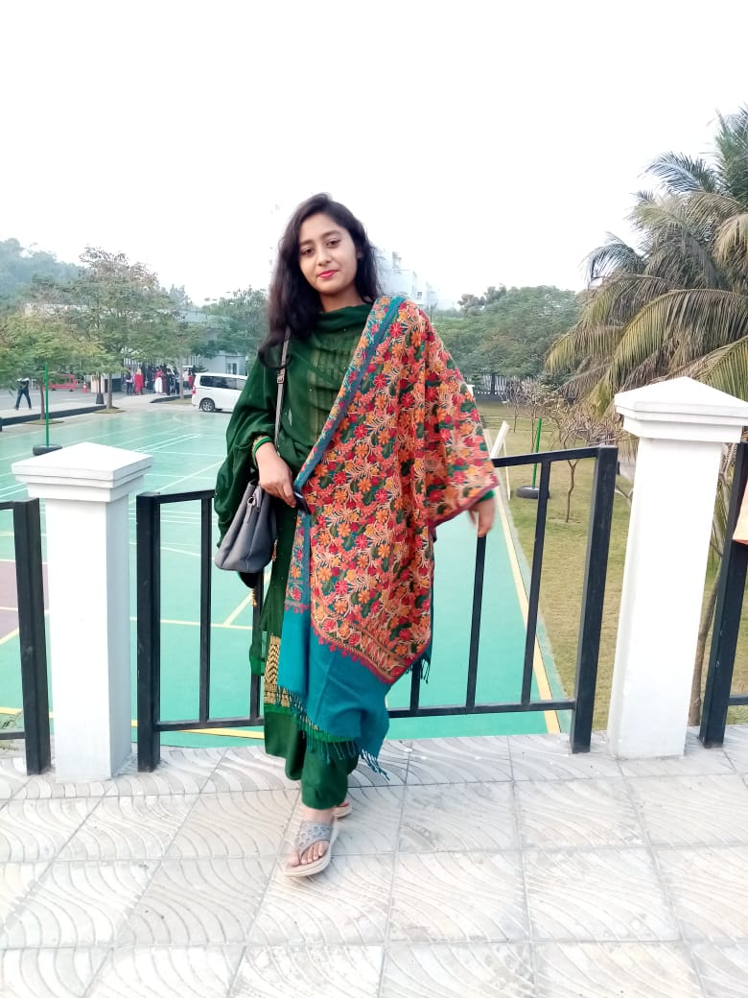

Contact:

**Address:**

Bogura,Bangldesh

Post Code -5800

Phone:

+88 01737336101

Email:

[tresna312@gmail.com](mailto:tresna312@gmail.com)

LinkedIn:

<https://www.linkedin.com/in/tresna-rani-b20b11248/>

Language:

C C++

JAVA JavaScript

Hobbies:

* Coding
* Design
* Writing

**Summary:**

**Web Developer specializing in front end developer.**

**Experienced with all stages of the development cycle For dynamic web projects. Well-versed in numerous programming language including HTML5,CSS,JavaScript MySQL, good knowledge in Bootstrap, Bootsnipp Framwork.**

**Details(GitHub)-** [**https://github.com/TresnaRani**](https://github.com/TresnaRani)

**Skill Highlights**

* **Project management**
* **Strong decision maker**
* **Complex problem solver**
* **Creative Design**
* **Service-focused**

**Project**

**Web Developer As a Full-Stack Developer**

* **Bidding System In Tourism Industry**
* **Web with AI etc**

**Education**

**B.sc Engineering: Computer Science & Engineering-(Final year Student)**

**University of Rajshahi, Bangladesh**

**Certification**

**Android App Components-Coursera**

Tresna Rani