Cover page

Table of Contents
Figure table 5
1 Introduction 8
2 Objectives 8
3 Preprocessing 8
3.1 Data Import 8
3.2 Removing duplicate rows 9
3.3 Handling missing values 10
3.4 Data summarization 10
3.5 Structure of dataset 11
3.6 Head of dataset 13
3.7 Data Import 14
4 Questions and analysis 15
4.1 Question 1: Is there any type of discrimination when it comes to work placement? 15
4.1.1 Analysis 1-1 15
4.1.2 Analysis 1-2 16
4.2 Question 2: what can increase the chance of having a job placement? 18
4.2.1 Analysis 2-1 18
4.2.2 Analysis 2-2 19
4.2.3 Analysis 2-3 20
4.2.4 Analysis 2-4 21
4.2.5 Analysis 2-5 22
4.3 Question 3: How do background influence school performance? 24
4.3.1 Analysis 3-1 24
4.3.2 Analysis 3-2 25
4.3.3 Analysis 3-3 26
4.3.4 Analysis 3-4 27
4.3.5 Analysis 3-5 29
4.4 Question 4: What is the most appealing degree to go for? 31
4.4.1 Analysis 4-1 31
4.4.2 Analysis 4-2 32
4.4.3 Analysis 4-3 33
4.4.4 Analysis 4-4 34
4.5 Question 5: Is there a significant difference in placement rates between male and female students? 37
4.5.1 Analysis 5-1 37
4.5.2 Analysis 5-2 38
4.5.3 Analysis 5-3 40
4.6 More analysis: 42
4.6.1 Extra-analysis 1: Is there a correlation between a student's Grade 10 score and their placement rate? 42
4.6.2 Extra-analysis 2: How does high school GPA correlate with placement rates? 43
4.6.3 Extra-analysis 3: Is there a correlation between student major and placement rate? 45
4.6.4 Extra-analysis 4: How does a student's extracurricular involvement impact their placement rate? 46
4.6.5 Extra-analysis 5: How does GPA vary by major? 48
4.6.6 Extra-analysis 6: Are there any differences in placement rates based on the industry a student is pursuing? 50
4.6.7 Extra-analysis 7 51
4.6.8 Extra-analysis 8: How to know the Grade12 GPA of students who have internet vs those who don't have internet? 53
4.6.9 Extra-analysis 9 : Are there any correlations between academic performance and placement status? For example, do students with higher GPAs tend to be more successful in securing placements? 54
4.6.10 Extra-analysis 10 55
5 Conclusion 57

Figure table
Figure 1: data import screenshot 8
Figure 2: removing duplicate data screenshot 9
Figure 3: removing rows with missing data 10
Figure 4: data summarization code 10
Figure 5: data summarization output 11
Figure 6: str() code 11
Figure 7: str () before removing rows with missing column 12
Figure 8: str () after removing rows with missing column 13
Figure 9: head () function 13
Figure 10: head () function output 13
Figure 11: tail() code 14
Figure 12: tail() output 14
Figure 13: Students placed vs students not placed code 15
Figure 14: Students placed vs students not placed graph 15
Figure 15: placement by gender bar graph code 16
Figure 16: placement by gender bar graph output 17
Figure 17: histogram code for employe's test score code 18
Figure 18: histogram code for employee's test score output 18
Figure 19: Employee test vs placement code 19
Figure 20: Employee test vs placement output 19
Figure 21: work experience influence over job placement code 20
Figure 22: work experience influence over job placement output 20
Figure 23: degree GPA vs Placement status code 21
Figure 24: degree GPA vs Placement status output 21
Figure 25: work placement based on degree qualifications code 22
Figure 26: work placement based on degree qualifications graph 22
Figure 27: : work placement based on degree qualifications table 23
Figure 28: Average Grade 12 GPA based on internet used code 24
Figure 29: Average Grade 12 GPA based on internet used output 24
Figure 30: Average Graduation GPA based on internet used code 25
Figure 31: Average Graduation GPA based on internet used code 25
Figure 32: father's occupation vs Grade 12's GPA code 26
Figure 33: : father's occupation vs Grade 12's GPA output 26
Figure 34: mother's occupation vs Grade 12's GPA code 27
Figure 35: mother's occupation vs Grade 12's GPA output 28
Figure 36: Parents occupation vs student’s occupation code 29
Figure 37: Parents occupation vs student’s occupation output 29
Figure 38: average salary per degree code 31
Figure 39: average salary per degree output 31
Figure 40: number of students place per degree code 32
Figure 41: number of students place per degree output 32
Figure 42: high school board vs placement code 33
Figure 43: high school board vs placement output 33
Figure 44: salary vs major code 34
Figure 45: salary vs major graph 35
Figure 46: male vs female placement code 37
Figure 47: male vs female placement output 37
Figure 48: percentage of male students place per specialism code 38
Figure 49: percentage of male students place per specialism result 38
Figure 50: percentage of female students place per specialism code 40
Figure 51: percentage of female students place per specialism output 40
Figure 52: Extra-analysis 1 code 42
Figure 53: Extra-analysis 1 output 42
Figure 54: Extra-analysis 2 code 43
Figure 55: Extra-analysis 2 output 44
Figure 56: Extra-analysis 3 code 45
Figure 57: Extra-analysis 3 output 45
Figure 58: Extra-analysis 4 code 46
Figure 59: Extra-analysis 4 output 47
Figure 60: Extra-analysis 5 code 48
Figure 61: Extra-analysis 5 graph 48
Figure 62: Extra-analysis 6 code 50
Figure 63: Extra-analysis 6 output 51
Figure 64: Extra-analysis 7 code 52
Figure 65: Extra-analysis 7 output 52
Figure 66: Extra-analysis 8 code 53
Figure 67:Extra-analysis 8 output 53
Figure 68: Extra-analysis 9 code 54
Figure 69: Extra-analysis 9 output 54
Figure 70: Extra-analysis 10 code 55
Figure 71: Extra-analysis 10 output 56

Introduction
This assignment aims to explore the application of data analytics techniques to a provided dataset related to students' placement information and attribution. The dataset contains 25 columns and 17007 rows, including personal details, family backgrounds, extra activities, academic records, and placements information of the students.
The analysis will adopt the data Exploration, Manipulation, Transformation, and Visualization concepts to guide through the solution process. It will involve a number of techniques categorized into different criteria to deeply explore the dataset, including pre-processing, data cleaning, feature selection, dimensionality reduction, clustering, and classification.
In addition, the analysis will go beyond what has already been covered in this course and explore further concepts to improve the retrieval effects. The findings will be outlined, analyzed, and justified correctly with appropriate graphs using R programming concepts.
Overall, the goal of this assignment is to provide a detailed exploration and analysis of the dataset, highlighting the potential applications of data analytics techniques in the education domain.

Objectives
The main objective of this coursework is to provide students with an opportunity to explore and analyze a set of data, apply different data analytics techniques to it, and reconstruct it into meaningful representations for decision making. By completing this coursework, students will be able to develop their skills in data exploration, manipulation, transformation, and visualization, and apply these skills to real-world problems.

Preprocessing

Data Import

Code
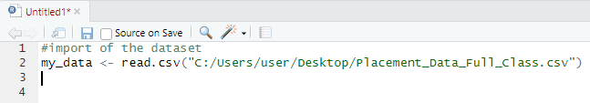
Figure 1: data import screenshot

Justification
“my_data”: This is a variable name that you are assigning to the dataset that you are about to read in from the CSV file. “<-”: This is the assignment operator in R that assigns the value on the right-hand side of the operator to the variable on the left-hand side. “read.csv()”: This is a function in R that reads a CSV (Comma Separated Values) file into a data frame. It takes one mandatory argument, which is the path to the CSV file that you want to read. In this case, the path is C:/Users/user/Desktop/Placement_Data_Full_Class.csv.
"C:/Users/user/Desktop/Placement_Data_Full_Class.csv": This is the path to the CSV file that you want to read. It is a string, enclosed in double quotes, that specifies the location of the file on your computer. In this case, the file is located on the desktop of the user named "user".
So, when you run the code my_data <-read.csv("C:/Users/user/Desktop/Placement_Data_Full_Class.csv"), R will read in the CSV file located at the specified path, convert it into a data frame, and assign it to the variable my_data. The resulting data frame contains all the rows and columns of the original CSV file, and you can use various functions and operations in R to manipulate, transform, and analyze the data.

Removing duplicate rows

Code

Figure 2: removing duplicate data screenshot

Justification
The unique() function is used to identify the unique rows of a data frame. When called with a single argument, it returns a vector or a data frame containing only the unique values of that argument. When called with a data frame as an argument, it returns a data frame containing only the unique rows of that data frame.
Therefore, my_dataset <- unique(my_data) creates a new data frame called my_dataset that contains only the unique rows of the my_data data frame. If my_data contains any duplicate rows, those rows will be removed from my_dataset.
Note that the unique() function only considers exact duplicates. If there are rows with the same values in all columns, but in a different order, unique() will not identify them as duplicates. In that case, you may need to use additional methods to identify and remove those rows.

Handling missing values

Code
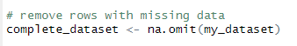
Figure 3: removing rows with missing data

Justification
This code removes all rows with missing data from the original dataset and creates a new dataset called complete_dataset. Here's a breakdown of the code:
na.omit() is a function in R that removes all rows with missing values from a dataset. The my_dataset dataset is passed as an argument to this function. If any row in my_dataset has missing data, that entire row is removed from the dataset.
The resulting dataset with complete cases is then assigned to a new variable called complete_dataset. This new dataset will contain all the rows that have no missing values across all columns.
By removing the rows with missing data, the analysis will be based on a subset of the original data. This approach can be useful to ensure that the remaining data is complete and valid for analysis. However, it's important to be aware that removing missing data can introduce bias if the missing values are related to the outcome of interest or any of the other variables in the analysis. Therefore, it's important to carefully consider the reasons for the missing data and the potential impact on the results before removing the missing data.

Data summarization

Code
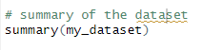
Figure 4: data summarization code

Justification
The summary() function in R is used to generate a summary of the distribution of values for the variables in a dataset. The code summary(my_dataset) will apply this function to the my_dataset data frame, producing a summary of the distribution of values for each of the variables in the dataset.
The summary produced by summary() will depend on the type of the variable being summarized. For numeric variables, the summary will include the minimum and maximum values, the first and third quartiles, and the median (i.e., the 50th percentile). For categorical variables, the summary will include the frequency and proportion of each category.
The summary() function is a useful tool for quickly exploring the range and distribution of values in a dataset, but it is important to note that it does not provide a complete picture of the data. For example, it may not identify outliers, and it does not provide information about the relationships between variables. Other exploratory data analysis techniques, such as visualizations or more detailed statistical analyses, may be necessary to fully understand a dataset.

Output
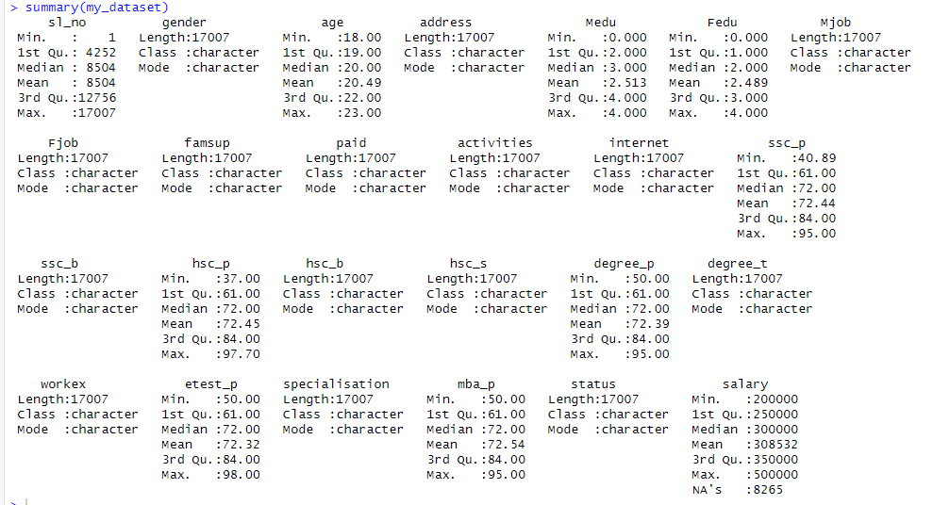
Figure 5: data summarization output

Structure of dataset

Code
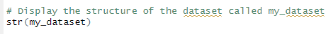
Figure 6: str() code

Justification
str() is a function that provides information about the structure of an R object. When you apply str() to a dataset, it displays a compact summary of the dataset's structure. Specifically, it displays the data type and the first few values of each column in the dataset. For example, if you have a dataset called my_data, running str(my_data) will output a summary of the structure of my_data, including the number of observations and variables, the names of the variables, and the data type of each variable. This information can be useful for understanding the contents of a dataset, and for identifying any potential issues with the data (e.g., missing values or unexpected data types).

Output
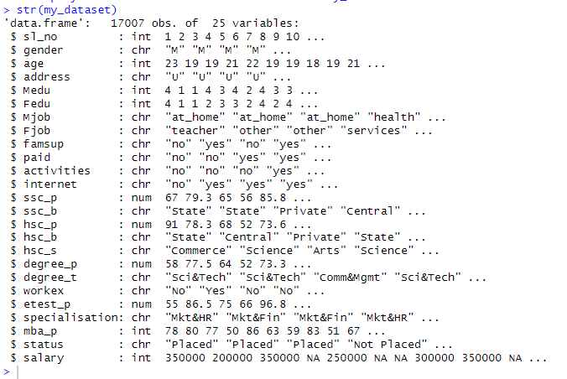
Figure 7: str () before removing rows with missing column
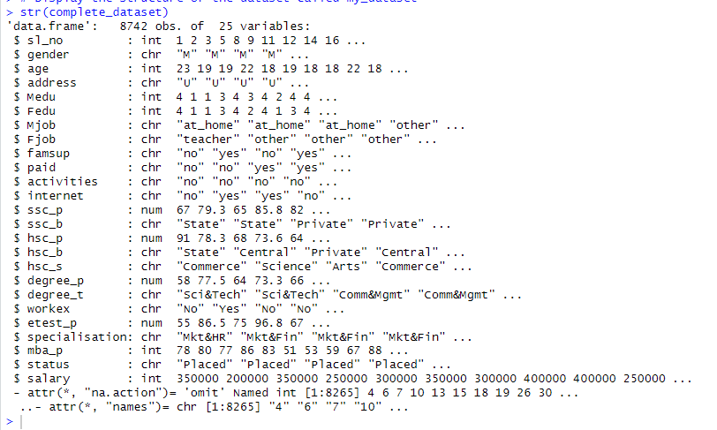
Figure 8: str () after removing rows with missing column

Head of dataset

Code
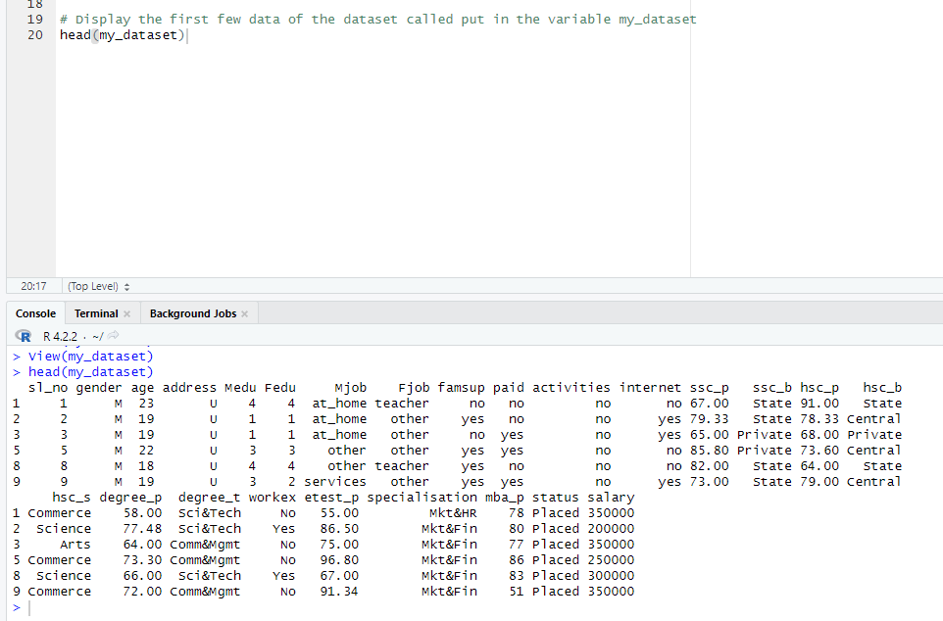
Figure 9: head () function

Output
Figure 10: head () function output

Justification
head() is a function that allows you to view the top few rows of a data frame. When you apply head() to a data frame, it returns the first 6 rows of the data frame by default. You can specify a different number of rows to view by providing a second argument to the function (e.g., head(my_dataset, 10) will show the first 10 rows of the data frame). For example, if you have a data frame called my_dataset, running head(my_dataset) will output the first 6 rows of the data frame. This function is often used to quickly inspect the contents of a data frame, and to verify that the data has been imported correctly and is in the expected format.

Data Import

Code
Figure 11: tail() code

Output
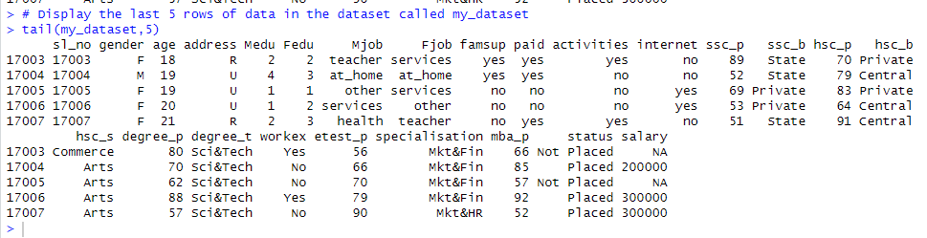
Figure 12: tail() output

Justification
The code above uses the tail() function to display the last 5 rows of data in the dataset called my_dataset. The tail() function is a built-in function in R that returns the last n rows of a data frame or matrix. In this case, tail(my_dataset,5) returns the last 5 rows of the my_dataset data frame. The function takes two arguments: the data frame or matrix to be displayed and the number of rows to display.
In this case, my_dataset is the data frame to be displayed, and 5 is the number of rows to display. The output of the code will be the last 5 rows of the my_dataset data frame. This can be useful for quickly checking the structure and content of a data frame, especially when working with large datasets.

Questions and analysis

Question 1: Is there any type of discrimination when it comes to work placement?

Analysis 1-1

Code
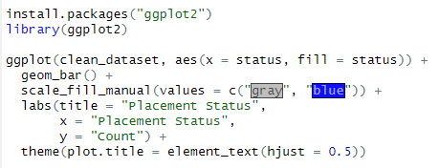
Figure 13: Students placed vs students not placed code

Output
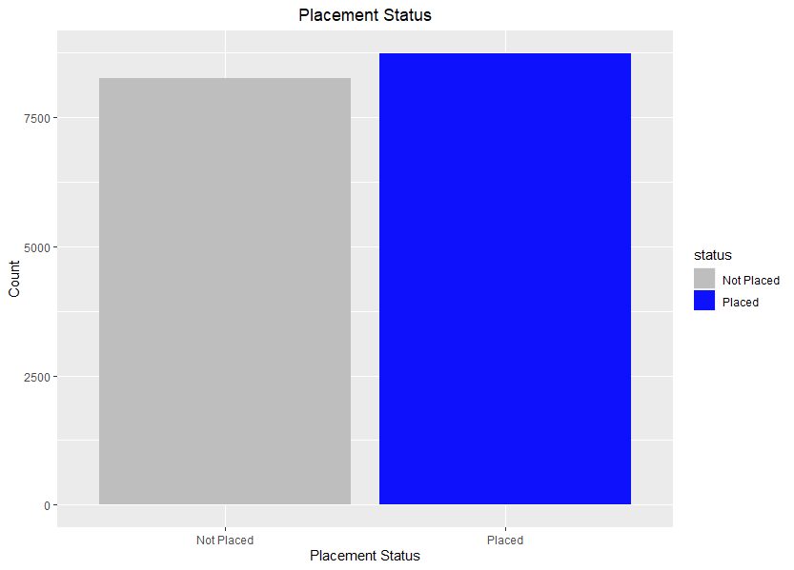
Figure 14: Students placed vs students not placed graph

Justification
install.packages("ggplot2") is the line that installs the ggplot2 package. This package is used for creating data visualizations in R. library(ggplot2) is the line that loads the ggplot2 package into the current R session. This is necessary in order to use any of the functions provided by the package.
The line “ggplot(clean_dataset, aes(x = status, fill = status)) +” initializes a new ggplot object with the clean_dataset data frame as its data source, and maps the status column to the x-axis and fill aesthetic. This means that the plot will show a bar for each unique value of status, with each bar colored based on its corresponding status value.
The line “geom_bar() +” adds a bar chart layer to the plot. The geom_bar() function is used to create a bar chart. The line “scale_fill_manual(values = c("gray", "blue")) +” sets the colors for the fill aesthetic. The scale_fill_manual() function is used to manually specify the fill colors for the plot. In this case, the two possible status values ("Placed" and "Not Placed") are assigned the colors gray and blue, respectively.
The line “labs(title = "Placement Status", x = "Placement Status", y = "Count") +” sets the plot's title and axis labels. The labs() function is used to modify the plot's labels. In this case, the plot's title is set to "Placement Status", the x-axis label is set to "Placement Status", and the y-axis label is set to "Count".
The line “theme(plot.title = element_text(hjust = 0.5))” modifies the plot's theme. The theme() function is used to modify the plot's appearance. In this case, the plot.title argument is used to horizontally justify the plot's title to the center of the plot. This makes the plot title appear centered above the plot.

Analysis 1-2

Code
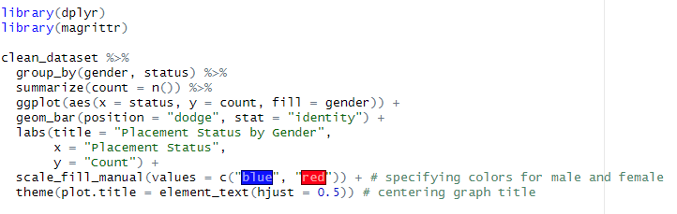
Figure 15: placement by gender bar graph code

Output
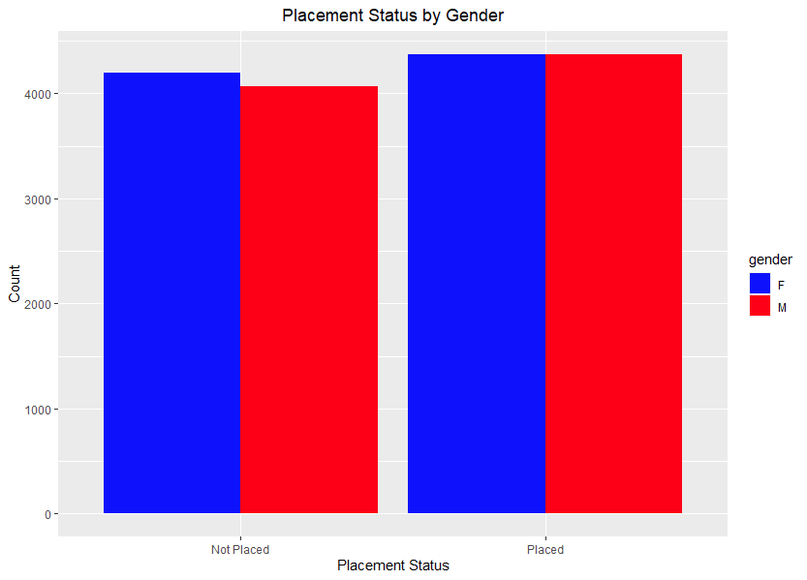
Figure 16: placement by gender bar graph output

Justification
This code uses the ggplot2 library in R to create a bar chart of placement status by gender in a dataset called clean_dataset. Here is a step-by-step explanation of the code:
The line of code “library(ggplot2)” loads the ggplot2 package into the R environment so we can use its functions to create a graph. The line of code ggplot(clean_dataset, aes(x = status, fill = gender)) sets up the basic ggplot object, telling it to use clean_dataset as the data source, and mapping the status variable to the x-axis and the gender variable to the fill (i.e. color) aesthetic.
The line of code geom_bar(position = "dodge") adds a bar layer to the ggplot object, using the default "count" statistic to calculate the height of the bars. The position = "dodge" argument tells ggplot to position the bars for each gender side-by-side, rather than stacked on top of each other.
The line of code labs(title = "Placement Status by Gender", x = "Placement Status", y = "Count") adds axis and title labels to the plot. The title argument sets the title of the plot, the x argument sets the label for the x-axis, and the y argument sets the label for the y-axis.
The line of code scale_fill_manual(values = c("blue", "red")) manually sets the colors for the fill aesthetic. In this case, it sets blue represents male students, and red represents female students.
theme(plot.title = element_text(hjust = 0.5)): This line centers the graph title by setting the horizontal justification of the plot.title element to 0.5 (which means it will be centered). The theme() function is used to modify various elements of the plot's appearance.

Question 2: what can increase the chance of having a job placement?

Analysis 2-1

Code
Figure 17: histogram code for employe's test score code

Output
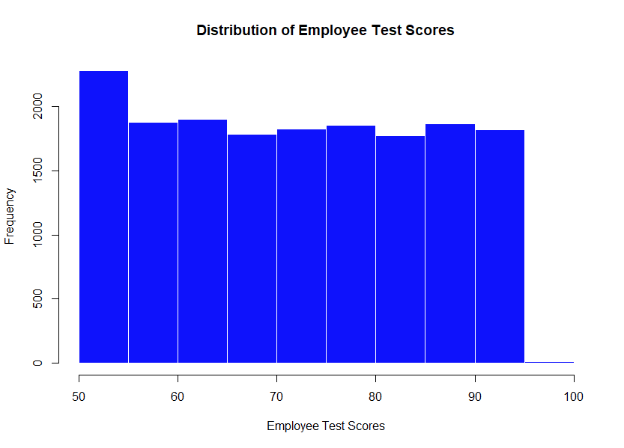
Figure 18: histogram code for employee's test score output

Justification
This code generates a histogram of the "etest_p" variable in the "clean_dataset" data frame. hist() is a function used to create a histogram. It takes several arguments, including the variable to be plotted, color, border color, and labels for the main title and axes.
clean_dataset$etest_p specifies the variable "etest_p" from the "clean_dataset" data frame that will be used for the histogram. col = "blue" sets the fill color of the bars in the histogram to blue.
border = "white" sets the border color of the bars to white.
main = "Distribution of Employee Test Scores" sets the main title of the histogram to "Distribution of Employee Test Scores". xlab = "Employee Test Scores" sets the label of the x-axis to "Employee Test Scores".

Analysis 2-2

Code
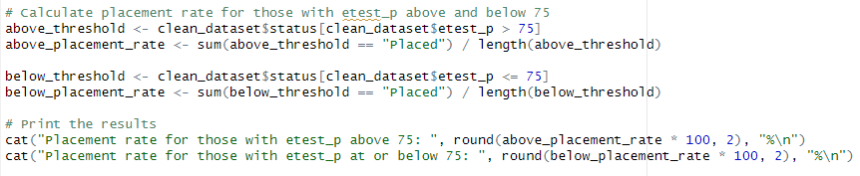
Figure 19: Employee test vs placement code

Output
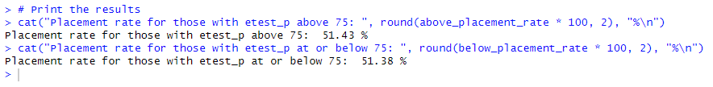
Figure 20: Employee test vs placement output

Justification
This code is calculating the placement rate (the percentage of people who got placed in a job) for two groups of people, those who have an etest_p score above 75 and those who have a score of 75 or below.
The first two lines create a subset of the clean_dataset where the status is "Placed" for those with etest_p above 75, and then calculates the placement rate for that group by dividing the number of placed individuals by the total number of individuals in that group. The result is saved in a variable called above_placement_rate.
The next two lines create a subset of the clean_dataset where the status is "Placed" for those with etest_p at or below 75, and then calculates the placement rate for that group by dividing the number of placed individuals by the total number of individuals in that group. The result is saved in a variable called below_placement_rate.
Finally, the last two lines use the cat() function to print out the placement rate for each group rounded to two decimal places, along with some explanatory text.
Based on the results, it seems that having an etest_p score above 75 does not necessarily result in a higher placement rate compared to those with a lower score. The placement rates for both groups are quite similar.

Analysis 2-3

Code
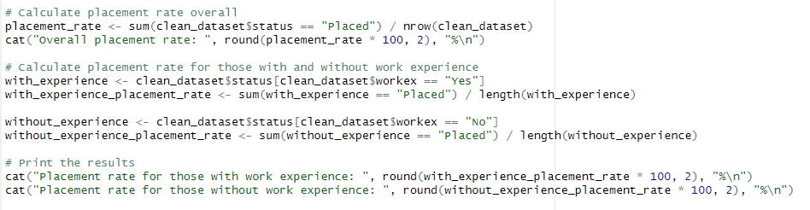
Figure 21: work experience influence over job placement code

Output
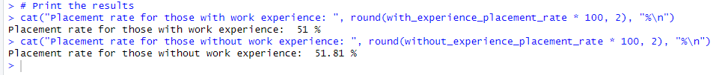
Figure 22: work experience influence over job placement output

Justification
The code first calculates the overall placement rate by dividing the number of students who were placed (clean_dataset$status == "Placed") by the total number of students in the dataset (nrow(clean_dataset)). The sum() function is used to count the number of students who were placed.
The code then calculates the placement rate for students with work experience and without work experience. It does this by creating two new variables (with_experience and without_experience) that are subsets of the original dataset, with only the rows corresponding to students with and without work experience, respectively. It then calculates the placement rate for each group using the same method as before.
Finally, the code prints out the overall placement rate and the placement rates for each group, rounded to two decimal places. Based on the results of this analysis, it appears that having work experience does not have a significant impact on job placement, as the placement rate for students with work experience (51%) is very similar to the placement rate for students without work experience (51.81%).

Analysis 2-4

Code
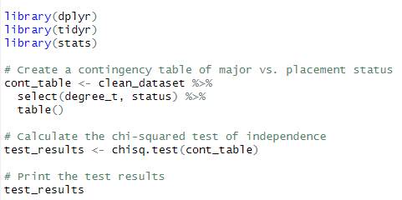
Figure 23: degree GPA vs Placement status code

Output
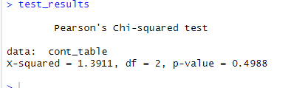
Figure 24: degree GPA vs Placement status output

Justification
This code is performing a chi-squared test of independence to determine if there is a significant association between major and job placement status in the clean_dataset. Here's a breakdown of the code:
First, the required packages are loaded: dplyr, tidyr, and stats. Next, the select() function from dplyr is used to select the columns degree_t and status from the clean_dataset. These columns are then used to create a contingency table using the table() function. The chisq.test() function is used to perform the chi-squared test of independence on the contingency table created in step 2.
Finally, the test results are printed to the console, including the calculated chi-squared statistic (X-squared), degrees of freedom (df), and p-value (p-value). The output shows that the chi-squared test of independence results in a p-value of 0.4988, which is not statistically significant at a significance level of 0.05. Therefore, we do not have sufficient evidence to reject the null hypothesis that there is no association between major and job placement status.

Analysis 2-5

Code
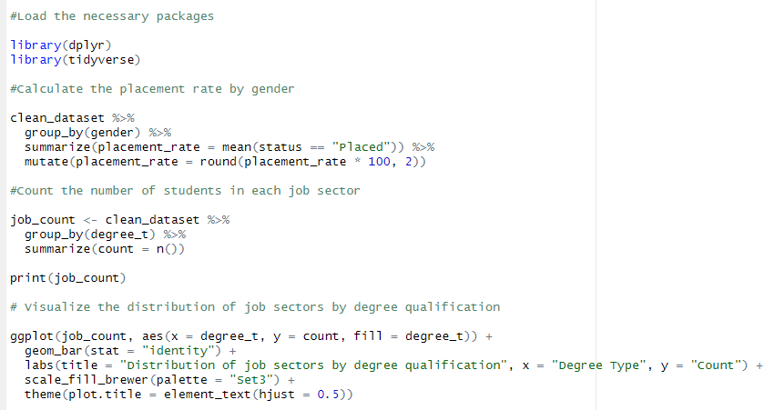
Figure 25: work placement based on degree qualifications code

Output
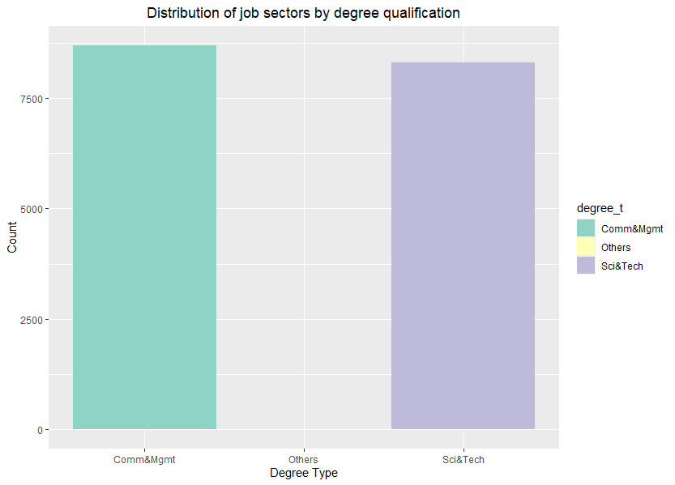
Figure 26: work placement based on degree qualifications graph
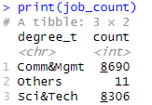
Figure 27: : work placement based on degree qualifications table

Justification
The dplyr package provides a set of functions for data manipulation, while the tidyverse package is a collection of packages, including ggplot2, that allows for data visualization. This code takes the clean_dataset data frame and groups it by gender. It then calculates the mean of status == "Placed", which gives the placement rate.
The summarize function creates a summary data frame with one row per group, while the mutate function rounds the placement rate to two decimal places. The resulting tibble shows the placement rate by gender. This code groups the clean_dataset data frame by degree_t, which is the type of degree qualification.
It then counts the number of students in each group using the n() function, and creates a summary data frame with one row per group. This code uses ggplot to create a bar chart that shows the distribution of job sectors by degree qualification. The aes function specifies the variables to use on the x and y axes, as well as the fill color.
The geom_bar function specifies that the chart should be a bar chart, with the stat = "identity" argument specifying that the y-axis values should be used as the heights of the bars. The labs function adds a title and labels for the x and y axes. The scale_fill_brewer function sets the color palette to use. Finally, the theme function adjusts the appearance of the plot, including centering the title using the element_text function with hjust = 0.5.

Question 3: How do background influence school performance?

Analysis 3-1

Code
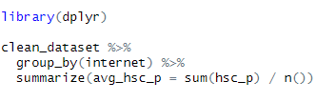
Figure 28: Average Grade 12 GPA based on internet used code

Output
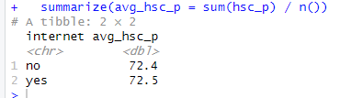
Figure 29: Average Grade 12 GPA based on internet used output

Justification
This code uses the dplyr package to group the clean_dataset by the internet column, and then calculates the average hsc_p (Higher Secondary Education Percentage) for each group.
The %>% operator is used to pipe the clean_dataset into a series of operations. First, the group_by() function is used to group the dataset by the internet column. Then, the summarize() function is used to calculate the average hsc_p for each group.
The sum() function calculates the sum of the hsc_p values within each group, and n() function calculates the number of observations within each group. Dividing the sum by the number of observations gives the average value for each group. The resulting output is a tibble (a data frame with some additional features) with two columns: internet and avg_hsc_p. The internet column contains the two unique values of the internet variable (yes and no), and the avg_hsc_p column contains the average hsc_p value for each group.

Analysis 3-2

Code
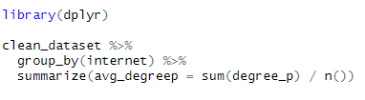
Figure 30: Average Graduation GPA based on internet used code

Output
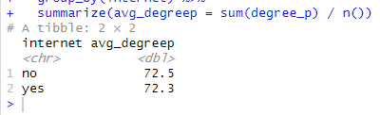
Figure 31: Average Graduation GPA based on internet used code

Justification
This code performs a group-wise summary of the average degree percentage (degree_p) based on the internet variable in the clean_dataset dataframe.
library(dplyr) loads the dplyr package which is used for data manipulation tasks. clean_dataset %>% starts a chain of operations using the clean_dataset dataframe. group_by(internet) groups the data based on the internet variable, creating two subsets for each value of internet ("yes" and "no").
summarize(avg_degreep = sum(degree_p) / n()) creates a summary of the data by calculating the average degree percentage for each group. avg_degreep is the new variable name for this summary statistic. The sum function calculates the sum of degree percentages for each group and n() calculates the number of observations in each group. By dividing the sum by the number of observations, we obtain the average degree percentage for each group.
The output is a tibble (a data frame) that shows the average degree percentage for each group: no has an average degree percentage of 72.5, and yes has an average degree percentage of 72.3.

Analysis 3-3

Code
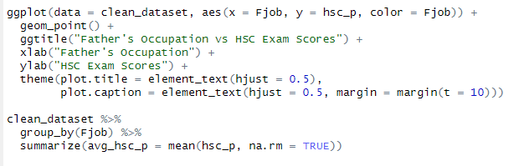
Figure 32: father's occupation vs Grade 12's GPA code

Output
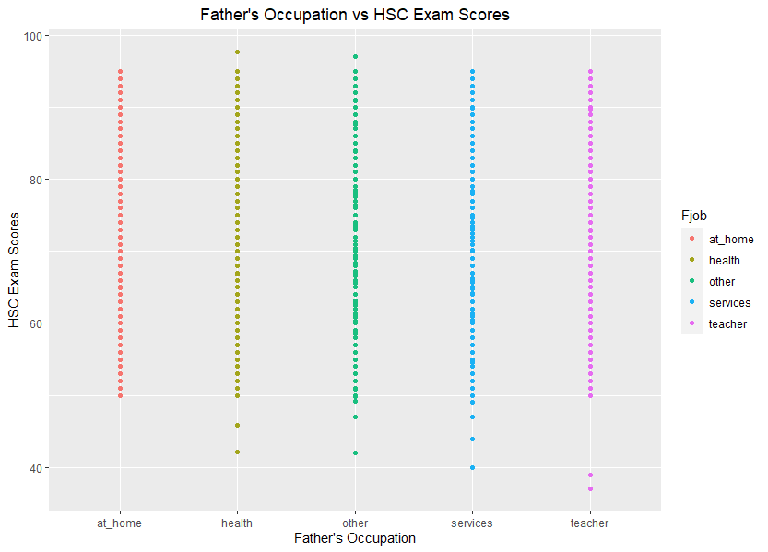
Figure 33: : father's occupation vs Grade 12's GPA output

Justification
This code generates a scatter plot showing the relationship between the father's occupation and the HSC (Higher Secondary Certificate) exam scores of students. The scatter plot is created using ggplot2 package.
ggplot(data = clean_dataset, aes(x = Fjob, y = hsc_p, color = Fjob)) sets the data source to clean_dataset, specifies Fjob variable for the x-axis, hsc_p variable for the y-axis and Fjob variable again for coloring the points based on the occupation. geom_point() adds a layer to the plot to show the data points as dots. ggtitle("Father's Occupation vs HSC Exam Scores") adds a title to the plot.
xlab("Father's Occupation") adds a label to the x-axis. ylab("HSC Exam Scores") adds a label to the y-axis. theme(plot.title = element_text(hjust = 0.5), plot.caption = element_text(hjust = 0.5, margin = margin(t = 10))) sets the theme for the plot, which includes centering the plot title and adjusting the plot caption position.
The second part of the code uses the group_by() function from the dplyr package to group the clean_dataset by the Fjob variable. Then, the summarize() function is used to calculate the average HSC exam score (avg_hsc_p) for each group of fathers' occupations. The results are printed as a tibble with two columns (Fjob and avg_hsc_p).
The output of the code is a scatter plot that shows the relationship between the father's occupation and the HSC exam scores of students, with each point colored according to the corresponding father's occupation. The plot title is centered, and the plot caption is adjusted to be positioned at a margin of 10 from the top. The tibble output shows the average HSC exam scores for each group of fathers' occupations.

Analysis 3-4

Code
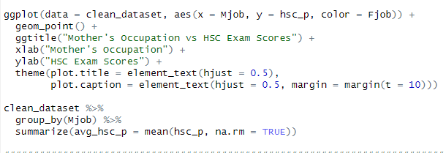
Figure 34: mother's occupation vs Grade 12's GPA code

Output
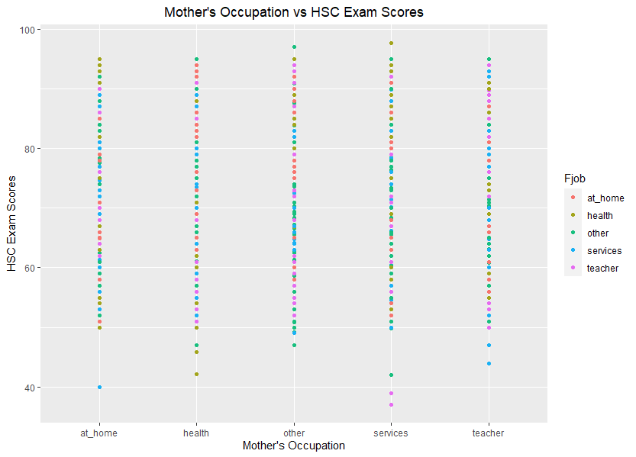
Figure 35: mother's occupation vs Grade 12's GPA output

Justification
This code is creating a scatter plot using ggplot2 to visualize the relationship between the mother's occupation and the HSC exam scores of the students.
The line of code ggplot(data = clean_dataset, aes(x = Mjob, y = hsc_p, color = Fjob)) set up the basic structure of the plot. We are using the clean_dataset as the data source, with the mother's occupation on the x-axis, the HSC exam scores on the y-axis, and using the father's occupation to color the points.
The line of code geom_point() adds the points to the plot. ggtitle("Mother's Occupation vs HSC Exam Scores") sets the title of the plot to "Mother's Occupation vs HSC Exam Scores". xlab("Mother's Occupation") sets the label for the x-axis to "Mother's Occupation". ylab("HSC Exam Scores") sets the label for the y-axis to "HSC Exam Scores".
theme(plot.title = element_text(hjust = 0.5), plot.caption = element_text(hjust = 0.5, margin = margin(t = 10))), this sets the theme of the plot, including centering the title and caption with hjust = 0.5 and adding a margin of 10 units to the top of the caption.
clean_dataset %>% group_by(Mjob) %>% summarize(avg_hsc_p = mean(hsc_p, na.rm = TRUE)), this groups the clean_dataset by the mother's occupation and calculates the average HSC exam score for each group. The resulting table shows the average HSC exam score for each mother's occupation.

Analysis 3-5

Code
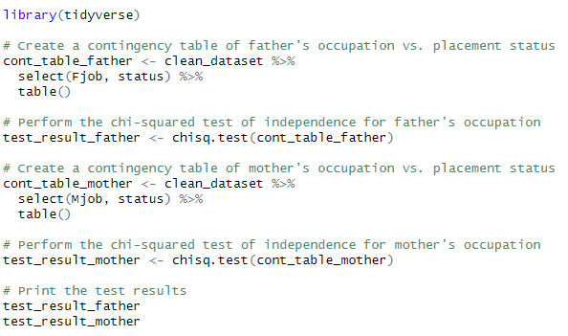
Figure 36: Parents occupation vs student’s occupation code

Output
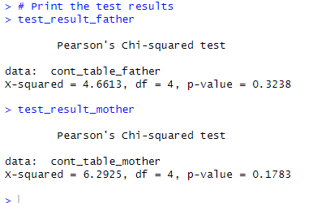
Figure 37: Parents occupation vs student’s occupation output

Justification
This code uses the tidyverse package for data manipulation and the chi-squared test for testing the independence of two categorical variables. Here's what each section of the code does:
cont_table_father <- clean_dataset %>% select(Fjob, status) %>% table(): This creates a contingency table of father's occupation (Fjob) against placement status, by first selecting the relevant columns from the clean_dataset using select() and then using table() to create the contingency table. The %>% operator is used for piping the output of one function into another.
test_result_father <- chisq.test(cont_table_father): This performs the chi-squared test of independence on the cont_table_father using the chisq.test() function and stores the results in test_result_father.
cont_table_mother <- clean_dataset %>% select(Mjob, status) %>% table(): This creates a contingency table of mother's occupation (Mjob) against placement status, by first selecting the relevant columns from the clean_dataset using select() and then using table() to create the contingency table.
test_result_mother <- chisq.test(cont_table_mother): This performs the chi-squared test of independence on the cont_table_mother using the chisq.test() function and stores the results in test_result_mother.
test_result_father and test_result_mother: These two lines print the results of the chi-squared tests conducted for father's occupation and mother's occupation, respectively. The results show the value of the chi-squared statistic, the degrees of freedom, and the p-value for the test. The p-value indicates the probability of observing a test statistic as extreme or more extreme than the one obtained if the null hypothesis (in this case, independence between the variables) is true. If the p-value is less than a chosen significance level (usually 0.05), the null hypothesis is rejected.
The output shows the results of the chi-squared test of independence for the contingency tables created for father's occupation vs. placement status and mother's occupation vs. placement status.
For father's occupation, the value of X-squared is 4.6613 with 4 degrees of freedom, and the p-value is 0.3238. Since the p-value is greater than the significance level of 0.05, we fail to reject the null hypothesis that there is no association between father's occupation and placement status. This means that there is no evidence to suggest that a student's placement status is related to their father's occupation.
For mother's occupation, the value of X-squared is 6.2925 with 4 degrees of freedom, and the p-value is 0.1783. Again, since the p-value is greater than the significance level of 0.05, we fail to reject the null hypothesis that there is no association between mother's occupation and placement status. This means that there is no evidence to suggest that a student's placement status is related to their mother's occupation.

Question 4: What is the most appealing degree to go for?

Analysis 4-1

Code
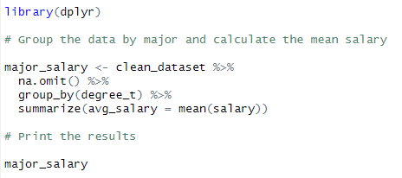
Figure 38: average salary per degree code

Output
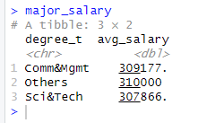
Figure 39: average salary per degree output

Justification
This code is designed to calculate the average salary for each degree in the dataset while removing rows that contain missing data.
The first line of code loads the dplyr package, which is used for data manipulation. The second line of code sets a variable major_salary to store the result of the data manipulation. The third line of code uses the %>% operator to pipe the dataset clean_dataset into the na.omit() function. This function removes any rows that contain missing data.
The fourth line of code uses the %>% operator to pipe the result from the na.omit() function into the group_by() function. This function groups the data by the variable degree_t. The fifth line of code uses the %>% operator to pipe the result from the group_by() function into the summarize() function. This function calculates the average salary for each group and stores the result in the avg_salary column. The last line of code prints the major_salary dataset to the console, displaying the average salary for each degree.

Analysis 4-2

Code
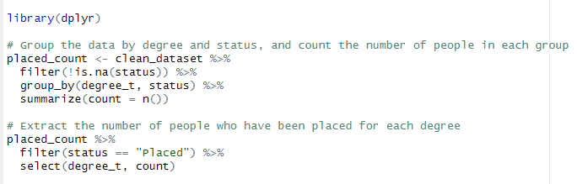
Figure 40: number of students place per degree code

Output
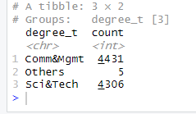
Figure 41: number of students place per degree output

Justification
This code aims to count the number of people who have been placed in each degree category from a given dataset, using the dplyr package in R. First, the code creates a new object named placed_count which counts the number of people who have been placed in each degree category.
clean_dataset is the original dataset. filter(!is.na(status)) removes the rows where the status column has missing values (NA). group_by(degree_t, status) groups the data by degree and status.
summarize(count = n()) creates a summary of the number of people in each group. Next, the code selects only the rows where the status is "Placed" using the filter() function, and then selects only the degree_t and count columns using the select() function. The resulting output is a table showing the number of people who have been placed for each degree category.

Analysis 4-3

Code
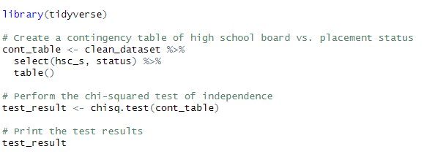
Figure 42: high school board vs placement code

Output
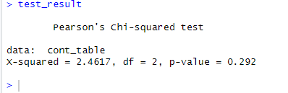
Figure 43: high school board vs placement output

Justification
This code performs a chi-squared test of independence to determine if there is a relationship between a student's high school board and their placement status in the clean_dataset.
Here's how it works:
library(tidyverse) loads the tidyverse package, which includes the dplyr package for data manipulation and the ggplot2 package for data visualization.
cont_table <- clean_dataset %>% select(hsc_s, status) %>% table() creates a contingency table of the high school board variable (hsc_s) and the placement status variable (status) in the clean_dataset data frame. The %>% operator is used to pipe the clean_dataset data frame into the select() function to select only the hsc_s and status variables, and then pipe the resulting data frame into the table() function to create the contingency table.
test_result <- chisq.test(cont_table) performs the chi-squared test of independence on the contingency table created in step 2 and saves the results in the test_result variable.
test_result prints the test results, which include the chi-squared statistic (X-squared), degrees of freedom (df), and the p-value (p-value), indicating the probability of observing a test statistic as extreme as the one calculated from the sample data under the null hypothesis that there is no relationship between the two variables. A p-value less than the significance level (usually 0.05) indicates strong evidence against the null hypothesis, and suggests that there is a relationship between the two variables. In this case, the p-value is 0.292, which is greater than 0.05, so we fail to reject the null hypothesis and conclude that there is no significant relationship between a student's high school board and their placement status.
The output shows the test statistic X-squared = 2.4617, degrees of freedom df = 2, and p-value = 0.292. Since the p-value is greater than 0.05, we fail to reject the null hypothesis that there is no relationship between the high school board of a student and their placement status. In other words, there is no evidence that the high school board of a student affects their placement status.

Analysis 4-4

Code
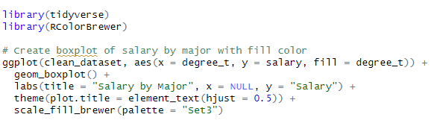
Figure 44: salary vs major code

Output
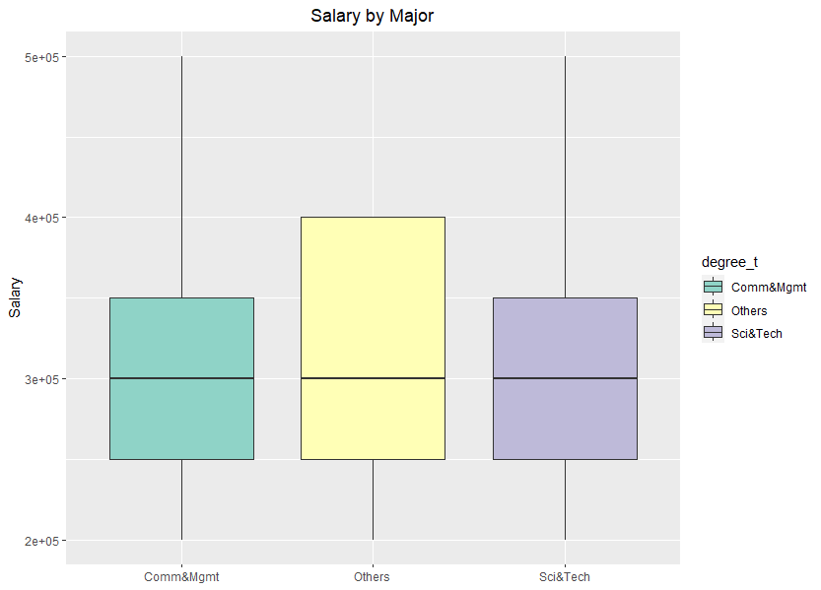
Figure 45: salary vs major graph

Justification
This code produces a boxplot visualization of salary by major, where the fill color of each box corresponds to the major. Here is a detailed explanation of the code:
library(tidyverse) and library(RColorBrewer): These lines load the tidyverse and RColorBrewer libraries, which are necessary for data wrangling and color palettes, respectively.
ggplot(clean_dataset, aes(x = degree_t, y = salary, fill = degree_t)): This creates a ggplot object using the clean_dataset data frame. The aes() function specifies the mapping of variables to visual aesthetics, including the x-axis (degree_t), y-axis (salary), and fill color (degree_t).
geom_boxplot(): This adds a boxplot layer to the ggplot object, which shows the distribution of salary for each major.
labs(title = "Salary by Major"): This adds a title to the plot.
scale_fill_brewer(palette = "Set3"): This sets the fill color scale for the plot using the Set3 color palette from RColorBrewer.
The resulting plot shows a boxplot for each major, with the fill color of each box corresponding to the major. The x-axis shows the major categories, and the y-axis shows the salary ranges for each major.

Question 5: Is there a significant difference in placement rates between male and female students?

Analysis 5-1

Code
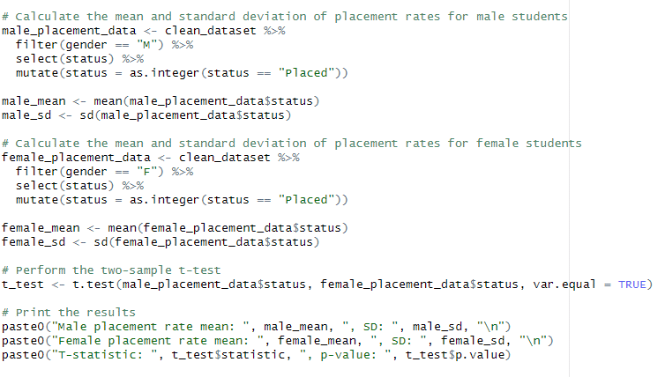
Figure 46: male vs female placement code

Output
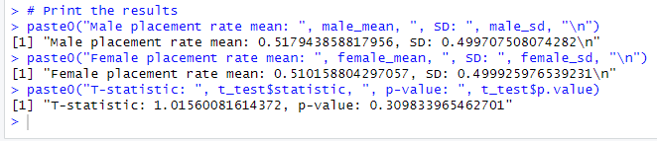
Figure 47: male vs female placement output

Justification
This code performs a two-sample t-test to compare the placement rates between male and female students. Here's what each part of the code does:
The code first creates a subset of the data that includes only male students and their placement status. It converts the "Placed" status to 1 and the "Not Placed" status to 0.
Then, it calculates the mean and standard deviation of the placement rates for male students using the mean() and sd() functions.
The code then repeats the same steps for female students, creating a separate subset of the data for female students and calculating their mean and standard deviation of placement rates.
Next, the t.test() function is used to perform a two-sample t-test with equal variances, comparing the placement rates between male and female students.
Finally, the results of the t-test are printed to the console using the paste0() function, including the means and standard deviations for both male and female students and the t-statistic and p-value from the t-test.
The output of the code shows that the mean placement rate for male students is slightly higher than for female students (51.8% vs 51.0%). However, the t-test indicates that this difference is not statistically significant (p-value = 0.31), meaning that we cannot reject the null hypothesis that there is no difference in placement rates between male and female students.

Analysis 5-2

Code
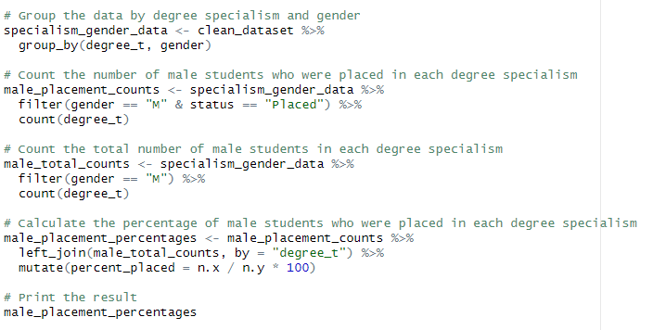
Figure 48: percentage of male students place per specialism code

Output
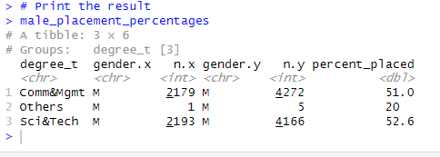
Figure 49: percentage of male students place per specialism result

Justification
This code is using the dplyr package to group the clean_dataset by degree_t (degree specialization) and gender. It then calculates the percentage of male students who were placed in each degree specialism.
Here is a step-by-step explanation of the code:
specialism_gender_data <- clean_dataset %>% group_by(degree_t, gender) - This line groups the clean_dataset by degree_t and gender using the %>% pipe operator. The resulting object is a grouped data frame.
male_placement_counts <- specialism_gender_data %>% filter(gender == "M" & status == "Placed") %>% count(degree_t) - This line filters the specialism_gender_data to only include male students who were placed (gender == "M" & status == "Placed") and then counts the number of students in each degree_t. The resulting object is a data frame with two columns: degree_t and n, where n is the count of male students who were placed in each degree specialism.
male_total_counts <- specialism_gender_data %>% filter(gender == "M") %>% count(degree_t) - This line filters the specialism_gender_data to only include male students (gender == "M") and then counts the total number of students in each degree_t. The resulting object is a data frame with two columns: degree_t and n, where n is the total count of male students in each degree specialism.
male_placement_percentages <- male_placement_counts %>% left_join(male_total_counts, by = "degree_t") %>% mutate(percent_placed = n.x / n.y * 100) - This line joins the male_placement_counts and male_total_counts data frames together by degree_t using the left_join function. It then adds a new column called percent_placed, which is calculated by dividing the number of male students who were placed (n.x) by the total number of male students in each degree specialism (n.y) and multiplying by 100. The resulting object is a data frame with three columns: degree_t, n.x, and percent_placed.
male_placement_percentages - This line prints the male_placement_percentages data frame, which shows the percentage of male students who were placed in each degree specialism.

Analysis 5-3

Code
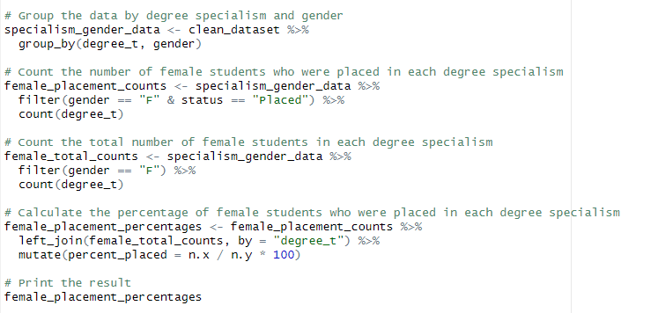
Figure 50: percentage of female students place per specialism code

Output
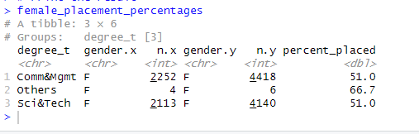
Figure 51: percentage of female students place per specialism output

Justification
This code is calculating the percentage of female students who were placed in a job per degree specialism. Here's what each line does:
The first line groups the dataset by both degree specialism and gender, so that we can analyze the data separately for each combination of degree specialism and gender.
The second line filters the data to only include female students who were placed in a job, and then counts the number of such students in each degree specialism group.
The third line filters the data to only include female students, and then counts the total number of such students in each degree specialism group.
The fourth line left-joins the female_placement_counts and female_total_counts data frames on the "degree_t" column, so that we can combine the counts of female students who were placed in a job and the total counts of female students in each degree specialism.
Finally, the fifth line calculates the percentage of female students who were placed in a job in each degree specialism group by dividing the female_placement_counts by the female_total_counts and multiplying by 100. The resulting data frame, female_placement_percentages, shows the percentage of female students who were placed in a job for each degree specialism.

More analysis:

Extra-analysis 1: Is there a correlation between a student's Grade 10 score and their placement rate?

Code
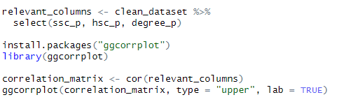
Figure 52: Extra-analysis 1 code

Output
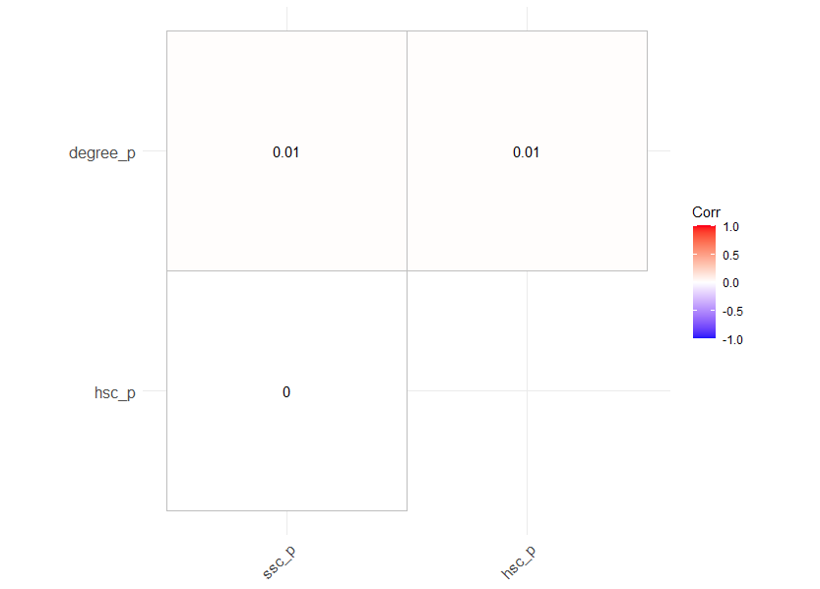
Figure 53: Extra-analysis 1 output

Justification
This code generates a correlation plot to visualize the correlation between the selected columns from the clean_dataset dataset.
First, the relevant_columns object is created using the %>% operator from the tidyverse package. This selects three columns ssc_p, hsc_p, and degree_p from the clean_dataset dataset.
Next, the ggcorrplot library is installed and loaded using the install.packages() and library() functions. This library provides a function ggcorrplot() to create a correlation plot.
A correlation matrix is created from the relevant_columns object using the cor() function. This calculates the pairwise correlation coefficients between the selected columns.
Finally, the ggcorrplot() function is used to create the correlation plot. The type argument specifies to display only the upper triangular portion of the correlation matrix, as the lower half is redundant. The lab argument is set to TRUE to display labels for the correlation coefficients. The resulting plot shows a matrix of scatter plots and corresponding correlation coefficients for the selected columns.

Extra-analysis 2: How does high school GPA correlate with placement rates?

Code
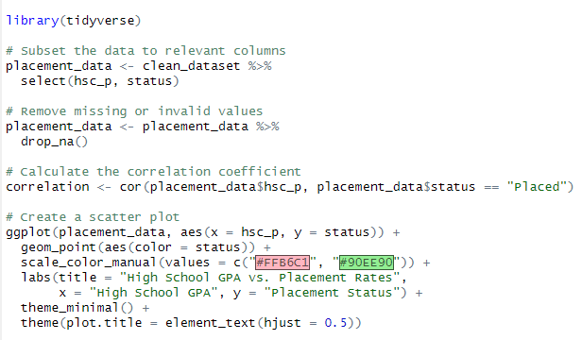
Figure 54: Extra-analysis 2 code

Output
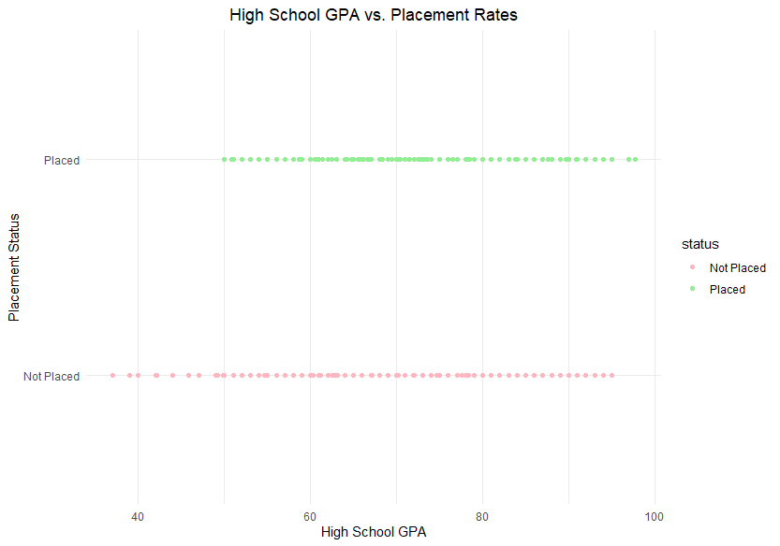
Figure 55: Extra-analysis 2 output

Justification
This code uses the tidyverse package to analyze the relationship between high school GPA and placement rates. The code starts by selecting the "hsc_p" (high school GPA) and "status" columns from the "clean_dataset" data and creating a new data frame called "placement_data" using the pipe operator (%>%) and the "select" and "drop_na" functions from the dplyr package. The "drop_na" function removes any rows with missing or invalid values.
Next, the code calculates the correlation coefficient between high school GPA and placement status using the "cor" function. The "cor" function takes two vectors as inputs and returns a correlation coefficient between -1 and 1. A positive correlation coefficient indicates a positive relationship between the two variables (as one variable increases, so does the other), while a negative correlation coefficient indicates a negative relationship (as one variable increases, the other decreases).
Finally, the code creates a scatter plot using the ggplot2 package to visualize the relationship between high school GPA and placement status. The "geom_point" function creates the points on the plot, and the "scale_color_manual" function sets the color of the points based on the placement status. The "labs" function adds a title and axis labels to the plot, and the "theme_minimal" function sets a minimalistic theme for the plot.

Extra-analysis 3: Is there a correlation between student major and placement rate?

Code
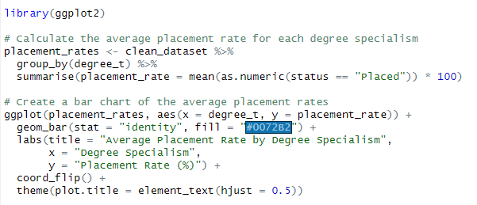
Figure 56: Extra-analysis 3 code

Output
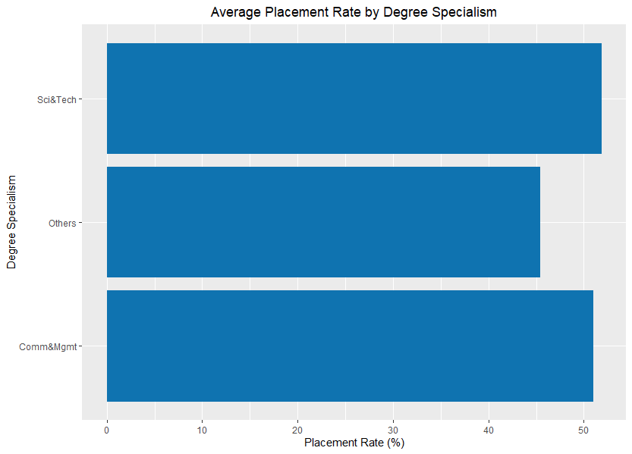
Figure 57: Extra-analysis 3 output

Justification
This code first calculates the average placement rate for each degree specialism in the clean_dataset data frame. It does this by grouping the data by degree_t using the group_by function and then using the summarize function to calculate the mean of the status variable where it equals "Placed". The placement rate is converted to a percentage by multiplying by 100.
Next, the code creates a bar chart of the average placement rates using the ggplot function. The placement_rates data frame is used as the data source for the plot, and the x-axis is set to degree_t and the y-axis is set to placement_rate. The geom_bar function is used to create a bar chart with the stat parameter set to "identity", which means that the height of each bar corresponds to the value in the placement_rate column. The fill parameter is set to "#0072B2", which is a hexadecimal code for a blue color that is used to fill the bars.
The labs function is used to set the title of the plot to "Average Placement Rate by Degree Specialism", the x-axis label to "Degree Specialism", and the y-axis label to "Placement Rate (%)". Finally, the coord_flip function is used to flip the x and y axes of the plot, so the degree specialisms are displayed on the y-axis and the placement rates are displayed on the x-axis.

Extra-analysis 4: How does a student's extracurricular involvement impact their placement rate?

Code
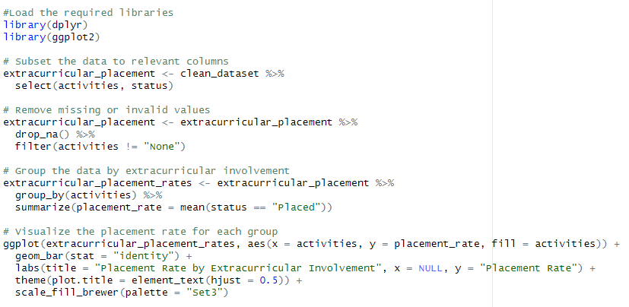
Figure 58: Extra-analysis 4 code

Output
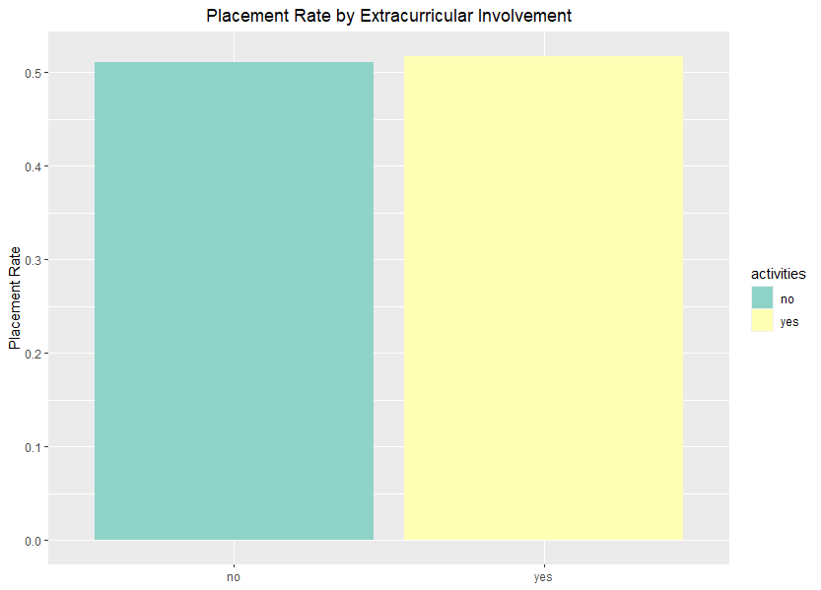
Figure 59: Extra-analysis 4 output

Justification
The dplyr library is used for data manipulation, and ggplot2 is used for data visualization. This code selects only the activities and status columns from the clean_dataset data frame and assigns the resulting data frame to the extracurricular_placement variable. This code uses the drop_na() function to remove any rows that contain missing values, and the filter() function to remove any rows where the activities column is "None". This code groups the data in the extracurricular_placement data frame by the activities column using the group_by() function, and then calculates the average placement rate for each group using the summarize() function. This code uses the ggplot() function to create a new plot. The aes() function maps the activities column to the x-axis, the placement_rate column to the y-axis, and the activities column to the fill color. The geom_bar() function is used to create a bar chart, and stat = "identity" is used to ensure that the heights of the bars correspond to the placement rates. The labs() function is used to add a title to the plot, and to label the x-axis and y-axis. The theme() function is used to center the plot title, and the scale_fill_brewer() function is used to apply a color palette to the bars.

Extra-analysis 5: How does GPA vary by major?

Code
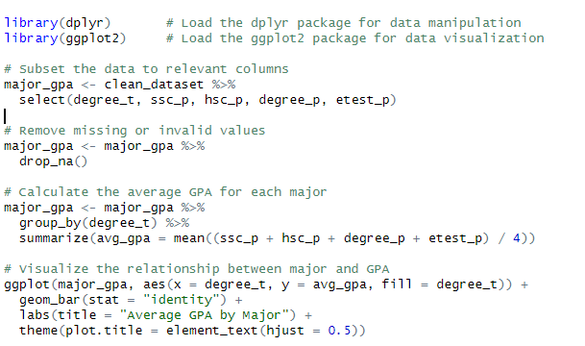
Figure 60: Extra-analysis 5 code

Output
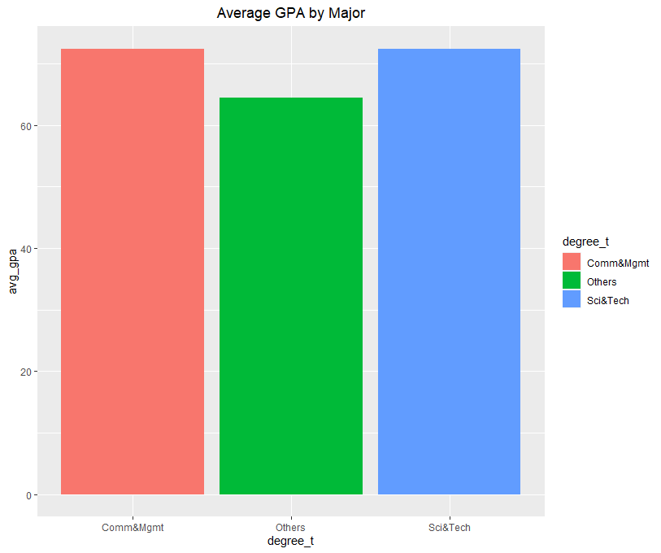
Figure 61: Extra-analysis 5 graph

Justification
This code is used to visualize the relationship between majors and average GPA. library(dplyr) loads the dplyr package, which is used for data manipulation. library(ggplot2) loads the ggplot2 package, which is used for data visualization.
major_gpa <- clean_dataset %>% select(degree_t, ssc_p, hsc_p, degree_p, etest_p) subsets the clean_dataset by selecting only the relevant columns for this analysis, which are degree_t (type of degree), ssc_p (secondary school percentage), hsc_p (higher secondary school percentage), degree_p (degree percentage), and etest_p (employability test percentage). The %>% operator is used to pipe the clean_dataset into the select() function.
major_gpa <- major_gpa %>% drop_na() removes any rows with missing or invalid values in major_gpa. major_gpa <- major_gpa %>% group_by(degree_t) %>% summarize(avg_gpa = mean((ssc_p + hsc_p + degree_p + etest_p) / 4)) groups major_gpa by degree_t and calculates the average GPA for each major using the summarize() function. The mean() function is used to calculate the average of the four GPA values.
ggplot(major_gpa, aes(x = degree_t, y = avg_gpa, fill = degree_t)) creates a ggplot object with major_gpa as the data source and sets the x axis to degree_t, the y axis to avg_gpa, and fills the bars with colors based on degree_t.
geom_bar(stat = "identity") adds a bar layer to the plot. labs(title = "Average GPA by Major") adds a title to the plot. theme(plot.title = element_text(hjust = 0.5)) adjusts the theme of the plot so that the title is centered horizontally.

Extra-analysis 6: Are there any differences in placement rates based on the industry a student is pursuing?

Code
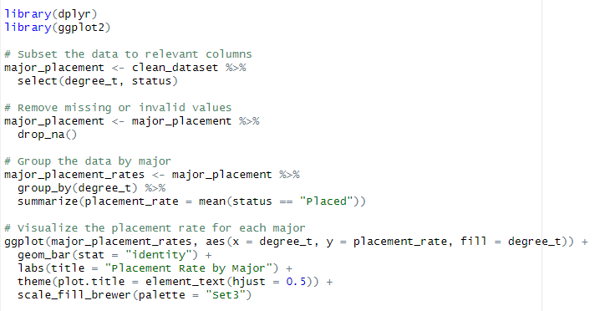
Figure 62: Extra-analysis 6 code

Output
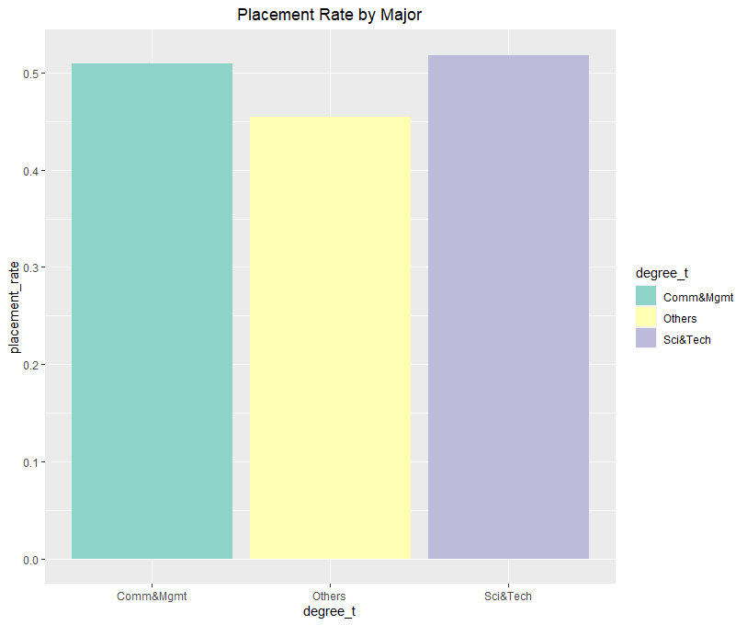
Figure 63: Extra-analysis 6 output

Justification
This code is using the dplyr and ggplot2 packages to analyze and visualize the placement rates of students based on their major in a dataset called clean_dataset. library(dplyr) loads the dplyr package, which provides a set of functions for manipulating and summarizing data. library(ggplot2) loads the ggplot2 package, which provides a powerful system for creating visualizations and plots.
major_placement <- clean_dataset %>% select(degree_t, status): Uses the %>% operator (pipe operator) to take the clean_dataset and select only the degree_t and status columns, and assigns the resulting data frame to major_placement. major_placement <- major_placement %>% drop_na(): Removes any rows that contain missing values from major_placement.
major_placement_rates <- major_placement %>% group_by(degree_t) %>% summarize(placement_rate = mean(status == "Placed")): Groups major_placement by degree_t and calculates the placement rate (the proportion of students who were placed) for each major using summarize(). The resulting data frame is assigned to major_placement_rates.
ggplot(major_placement_rates, aes(x = degree_t, y = placement_rate, fill = degree_t)) + geom_bar(stat = "identity") + labs(title = "Placement Rate by Major") + scale_fill_brewer(palette = "Set3"): Creates a bar plot using ggplot2 with the x-axis representing the majors, the y-axis representing the placement rates, and the fill color representing the majors. The geom_bar(stat = "identity") function specifies that the heights of the bars should represent the values in the placement_rate column. The labs() function adds a title to the plot, and the scale_fill_brewer() function sets the color palette for the bars.

Extra-analysis 7

Code
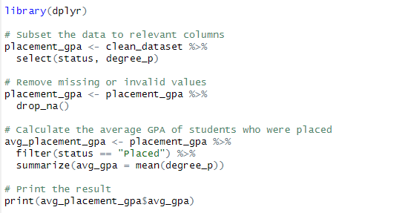
Figure 64: Extra-analysis 7 code

Output
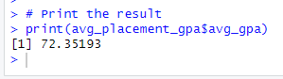
Figure 65: Extra-analysis 7 output

Justification
This code analyses the average GPA of students who were placed in a job. Here is a detailed explanation of each line of code:
library(dplyr): This line loads the dplyr library, which is used for data manipulation.
placement_gpa <- clean_dataset %>% select(status, degree_p): This line subsets the clean_dataset dataframe to only include the status and degree_p columns, and saves it as a new dataframe called placement_gpa. %>% is the pipe operator, which allows you to chain together multiple dplyr functions.
placement_gpa <- placement_gpa %>% drop_na(): This line removes any rows with missing or invalid values from the placement_gpa dataframe using the drop_na() function.
avg_placement_gpa <- placement_gpa %>% filter(status == "Placed") %>% summarize(avg_gpa = mean(degree_p)): This line filters the placement_gpa dataframe to only include students who were placed (status == "Placed") and calculates the mean degree_p for this subset using the summarize() function. The resulting mean GPA is saved as a new variable avg_placement_gpa.
print(avg_placement_gpa$avg_gpa): This line prints the average GPA of students who were placed in a job, which is stored in the avg_gpa column of the avg_placement_gpa dataframe. $ is used to access a specific column of a dataframe.

Extra-analysis 8: How to know the Grade12 GPA of students who have internet vs those who don't have internet?

Code
Figure 66: Extra-analysis 8 code

Output
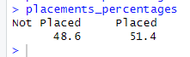
Figure 67:Extra-analysis 8 output

Justification
This code first converts the "status" column in the "clean_dataset" data frame to a factor variable with the levels "Not Placed" and "Placed". It then uses the summary() function to get the count of each level in the factor variable. The resulting summary object is then used to calculate the percentage of students who were "Not Placed" and "Placed" using simple arithmetic operations. The round() function is used to round the percentages to two decimal places. Finally, the resulting percentages are printed to the console.

Extra-analysis 9 : Are there any correlations between academic performance and placement status? For example, do students with higher GPAs tend to be more successful in securing placements?

Code
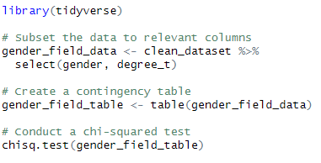
Figure 68: Extra-analysis 9 code

Output
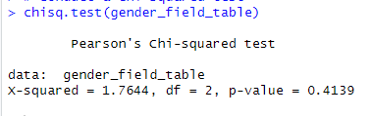
Figure 69: Extra-analysis 9 output

Justification
The given code is analyzing the relationship between gender and field of study using a chi-squared test. Here's a step-by-step breakdown of the code:
The tidyverse package is loaded, and some conflicts with existing functions are resolved.
The data is subsetted to relevant columns, namely gender and degree_t.
A contingency table is created using the table() function. This table will show the frequency counts of each combination of gender and degree_t values.
A chi-squared test is conducted using the chisq.test() function on the contingency table. The test assesses whether the observed frequencies in the contingency table differ significantly from the frequencies that would be expected if there were no relationship between gender and degree_t.
The results of the chi-squared test show that the calculated chi-squared statistic is 1.7644, and the corresponding p-value is 0.4139. The degrees of freedom are 2. Since the p-value is greater than the conventional significance level of 0.05, we fail to reject the null hypothesis that there is no association between gender and degree_t. In other words, the test found no significant relationship between the two variables.

Extra-analysis 10

Code
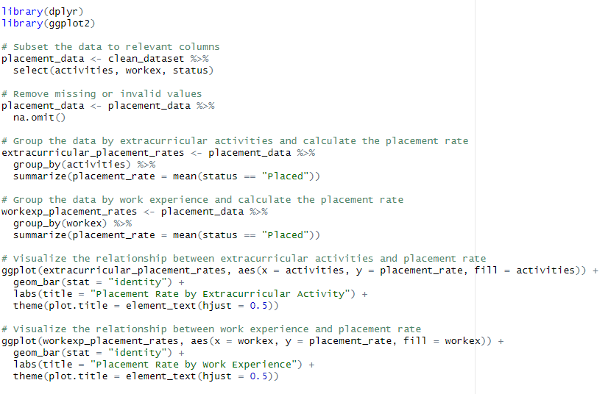
Figure 70: Extra-analysis 10 code

Output
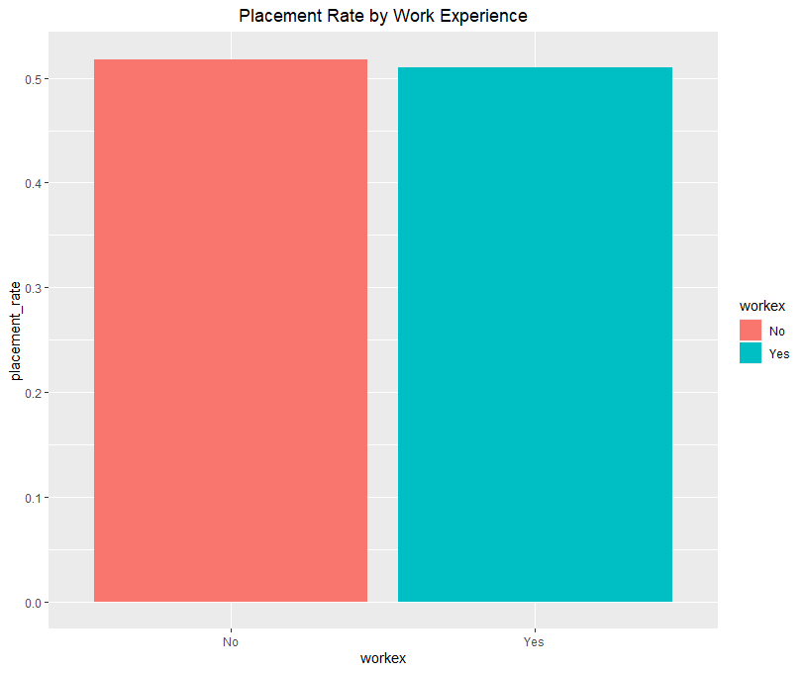
Figure 71: Extra-analysis 10 output

Justification
This loads the necessary packages dplyr and ggplot2 for data manipulation and visualization, respectively. This creates a new data frame placement_data from the clean_dataset data frame. It selects only the activities, workex, and status columns using the select() function from dplyr. This removes any missing values in the placement_data data frame using the na.omit() function. This groups the placement_data data frame by activities using the group_by() function from dplyr. Then, it calculates the placement rate for each group using the summarize() function. The mean() function is used to calculate the proportion of students who were placed (status == "Placed") in each group. This groups the placement_data data frame by workex using the group_by() function from dplyr. Then, it calculates the placement rate for each group using the summarize() function. The mean() function is used to calculate the proportion of students who were placed (status == "Placed") in each group. This creates a bar chart using ggplot2 to visualize the relationship between extracurricular activities and placement rate. The extracurricular_placement_rates data frame is used as the data source. The aes() function specifies the x-axis (activities), y-axis (placement_rate), and fill color (activities). The geom_bar() function specifies the type of plot to create, in this case a bar chart. The labs() function sets the title of the plot. This creates a bar chart using ggplot2 to visualize the relationship between work experience and placement rate. The workexp_placement_rates data frame is used as the data source. The aes() function specifies the x-axis (workex), y-axis (placement_rate), and fill color (workex). The geom_bar() function specifies the type of plot to create, in this case a bar chart. The labs() function sets the title of the plot.

Conclusion
This coursework provides an excellent opportunity for students to apply the knowledge gained in the course to a real-world problem. By exploring the dataset and applying different data analytics techniques to it, students will be able to identify any hidden problems and provide meaningful insights for decision making. The coursework will help students develop their skills in data exploration, manipulation, transformation, and visualization, which are essential skills for anyone working with data. The results of this analysis could potentially provide valuable insights for the organization and help them make informed decisions in the future.

References
edureka! (Director). (2018). R programming for beginners | R lanaguage tutorial | R tutorial for beginners | Edureka! [Motion Picture].
freeCodeCamp.org (Director). (2020). R Programming Tutorial - Learn the Basics of Statistical Computing [Motion Picture].
Johnson, D. (2023, January 21). What is R Programming Language? Introduction & Basics of R. Retrieved from https://www.guru99.com/: https://www.guru99.com/r-programming-introduction-basics.html
Martin, G. H. (Director). (2018). R programming for beginners – statistic with R (t-test and linear regression) and dplyr and ggplot [Motion Picture].
programming101, R. (Director). (2022). R programming for absolute beginners [Motion Picture].
programming-DDS, R. (Director). (2021). R programming for beginners | complete tutorial | R & Rstudio [Motion Picture].
Simplilearn (Director). (2022). R Programming Full Course for 2022 | R Programming For Beginners | R Tutorial | Simplilearn [Motion Picture].
Simplilearn. (2022, November 24). What is R: Overview, its Applications and what is R used for? Retrieved from https://www.simplilearn.com/: https://www.simplilearn.com/what-is-r-article
Studytonight (Director). (2020). Introduction to R lanaguage - R lanaguage Tutorial [Motion Picture].

