Modeling Human Activity States Using Hidden Markov Models

Tresor Shingiro Nkurunziza
Machine Learning Techniques II
https://github.com/Tresorshingiro/MarkovModels.git

1. Background and Motivation
When a physiotherapist is working with a patient recovering from a knee injury they must know the patient's home programme and be aware that it involves first standing and then walking and finally jumping. Knowing that the activity would allow an app to automatically record that each patient's time spent exercising rather than relying on memory, and knowing that a patient's exercise time would be suspended if their phone was not moving when they were resting or exercising. An activity cannot be seen directly by a phone. Only registers noisy motion signals, hidden behind measurements is the true activity. This problem is ideal for a Hidden Markov Model (HMM) since it incorporates the current observation of the sensors and what is expected to occur next. For this project I collected my own motion information, created a basic HMM using NumPY and determined if it could recognize 4 activities which were not in the training set: standing, walking, jumping and still.
2. Data Collection and Pre-processing
I collected 80 recordings, 20 per activity, using the sensor Logger app on Samsung SM-A235F. Each recording last about 10 seconds and stores the accelerometer and gyroscope (x, y, z) with timestamps.
Activity | Files | Total time (s) | Shortest (s) | Longest (s) | Raw rate (Hz) | Video
Standing | 20 | 212.4 | 10.0 | 11.3 | 102.07 | Standing.mp4
Walking | 20 | 207.9 | 9.6 | 11.3 | 102.07 | walking.MOV
Jumping | 20 | 201.6 | 8.6 | 10.7 | 102.07 | Jumping.mp4
Still | 20 | 210.3 | 9.6 | 11.7 | 102.07 | Still.mp4

Sampling rate. This is an individual project with one phone, so my only rate is about 102.07 Hz and no harmonising between phones was needed. The accelerometer and gyroscope file could still differ by a few rows, so I interpolated both onto a shared 100Hz clock. This gives every recording the same time base, and it would also handle data from another phone.
Cleaning. There were no missing values, and the largest gap between readings was 0.01 s. I trimmed1 s from each end of every recording, because that is when the phone was being started or stopped.
Windowing. Each window has 256 samples, which is 2.56 s at 100Hz, with 50% overlap. My walking rhythm is about 1.2Hz, so a window holds about three steps, enough to show a rhythm. It also gives a frequency resolution of about 0.39 Hz, and 256 is convenient FFT length. This produced 408 windows: 103 standing, 102 walking, 98 jumping and 105 still.
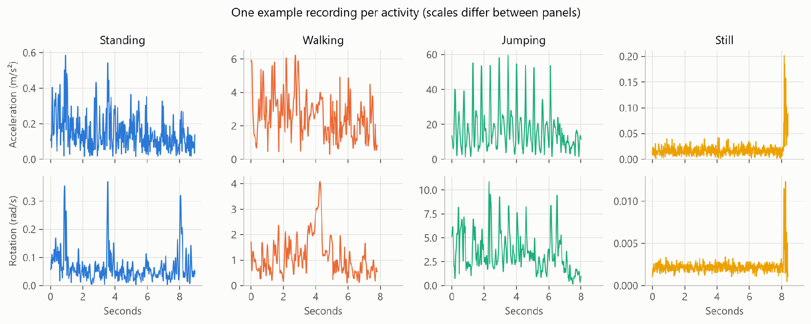

3. HMM Setup and Implementation

Element | In this project
Hidden states (Z) | Standing, walking, jumping, still
Observations (X) | A vector of 10 features for each window
Transitions (A) | A 4 × 4 matrix of the chance of moving between activities
Emissions (B) | One Gaussian per feature per activity, with features treated as independent (diagonal covariance)
Initial probabilities (π) | The chance of each activity at the start of a sequence
Features. Each window gives six time-domain and four FFT-based features, using the magnitude of each sensor so that the result depends less on how the phone is held.
Feature | Domain | Why it helps
Acceleration variance (log) | Time | Grows from still to standing, walking and jumping
Rotation variance (log) | Time | Separates a phone on a surface from one held by a person
Signal magnitude area (log) | Time | Measures overall movement across the axes
Rotation RMS (log) | Time | Shows a phone on a surface barely rotates
Axis correlation, x-y and y-z | Time | Shows movement direction; jumping has a strong y-z link
Dominant frequency, acceleration | Frequency | Separates walking rhythm from jumping rhythm
Dominant frequency, rotation | Frequency | Gives a second measure of rhythm
Spectral energy (log) | Frequency | Separates forceful from gentle movement
Spectral entropy | Frequency | Is high for a still phone, whose signal is mostly noise

The strength features were logarithmically transformed since the values range over approximately 1,000 fold (still and jumping) but the values were more Gaussian.
Normalisation. I have used z-scores due to the different ranges of the features. I selected them instead of min-max because a min-max would get squashed if one extreme jump occurred. The mean and the standard deviation are computed only from the training data, which means that no test data gets into the training.
Algorithms. My decoder is Viterbi, which will output the sensitivity, specificity and accuracy, as it finds the most likely full activity sequence. Forward-Backward provides a probablity for each window's state, providing the Baum-Welch updates and a confidence score. Baum-Welch optimises A, B and π, but optimises for likelihood, not accuracy so I check the metrics before and after.
Training. I initially estimated the parameters based on the activity label, and then estimated them again using Baum-Welch so that the meaning of the activities in each state remains intact. Training is terminated when the log likelihood per window increases less than 0.0001 and 200 rounds is just a precaution. With Forward-Backward and Viterbi, numerical underflow is prevented by scaling in Forward-Backward and by taking logs in Viterbi.
I tested the code with small made up data before using real data. Forward and Viterbi did a brute-force check of all paths, and Baum-Welch recovered known parameters.

4. Results and Interpretation
The model reached 95.1% accuracy on unseen data, with all four errors being still windows predicted as standing.
Unseen data. I held out recordings 17-20 of each activity, 16 recordings in total, and never used them for training or normalisation. I split by whole recording because neighbouring windows overlap. Each recording holds one activity, so I joined them into two test files to create activity changes. They contain 42 and 40 windows.

State (Activity) | Number of Samples | Sensitivity | Specificity | Overall Accuracy
Standing | 20 | 1.000 | 0.935 | 0.951
Walking | 21 | 1.000 | 1.000 | 1.000
Jumping | 20 | 1.000 | 1.000 | 1.000
Still | 21 | 0.810 | 1.000 | 0.951
All activities | 82 |  |  | 0.951

The first test file scored 90.5% and the second scored 100%. All four errors come from one recording, Still_18, so the result depends partly on which recordings were held out. As a stability check, I ran 5-fold cross-validation across all 80 recordings, splitting by recording. It gave 97.5% accuracy and a still sensitivity of 0.914.
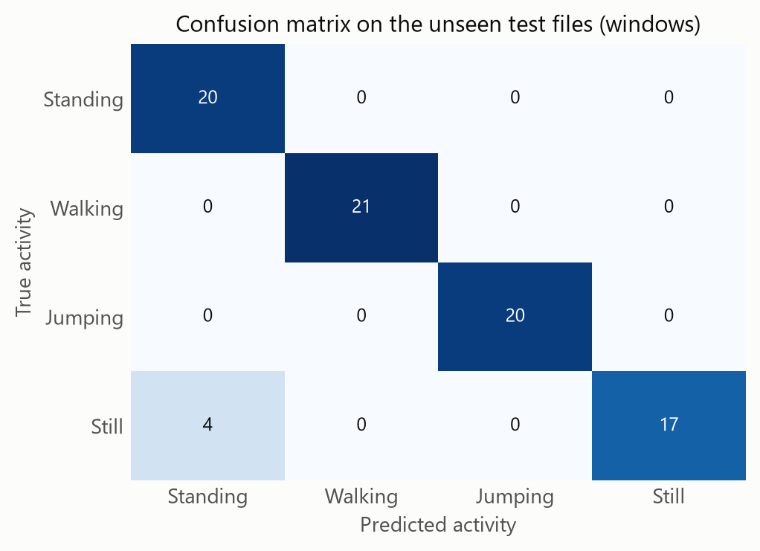

Training. Baum-Welch converged after 6 rounds, and the log-likelihood rose every round, from -1421.0 to -114.0.

Model | Training accuracy | Test accuracy
Labels only | 0.991 | 1.000
After Baum-Welch | 0.979 | 0.951
Baum-Welch made the model explain the data better but classify it slightly worse. It narrowed the still emission onto the quiet windows, reducing the spread of acceleration variance from 0.274 to 0.114 in z-score units. Still windows with more movement than usual then fitted standing better. I kept 95.1% as my main result, because choosing a model from its test score would not be a fair test.
Transitions. The chance of staying in the same activity is 0.82-0.85, and the chance of each switch is 0.03-0.09.
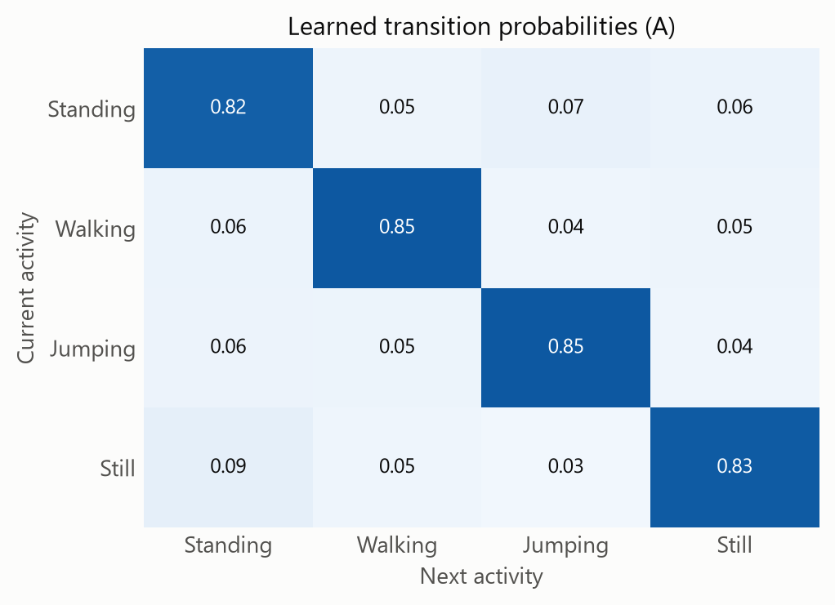
Emissions. Acceleration variance separates all four activities clearly. Dominant frequency separates walking from jumping, but it is very wide for still, whose signal is mostly noise.
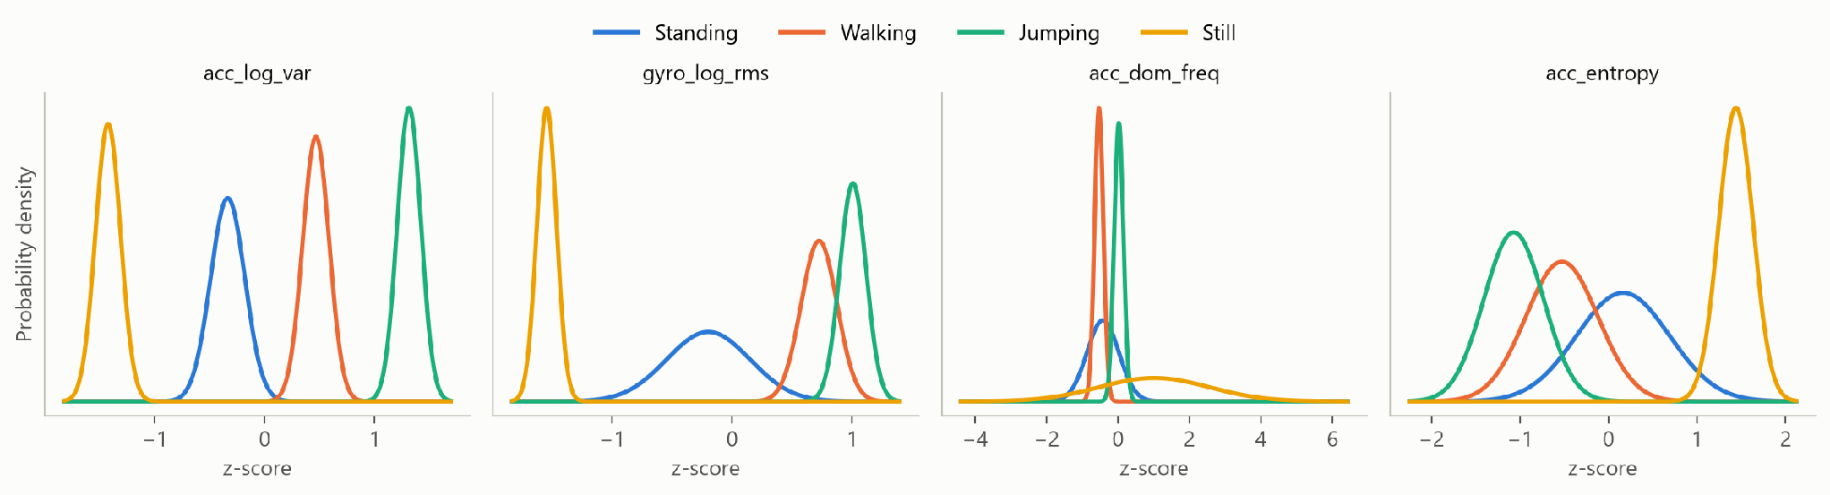
Decoded sequences. Viterbi follows every activity change except the one into still at the start of Still_18, where it switches back and forth between still and standing. Confidence stays close to 1 even during those errors, so the model is overconfident.
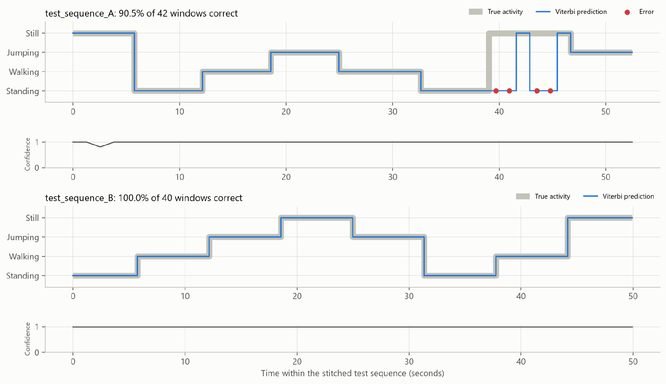

5. Discussion and Conclusion
Easiest and hardest activities. Jumping was easiest, and had perfect scores on test files and cross-validation. It moves more powerfully than the others and has a regular rhythm. Still and standing were the most difficult movements since there was minimal movement involved. Most have no movement in them but a few have more movement, these look like they are standing. Still_18's acceleration variance is much higher than a typical still recording and the rotation remains low (median log variance of -2.89, compared to about -4.34, which is about 30 times higher), so I believe the phone was bumped or vibrated on the surface instead of being picked up. The model only correctly labelled the two quietest windows and called the other six windows standing, indicating that it uses mainly the acceleration to label the windows.
Transition probabilities. Staying probabilities are high and plausible, as one tends to stay in a given activity for some time, but mostly because of my recording and window lengths. Switching probabilities do not tell about real behaviour. There are no real activity changes in my list, and I entered them in arbitrary order, and the switching values are from arbitrary order. π is not meaningful for the same reason, as it is based on five random sequence starts.
Sampling Rate & Noise. The sampling rate was not a problem because there were no gaps and the rate was steady at approximately 102 Hz and well above the movement rhythms here. Noise mattered more. The handling was heavily reduced but there is still a slight rise near the end of Still_05 after the trimming. The emission curve of a still window is quite wide because the dominant frequency in the window is mostly random.
Generalisation. The model performs well for new recordings done in the same setting, but doesn't make claims to being more generalizable than that. The same phone, person and sessions are used for the test data as for the training data. However, the model is likely to capture some variation in sessions, as it was observed that the number of observations for standing and walking was 27 on 29 October, and for jumping and still mostly 29 on 29 October. The changes in the activity are also stitched together, so actual gradual changes have not been tested.
Improvements.
Record continuous sessions on a new day, working through all four activities, to become a stronger test with real transitions.
Import data from other people and phones.
Gather more of the still state with small disturbances, or add a mixture of Gaussians to the still state data, as there are two groups of data for this state.
Consider full covariance Gaussians which may alleviate over-confidence by incorporating related features.
Conclusion. An HMM that was trained from scratch was able to identify four activities with 95.1% accuracy on unseen recordings and 97.5% accuracy in cross-validation. The most important thing for me to take away from this is that a high likelihood doesn't guarantee good classification, so it is always best to check the metrics. Testing on real continuous activity is the next step.

