**Experiment no:10**

**Aim:** Familiarization with Linux command.

**CO4:** Write shell scripts required for system administration.

**Procedure:**

1. Write a shell script to display the fruit you like?

Output:

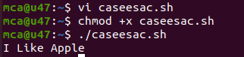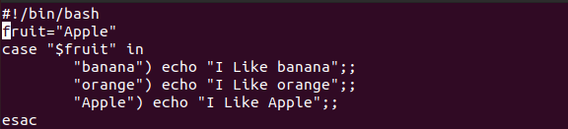

2. Write a shell script to display the colour in rainbow?

Output:

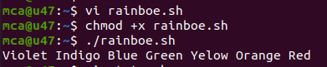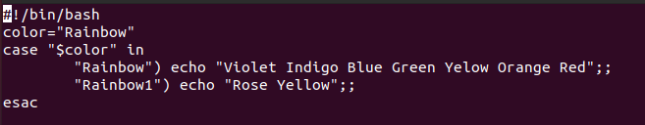

3. Write a shell script to display the capital of state using case..esac statement?

Output:

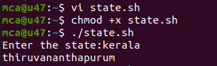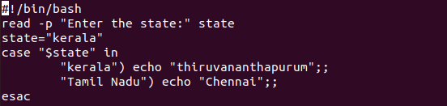

4.Write a shell script to display number in a certain limit using a while loop?

Output:

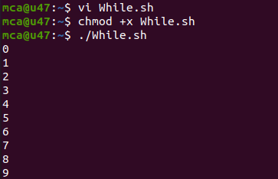

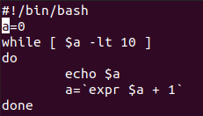

5.Write a shell script to print numbers in reverse order using while loop?

Output:

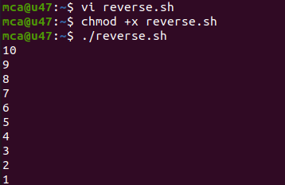

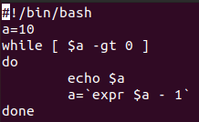

6.Write a shell script to check whether it is palindrome or not?

Output:

7.Write a shell script to demonstrate for loop?

Output:

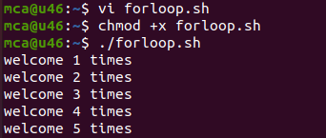

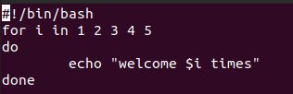

8.Write a shell script to implement for loop with break statement ?

Output:

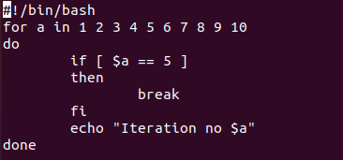

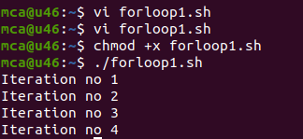

9.Write a shell script to implement for loop with continue statement ?

Output:

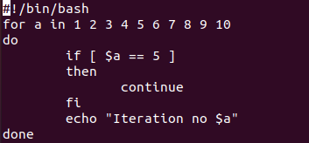

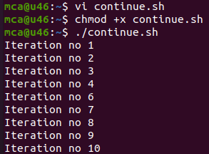

10.Write a shell script to display colors using for loop?

Output:

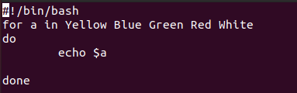

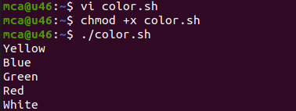

11.Write a shell script to display numbers upto 10?

Output:

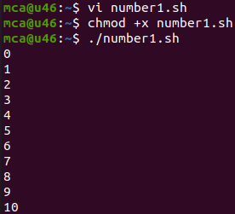

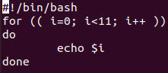

12.Write a shell script to count the number in reverse direction?

Output:

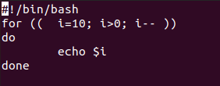

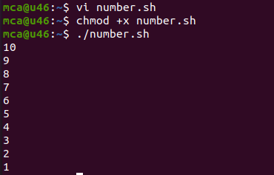

13. Write a shell script to display number from 2 to 15 until loop?

Output:

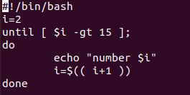

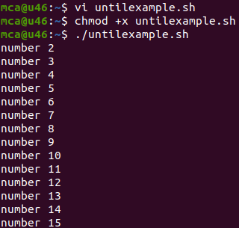

14.Write a shell script to display shell function

Output:

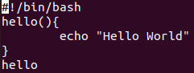

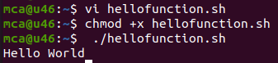

15.Write a shell script to display

Output:

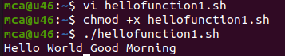

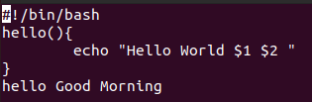

16.Write a shell script to check whether the number is palindrome or not?

Output:

17.Write a shell script to check whether a given number is Armstrong or not?

Output:

18.Write a shell script to check whether a number is prime or not?

Output:

19.Write a shell script for factorial of a number?

Output:

20.Write a shell script to print Fibonacci series?

Output:

21.Write a shell script to check if the current year ia a leap year or not?

Output: