**Experiment no:3 Date:09-03-2023**

**Aim:** Familiarization with Linux command.

**CO2:** Perform system administration tasks.

**Procedure:**

1. pwd: to print the working directory.

**.** print the path of the working directory.

$pwd

Output:



1. ls: Used to list the files and contents

$ls

Output:

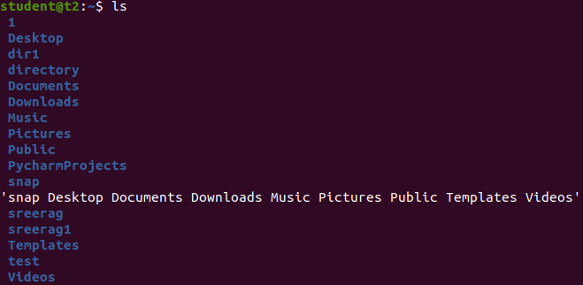

1. ls -R: This will list all the subdirectories

$ls -R

Output:

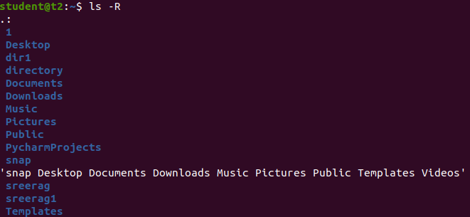

1. ls -l: long listing,

$ls -l

Output:

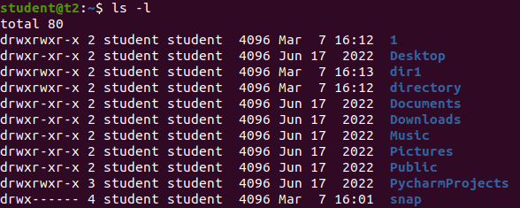

1. ls -a: To view the hidden files.

$ls -a

Output:

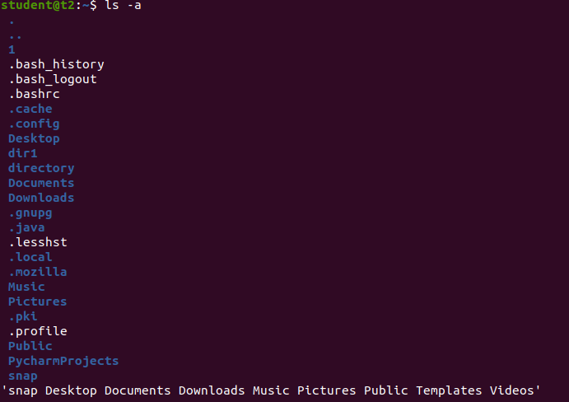

1. ls -al: list the files and directories with detailed information including hidden files.

$ls -al

Output:

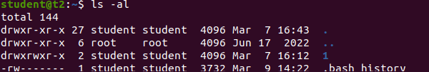

1. ls -t: list the files in sorted in the order of last modified.

$ ls -t

Output:



1. ls -r: reverse the actual sorting order.

$ls -r

Output:



1. mkdir: to make the directory

$mkdir [filename]

Output:



1. cd: to navigate through the directory.

$cd [filename]

Output:



1. cd -- / cd ..: to go to the previous directory.

$cd ..

Output:



1. history: to view the history and the commands which you have been executed for certain period of time.

$history

Output:

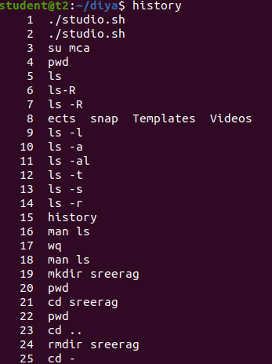

1. man: we can learn and understand about the shell using man command.

$man ls

Output:

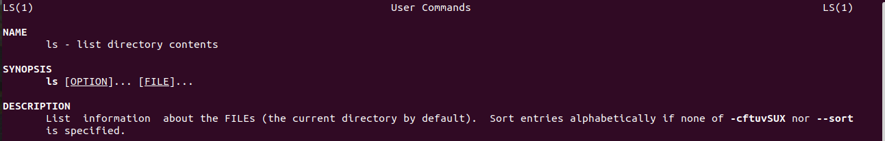

1. cat: to create file.
2. $cat > [filename]

Output:

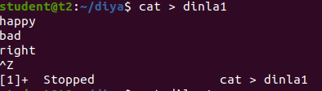

1. cat [filename]: to display the file contents.

$ cat dinla1

Output:

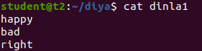

1. cat >> [filename]: to append the file.

$cat >> dinla1

Output:

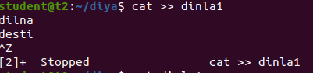

1. cat -n [filename]: to display the line number.

$cat -n dinla1

Output:

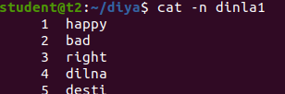

1. cat -b [filename]: to remove numbering from empty line.

$cat -b dinla1

Output:

