**Experiment no:5 Date:13-03-2023**

**Aim:** Familiarization with Linux command.

**CO2:** Perform system administration tasks.

**Procedure:**

1. read: to use to read the content of line by default.

$read

$echo $REPLY

Output:



i)

$read var1 var2 var3

$echo “[$var1][$var2][$var3]”

Output:

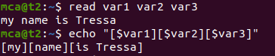

ii)

$read

My \

>name is \

>tressa

$echo $REPLY

My name is tressa

Output:

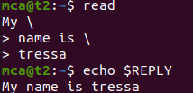

iii)

read -p:prompt

a)

$read -p “Enter your name ”

Enter your name Tressa

Output:



ii)

$read -n 6 -p “Enter 6 characters only ”

Output:



$echo “My name is $REPLY”

Output:



$

Output:

1. cat: to create file.
2. $cat > [filename]

Output:

1. cat [filename]: to display the file contents.

$ cat dinla1

Output:

1. cat >> [filename]: to append the file.

$cat >> dinla1

Output:

1. cat -n [filename]: to display the line number.

$cat -n dinla1

Output:

1. cat -b [filename]: to remove numbering from empty line.

$cat -b dinla1

Output: