1.egrep -c '(vmx|svm)' /proc/cpuinfo

$ egrep -c '(vmx|svm)' /proc/cpuinfo

Output:

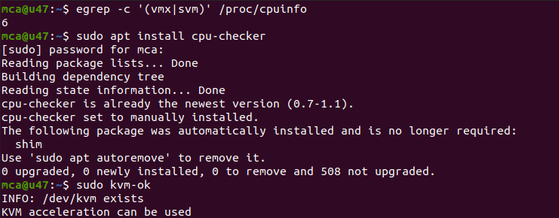

2.sudo apt install cpu-checker

$ sudo apt install cpu-checker

Output:



3.sudo kvm-ok

$ sudo kvm-ok

Output:



4.sudo apt install qemu-kvm libvirt-daemon-system libvirt-clients bridge-utils

$ sudo apt install qemu-kvm libvirt-daemon-system libvirt-clients bridge-utils

Output: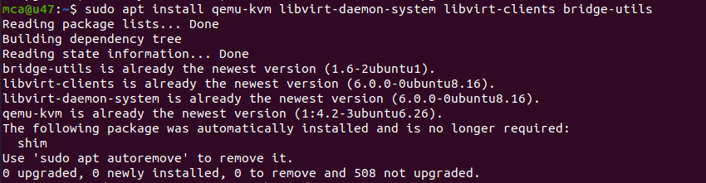

5.sudo systemctl status libvirtd

$ sudo systemctl status libvirtd

Output:

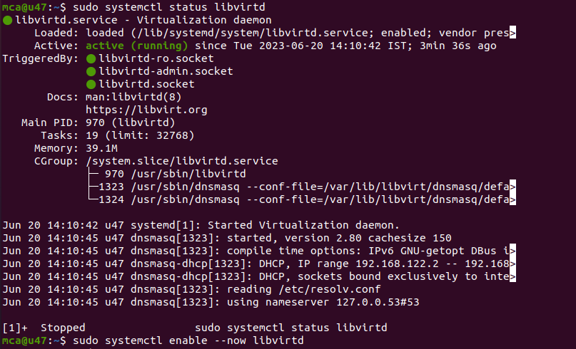

6. sudo systemctl enable --now libvirtd

$ sudo systemctl enable --now libvirtd

Output:



7. sudo apt install virt-manager

$ sudo apt install virt-manager

Output:

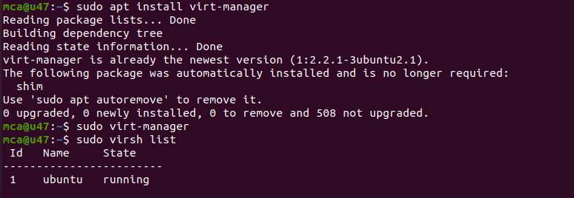

8. sudo virt-manager

$ sudo virt-manager

Output:



9.sudo virsh list

$ sudo virsh list

Output:



10.sudo virsh

$ sudo virsh

Output:

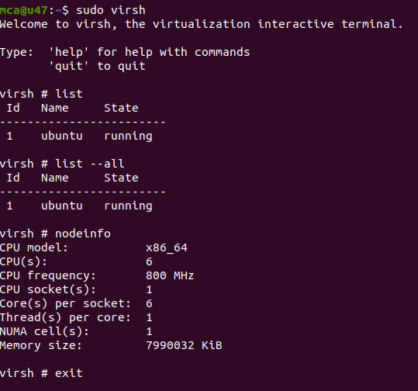







Output:

