**Experiment no:9**

**Aim:** Familiarization with Linux command.

**CO2:** Perform system administration tasks.

**Procedure:**

1.sudo apt update

$ sudo apt update

Output:

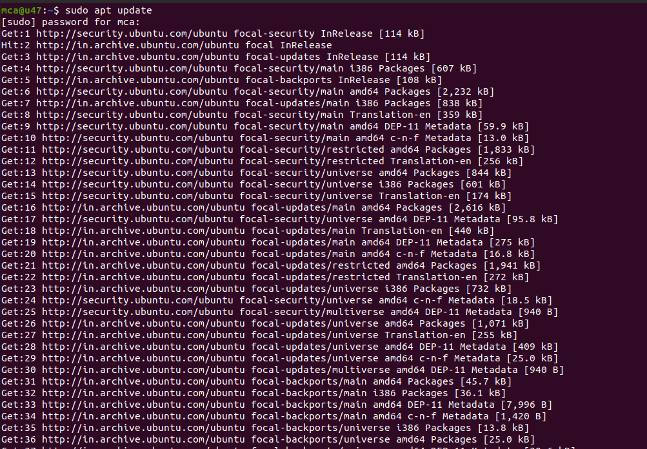

2. sudo apt install net-tools

$ sudo apt install net-tools

Output:

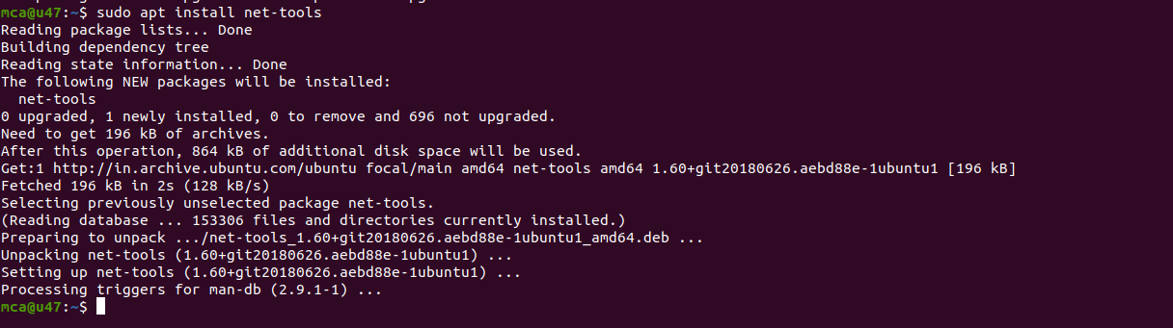

3.ifconfig

$ ifconfig

Output:

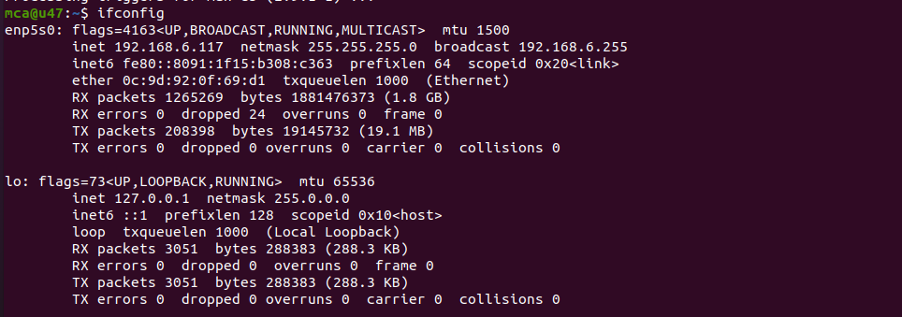

4.sudo apt install ifupdown

$ sudo apt install ifupdown

Output:

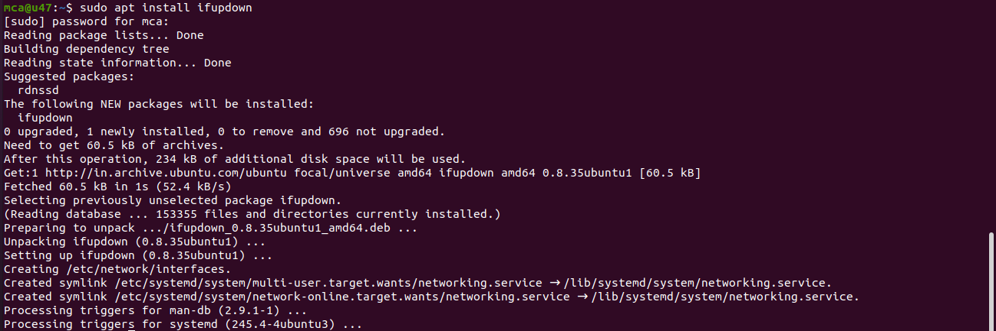

5.ping google.com

ping google.com

Output:

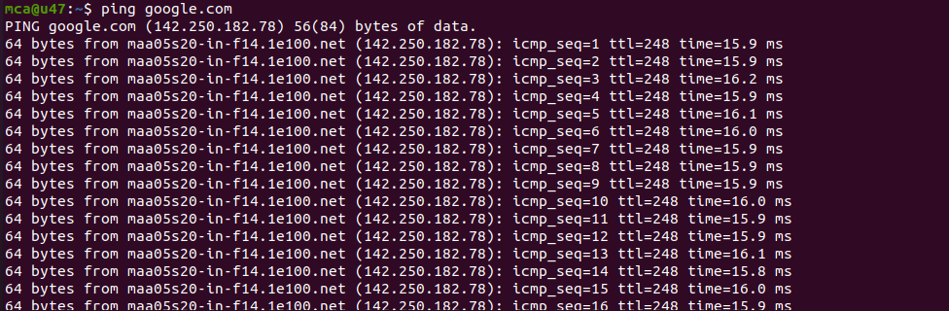

6.ping 142.250.182.78

$ ping 142.250.182.78

Output:

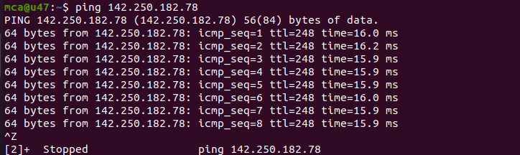

7. ping -c 5 google.com

$ ping -c 5 google.com

Output:

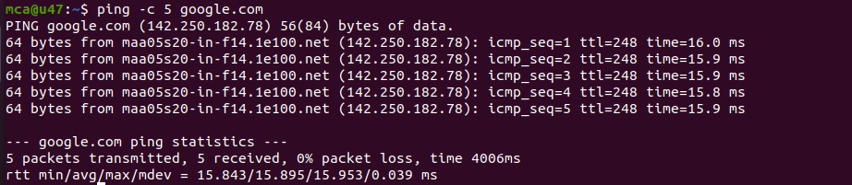

8. sudo apt install traceroute

$ sudo apt install traceroute

Output:

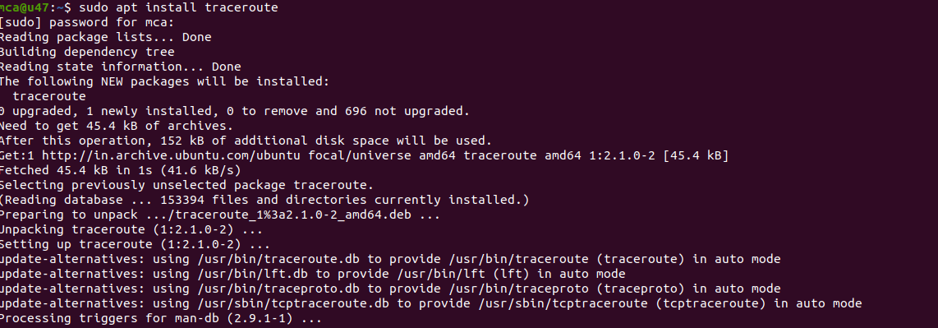

9. traceroute google.com

$ traceroute google.com

Output:

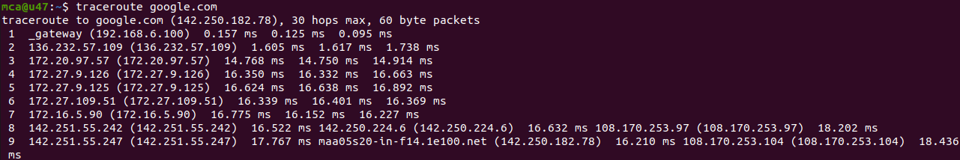

10. sudo apt install whois

$ sudo apt install whois

Output:

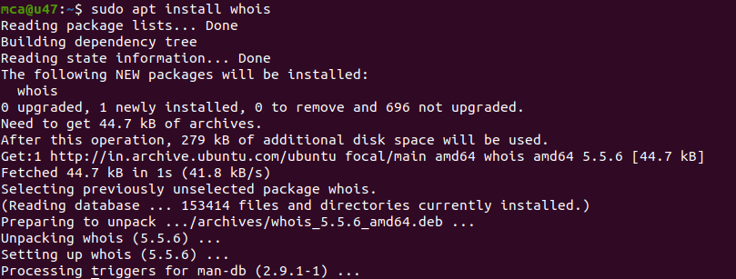

11.whois google.com

$ whois google.com

Output:

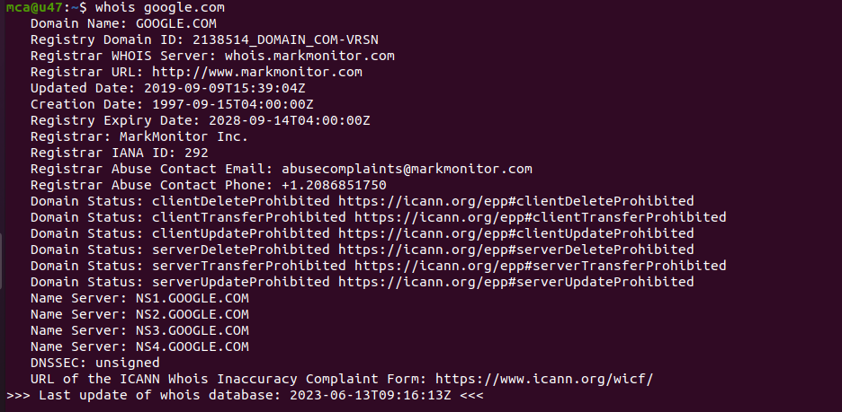

12. sudo ifconfig enp5s0 down

$ sudo ifconfig enp5s0 down

Output:

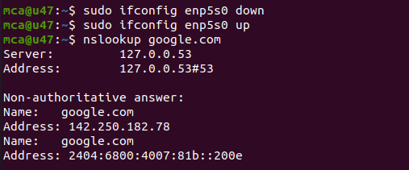

13. sudo ifconfig enp5s0 up

$ sudo ifconfig enp5s0 up

Output:



14.nslookup google.com

$ nslookup google.com

Output:



15.ls - used to list the files and contents

$ls

Output:

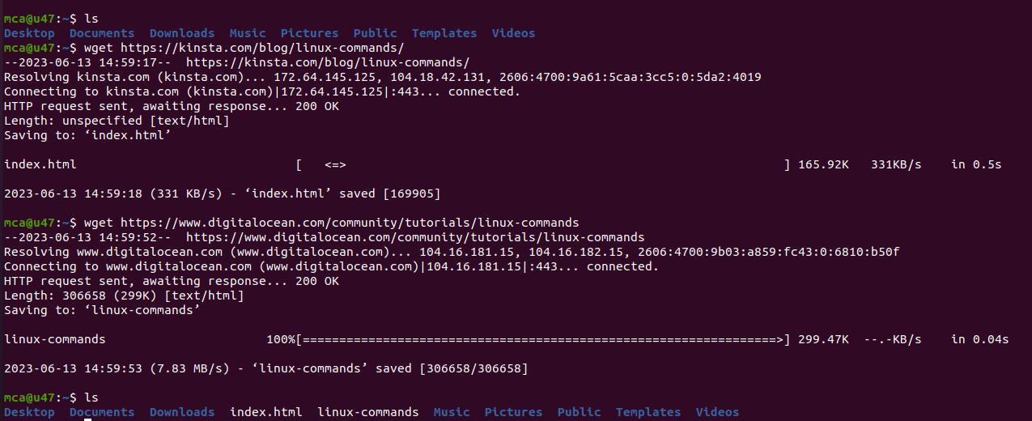

16. wget [website link]

$ wget https://www.digital.ocean.com/community/tutorials/Linux-commands

Output:

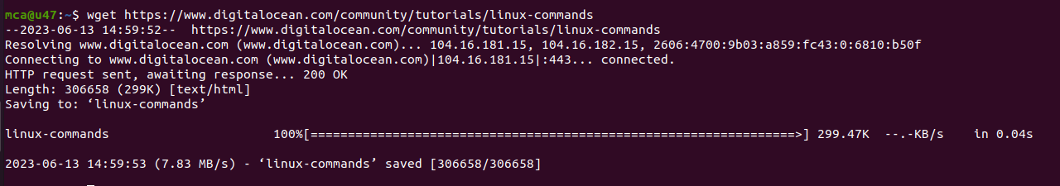

17. ls - used to list the files and contents

$ls

Output:



18. sudo tcpdump -D

$sudo tcpdump -D

Output:

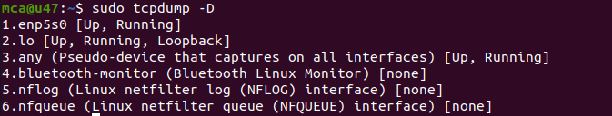

19. sudo tcpdump

$ sudo tcpdump

Output:

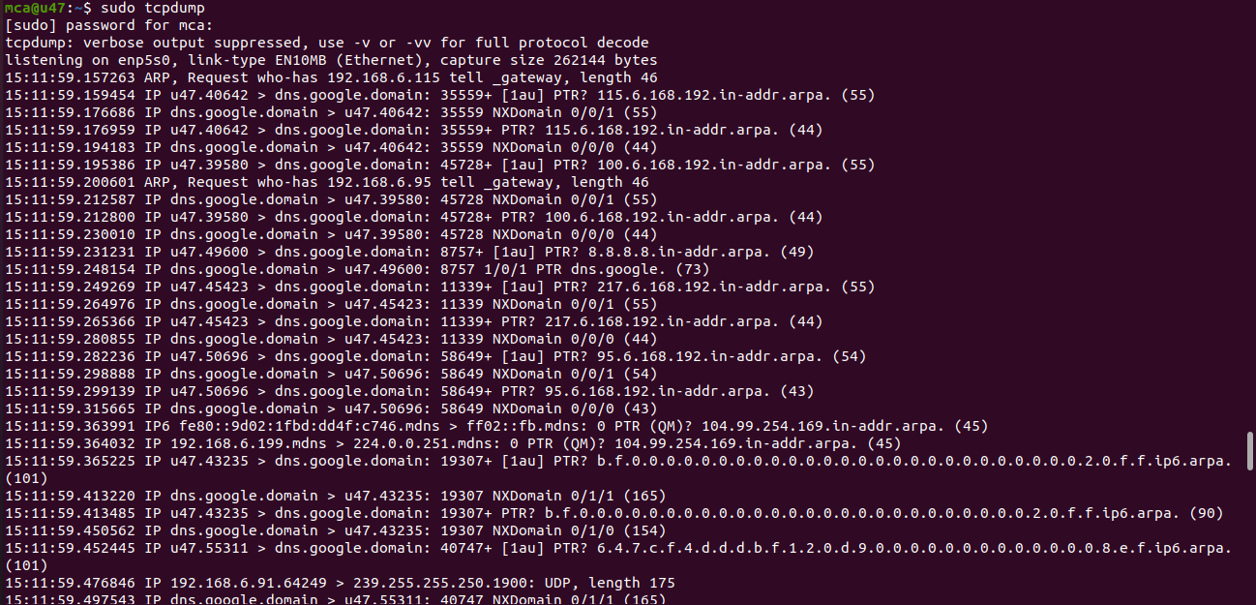

20. sudo tcpdump -A -i enp5s0

$ sudo tcpdump-A -i enp5s0

Output:

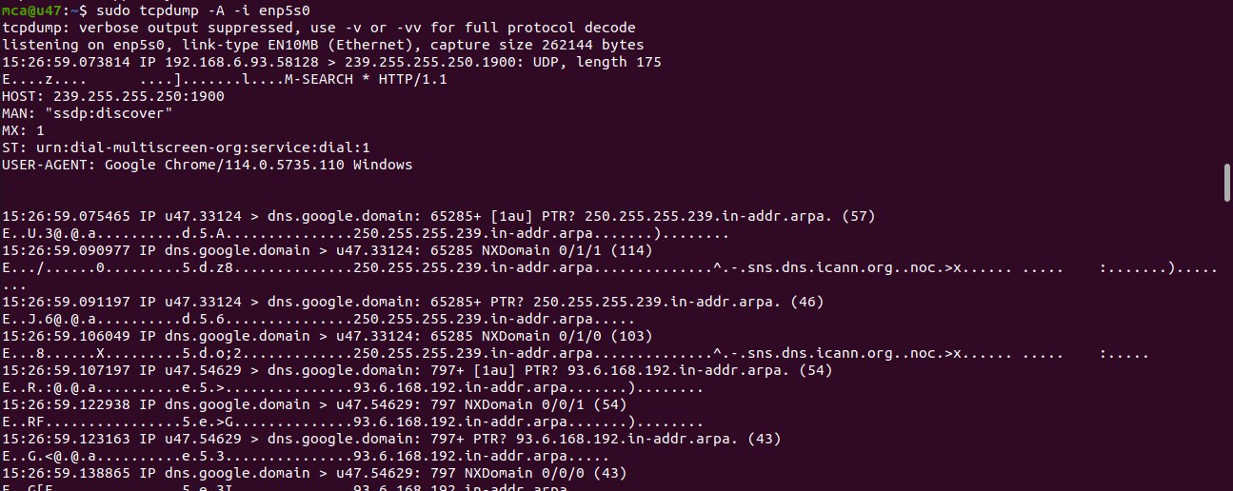

21. sudo tcpdump -w ab.txt -i enp5s0

$ sudo tcpdump -w ab.txt -i enp5s0

Output:

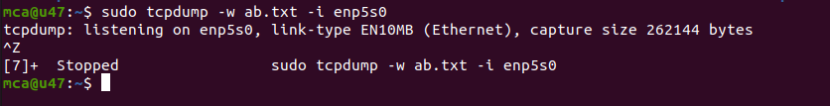

22. ls - used to list the files and contents

$ls

Output:

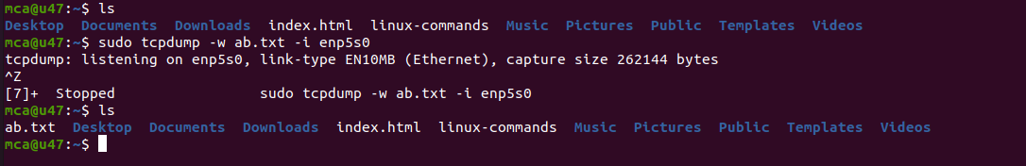

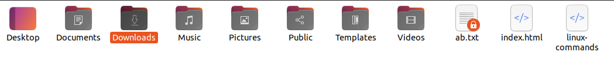

23. sudo apt install wireshark

$ sudo apt install wireshark

Output:

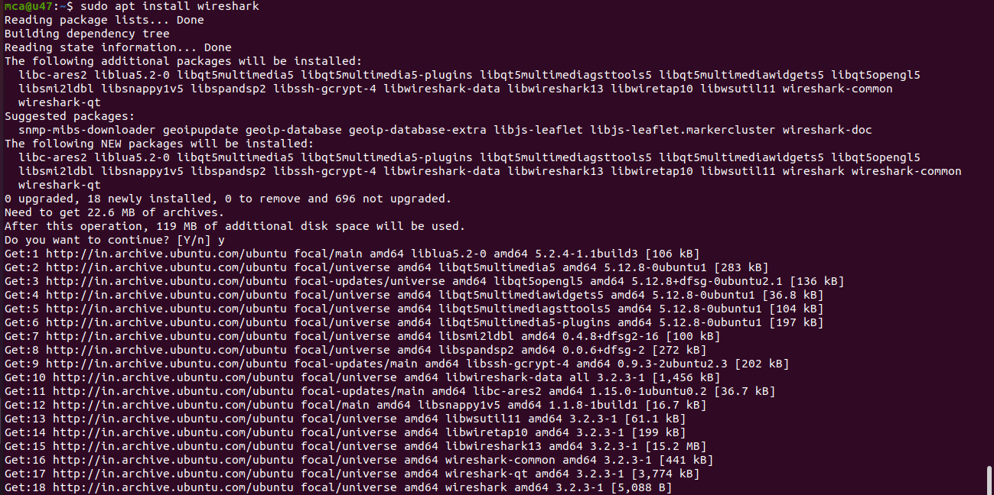

24. sudo wireshark

$ sudo wireshark

Output:



