**Experiment no:3 Date:09-03-2023**

**Aim:** Familiarization with Linux command.

**CO2:** Perform system administration tasks.

**Procedure:**

1. pwd: to print the working directory.

$pwd

Output:



1. ls: Used to list the files and contents

$ls

Output:



1. ls -R: This will list all the subdirectories

$ls -R

Output:



1. ls -l: long listing,

$ls -l

Output:

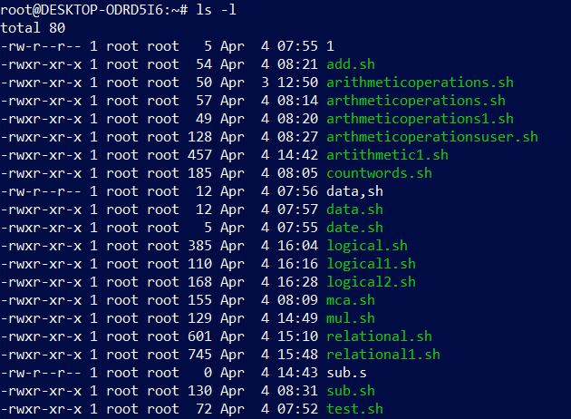

1. ls -a: To view the hidden files.

$ls -a

Output:



1. ls -al: list the files and directories with detailed information including hidden files.

$ls -al

Output:

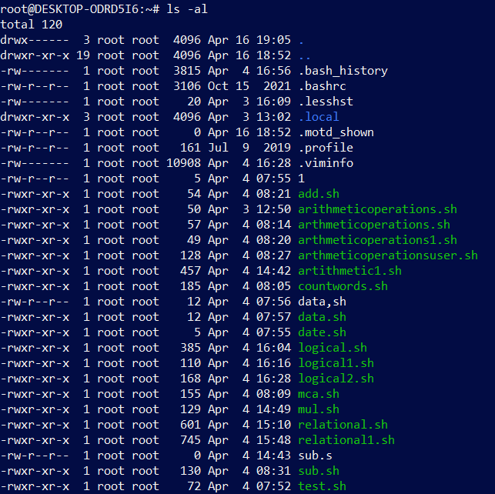

1. ls -t: list the files in sorted in the order of last modified.

$ ls -t

Output:



1. ls -r: reverse the actual sorting order.

$ls -r

Output:



1. history: to view the history and the commands which you have been executed for certain period of time.

$history

Output:

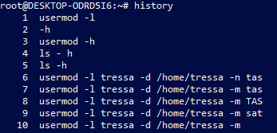

1. man: we can learn and understand about the shell using man command.

$man ls

Output:

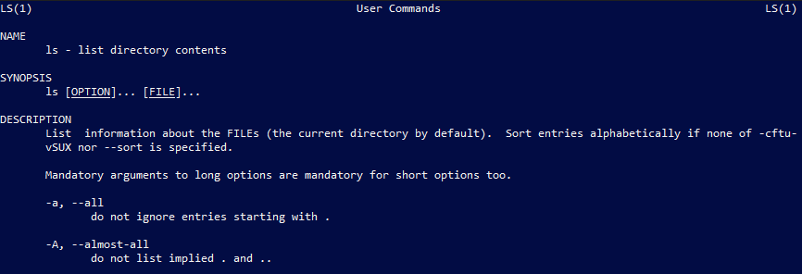

1. mkdir: to make the directory

$mkdir [filename]

Output:



1. cd: to navigate through the directory.

$cd [filename]

Output:



1. cd -- / cd ..: to go to the previous directory.

$cd ..

Output:



1. cat: to create file.
2. $cat > [filename]

cat > file

Output:

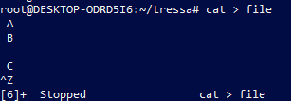

1. cat [filename]: to display the file contents.

$ cat file

Output:

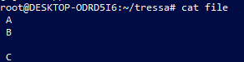

1. cat >> [filename]: to append the file.

$cat >> file

Output:



1. cat -n [filename]: to display the line number.

$cat -n file

Output:

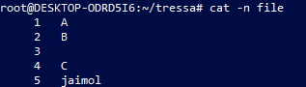

1. cat -b [filename]: to remove numbering from empty line.

$cat -b file

Output:

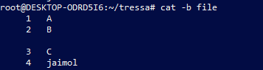

1. cat [filename][filename] > [filename]:

$cat file file1 > file2

Output:

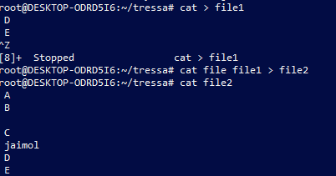

1. cat [filename] | tr a-z A-Z > [filename]

$cat file2 | tr a-z A-Z > file3

Output:

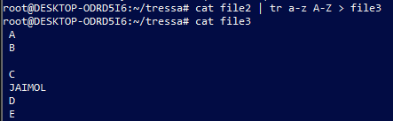

**Result**

The program was executed and the result was successfully obtained. Thus CO2 was obtained.

**Experiment no:4**

**Aim:** Familiarization with Linux command.

**CO2:** Perform system administration tasks.

**Procedure:**

1. cut - cutting out the sections from each line of files and writing the result to standard output.
2. cut -b [filename]- cut the letters of words from each lines

$cut -b2 colour

Output:

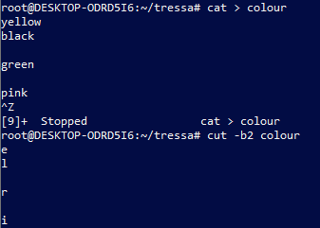

1. cut -c3 [filename] - cutting the third letter of words from each line.

$cut -c3 colour

Output:

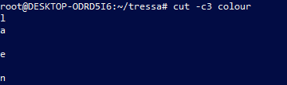

1. cut -d - -f1 [filename] – cutting the highfen(delimiter) from the file.

$cut -d : -f1 mark

Output:

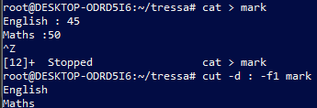

1. cut -c 1,4,6 [filename] – cutting 1st,4th and 6th letters.

$cut -c 1,4,6 colour

Output:

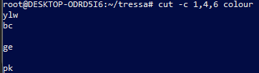

1. paste - join files horizontally[each file consisting of different lines]

i. paste [filename] [filename]

$paste mark mark1

Output:

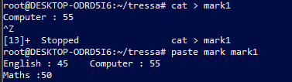

ii. paste [filename] [filename] > [filename]

$paste mark mark1 > mark2

$cat mark2

Output:



iii. $paste -d ‘%’ mark mark1 – appending % at list.

Output:



iv. $paste -d ‘%’ mark mark1 > mark3

$cat mark3

Output:



v. paste -s filename – display the content in the same line.

Output:

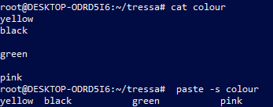

1. cp [filename][filename]- to copy the content to an existing file.

$cp file file1

$cat file1

Output:

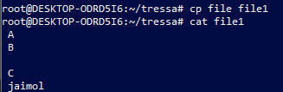

**Result**

The program was executed and the result was successfully obtained. Thus CO2 was obtained.

**Experiment no:5**

**Aim:** Familiarization with Linux command.

**CO2:** Perform system administration tasks.

**Procedure:**

1. read: to use to read the content of file.

i. $read

MY NAME IS TRESSA

$echo $REPLY

Output:



ii. $read var1 var2 var3

my name is tressa

$echo “[$var1][$var2][$var3]”

Output:



iii. $read

Hello \

> Good \

> Morning

$echo $REPLY

Output:

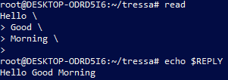

iv. read -p: prompt

$read -p “Enter your name ”

Output:



v. read -n 7 -p: able to enter 7 characters only.

$read -n 7 -p “Enter 7 characters only ”

Output:



vi.

$ read -s -p “enter the password:”

Output:



$ echo “password is $REPLY”

Output:



$cat > profile

Output:

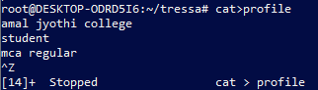

1. wc: to display the word count in an format.

$wc profile

Output:



1. $wc -l profile: to display the no.of lines.

Output:



1. $wc -m profile: display the no.of characters.

Output:



1. $wc -c profile: display no.of bytes.

Output:



1. $wc -w profile: display the no.of words.

Output:



1. $wc -L profile: print length of the longest line.

Output:



$ cat content.txt

Output:

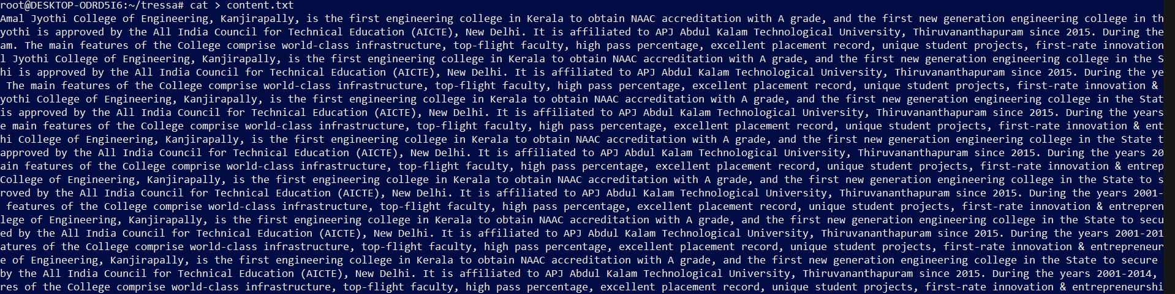

3. more – similar to cat to display the content, the only difference is that in case of large file cat command output will scroll off your screen while more command display output one screenful at a time.

$ more content

Output:

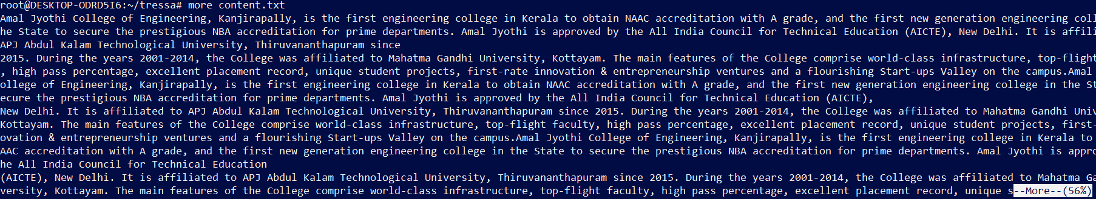

i. $more +20 content: display contents after 20 lines.

Output:

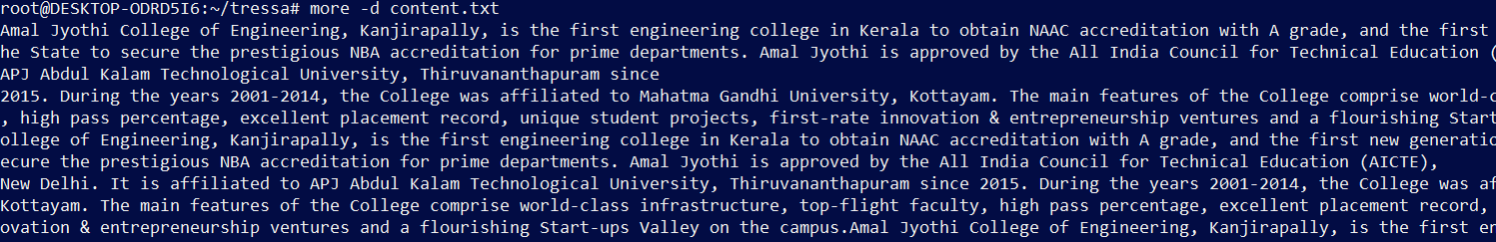

ii. $more +/amal{pattern} content: search the pattern string from the content and view all the instances,by navigating through the result.

Output:



iii. $more -p content: clear the screen and show the output.

Output:

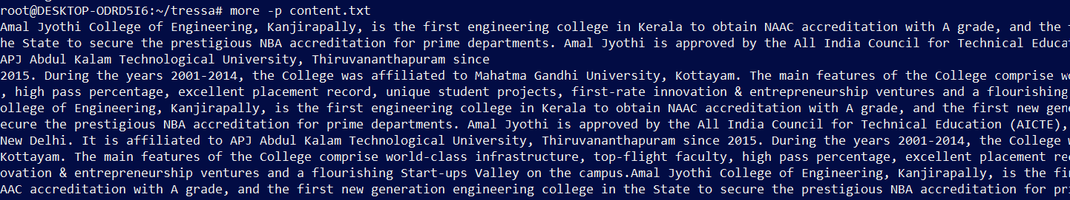

iv. $ more -d content: help the users to navigate,press space to continue,q to quit

Output:

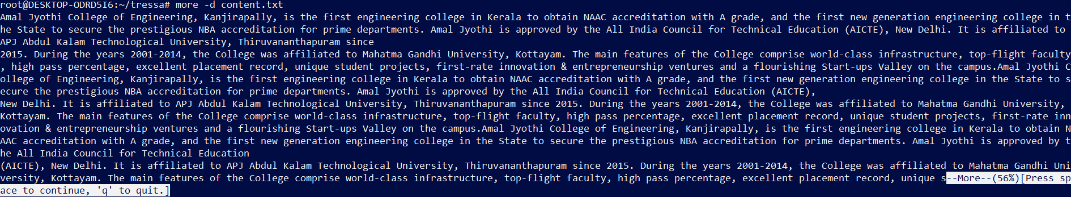

**Result**

The program was executed and the result was successfully obtained. Thus CO2 was obtained.

**Experiment no:6**

**Aim:** Familiarization with Linux command.

**CO2:** Perform system administration tasks.

**Procedure:**

1. grep-  is used to filter the contents,which makes our search easy.
   1. grep -i [content][filename]: case sensitive search

$grep -i 40 total

Output:

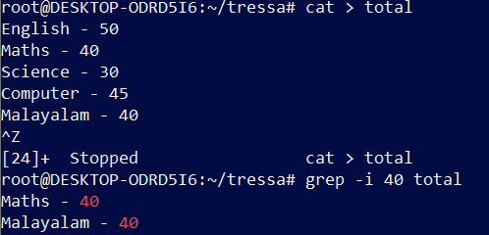

* 1. grep -v [content][filename]: inverted search(all content except the search content displays)

$ grep -v 45 total

Output:

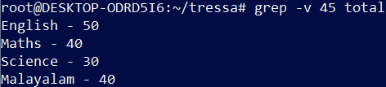

* 1. grep -A1 [content][filename]: view the content along with the  line after.

$ grep -A1 English total

Output:



* 1. grep -B1 [content][filename]: display content before also.

$ grep -B1 Science total

Output:

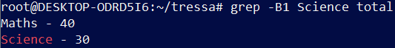

* 1. grep -C1 [content][filename]: before and after the content displays.

$ grep -C1 Computer total

Output:

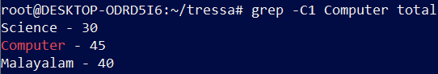

1. head - display the top content of the file by default.

Output:

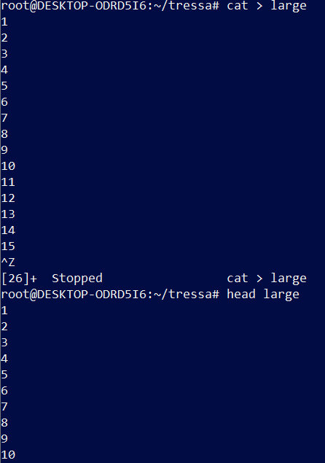

* 1. head -5 [filename]: displays first 5 lines.

$head -5 large

Output:

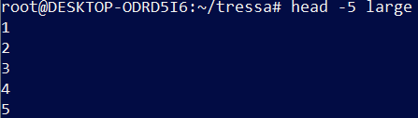

1. tail- display the content of the file by default it displays last ten lines.

$tail large

Output:

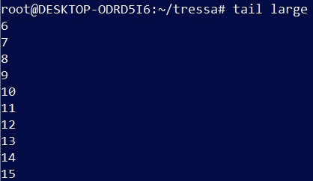

* 1. $tail -5 large

Output:

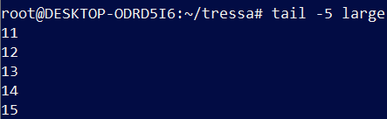

1. mv - move

mv -b [filename][filename]: backups

$mv -b total profile

Output:

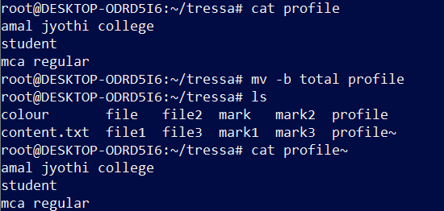

* 1. mv -i [filename][filename]: displays prompt message.

mv -i cat profile1

Output:

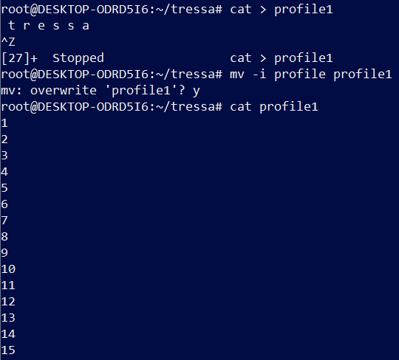

**Result**

The program was executed and the result was successfully obtained. Thus CO2 was obtained.

**Experiment no:7**

**Aim:** Familiarization with Linux command.

**CO2:** Perform system administration tasks.

**Procedure:**

1. expr- evaluate the given expression and display the output.

i. $ expr 12 + 8

ii. $ expr 12 – 8

iii. $ expr 12 / 4

iv. $ expr 12 /* 3

v. $ expr $x + $y

Output:

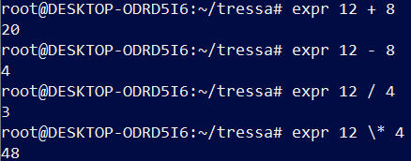

1. df -  disutilised information (represent system disk space usage)

$ df

Output:

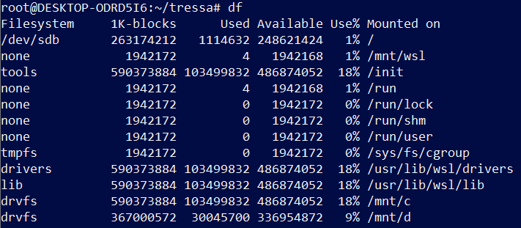

1. du - how much space a file or directory takes in the current directory

$ du colour

Output:



1. sudo useradd user_name: add a new user to the system.

$ sudo useradd tressa

i. $ sudo psswd tressa

ii. $ sudo groupadd -g 710 mcastudent: adding a new group mca student with unique identity 710.

iii. $ sudo usermod -G mcastudent tressa

iv. $ id tressa

Output:

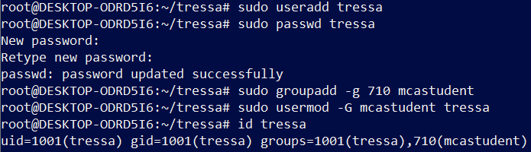

1. $ compgen -g

Output:

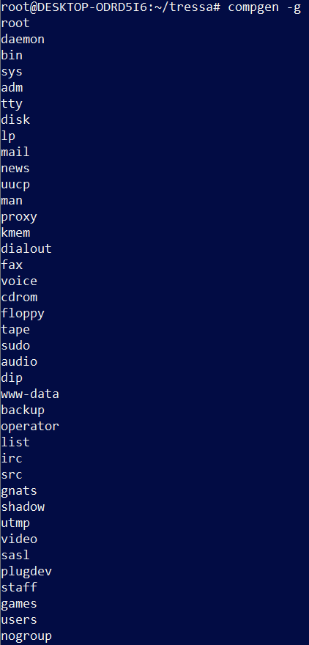

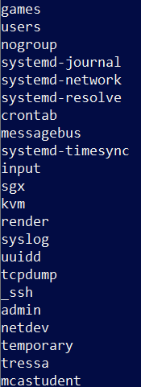

1. $ chmod -wx [filename]: deny permission for write and execute.
2. $ chmod +rwx [filename]: give permission to read,write,execute

Output:

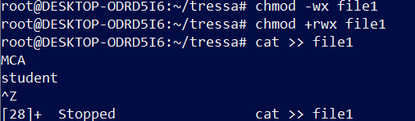

1. $ sudo chown [username][file1]: change owner permission

Output:

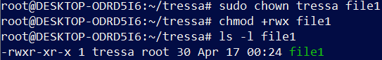

1. $ sudo userdel [username]
2. $ sudo groupdel [groupname]

Output:



**Result**

The program was executed and the result was successfully obtained. Thus CO2 was obtained.

**Experiment no:8**

**Aim:** Familiarization with Linux command.

**CO2:** Perform system administration tasks.

**Procedure:**

1. ip addr: ip address

$ ip addr

Output:

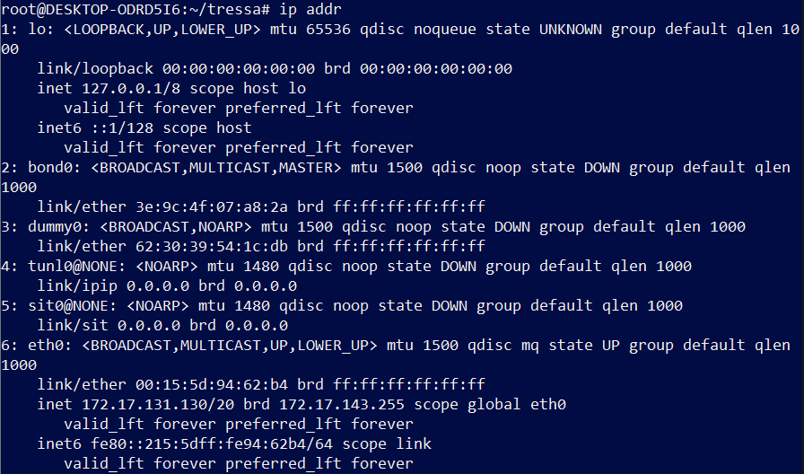

2. $ sudo apt-get update

Output:

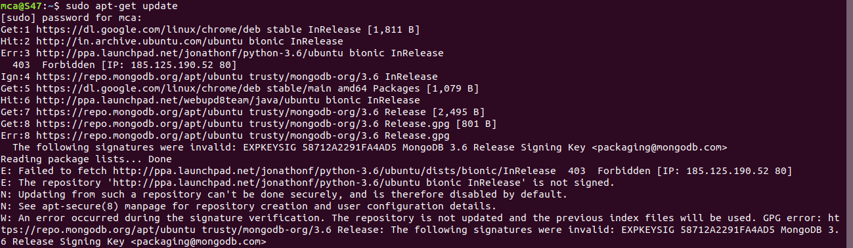

3. $ sudo apt-get install openshh-server

Output:

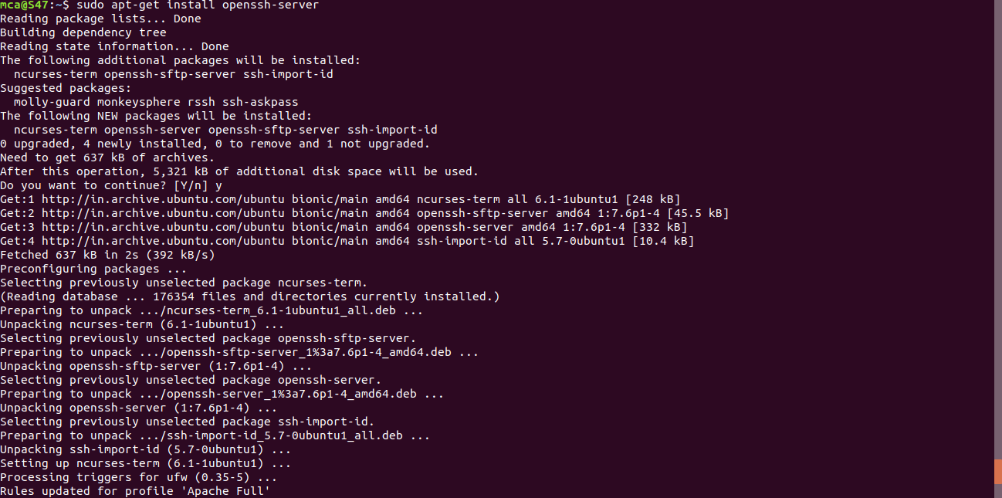

4. $ sudo ufw allow 22: 22-port number

Output:



5. ssh user@portnumber -> ssh-secure shell protocol : used to securely connect to a remote server or a system.ssh is secured in reuse,it transfer data in encrypted form between host and clients.

Output:

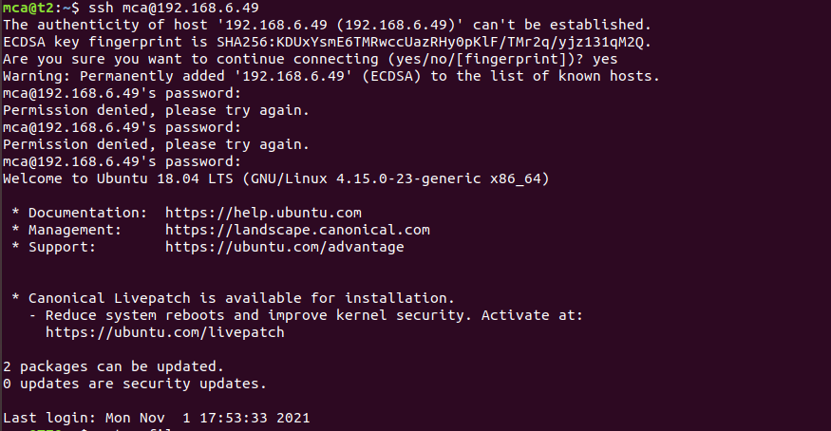

6. $ shh-keygen

Output:

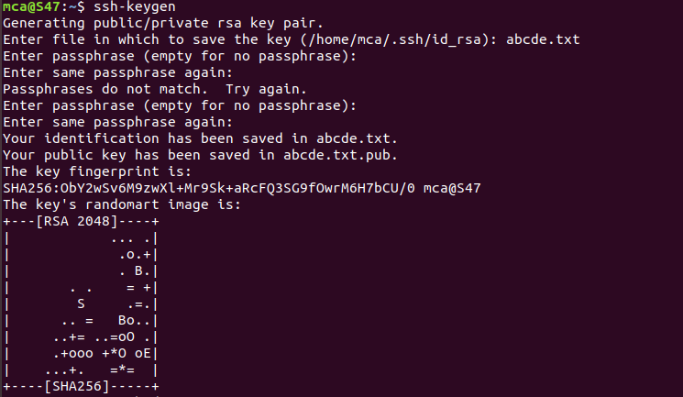

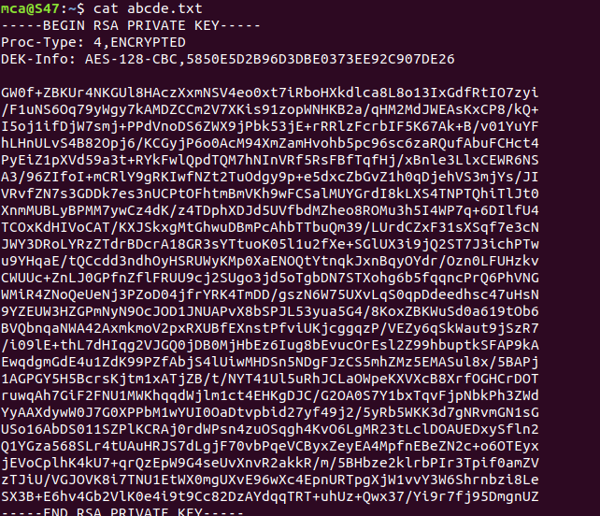

7. $ ps

Output:

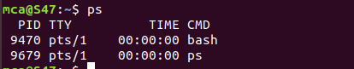

i. ps -u [username]

Output:

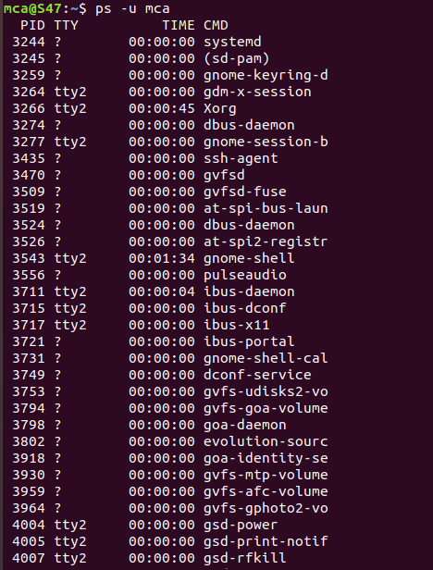

ii. $ ps -c chrome

Output:

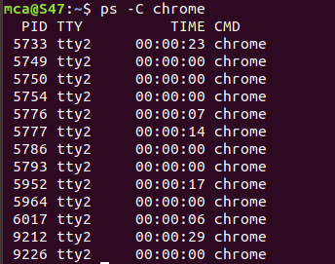

iii. $ ps -f -p 2168

Output:



**Result**

The program was executed and the result was successfully obtained. Thus CO2 was obtained.