Make

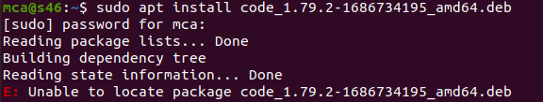



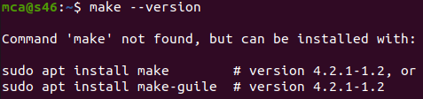

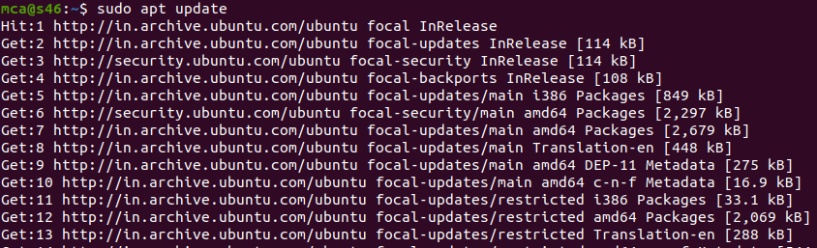

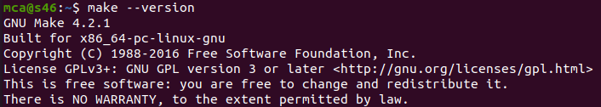



Sudo apt install build-essential :If there is no directory

Open vs code

Create a folder Tressa in desktop

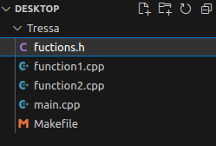

Create file name **main.cpp**

#include<iostream>

#include "function.h"

int main(){

print_hello();

std::cout << std::endl;

std::cout << `the factorial od 5 is`<<factorial(5)<<std::endl;

return 0;

}

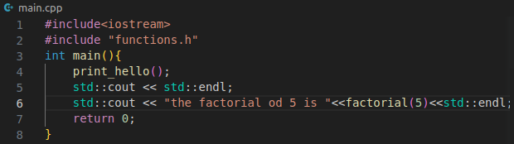

Create another file name **function1.cpp**

#include "functions.h"

int factorial(int n){

if(n!=1){

return(n*factorial(n-1));

}

else return 1;

}

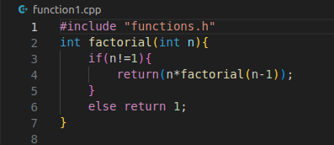

Create another file name **function2.cpp**

#include <iostream>

#include "functions.h"

void print_hello(){

std::cout << "Hello World";

}

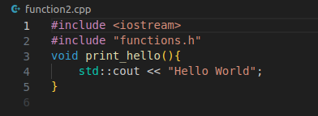

Create another file name **functions.h**

void print_hello();

int factorial(int n);

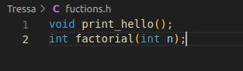

Create file name **Makefile**

all;

g++ main.cpp function1.cpp function2.cpp -o hello

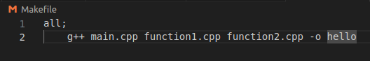







g++ main.cpp fuction1.cpp function2.cpp -o hello

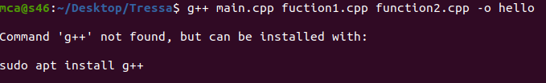

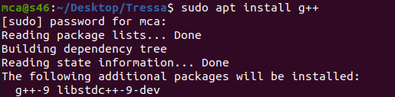







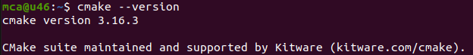

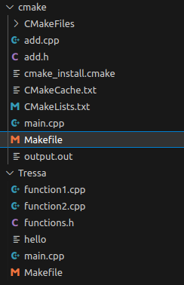

Create file name **main.cpp**

#include<iostream>

#include "add.h"

int main()

{

std::cout << "Sum of 20 and 30 is" << add(20,30)<<"\n";

return 0;

}

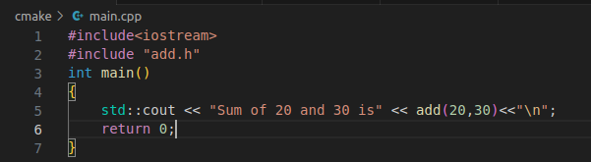

Create file name **CMakeLists.txt**

cmake_minimum_required(VERSION 3.16.3)

project("Hello World")

add_executable(output.out main.cpp add.cpp)

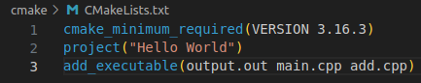

#pragma once

int add(int a, int b);

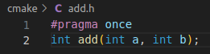

#include "add.h"

int add(int a, int b)

{

return a + b;

}

