Experiment-7

AIM

1.expr – Evalute the given expression and display the output.

a.ADDITION
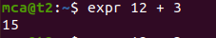

b.SUBSTRACTION


c.DIVISION
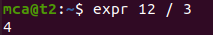

d.MULTIPLICATION
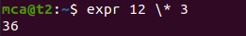

2.
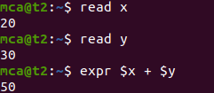

3. df – To find the utilisation in system.
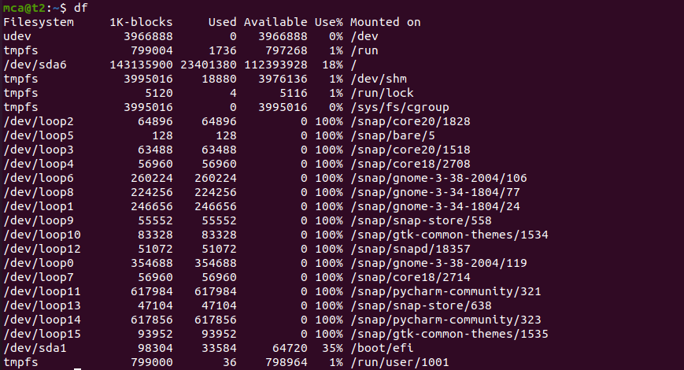

4. du – To check whether how much space in a file or directory

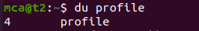

5. sudo useradd [user name]

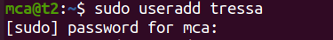

a. sudo passwd [user password]

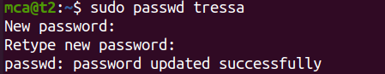

6. sudo groupadd -g [group id][group name]

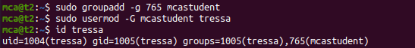
7. id tressa

7.compgen -g
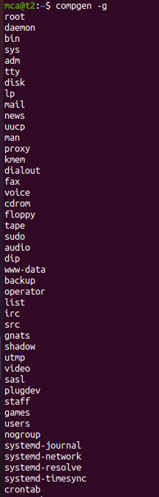

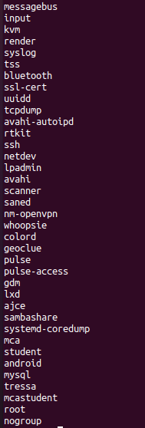

8.

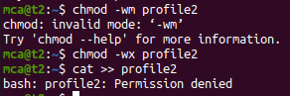

9.

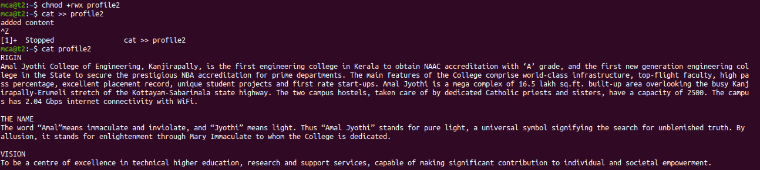

10.

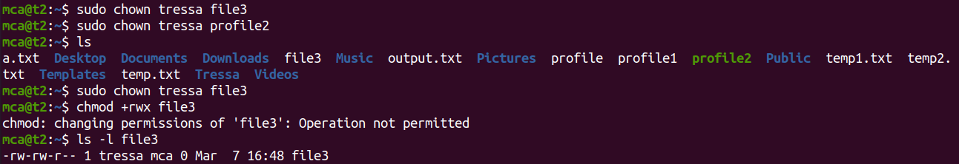

11.

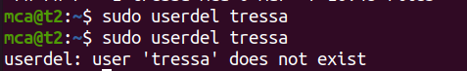

12.

