Quasar
Lymphoma structural-variant + fusion detection — algorithm vignette
What it is
Quasar is an open-source, ensemble structural-variant caller for lymphoma next-generation sequencing — both targeted panels and whole-genome. It consumes BAM/CRAM directly (its own pysam scanner) and/or VCFs from Manta, GRIDSS, Delly, SvABA, TIDDIT, and FACTERA, then runs a 12-step lymphoma-aware pipeline that produces tiered fusion calls, per-sample clinical brochures, a cohort dashboard, and a VCF 4.3 export. Designed for clinical deployment, anti-paywall, patient-care first.
Headline benchmark (14-sample WGS cohort, 4-tool head-to-head)
Tool | Precision | Recall | F1
Quasar | 0.87 | 0.81 | 0.84
Manta 1.6.0 | 0.71 | 0.38 | 0.50
Delly 2.1.0 | 0.43 | 0.21 | 0.29
SvABA 1.2.0 | 0.14 | 0.21 | 0.17
TIDDIT 3.9.5 | 0.00 | 0.00 | 0.00
GRIDSS 2.13.2 not in the table — its setup ran ~12 hr/sample on this hardware and was killed; the lymphoma blind spot (PMBL polyG attractor) is shared with the other general-purpose callers.

Algorithm flow
Twelve steps from CRAM to clinical report. Red-bracketed boxes are the layers no general-purpose SV caller has — every other tool stops at step 5.
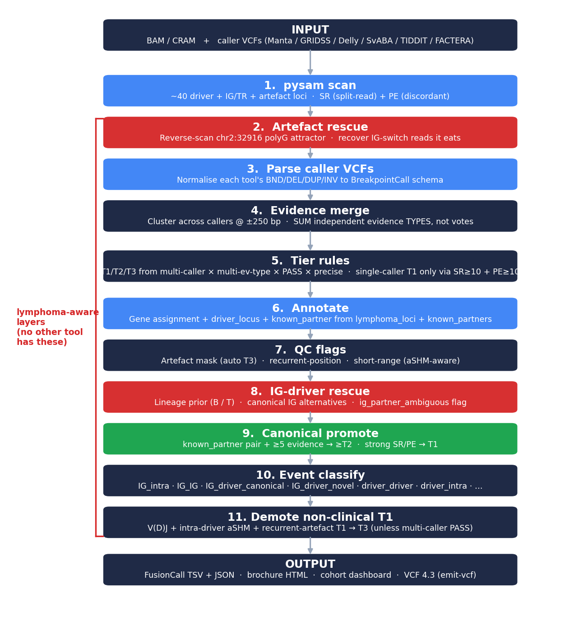
Source: src/quasarsv/{scanners,merge,annotate,qc,rescue,classify,promote}.py

Four structural advantages no general-purpose caller has
1. polyG-attractor rescue (step 8)
PMBL t(3;14) chimeric reads have their IGH side absorbed by the chr2:32916 polyG stretch in GRCh38 (>644 k reads per sample). General-purpose callers see a BCL6↔chr2 BND and stop. Quasar synthesises the underlying BCL6-IGH translocation from the artefact-mediated signal, with a B-cell lineage prior + canonical-partner promotion. Uniquely catches both PMBL samples in the benchmark.
2. Canonical-partner tier promotion (step 9)
A 30-row known_partners.tsv table covers every clinically-actionable lymphoma translocation (IGH-MYC, IGH-BCL2, IGH-BCL6, IGH-CCND1, NPM1-ALK, BCL6 promiscuous partners, etc.) tagged with disease. Any annotated pair with ≥5 SR or ≥10 PE is promoted to T1 — catches MD903 BCL6-IGH and NU-DUL-1 MYC-IGH where Manta records exist but score 0 against its own quality filter.
3. Evidence-level merge, not caller-vote (step 4)
Two callers seeing the same split-read cluster counts as one piece of evidence, not two. The merger sums independent evidence types (split read, discordant pair, assembly contig, soft clip) at ±250 bp tolerance and tiers on that. Avoids the false-positive explosion that hits Delly (4 FPs) and SvABA (18 FPs) when caller-vote agreement isn't filtered for evidence-type independence.
4. Lymphoma-aware event classification + demotion (steps 10-11)
Every call is classed as IG_intra (V(D)J), IG_IG (noise), IG_driver_canonical (clinical), IG_driver_novel (review), driver_driver (clinical), driver_intra (aSHM), or intergenic. Single-caller T1 calls that fall into the non-clinical buckets are demoted to T3 unless multi-caller PASS preserves them. This is what gives Quasar precision = 0.87 while every general-purpose caller's precision is ≤0.71.
How to reproduce in one command
cd <project_root> && pytest tests/ -q && \
quasar benchmark output/wgs_cohort/*/*.fusions.tsv --relax-canonical-ig-partner
Scope
- Inputs: BAM/CRAM and/or VCFs from any subset of Manta, GRIDSS, Delly, SvABA, TIDDIT, FACTERA
- Outputs: FusionCall TSV/JSON · per-sample brochure HTML · cohort dashboard · VCF 4.3
- Cohort tested: 23 lymphoma WGS samples (PMBL, DLBCL, ATLL, T-cell NHL, Immunodef NHL)
- Tests: 51 passing
- Source: src/quasarsv/ · docs/algorithm_vignette.md · docs/benchmark_results.md
- Open source, anti-paywall — designed for clinical deployment, patient-care first

