**The Fossil Fuel Paradox: Balancing Growth and Sustainability**

**Description:**  
The below visualizations unravels the paradoxical relationship between fossil fuel consumption, renewable energy growth, and CO₂ emissions from 1960 to 2023. Using data from the World Bank, we compare global energy trends across countries and decades. The dashboard highlights energy transition progress, identifies high and low-performing nations, and uncovers how some economies are advancing sustainability while others lag behind. By translating complex data into intuitive visuals, this project aims to provoke thought, spark policy conversations, and inspire action toward a greener future.

1. **Line graph showing Average Fossil Fuel Consumption over Time**

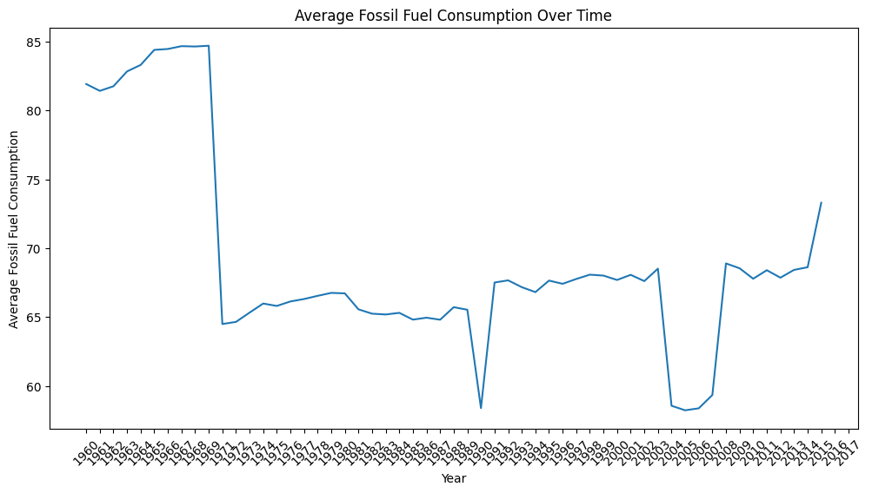

* Imagine a line showing how much fossil fuel people used each year from 1960 to 2017. It started high in the early 60s, then dropped sharply around 1970 and again around 1990. After bouncing around in the mid-range for a while, it dipped again around 2005 before generally increasing towards 2017. So, it shows some big drops and then a recent upward trend.

**2.Correlation Heatmap**

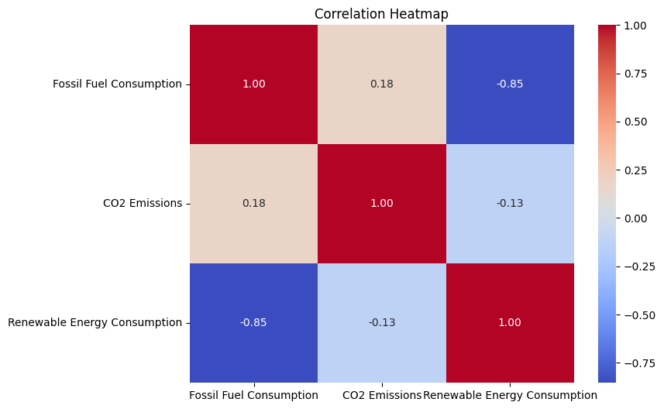

* Okay, imagine a colorful grid. This grid shows how related three things are: fossil fuel use, CO2 emissions, and renewable energy use.

Each square in the grid has a number and a color. The number tells us how strongly these things are linked (from -1 to 1), and the color makes it easy to see: red means a strong positive link (when one goes up, the other tends to go up too), blue means a strong negative link (when one goes up, the other tends to go down), and white means a weak link.

Looking at it quickly:

* **Fossil fuel use and CO2 emissions** have a light red color and a number close to 1 (0.18). This means they have a weak positive link – when fossil fuel use goes up a little, CO2 emissions tend to go up a little too.
* **Fossil fuel use and renewable energy use** have a strong blue color and a number close to -1 (-0.85). This means they have a strong negative link – when fossil fuel use goes up, renewable energy use tends to go down a lot, and vice versa.
* **CO2 emissions and renewable energy use** have a light blue color and a number close to 0 (-0.13). This means they have a weak negative link – when CO2 emissions go up a little, renewable energy use tends to go down a little.

So, the main takeaway is that using more fossil fuels is strongly tied to using less renewable energy. CO2 emissions are somewhat linked to both, but less strongly.

* 1. **Declining Fossil Fuel Use and Rising Renewables in the USA (2004-2023)**

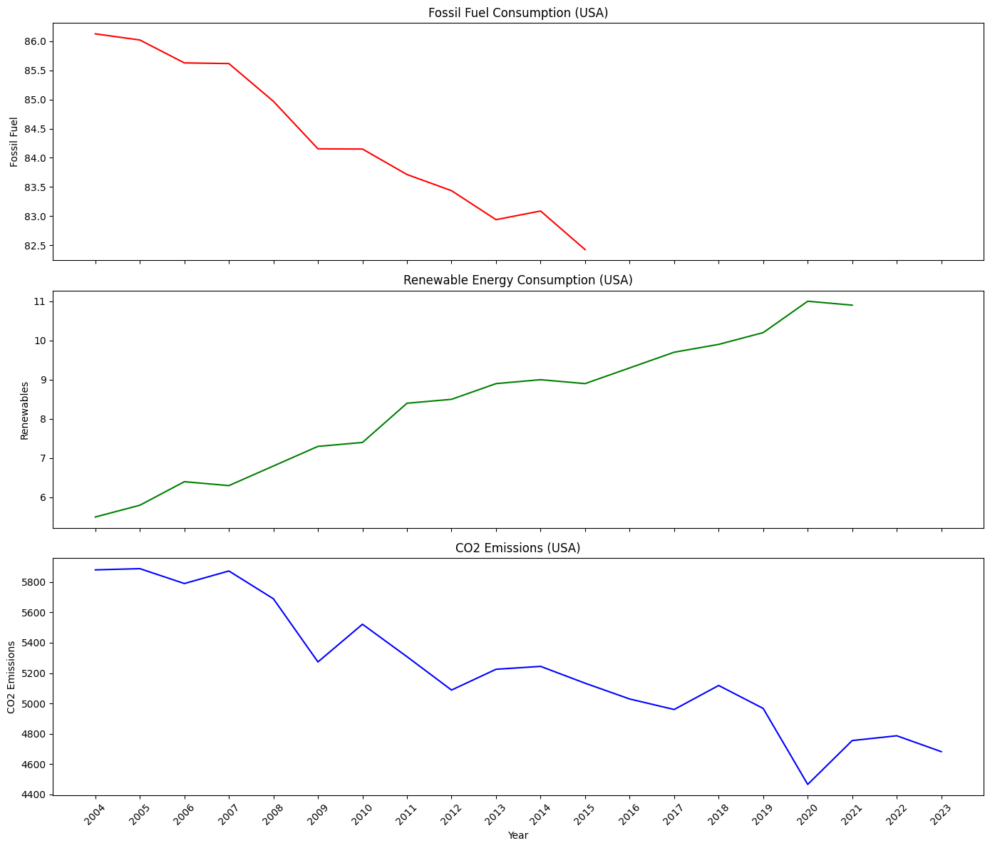

* The **top graph** has a red line, and it shows **fossil fuel use**. Notice how this red line is mostly going downwards over these years. This means the USA has generally been using less fossil fuels.
* The **middle graph** has a green line, and it shows **renewable energy use**. This green line is mostly going upwards. This tells us that the USA has been using more and more renewable energy like solar and wind.
* The **bottom graph** has a blue line, and it shows **CO2 emissions**. This line goes up and down a bit, but overall, it has a slight downward trend, especially towards the end. This suggests that the amount of carbon dioxide released into the air has generally decreased a little over this period.

So, in short: the USA has been using less fossil fuels and more renewable energy, and as a result, their CO2 emissions have generally been trending downwards.

**4.Tableau Dashboard(Link at the end)**

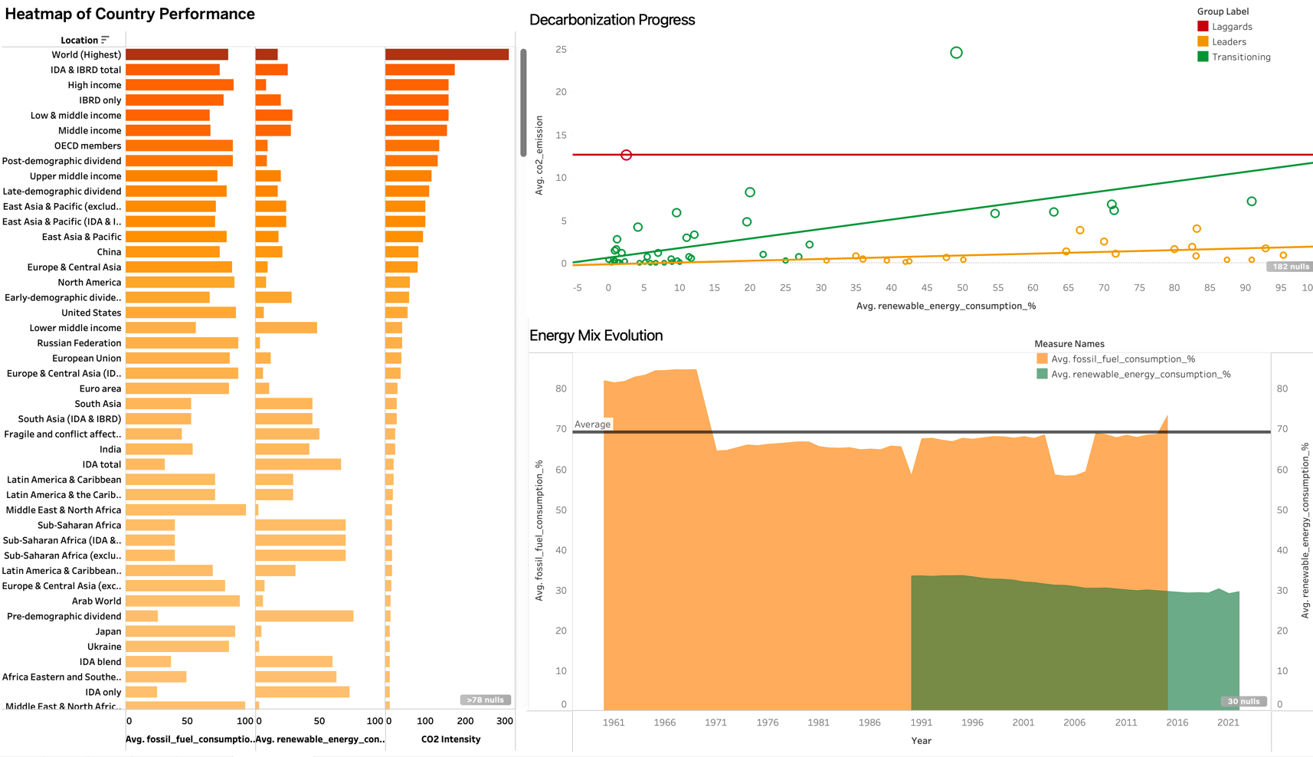

This dashboard provides a multi-faceted view of global and regional decarbonization progress.

* **Left Panel: "Heatmap of Country Performance"** displays a horizontal bar chart comparing various global regions and income groups across three key metrics: average fossil fuel consumption (Avg. fossil_fuel_consumption, %), average renewable energy consumption (Avg. renewable_energy_consumption, %), and CO2 intensity. The length and color intensity of the bars indicate the relative performance. For instance, "World (Highest)" shows high fossil fuel consumption and CO2 intensity, while regions with longer orange bars for renewable energy consumption demonstrate a greater reliance on cleaner sources.
* **Top Right Panel: "Decarbonization Progress"** is a scatter plot visualizing the relationship between average renewable energy consumption (%) on the x-axis and average CO2 intensity (kg CO2/USD GDP) on the y-axis for various countries. The color of the circles indicates a "Group Setter" (Leaders in green, Laggards in red, Transitioning in yellow). A downward sloping trend line in green suggests that, generally, higher renewable energy consumption is associated with lower CO2 intensity. The red horizontal line potentially marks a significant CO2 intensity threshold.
* **Bottom Right Panel: "Energy Mix Evolution"** is a stacked area chart showing the change in average fossil fuel consumption (%) (orange area, left y-axis) and average renewable energy consumption (%) (green area, right y-axis) over time (from 1961 to 2021). The total height of the stacked areas represents the total energy consumption mix. An overlaid horizontal line likely indicates an average fossil fuel consumption level. This chart clearly illustrates the historical shift in the energy mix, with fossil fuels dominating initially and renewable energy gradually increasing its share.

**Key Insights:**

* **Trade-offs exist:** The heatmap suggests an inverse relationship between fossil fuel and renewable energy consumption across different regions.
* **Renewables drive decarbonization:** The scatter plot indicates a general trend where higher renewable energy adoption correlates with lower CO2 intensity, highlighting their role in decarbonization.
* **Historical energy shift:** The stacked area chart demonstrates a long-term, albeit gradual, transition towards a more diversified energy mix with increasing renewable energy and a relative decrease in fossil fuel dependence in the observed period.
* **Regional disparities:** The heatmap reveals significant differences in energy consumption patterns and CO2 intensity across various geographies and income levels, emphasizing the uneven pace of decarbonization globally.

**5.Additional Graphs**

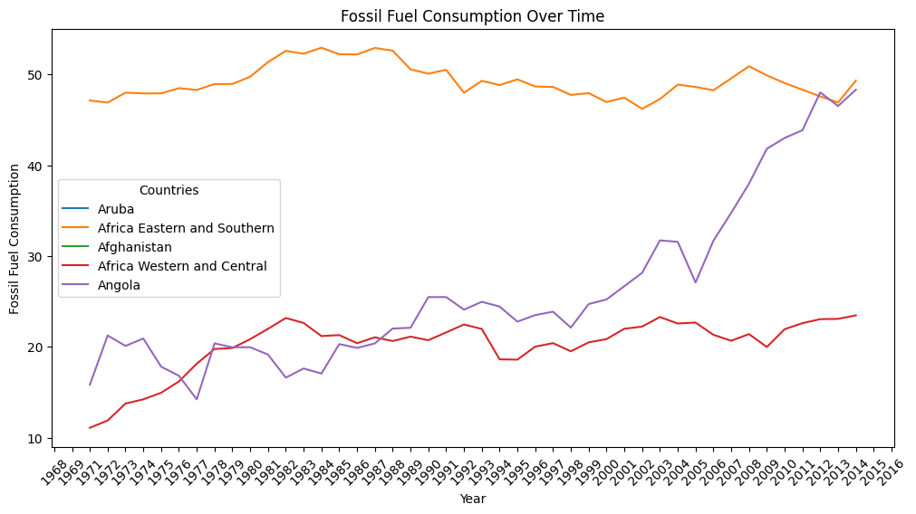

* The above line graph shows how fossil fuel consumption has changed over time (from 1968 to 2014) for five different entities: Aruba, Africa Eastern and Southern, Afghanistan, Africa Western and Central, and Angola. It shows that most of the countries out of the 5 above have increased the use of Fossil Fuels over the time period. Each entity is represented by a different colored line, making it easy to compare their individual trends in fossil fuel use across the years. The y-axis shows the percentage of fossil fuel consumption, while the x-axis displays the years.

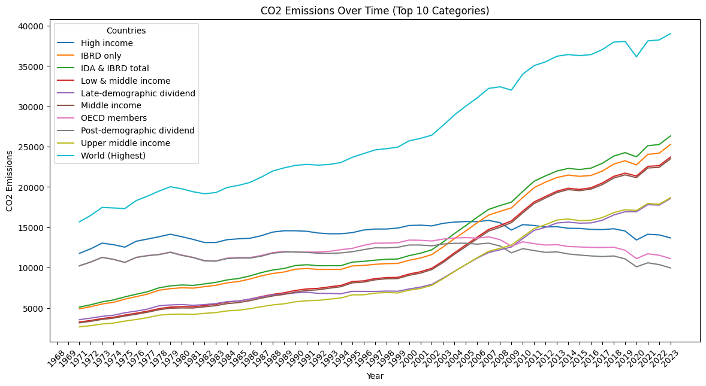

* The above line graph tracks CO2 emissions over time (1968-2023) for the top 10 categories, which are groupings of countries based on income level or economic status (e.g., High income, Low & middle income, OECD members, World (Highest)). Each category has its own colored line, allowing for a visual comparison of how their CO2 emissions have evolved across the years. The y-axis represents CO2 emissions, and the x-axis shows the years. The title indicates that these are the categories with the highest overall CO2 emissions during this period.

Summary:

We started by observing a trend of **average global fossil fuel consumption** that saw highs in the early 1960s, significant drops in the 1970s and around 1990, and a more recent upward trend towards 2017.

Then, a **correlation heatmap** showed us that higher fossil fuel use tends to be strongly linked to lower renewable energy use, while the relationship with CO2 emissions is weaker but still positive.

Next, we examined **trends specifically for the USA (2004-2023)**, where fossil fuel consumption has generally decreased, renewable energy use has increased, and CO2 emissions have shown a slight downward trend.

A more complex **dashboard** provided a global perspective, revealing that higher renewable energy consumption is generally associated with lower CO2 intensity, and it illustrated the historical shift towards a more diverse energy mix with increasing renewables, though with significant regional differences in energy consumption and decarbonization progress.

Finally, two line graphs showed **fossil fuel consumption (1968-2014)** and **CO2 emissions (1968-2023)** over time for various country groupings, highlighting the different trajectories of energy use and emissions across these entities.

**In short, the data collectively suggests a complex global energy landscape with a general (though uneven) trend towards reduced fossil fuel dependence and increasing renewable energy, which is influencing CO2 emissions. However, significant variations exist across different regions and income levels.**

* Tableau Dashboard link: https://public.tableau.com/app/profile/trevin.rodrigo/viz/GlobalEnergyTransitionClimateImpact/GlobalEnergyTransitionClimateImpact