**Do You Like Chipotle?**

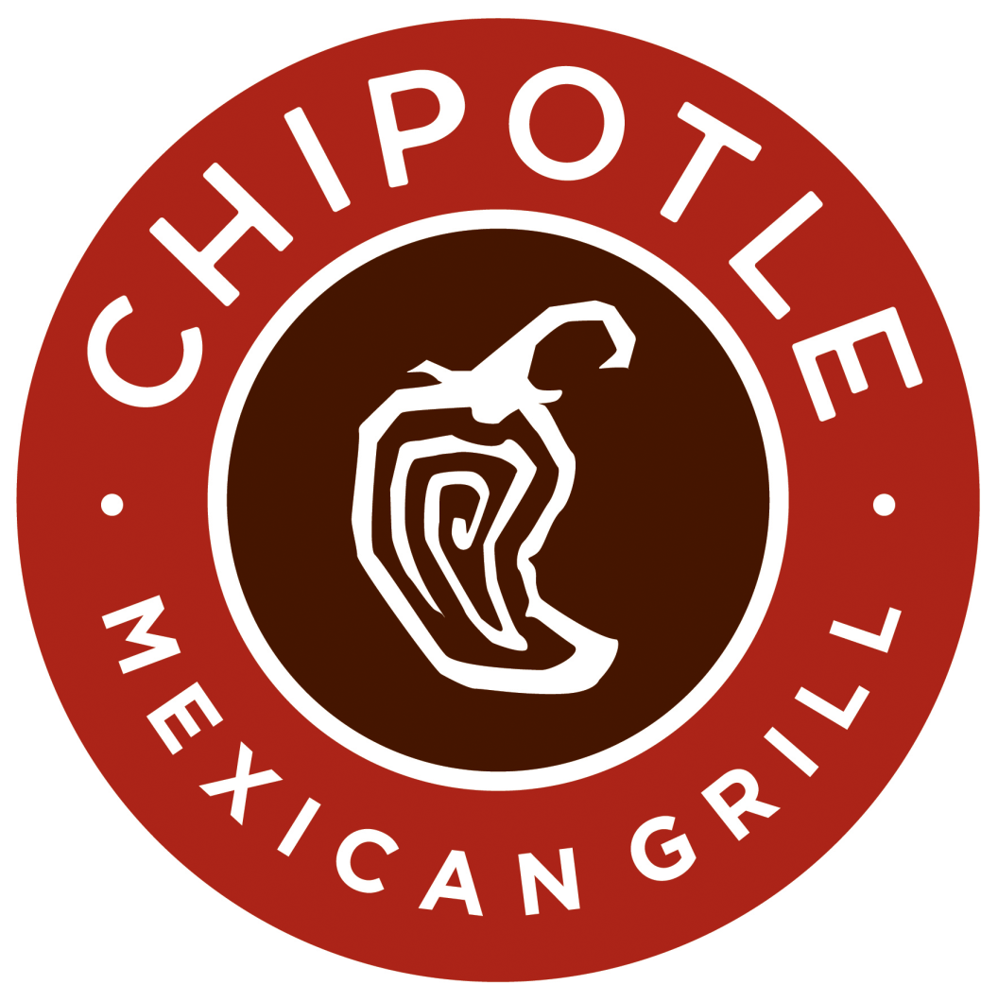

**Pick your order up at CMU**

Don’t you wish you could save your time and not walk all the way to Pitt but still enjoy Chipotle? Now you can, simply tell us what you want from chipotle by the end of the day on Thursday September 20th and we will have it ready for you to pick up by Doherty Hall on Friday between 11:45am and 1:00pm