**Abstract**

Climate change may alter how organisms disperse; this may in turn affect how species spread across a landscape, making management more challenging or requiring changes in current management practices. Wind dispersed plants have emerged as a useful study system for investigating the effects of climate change on dispersal; while many previous studies in this system have successfully quantified wind dispersal through a variety of different models, they often assume that propagules are released from only a single point on an individual. This simplifying assumption, while useful, has the potential to over- or under-estimate dispersal. Here, we investigate the effects of climate change on dispersal and examine how projected dispersal patterns change when accounting for all sources of seed release on a plant. Using the wind-dispersed invasive thistles Carduus nutans and Carduus acanthoides, we quantify temperature-driven shifts in the entire distribution of flower heights using a passive warming experiment, and then model the effects of these flower height shifts on dispersal using the Wald analytical long distance (WALD) dispersal model. We also compare dispersal distances considering the entire distribution of flower heights to those under the common practice of using only maximum seed release height.

An approximately 0.6 °C increase in ambient temperature increased C. nutans mean and maximum flower heights by 11.88 cm (12.46%) and 12.82 cm (12.12%), respectively; larger mean and maximum flower height increases of 21.30 cm (26.44%) and 31.90 cm (36.84%) were observed in C. acanthoides. Seeds from warmed individuals were more likely to exceed a given dispersal distance than those from their unwarmed counterparts; warmed C. nutans and C. acanthoides seeds were on average 1.83 and 2.70 times as likely, respectively, to travel 50 m or more, with this disparity becoming stronger at longer dispersal distances. Long-distance dispersal events were less likely to occur when kernels considered the entire flower height distribution rather than assuming all seeds are released from the maximum height, as is commonly assumed. This has especially important implications in models of population spread, as such models are often sensitive to long-distance dispersal events so that overestimating the frequency of these events may overestimate spread rates.

**Introduction**

Climate change poses a significant challenge to the management of invasive species by possibly altering how they grow, reproduce, and spread (Mainka and Howard 2010, Ziska *et al.* 2011). As a result, current invasive species management strategies may no longer match the phenology of their target species and become less effective or no longer suitable in future climates (Hellmann *et al.* 2008). Concerns regarding invasive species control in future climates have become widespread among natural resource managers; a recent survey by Beaury *et* *al.* (2020) reports that many natural resource managers worry about how climate change will affect invasive species management, and 65% of managers have incorporated climate change into their management plans.

One particular challenge for managers of invasive species lies within how climate change affects dispersal, as dispersal governs where and how quickly invasive species populations spread. Knowledge of how climate change affects dispersal patterns is especially important in invasive plants, given the short window of their life cycle in which movement is possible since the propagule stage is the only motile part of an otherwise mostly sessile existence (Teller *et al*. 2016). In invasive plants, climate change has the potential to alter dispersal patterns by affecting factors that directly or indirectly control dispersal; examples include structure of the maternal plant from which seeds come, the number of seeds produced, the shape and size of the seeds themselves, and vectors of propagule dispersal such as wind or water (Johnson *et al*. 2019; Snell *et al*. 2019). Knowledge of how climate change may alter movement and dispersal patterns would be useful in helping invasive species managers improve predictions of spread speeds and make more informed management decisions (Caplat *et al*. 2013), ultimately saving time and money in the process.

In recent years, wind-dispersed plants have emerged as a study system for investigating how climate change may affect dispersal, with experiments and modelling helping illuminate possible shifts in dispersal patterns. For example, Kuparinen *et al*. (2009) use micrometeorological data to show that increased air temperatures can lead to higher rates of long-distance dispersal for a variety of plant types in a southern Finland boreal forest; Zhang *et al*. (2011) use a combination of field experiments and models to examine how increases in temperature affect reproduction and seed dispersal distances in the invasive thistle *Carduus nutans*, as well as how this leads to an increased rate of population spread in the northeastern United States; and Bullock *et al*. (2012) model how predicted changes in wind speed later in this century would affect the spread of flora in the British Isles. The majority of dispersal studies on wind-dispersed plants model the process as occurring from a single release height, often the maximum observed seed release height; that is, for dispersal on the level of the individual plant, all seeds are assumed to be released from a single point on that plant. However, wind-dispersed plants usually have multiple reproductive structures and thus multiple points of seed release that are not necessarily the same height above the ground. Seed release height is an important factor in modelling dispersal distances (e.g. Katul *et al*. 2005; Kuparinen *et al*. 2006; Nathan *et al*. 2011) because it will determine how long a seed is suspended in air and thus how far it is carried by wind; thus, by accounting for the distribution of seed release heights within individuals instead of using just the maximum height, more representative dispersal estimates can be constructed.

Here, we present an approach combining field experiments and dispersal modelling to assess effects of climate change on dispersal when accounting for multiple release heights within individuals. Given there are numerous aspects to climate change, we focus our investigation on increases in mean temperature, and seek to examine the effects of increased growing temperature on dispersal while accounting for the entire distribution of seed release heights rather than a point source at the maximum. In this investigation, we address three questions of interest. First, how does increased temperature affect the distribution of flower heights (and thus seed release heights)? Second, how does increased temperature affect dispersal distances over the distribution of flower heights? And third, are there differences in dispersal when using the distribution of seed release heights rather than the maximum height?

**Methods and Materials**

***Study******Species***

*Carduus nutans* L. (“musk thistle” or “nodding thistle”) and *Carduus acanthoides* L. (“plumeless thistle”) are two closely-related invasive thistles in the Asteraceae family. Both species germinate in autumn or spring and bolt in the early summer (Zhang *et al*. 2012), reproduce exclusively by seed, and have monocarpic perennial life cycles that have been demonstrated to shift from biennial towards annual under warming conditions (Keller and Shea, *in press*). While sharing similar life histories, the two species display significant morphological differences in dispersal-related characteristics such as number of flower heads, flower head size, number of seeds produced per flower head, and distribution of flower heads across an individual (Desrochers *et al*. 1988). These invasive thistles have high reproductive potential and are a considerable agricultural pest since they thrive in pastures, are unpalatable to most grazers, and decrease pasture productivity (Trumble and Kok 1982). In addition to pastures, these thistles occur in other highly disturbed areas such as drainages and roadsides. Both species can be found across the U.S. and often co-occur (Allen and Shea 2006), and are listed as noxious weeds in several states (Skinner *et al.* 2000).

Wind serves as the primary dispersal vector in both *C. nutans* and *C. acanthoides*. Seeds of both species display a prominent pappus that, when remaining attached to the achene, increases hang time and makes it possible for seeds to be carried at long distances; Skarpaas and Shea (2007) detected seeds travelling away from their parent plants at distances up to 96 m for *C. nutans* and 16 m for *C. acanthoides*, though longer distances are likely possible in extreme wind events. The achenes and pappi of both species differ in size; *C. nutans* seedsare on average larger than those of *C. acanthoides* (Skarpaas *et al*. 2011), and there is between- and within-species variation in plume loading and plume density that generates variation in seed terminal velocity. Dispersal of these seeds also extends beyond wind, with paths of secondary dispersal possible after seeds have hit the ground. Seeds from both species contain elaiosomes that are thought to play a role in ant-mediated dispersal (Pemberton and Irving 1990), and have been documented to be moved by insects and small mammals (Jongejans *et al*. 2015). Here, we focus exclusively on wind-driven primary dispersal.

***Experimental Design***

Experiments measuring the effects of warming on the distribution of *C. nutans* and *C. acanthoides* flower heights were conducted a field experiment at the Russell E. Larson Agricultural Research Farm in Rock Springs, Pennsylvania. The field site contains rocky soils and lies at the base of a mountain ridge dominated by deciduous forest, and was previously a pasture. To simulate the disturbed habitats in which these thistles are often found, aboveground vegetation at the site was killed using an offset disk, and the soil surface was levelled using a roller harrow before any planting occurred.

After being started in a greenhouse for approximately one month, thistle rosettes for each species were planted in groups of four, each in a 2m x 2m plot; a total of 272 *C. nutans* and 136 *C. acanthoides* were planted in 17 blocks, with each block consisting of 16 *C. nutans* and 8 *C. acanthoides*. To simulate increased ambient temperatures, 100 *C. nutans* and 48 *C. acanthoides* were randomly chosen to receive a fibreglass open-top chambers (OTC) shortly after being planted in the field. These OTCs simulate an approximately 0.6 °C increase in temperature while not affecting soil moisture or snow depth (Zhang *et al*. 2011) and are built to the specifications listed in the International Tundra Experiment Manual (Molau and Mølgaard 1996). All OTCs were held into the ground with rebar and remained in place for the remainder of the thistle life cycle. Over the course of the experiment, plot vegetation was trimmed to prevent confounding with different vegetation interactions while simulating growth after invasion into newly disturbed ground; however, vegetation was not trimmed in winter due to snow cover.

As flowers began to set seed, mesh pollen bags were used to keep seeds from escaping into the environment while still allowing the flowers access to air, water, and sunlight. Once any particular individual a) desiccated, b) collapsed under its own weight, or c) stopped producing new flower buds, the heights of all flowers on the individual were measured before cutting the plant down. In instances where pollen bags caused flowers to droop, the erect height of the flower was measured. All flower height measurements were taken over the course of three weeks, starting in mid-July and terminating in early August.

***Dispersal model***

Dispersal was modelled using the Wald analytical long-distance dispersal (WALD) model. This mechanistic model, based in fluid dynamics, predicts the distribution of propagule dispersal distances by wind and has been shown to be a suitable approximation of empirically determined kernels for wind-dispersed plants (Katul et al. 2005; Skarpaas and Shea 2007). The dispersal kernel generated under this model is an inverse Gaussian distribution of the form

$$p\left(r\right)={\left(\frac{λ^{'}}{2πr^{3}}\right)}^{1/2}\exp\left[-\frac{λ^{'}{\left(r-μ^{'}\right)}^{2}}{2{μ^{'}}^{2}r}\right]$$

where $r$ denotes a given dispersal distance. The location parameter $λ^{'}={(H/σ)}^{2}$ and scale parameter $μ^{'}=HU/F$ are functions of seed release height $H$, wind speed $U$, seed terminal velocity $V$, and turbulent flow parameter $σ$.

To correct wind speed measurements for use at any seed release height rather than at measurement height, we used the same procedure as Skarpaas and Shea (2007) and Bullock *et al*. (2012) and integrate wind speed over the logarithmic wind profile

$$U= \frac{1}{H}\int_{d+ z_{0}}^{H}{\frac{u^{*}}{K}\log\left(\frac{z-d}{z_{0}}\right)dz}$$

where $u^{*}$ is the friction velocity, $z$ is the height above the ground, d is the zero-plane displacement, $z_{0}$ is the roughness length, and $K$ is the von Karman constant. More information about calculating zero-plane displacement and roughness length can be found in Raupach (1994); suitable approximations of these values in grassland environments can be found in Wiernga (1993). Calculations for $σ$ and $u^{*}$ were performed using the methods in Skarpaas and Shea (2007).

While the WALD model can be evaluated using mean measurements of wind speed and terminal velocity, failure to account for variation in these parameters may over- or under- estimate dispersal. To better account for the effects of variation in wind speed and terminal velocity we integrate over them using the same methods as Skarpaas and Shea (2007), who have applied this technique to both *C. nutans* and *C. acanthoides*, to get a modified kernel

$$K\left(r\right)=\iint{p\left(F\right)p\left(U\right)p\left(r\right) dFdU}$$

where $p(F)$ and $p(U)$ are the probability density functions for seed terminal velocity and wind speed, respectively. Wind speed data were obtained from a local weather station, and the distribution of terminal velocities from seed drop experiments in a laboratory setting. We build upon this by also integrating across the distribution of seed release heights $p(H)$ from the field experiment such that

$$K\left(r\right)=\iiint{p\left(F\right)p\left(U\right)p(H)p\left(r\right) dFdUdH}$$

so the new dispersal kernel accounts for variation in wind speed and seed terminal velocity as well as all of the different flower heights that seeds can be released from (Skarpaas *et al*. 2011). Note that unlike in previous *C. nutans* and *C. acanthoides* studies, $p(H)$ represents the distribution of all flower heights, not just the maxima.

***Statistical Analyses***

All modelling and statistical analyses were performed in R (R Development Core Team, 2009). For each species, the effect of warming treatment on mean plant height was assessed using a mixed-effects linear model in the package lme4 (Bates *et al*. 2012) with treatment as a fixed effect, and the block and row in which an individual was located as random effects. Shapiro-Wilks tests were used to assess normality of data and model residuals; Kolmogorov-Smirnov tests were used to assess the significance of differences between flower height distributions for warmed and unwarmed groups, as well as differences between dispersal kernels for warmed and unwarmed groups.

**Results**

***Flower Heights***

In both species, individuals that received warming treatments had taller flowers on average; an 11.88 cm, or 12.46%, increase in mean flower height was observed in *C. nutans* (linear mixed-effects model, n = 1404, $p<0.001$), while a 21.30 cm (26.44%) increase mean flower height was observed in *C. acanthoides* (linear mixed-effects model, n = 1519, $p<0.001$). The resulting increases in mean flower were associated with rightward shifts in the distributions of flower height (Figure 1), resulting in significant differences between the warmed and unwarmed flower height distributions for *C. nutans* (Kolmogorov-Smirnov test, $p<0.001$) and *C. acanthoides* (Kolmogorov-Smirnov test, $p<0.001$). Individuals that received warming treatments also geenrally displayed greater maximum flower heights; a 12.82 cm, or 12.12%, increase in mean maximum flower height was observed in *C. nutans* (linear mixed-effects model, n = 199, $p<0.001$), while a 31.90 cm (36.84%) increase mean maximum flower height was observed in *C. acanthoides* (linear mixed-effects model, n = 84, $p<0.001$).

***Dispersal: Warmed vs. Unwarmed***

Shifts in the distributions of flower height also resulted in different dispersal kernels between warmed and unwarmed individuals in each species (Figure 2). Dispersal kernels of warmed individuals displayed notably lower peaks and fatter tails compared those of unwarmed individuals, and were markedly different in both *C. nutans* (Kolmogorov-Smirnov test, $p<0.001$) and *C. acanthoides* (Kolmogorov-Smirnov test, $p<0.001$). The mean *C. nutans* dispersal distance experienced a 21.65% increase from 2.46 m to 2.99 m, while the mean *C. acanthoides* dispersal distance experienced a 38.66% increase from 1.94 m to 2.69 m (Table 1).

The frequency of longer-distance dispersal events was also affected by the warming-induced shift in flower height distribution. The mean 95th and 99th percentile dispersal distances for *C. nutans* were 8.36 m and 19.40 m respectively for unwarmed individuals, with a shift to 10.12 and 23.53 m for warmed individuals; for *C. acanthoides*, the mean 95th and 99th percentile dispersal distances were 6.58 m and 15.13 m respectively for unwarmed individuals, with a shift to 9.09 and 21.00 m for warmed individuals (Table 1). Warming also increased the probability that a seed would exceed a given distance, with this effect becoming more pronounced at higher dispersal distances (Figure 3); seeds warmed *C. nutans* and *C. acanthoides* were on average 1.80 and 2.83 times as likely, respectively, to travel 50 m as their unwarmed counterparts. Uncertainty in these relative frequencies of dispersal events also increases and becomes quite large at high dispersal distances, likely due to long-distance dispersal events becoming increasingly rare and difficult to capture in dispersal simulations.

***Dispersal: Maximum Height vs. Height Distribution***

Using the maximum flower height instead of the distribution of flower heights in the WALD dispersal model resulted in a significantly different dispersal kernel (Figure 4); this was evident for warmed *C. nutans*, unwarmed *C. nutans*, and warmed *C. acanthoides* (Kolmogorov-Smirnov test, $p<0.001$), with limited evidence for this pattern in unwarmed *C. acanthoides* (Kolmogorov-Smirnov test, $p=0.173$). The effects on the shape of the dispersal kernel when using the maximum flower height instead of the distribution of flower heights was similar to the effects of the warming treatment; lower peaks and fatter tails were present when using the maximum flower height, though comparing Figures 2 and 4 shows that the differences between the kernels are not as pronounced as the differences between the kernels when comparing warmed and unwarmed individuals.

The frequency of longer-distance dispersal events was also affected when using the maximum flower height instead of the flower height distribution. Using the maximum flower height increased mean 95th and 99th percentile dispersal distances across the four combinations of species and warming treatment (Table 2), though not by much in comparison to the differences between warmed and unwarmed treatment groups when using the entire flower height distribution. The probability of seeds exceeding a given dispersal distance increase also increases when using the maximum flower height (Figure 5) but again less so compared to differences between warmed and unwarmed treatments, though the massive increases in uncertainty are still present.

**Discussion**

Our results demonstrate that increases in temperature, which are expected in the wake of climate change across much of the geographical range *C. nutans* and *C. acanthoides*, can increase mean flower height and shift the distribution of flower heights in these two invasive thistles. Such changes in flower height generate dispersal kernel shifts and increase the distances that wind-dispersed seeds travel, especially along the right tail of the kernels. For *C. nutans*, our results are consistent with a similar study conducted by Zhang *et al*. (2011) that used the same warming treatments and observed similar changes in *C. nutans* dispersal and a 9% increase in maximum flower height, compared to the approximately 12.12% increase in maximum flower height that we measured. The 12.46% increase in mean flower height that we observed is similar to the increases in maximum flower height reported by both us and Zhang *et al*. We also demonstrate that using the maximum height rather than height distribution when modelling dispersal kernels may overestimate dispersal at higher dispersal distances; however, the resulting differences in dispersal patterns are smaller than the differences between control individuals and those receiving a warming treatment.

Warming-induced height increases are only one aspect of how climate change may affect dispersal patterns in wind-dispersed plants. For example, increases in air temperature may increase seed dispersal distances by increasing air turbulence (Kuparinen et al 2009). Shifts in wind speeds may shift dispersal patterns and the rates at which wind-dispersed species spread (Bullock *et al*. 2012), and increases in the frequency of extreme wind events may increase frequency of long-distance dispersal events (Soons et al 2004). Furthermore, even wind dispersal itself is only one aspect of overall dispersal, as these kinds of plants typically have multiple dispersal vectors that occur in parallel or series with wind dispersal (Rogers *et al*. 2019). Climate change may affect one or more dispersal vectors within a particular system, thus affecting the total dispersal kernel, or the probability distribution of dispersal distances when all dispersal vectors are taken into account.

Dispersal kernels like the ones in this study are often used to estimate the rate at which species spread, and are often included integrodifference and integral projection models of population spread (e.g. Kot et al. 1996; Neubert and Caswell 2000, Ellner and Rees 2006, Jongejans et al. 2011). These sorts of models can be highly sensitive to the right tails of dispersal kernels used in the model framework; population movement here can often be driven by a small handful of long-distance dispersal events (Kot et al. 1996; Clark et al. 1998, 2001). Because propagules dispersed long distance can escape density-dependent mortality (Janzen 1970; Connell 1971) from sources such as predation (Blundell and Peart 1998; Norghauer et al 2010) or infection by pathogens (Augspurger 1983; Augspurger and Kelly 1984), or because they can simply find more suitable habitat, they can experience increased fitness and make significant contributions to population growth and spread. If warming due to climate change increases the likelihood or magnitude of dispersal events in the right tail of the kernel as we have shown, it may have strong effects on spread rates, even if the aforementioned increases are somewhat modest. The information used to construct dispersal kernels can affect estimates of spread rates too. For example, Teller *et al*. (2016) demonstrate that *C. nutans* seeds from warmed maternal plants are more likely to be released from the seed head and that ignoring this can underestimate the rate of population spread by approximately 11%. Modelling dispersal using maximum flower height rather than the distribution of flower heights may overestimate spread rates since models using the maximum height will assume that seeds are released from higher above the ground than they actually are; seeds will then spend more time in the air and thus be carried further by wind, leading to an overrepresentation of longer dispersal distances.

Given the sensitivity of population spread models to long distance dispersal events, a better understanding of how to quantify long distance dispersal is necessary for more accurate measurements of population spread; this improved accuracy is especially important since climate change and increased temperatures may, as our study demonstrates, make long-distance dispersal more common and necessitate new management strategies for invasive species like *C. nutans* and *C. acanthoides*. However, quantifying long distance dispersal events can be quite challenging and comes with a large degree of uncertainty (Cain *et al*. 2000, Nathan *et al*. 2003, Nathan 2006). This is quite evident in Figures 3 and 5; as dispersal distance increases, the uncertainty greatly increases because rare long-distance dispersal events do not always show up in simulations with a limited number of replicates. Even with the approximately ten million dispersal events simulated in each figure panel, extremely rare long distance dispersal events may not even occur. This is also made difficult by the fact the accuracy of the WALD model used here becomes increasingly difficult to assess with increasing dispersal distance, and should thus be used with caution especially in instances where it is challenging to empirically measure long distance dispersal events (Skarpaas and Shea 2007).

Understanding and quantifying dispersal is crucial for understanding how organisms move across a landscape, as it is the dispersal process that drives this movement. This is especially true for highly sessile organisms such as plants, where the propagule stage is usually the only part of the life cycle where movement occurs. Developing a better understanding of how climate change affects these dispersal patterns will be important for better managing invasive, and even native or endangered, plant species and better predicting how their populations will shift over the coming decades.

**References**

Allen, M. R., & Shea, K. (2006). Spatial segregation of congeneric invaders in central Pennsylvania, USA. Biological Invasions, 8(3), 509-521.

Augspurger, C.K., 1983. Seed dispersal of the tropical tree, Platypodium elegans, and the escape of its seedlings from fungal pathogens. The Journal of Ecology, pp.759-771.

Augspurger, C.K. and Kelly, C.K., 1984. Pathogen mortality of tropical tree seedlings: experimental studies of the effects of dispersal distance, seedling density, and light conditions. Oecologia, 61(2), pp.211-217.

Bates, D., Maechler, M., Bolker, B., Walker, S., Christensen, R. H. B., Singmann, H., ... & Scheipl, F. (2012). Package ‘lme4’. CRAN. R Foundation for Statistical Computing, Vienna, Austria.

Beaury, E. M., Fusco, E. J., Jackson, M. R., Laginhas, B. B., Morelli, T. L., Allen, J. M., Pasquarella, V. J., & Bradley, B. A. (2020). Incorporating climate change into invasive species management: insights from managers. Biological Invasions, 22(2), 233-252.

Blundell, A.G. and Peart, D.R., 1998. Distance-dependence in herbivory and foliar condition for juvenile Shorea trees in Bornean dipterocarp rain forest. Oecologia, 117(1-2), pp.151-160.

Bullock, J. M., White, S. M., Prudhomme, C., Tansey, C., Perea, R., & Hooftman, D. A. (2012). Modelling spread of British wind‐dispersed plants under future wind speeds in a changing climate. Journal of Ecology, 100(1), 104-115.

Cain, M.L., Milligan, B.G. and Strand, A.E., 2000. Long‐distance seed dispersal in plant populations. American journal of botany, 87(9), pp.1217-1227.

Caplat, P., Cheptou, P. O., Diez, J., Guisan, A., Larson, B. M., Macdougall, A. S., ... & Buckley, Y. M. (2013). Movement, impacts and management of plant distributions in response to climate change: insights from invasions. Oikos, 122(9), 1265-1274.

Clark, J.S., Fastie, C., Hurtt, G., Jackson, S.T., Johnson, C., King, G.A., Lewis, M., Lynch, J., Pacala, S., Prentice, C. and Schupp, E.W., 1998. Reid's paradox of rapid plant migration: dispersal theory and interpretation of paleoecological records. BioScience, 48(1), pp.13-24.

Clark, J.S., Lewis, M. and Horvath, L., 2001. Invasion by extremes: population spread with variation in dispersal and reproduction. The American Naturalist, 157(5), pp.537-554.

Connell, J.H., 1971. On the role of natural enemies in preventing competitive exclusion in some marine animals and in rain forest trees. Dynamics of populations, 298, p.312.

Desrochers, AM, Bain, JF, & Warwick, SI (1988). The Biology of Canadian Weeds.: 89. Carduus nutans L. and Carduus acanthoides L. Canadian Journal of Plant Science , 68 (4), 1053-1068.

Ellner, S.P. and Rees, M., 2006. Integral projection models for species with complex demography. The American Naturalist, 167(3), pp.410-428.

Hellmann, J. J., Byers, J. E., Bierwagen, B. G., & Dukes, J. S. (2008). Five potential consequences of climate change for invasive species. Conservation biology, *22*(3), 534-543.

Janzen, D.H., 1970. Herbivores and the number of tree species in tropical forests. The American Naturalist, 104(940), pp.501-528.

Johnson, J. S., Cantrell, R. S., Cosner, C., Hartig, F., Hastings, A., Rogers, H. S., ... & Pufal, G. (2019). Rapid changes in seed dispersal traits may modify plant responses to global change. AoB Plants, 11(3), plz020.

Jongejans, E., Shea, K., Skarpaas, O., Kelly, D. and Ellner, S.P., 2011. Importance of individual and environmental variation for invasive species spread: a spatial integral projection model. Ecology, 92(1), pp.86-97.

Jongejans, E., Silverman, E. J., Skarpaas, O., & Shea, K. (2015). Post-dispersal seed removal of Carduus nutans and C. acanthoides by insects and small mammals. Ecological research, 30(1), 173-180.

Katul, G. G., Porporato, A., Nathan, R., Siqueira, M., Soons, M. B., Poggi, D., ... & Levin, S. A. (2005). Mechanistic analytical models for long-distance seed dispersal by wind. The American Naturalist, 166(3), 368-381.

Keller and Shea. *In press*.

Kot, M., Lewis, M.A. and van den Driessche, P., 1996. Dispersal data and the spread of invading organisms. Ecology, 77(7), pp.2027-2042.

Kuparinen, A. (2006). Mechanistic models for wind dispersal. Trends in Plant Science, 11(6), 296-301.

Kuparinen, A., Katul, G., Nathan, R., & Schurr, F. M. (2009). Increases in air temperature can promote wind-driven dispersal and spread of plants. Proceedings of the Royal Society B: Biological Sciences, 276(1670), 3081-3087.

Mainka, S. A., & Howard, G. W. (2010). Climate change and invasive species: double jeopardy. Integrative Zoology, 5(2), 102-111.

Molau U, P. Mølgaard P (1996). International Tundra Experiment Manual. Danish Polar Centre, Copenhagen.

Nathan, R., Perry, G., Cronin, J.T., Strand, A.E. and Cain, M.L., 2003. Methods for estimating long‐distance dispersal. Oikos, 103(2), pp.261-273.

Nathan, R., 2006. Long-distance dispersal of plants. Science, 313(5788), pp.786-788.

Nathan, R., Katul, G. G., Bohrer, G., Kuparinen, A., Soons, M. B., Thompson, S. E., ... & Horn, H. S. (2011). Mechanistic models of seed dispersal by wind. Theoretical Ecology, 4(2), 113-132.

Neubert, M.G. and Caswell, H., 2000. Demography and dispersal: calculation and sensitivity analysis of invasion speed for structured populations. Ecology, 81(6), pp.1613-1628.

Norghauer, J.M., Grogan, J., Malcolm, J.R. and Felfili, J.M., 2010. Long-distance dispersal helps germinating mahogany seedlings escape defoliation by a specialist caterpillar. Oecologia, 162(2), pp.405-412.

Pemberton, R. W., & Irving, D. W. (1990). Elaiosomes on weed seeds and the potential for myrmecochory in naturalized plants. Weed Science, 615-619.

R Development Core Team (2009) R: A language and environment for statistical computing. R Foundation for Statistical Computing, Vienna, Austria.

Raupach, M. R. (1994). Simplified expressions for vegetation roughness length and zero-plane displacement as functions of canopy height and area index. Boundary-layer meteorology, 71(1), 211-216.

Rogers, H.S., Beckman, N.G., Hartig, F., Johnson, J.S., Pufal, G., Shea, K., Zurell, D., Bullock, J.M., Cantrell, R.S., Loiselle, B. and Pejchar, L., 2019. The total dispersal kernel: a review and future directions. AoB Plants, 11(5), p.plz042.

Skarpaas, O., & Shea, K. (2007). Dispersal patterns, dispersal mechanisms, and invasion wave speeds for invasive thistles. The American Naturalist, 170(3), 421-430.

Skarpaas, O., Silverman, E. J., Jongejans, E., & Shea, K. (2011). Are the best dispersers the best colonizers? Seed mass, dispersal and establishment in Carduus thistles. Evolutionary Ecology, 25(1), 155-169.

Skinner, K., Smith, L., & Rice, P. (2000). Using noxious weed lists to prioritize targets for developing weed management strategies. Weed Science, 48(5), 640-644.

Snell, R.S., Beckman, N.G., Fricke, E., Loiselle, B.A., Carvalho, C.S., Jones, L.R., Lichti, N.I., Lustenhouwer, N., Schreiber, S.J., Strickland, C. and Sullivan, L.L., 2019. Consequences of intraspecific variation in seed dispersal for plant demography, communities, evolution and global change. AoB Plants, 11(4), p.plz016.

Soons, M.B., Nathan, R. and Katul, G.G., 2004. Human effects on long‐distance wind dispersal and colonization by grassland plants. Ecology, 85(11), pp.3069-3079.

Teller, B. J., Zhang, R., & Shea, K. (2016). Seed release in a changing climate: initiation of movement increases spread of an invasive species under simulated climate warming. Diversity and Distributions, 22(6), 708-716.

Trumble, J.T. and Kok, L.T., 1982. Integrated pest management techniques in thistle suppression in pastures of North America. Weed Research, 22(6), pp.345-359.

Wiernga, J. (1993). Representative roughness parameters for homogeneous terrain. Boundary-Layer Meteorology, 63(4), 323-363.

Zhang, R., Jongejans, E., & Shea, K. (2011). Warming increases the spread of an invasive thistle. PLoS One, 6(6), e21725.

Zhang, R., Post, E., & Shea, K. (2012). Warming leads to divergent responses but similarly improved performance of two invasive thistles. Population ecology, 54(4), 583-589.

Ziska, L. H., Blumenthal, D. M., Runion, G. B., Hunt, E. R., & Diaz-Soltero, H. (2011). Invasive species and climate change: an agronomic perspective. *Climatic Change*, *105*(1-2), 13-42.

**Table 1**. Select dispersal statistics comparing warmed and unwarmed outcomes for *C. nutans* (“CN”) and *C. acanthoides* (“CA”). Values are given for the mean and lower/upper values of the 95% bootstrap interval (BI), and are rounded to the nearest hundredth.

|  |  |  |  |  |
| --- | --- | --- | --- | --- |
|  | | **95% BI Lower** | **Mean** | **95% BI Upper** |
| **Mean dispersal distance (m)** | |  |  |  |
| CN | Unwarmed | 2.30 | 2.46 | 2.63 |
|  | Warmed | 2.80 | 2.99 | 3.20 |
| CA | Unwarmed | 1.81 | 1.94 | 2.08 |
|  | Warmed | 2.52 | 2.69 | 2.86 |
|  | | | | |
| **95th percentile dispersal distance (m)** | |  |  |  |
| CN | Unwarmed | 7.72 | 8.36 | 9.01 |
|  | Warmed | 9.36 | 10.12 | 10.89 |
| CA | Unwarmed | 6.11 | 6.58 | 7.08 |
|  | Warmed | 8.44 | 9.09 | 9.73 |
|  | | | | |
| **99th percentile dispersal distance (m)** | |  |  |  |
| CN | Unwarmed | 17.54 | 19.41 | 21.56 |
|  | Warmed | 21.15 | 23.53 | 26.40 |
| CA | Unwarmed | 13.66 | 15.13 | 16.83 |
|  | Warmed | 18.96 | 21.00 | 23.23 |
|  | | | | |
| **50-m warmed/unwarmed risk ratio** | |  |  |  |
| CN |  | 0.72 | 1.80 | 3.93 |
| CA |  | 0.88 | 2.83 | 7.63 |

**Table 2**. Select dispersal statistics comparing warmed and unwarmed outcomes for *C. nutans* (“CN”) and *C. acanthoides* (“CA”). Values are given for the mean and lower/upper values of the 95% bootstrap interval (BI), and are rounded to the nearest hundredth.

|  |  |  |  |  |  |
| --- | --- | --- | --- | --- | --- |
|  | | | **95% BI Lower** | **Mean** | **95% BI Upper** |
| **Mean dispersal distance (m)** | | |  |  |  |
| CN | Height Dist. | Unwarmed | 2.29 | 2.46 | 2.64 |
|  |  | Warmed | 2.79 | 2.99 | 3.19 |
|  | Max. Height | Unwarmed | 2.59 | 2.77 | 2.97 |
|  |  | Warmed | 3.13 | 3.33 | 3.54 |
| CA | Height Dist. | Unwarmed | 1.82 | 1.94 | 2.07 |
|  |  | Warmed | 2.53 | 2.69 | 2.86 |
|  | Max. Height | Unwarmed | 1.96 | 2.10 | 2.25 |
|  |  | Warmed | 3.08 | 3.25 | 3.41 |
|  | | | | | |
| **95th percentile dispersal distance (m)** | | |  |  |  |
| CN | Height Dist. | Unwarmed | 7.72 | 8.38 | 9.09 |
|  |  | Warmed | 9.40 | 10.13 | 10.92 |
|  | Max. Height | Unwarmed | 8.74 | 9.41 | 10.06 |
|  |  | Warmed | 10.44 | 11.26 | 12.08 |
| CA | Height Dist. | Unwarmed | 6.11 | 6.58 | 7.08 |
|  |  | Warmed | 8.43 | 9.10 | 9.74 |
|  | Max. Height | Unwarmed | 6.66 | 7.17 | 7.69 |
|  |  | Warmed | 10.22 | 10.91 | 11.61 |
|  | | | | | |
| **99th percentile dispersal distance (m)** | | |  |  |  |
| CN | Height Dist. | Unwarmed | 17.40 | 19.46 | 21.74 |
|  |  | Warmed | 21.18 | 23.54 | 26.04 |
|  | Max. Height | Unwarmed | 19.40 | 21.75 | 24.26 |
|  |  | Warmed | 23.36 | 26.05 | 28.89 |
| CA | Height Dist. | Unwarmed | 13.71 | 15.20 | 16.76 |
|  |  | Warmed | 18.72 | 21.01 | 23.34 |
|  | Max. Height | Unwarmed | 15.04 | 16.60 | 18.28 |
|  |  | Warmed | 22.73 | 25.13 | 27.72 |
|  | | | | | |
| **50-m max./dist. risk ratio** | | |  |  |  |
| CN |  | Unwarmed | 0.69 | 1.38 | 2.54 |
|  |  | Warmed | 0.58 | 1.47 | 3.11 |
| CA |  | Unwarmed | 0.80 | 1.71 | 3.36 |
|  |  | Warmed | 0.41 | 1.53 | 4.17 |

**Figure 1.** Distribution of flower heights, in the form of a probability density function, for *C. nutans* (A) and *C. acanthoides* (B) under the control and warming treatments. Solid lines indicate the mean values of the kernel for a given distance, and error bands indicate a 95% bootstrap interval on the mean.

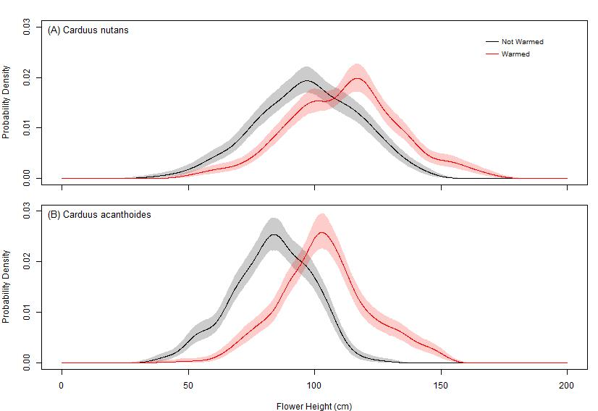

**Figure 2.** Dispersal kernels for *C. nutans* (A) and *C. acanthoides* (B) for the control and warming treatments. Solid lines indicate the mean values of the kernel for a given distance, and error bands indicate a 95% bootstrap interval on the mean.

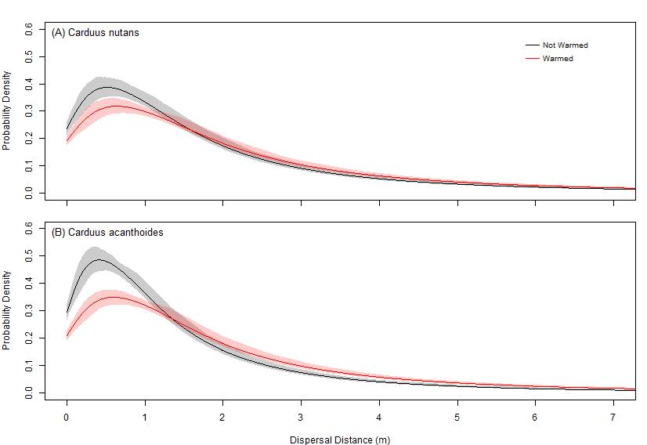

**Figure 3.** Relative risk of a seed exceeding a given distance when originating from a warmed maternal plant for *C. nutans* (A) and *C. acanthoides* (B), as measured by the ratio of complimentary cumulative distribution functions for the warmed and unwarmed groups. Solid lines indicate the mean values of relative risk for a given distance, while the dotted line indicate a relative risk of 1. Error bands indicate a 95% bootstrap interval on the mean.

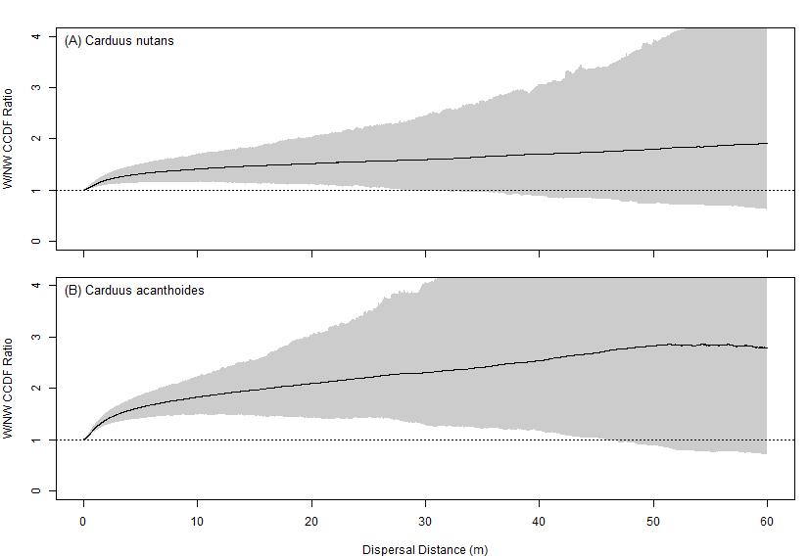

**Figure 4.** Probability density function of flower heights for unwarmed *C. nutans* (A), warmed *C. nutans* (B), unwarmed *C. acanthoides* (C), and warmed *C. acanthoides* (D), as measured by the ratio of complimentary cumulative distribution functions for the max height and distribution groups. Solid lines mean values of dispersal kernels generated using the entire distribution of flower heights, while the dotted lines represent mean values of dispersal kernels generated using only the maximum flower height; error bands indicate a 95% bootstrap interval on the mean.

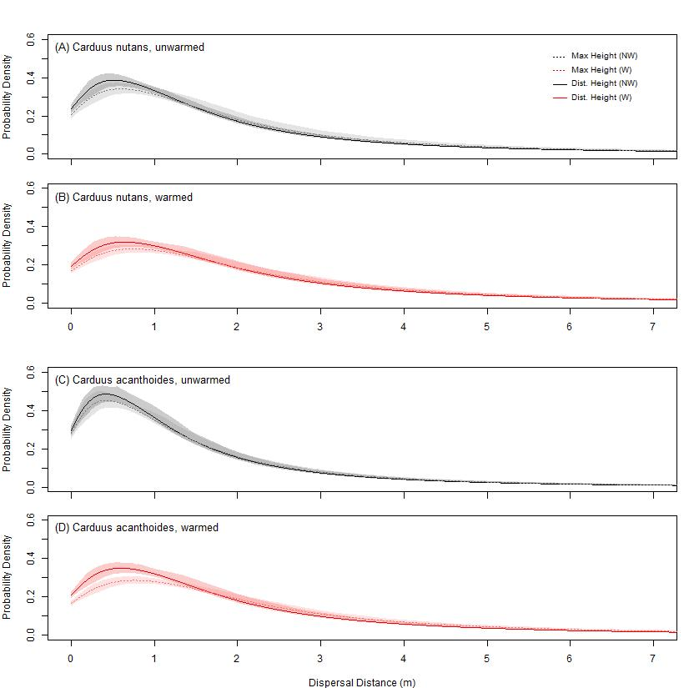

**Figure 5.** Relative risk of a seed exceeding a given distance when modelling dispersal using the maximum flower height rather than the flower height distribution for unwarmed *C. nutans* (A), warmed *C. nutans* (B), unwarmed *C. acanthoides* (C), and warmed *C. acanthoides* (D). Solid lines indicate the mean values of relative risk for a given distance, while the dotted line indicate a relative risk of 1. Error bands indicate a 95% bootstrap interval on the mean.

