Hazard-Space Scenario Selection for Robust Multi-Objective Re-Optimization of New York City’s Delaware Basin Reservoirs
Trevor Amestoy
Cornell University, Civil & Environmental Engineering

1.0 Introduction

1.1 Background and Motivation
Three New York City (NYC) reservoirs in the headwaters of the Delaware River Basin (DRB) supply roughly half of NYC’s drinking water while sustaining flows that protect downstream users. Operations of these reservoirs are governed by a 1954 Supreme Court Decree (New Jersey v. New York, 1954), hereafter the 1954 Decree, which sets the maximum NYC diversion allocation, entitles New Jersey (NJ) to its own diversion, and obligates NYC to make directed releases maintaining a minimum flow target at Montague, NJ. A second flow target at Trenton, NJ, established under the Delaware River Basin Commission (DRBC) Water Code, repels the salt front and protects the Philadelphia drinking water supply from salinity intrusion. The 1960s drought of record (1964 through 1967) demonstrated that the tensions among these obligations under sustained dry conditions. The limited NYC reservoir storage could not simultaneously support both the NYC diversion and the directed releases to Montague, leading to emergency conditions, violations of the Decree requirements, environmental and economic impacts across the states, and tensions between the DRBC party members (Hogarty, 1970; Kolesar and Serio, 2011; Amestoy et al., 2026).
Since 2007, NYC releases and diversions have been managed under successive versions of the Flexible Flow Management Program (FFMP), most recently revised in 2017 (Decree Parties, 2017). The FFMP is an adaptive policy in which the allowable diversions and the flow targets are reduced in negotiated steps as combined NYC storage declines through successive drought stages (Section 2.2). The operating rules that define these staged operations are the product of decades of negotiation, and any change to them requires unanimous consent of the Decree Parties. The FFMP’s release rules were developed with stakeholder engagement through simulation of candidate rules over the 1928 through 2000 historical record (Kolesar and Serio, 2011). Whether alternative operating rules could improve outcomes for multiple stakeholders at once has never been tested through formal multi-objective optimization, nor against hydrologic conditions beyond the historical record.
Evaluating any candidate revision of the FFMP's operating rules requires specifying the hydrologic conditions under which its performance is measured. The observed record provides one realization of the basin's hydrology, and policies evaluated against a single sequence are prone to overfitting the particular ordering of drought and flood events it contains (Brodeur et al., 2020; Giuliani et al., 2021). The observed record also understates the range of hydrological hazard conditions the region can plausibly experience. A 481-year tree-ring reconstruction for the greater NYC region identified droughts in the 16th and 17th centuries which were of similar intensity to the 1960s, and that the decades since 1970 constitute an unprecedented wet period for the region (Pederson et al., 2013). Neither the 1960s drought nor the post-1970 pluvial period can be attributed to radiative forcing due to the lack of their predictability by temperature-forced atmospheric GCMs and their occurrence is assumed to be the result of natural variability (Seager et al., 2012; Lehner and Deser, 2023). Water resources planning therefore goes beyond the observed record with synthetic streamflow ensembles generated by stochastic models fitted to it, which sample natural variability beyond the single observed sequence (Kirsch et al., 2013; Herman et al., 2016; Leitman et al., 2024).
Simulation-based search with multi-objective evolutionary algorithms (MOEAs) is an established approach for evaluating operational alternatives and characterizing the trade-offs they induce among competing water uses (Reed et al., 2013; Giuliani et al., 2016; Herman et al., 2020; Murgatroyd and Hall, 2021). Each candidate policy is evaluated by simulating it over an ensemble of streamflow realizations that is fixed before the search begins, and each objective value is a statistic computed across that ensemble, so the resulting trade-offs and Pareto-approximate policies depend on the streamflow conditions the ensemble contains (Quinn et al., 2017; Giuliani et al., 2021). We refer to the ensemble of streamflow realizations over which candidate policies are evaluated during the optimization search as the search ensemble. Stochastic hydrology provides methods for generating realizations that are statistically consistent with an observed record (Stedinger and Taylor, 1982), and MOEA applications commonly evaluate candidate policies over the observed record itself (Giuliani et al., 2016; Herman et al., 2020) or over an ensemble of realizations sampled independently from a fitted stochastic generator (Quinn et al., 2017; Zatarain Salazar et al., 2017; Murgatroyd and Hall, 2021). Prior studies show the benefit of evaluating candidate policies over many stochastic realizations during the search, but little attention has been given to which realizations, among the effectively unlimited number a generator can produce, the search ensemble should contain, or to how that choice influences the robustness of the resulting policies under a broader range of hydrologic uncertainty.

1.2 Literature Review
The scenarios used during the optimization search shape the characteristics of the resulting policies and their performance under uncertainty. Reservoir policy search has been shown to overfit the sequence of floods and droughts in its training record, with out-of-sample failures documented across reservoir systems (Brodeur et al., 2020; Giuliani et al., 2021; Taylor et al., 2024). Building on the multi-objective robust decision making (MORDM; Kasprzyk et al., 2013) framework, which conducts the MOEA search under a baseline state of the world (SOW) before re-evaluating the resulting policies across deeply uncertain SOWs, several studies have moved stressing conditions into the search itself (Watson and Kasprzyk, 2017; Trindade et al., 2017; Eker and Kwakkel, 2018; Bartholomew and Kwakkel, 2020). Watson and Kasprzyk (2017) re-ran the MOEA search separately under conditions that scenario discovery had identified as vulnerable and found that policies optimized under extreme conditions remained feasible across a wider range of conditions, at the cost of one additional search per identified scenario. Other scenario selection methods identify small, decision-relevant subsets by evaluating candidate scenarios through the system model, whether by measuring scenario importance based on an assumed initial decision choice (Hilbers et al., 2019) or by the regret of the current policy relative to one perfect-foresight optimization per candidate scenario (Cohen et al., 2021). Because these methods depend on the simulated system’s response to each candidate scenario, the selected subset is specific to one problem formulation, and the cost of selection grows with the number of candidate scenarios examined.
Zatarain Salazar et al. (2017) built search ensembles by generating a large ensemble of synthetic streamflow realizations and subsampling it by Latin hypercube sampling across the empirical quantiles of annual flow, so that the wettest and driest realizations were always included. Because the stratification uses a single annual streamflow statistic, the drought and flood hazards within each realization are not considered during the subsampling. Zaniolo et al. (2024) present a synthetic weather generator that controls drought frequency, intensity, and duration directly, but the target drought characteristics must be specified before generation rather than selected from the emergent sequences. To the best of our knowledge, no study has constructed a search ensemble to span multiple dimensions of emergent hydrologic hazard characterized independently of the water system, and no controlled comparison of such a construction against Monte Carlo sampling from the same generator exists for multi-objective policy search on a real water system.

1.3 Research Questions and Planned Contribution
In this study, we present an alternative method for constructing the streamflow ensembles used during multi-objective optimization of water resources system operations.
The proposed method selects a diverse set of realizations from a large candidate ensemble of independently generated streamflow sequences so that the selected realizations uniformly cover the range of plausible hydrologic hazard conditions resulting from natural variability. Since hydrologic hazard characteristics are properties of the streamflow sequences only, the ensemble is constructed without any simulation of the water system. We refer to this scenario design as the Hazard Filling (HF) design. We compare the Pareto-approximate policies obtained under the HF design against those obtained under a Monte Carlo (MC) sampling design, the common practice in which the search ensemble is drawn independently from the same stochastic generator. The comparison is performed on the re-optimization of NYC's DRB reservoir operations within the FFMP rule structure, simulated with the open-source Pywr-DRB model (Hamilton et al., 2024). The MC and HF designs are matched in ensemble size, record length, stochastic generator, and function-evaluation budget to isolate the effect of the construction of the search ensemble. We then compare the robustness of the resulting policies when re-evaluated across a large ensemble spanning deeply uncertain changes in future streamflow conditions.
Two research questions guide the experimental design:
- Can multi-objective search identify changes to the FFMP's operating rules that simultaneously improve outcomes for multiple basin stakeholders, spanning NYC water supply reliability, Montague and Trenton flow-target compliance, downstream flood exposure, and NYC reservoir storage, without degrading the outcomes of any party relative to current operations?
- Does constructing the search ensemble to span the basin's hydrologic hazards, rather than sampling realizations randomly, improve the robustness of the resulting Pareto-approximate policies when re-evaluated under a broad range of deeply uncertain future hydrologic conditions?

2.0 The Delaware River Basin Test Case

2.1 Institutional Water Management
The DRB spans four states and supplies the drinking, agricultural, and industrial water needs of more than 14 million people. NYC's three Delaware Basin reservoirs, Cannonsville, Pepacton, and Neversink, hold a combined usable capacity of 271 billion gallons and deliver roughly half of the city's supply through the Delaware Aqueduct. The 1954 Decree caps the max NYC diversion at 800 million gallons per day (MGD) as a running annual average, entitles NJ to a 100 MGD diversion, and obligates NYC to make directed releases maintaining a minimum flow of 1,750 cubic feet per second (cfs) at Montague, NJ, while the DRBC Water Code sets a 3,000 cfs flow target at Trenton, NJ (Decree Parties, 2017).
Drought drives these obligations into direct competition for the same limited storage. The emergency measures taken during the 1960s drought of record, curtailments of the NYC diversion coupled with reductions of the Montague flow target, were subsequently formalized into the storage-conditioned drought rules of the FFMP (Kolesar and Serio, 2011). The DRB's combination of Decree allocations, interstate regulation, and parties with distinct and legally protected interests makes it an institutionally complex water resources system (Hamilton et al., 2024), and because any change to the operation of NYC’s reservoirs requires unanimous consent of the Decree Parties, revisions must account for the outcomes of multiple parties.

2.2 The Flexible Flow Management Program Operating Rules
The FFMP is an adaptive policy in which the allowable diversions and the flow-target requirements depend on combined NYC storage. Combined storage is compared daily against seasonally varying rule curves that delineate five storage zones, from the top of storage the spill mitigation zone, the normal zone, and the three drought stages Drought Watch, Drought Warning, and Drought Emergency (Decree Parties, 2017). Each rule curve follows a seasonal cycle, lower through the summer when demands exceed inflows and higher through the spring when the reservoirs capture snowmelt and spring inflows.
The two largest volumes regulated by the FFMP are the NYC diversion and the directed releases to Montague. The reservoirs also make scheduled conservation releases for habitat protection under seasonal release schedules and, while combined storage is in the spill mitigation zone, spill mitigation releases that draw storage down to avoid overtopping (Decree Parties, 2017).
Entry to each drought stage reduces the allowable diversions and the flow targets in negotiated steps. When combined storage enters Drought Emergency, for example, the allowable NYC diversion is reduced 35 percent below its decreed allocation, from 800 to 520 MGD, and the Montague flow target is lowered from 1,750 to as low as 1,100 cfs (Decree Parties, 2017). These staged reductions are the program's adaptive mechanism, trading diversion and flow-target performance against protection of the remaining drought reserve as conditions deteriorate.
The FFMP's operating rules, consisting of the rule curve placements, the staged diversion and flow-target reductions, and the release schedules, define the program’s operations within a fixed rule structure. This study explores the operational benefits and trade-offs of modest changes to these operating rules while preserving the rule structure and every constraint imposed by the 1954 Decree.

2.3 Pywr-DRB Water Systems Model
All policy evaluations use Pywr-DRB, an open-source daily water availability and drought risk model of the basin (Hamilton et al., 2024). Pywr-DRB represents the NYC reservoirs and the major lower-basin reservoirs, the FFMP rule structure of Section 2.2, the Montague and Trenton flow targets, and the NYC and NJ diversions under the Decree's running-average accounting. Basin inflows for the historical record are taken from the reconstructed 1945 through 2023 dataset of Amestoy et al. (2026). The FFMP operating rules within Pywr-DRB were parameterized so that alternative rule parameterizations can be simulated during the MOEA search. These parameters are the decision variables discussed in Section 3.3.1.

3.0 Proposed Methodology
Figure 1 summarizes the experimental design. The stochastic generator, the ensemble size, the objective formulation, and the MOEA search algorithm are held constant, and only the construction of the search ensemble is varied (Figures 1a and 1b). Each search is conducted with the multi-master Borg MOEA (MM Borg) under an equal function-evaluation budget (Figure 1c). Every Pareto-approximate policy from every search is then re-evaluated on an ensemble spanning a deeply uncertain range of future streamflow conditions (Figure 1d). The re-evaluation results are used to calculate satisficing robustness and regret relative to current operations for every Pareto-approximate policy (Figure 1e), and differences in these metrics are compared across the scenario designs.
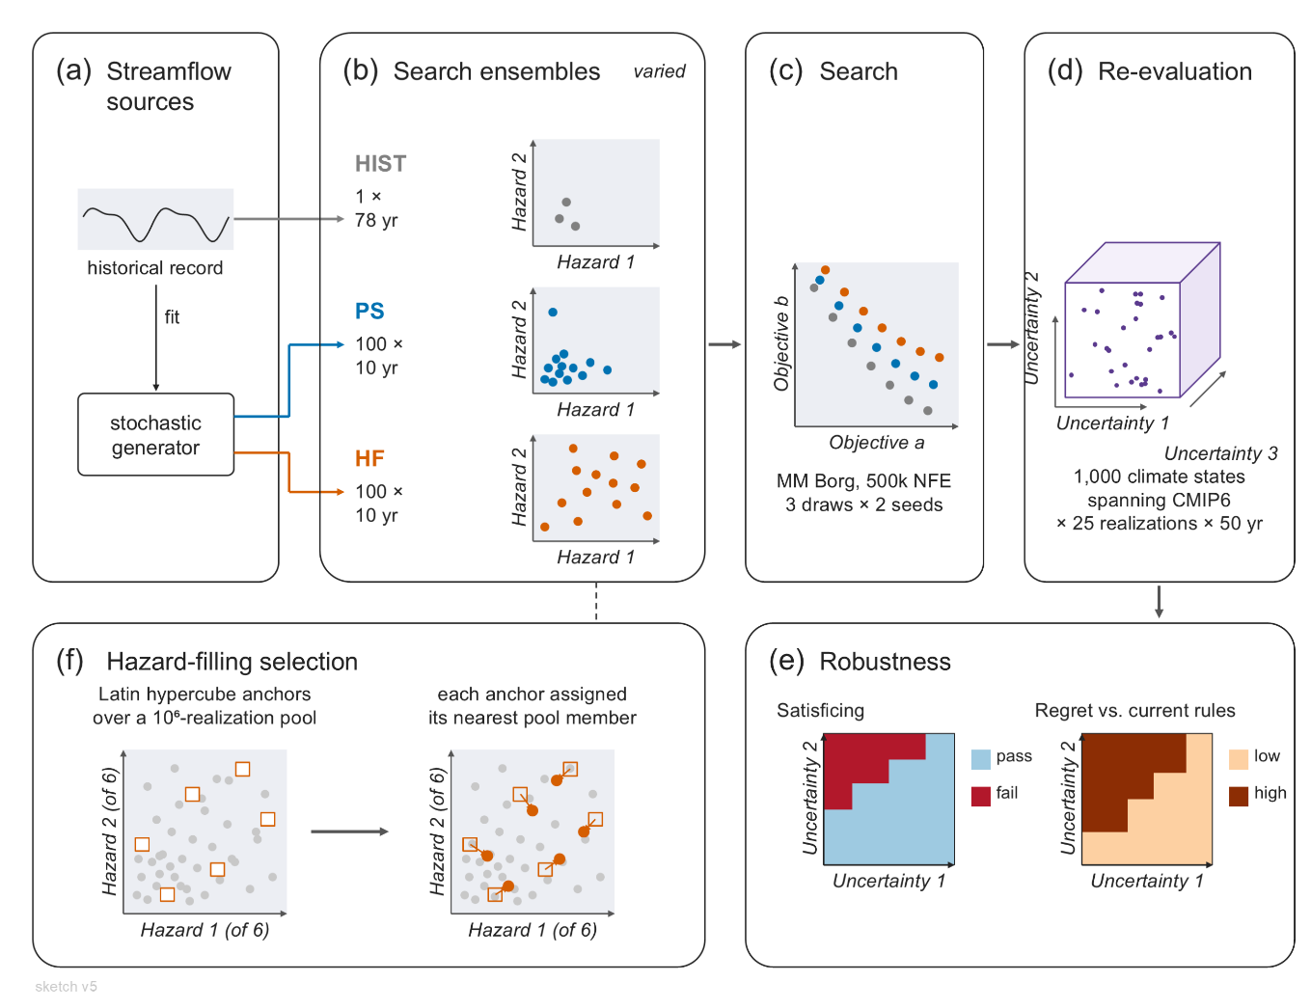
Figure 1: Graphical overview of proposed methodology.

3.1 Scenario Designs for Optimization Search
Three scenario designs for the search ensemble are compared (Table 1). The Historical (HIST) design simulates the reconstructed historical record as one continuous 78-year realization and is taken from Amestoy et al. (2026). Evaluating operational alternatives over the historical record is long-standing practice (Giuliani et al., 2016; Herman et al., 2020), and the record includes the 1960s drought of record, so every candidate policy is evaluated against a multi-year drought that depletes combined NYC storage under current operations (Amestoy et al., 2026). The MC design consists of $N$ realizations of $L$ years drawn independently from a stationary stochastic generator and held fixed during the search, the standard ensemble construction of simulation-based policy search (Quinn et al., 2017; Zatarain Salazar et al., 2017; Murgatroyd and Hall, 2021). The HF design selects $N$ realizations of length $L$ from a large candidate ensemble generated by the same stationary generator, chosen so that the selected realizations present diverse hydrologic conditions and uniformly span the basin’s hydrologic hazard space (Section 3.2). The MC and HF designs are constructed from the same generator, with the same $N$ and $L$, so any difference between their Pareto-approximate policy sets arises from the difference in the streamflow conditions the two ensembles present during the search.
Table 1: The three alternative designs for the search ensemble.
Design | Construction
Historical (HIST) | The reconstructed 1945-2023 historical record from Amestoy et al. (2026).
Monte Carlo (MC) sampling | $N$ = 300 realizations of $L$ = 10 years drawn independently from the stationary stochastic generator.
Hazard Filling (HF) sampling | $N$ = 300 realizations of $L$ = 10 years selected from a candidate ensemble of ${10}^{6}$ realizations generated independently by the same generator, sampled to achieve uniform coverage across six hydrologic hazard metrics (Section 3.2).

Daily, multi-site streamflow realizations are generated in two stages, with monthly flows generated using the method from Kirsch et al. (2013) and disaggregated to daily flows by nearest-neighbor resampling of historical streamflow sequences (Nowak et al., 2010). The generator is fitted to the reconstructed 1945 through 2023 record and run without climate perturbation, so the generator is stationary and all hazard variation within its output arises from natural variability.
Deeply uncertain climate or demand factors are not sampled within the search ensemble, in contrast to optimization under sampled deep uncertainties (Trindade et al., 2017), so that the comparison isolates the effect of the construction of the search ensemble within one well-characterized stationary population. Deeply uncertain streamflow change is introduced only in the re-evaluation of the Pareto-approximate policies (Section 3.5).
The MC and HF designs each use $N$ = 300 realizations of $L$ = 10 years, so each function evaluation simulates 3,000 years of streamflow. Initial diagnostics determined that $N$ = 300 is a sufficiently large ensemble size that the sampling noise of every objective is smaller than the objective precision specified for the search, so that policy rankings during the search reflect performance differences rather than sampling variability.
We use 10-year realizations, a design choice that keeps the event-specific drought and flood hazard metrics used to construct the HF ensemble interpretable (Section 3.2). Hazard characteristics are calculated from the largest drought event and the largest flood pulse in each realization, so a short realization is characterized by one event of each type, whereas a long realization would require aggregation across many events and would lose the information that distinguishes realizations. A 10-year realization is still long enough to contain a drought of the duration of the 1960s drought (Amestoy et al., 2026), and exposure to longer sequences of consecutive droughts and floods is provided by the 50-year realizations of the re-evaluation ensemble (Section 3.5).

3.2 Hazard Metrics and the Proposed Hazard Filling Scenario Design

3.2.1 Hazard Metrics
The HF ensemble construction method is intended to achieve diversity and coverage across the range of hydrologic drought and flood hazards plausible under natural variability. Diversity in this context refers to the variety among the streamflow characteristics across the ensemble members, so that each streamflow realization presents a unique set of hazard conditions relative to other realizations. Coverage in this context means that the selected realizations fill the hazard space approximately uniformly along each hazard metric and jointly.
The stationary generator produces marginal and joint hazard distributions reflective of the historical record, so an independently sampled ensemble such as the MC design represents hydrologic conditions in proportion to their probability under the generator and concentrates near the central mass of the joint hazard distribution, whereas the HF design seeks uniform coverage across the hazard space. The properties of the scenarios used during search shape the robustness of the resulting policies out of sample (Cohen et al., 2021; Zaniolo et al., 2023), and a policy's behavior under extreme conditions can influence the search only if the ensemble contains those conditions, so policies that perform well across a diverse set of streamflow conditions are hypothesized to generalize better to the extreme, uncertain and unseen conditions of the re-evaluation ensemble.
Constructing an ensemble for coverage deliberately departs from the stochastic hydrology verification and validation literature, which seeks ensembles with the same statistical properties as the record to which the generator is fitted (Stedinger and Taylor, 1982). The HF design instead intentionally over-represents extreme conditions relative to their frequency under the generator and, by design, distorts the marginal and joint distributions of the hazard characteristics. This distortion is confined to the search ensemble, where its role is to present diverse streamflow conditions during the optimization search. Increasing the frequency or depth of the drought conditions experienced by candidate policies during the optimization search has precedent, by reweighting the lower tail of the inflow distribution within the Monte Carlo evaluations of the search (Watson and Kasprzyk, 2017) and by prescribing the drought persistence, intensity, and frequency of the generated ensembles on which policies are trained (Zaniolo et al., 2023).
Hazard characteristics are calculated from the aggregate inflow to the three NYC reservoirs, because every FFMP operation is conditioned on combined NYC storage, which depends on this inflow, and because downstream flows are strongly correlated with upper basin flows. Six hazard metrics are used to define the hazard space, four characterizing each realization's largest drought event and two characterizing its largest flood pulse (Table 2). Rank correlations calculated on initial stationary ensembles confirm that no pair of axes is strongly correlated, so the 6 metrics measure distinct dimensions of the hydrologic hazards, in line with the design goal of achieving hydrologic diversity within the HF ensemble.

Table 2: Hazard metrics used to construct the HF ensemble
Metric | Description | Interpretation
Drought magnitude (deficit-months) | SSI-6 deficit accumulated over the deficit months of the largest drought event | Accumulated deficit of the event
Drought severity | Absolute value of the minimum SSI-6 reached during the event | Peak deficit of the event
Drought onset rate (per month) | Severity divided by the months from event onset to the minimum index value | How rapidly the deficit develops
Drought recovery rate (per month) | Severity divided by the months from the minimum index value to event termination | How rapidly the deficit terminates
Flood peak discharge | Maximum daily aggregate NYC inflow, normalized by the historical mean daily flow | Peak of the largest flood pulse
Flood pulse duration (days) | Consecutive days above the historical 95th percentile daily flow in the pulse containing the maximum | Duration of the largest flood pulse

Drought events are characterized using a 6-month Standardized Streamflow Index (SSI-6) of aggregate NYC inflow (Vicente-Serrano et al., 2012; Tijdeman et al., 2020). The SSI measures accumulated streamflow anomalies in units of standard deviations by fitting a gamma distribution to six-month accumulated flows, separately for each calendar month, and mapping the fitted probabilities to a standard normal distribution. The distributions are fitted to the 1945 through 2023 historical record and held fixed, so a given index value corresponds to the same departure from historical conditions in every realization. Drought events are identified from the monthly index series by a threshold-based definition in which an event begins when the index falls below zero, qualifies as a drought only if the index reaches -1.0, and ends after three consecutive non-negative months (Fleig et al., 2006; Van Loon, 2015). When a realization contains more than one event, the event with the largest accumulated SSI-6 deficit defines its drought hazard.
The four drought metrics (Table 2) are the drought magnitude, the drought severity, and the onset and recovery rates. Magnitude and severity quantify the accumulated and peak deficit of an event, and the two rates quantify how rapidly the deficit develops and how rapidly it terminates, aspects of drought behavior to which storage-conditioned rules respond differently.
Flood hazards are characterized by a peaks-over-threshold approach calculated using the NYC inflow against a threshold fixed at the 95th percentile of the historical record's daily flow. This threshold-exceedance approach for characterizing flood peak discharge, volume, and duration has been applied to stochastic streamflow ensembles (Brunner and Gilleland, 2020; Brunner, 2023). The flood pulse containing the realization’s maximum daily flow is scored for its peak discharge and its pulse duration (Table 2).

3.2.2 Hazard Filling Ensemble Construction
The HF ensemble construction follows four steps.
First, a candidate ensemble of one million streamflow realizations is generated with the stationary stochastic generator of Section 3.1, an ensemble large enough that the distributions of its hazard characteristics have converged.
Second, the six hazard metrics are calculated for each realization in the candidate ensemble.
Third, each hazard metric is scaled by its 1st and 99th percentile bounds across the candidate ensemble, so that no single metric dominates the selection distance.
Fourth, $N$ target hazard characteristics $u_{1},…,u_{N}$ are drawn as a Latin hypercube sample in the scaled space (McKay et al., 2000), and each target is assigned to the nearest unselected streamflow realization in Euclidean distance,
$$x_{\left(i\right)} =\underset{x ∈ C∖\left\{x_{\left(1\right)},…,x_{\left(i-1\right)}\right\}}{\arg{min}} {\left\|\overset{˜}{h}\left(x\right)-u_{i}\right\|}_{2}, i=1,…,N,$$
where $C$ is the candidate ensemble, $\overset{˜}{h}\left(x\right)$ is the vector of scaled hazard characteristics of realization $x$, and $u_{i}$ is the $i$th vector of target hazard characteristics.
The selected realizations form the HF search ensemble. Selecting streamflow realizations whose measured attributes approximate a Latin hypercube design follows conditioned Latin hypercube sampling (Minasny and McBratney, 2006).

3.3 Multi-Objective Problem Formulation
The re-optimization is formulated as an eight-objective problem with 36 decision variables that parameterize the 2017 FFMP operating rules. Section 3.3.1 defines the decision variables and Section 3.3.2 defines the objectives.

3.3.1 Decision Variables
The decision variables parameterize the FFMP's operating rules while preserving the rule structure, including the storage-conditioned zones, the seasonal form of the rule curves, and the running-average accounting of the NYC and NJ diversions. They fall into six groups (Table 3).

Table 3: Decision variables used for the FFMP operational formulation.
Decision Variable Group | No. DVs | Description
Rule curve vertical shifts | 9 | Shifts the upper and lower plateau of each drought-stage curve vertically.
Rule curve temporal shifts | 6 | Shifts each rule curve seasonally, up to 30 days.
Drought zone staged NYC & NJ diversion reductions | 5 | Fractional reduction of the NYC & NJ diversion allowance upon entry into each subsequent drought zone.
Montague & Trenton flow target reductions | 6 | Fractional reduction of the Montague & Trenton flow targets upon entry into each subsequent drought zone.
Spill mitigation releases | 6 | Prescribed spill mitigation release when NYC reservoir storage is within the Spill Mitigation zones.
Conservation release seasonal scales | 4 | Seasonal multipliers on the reservoirs’ conservation release schedules for winter, spring, summer, and fall.

The problem formulation maintains the constraints established by the 1954 Decree and the DRBC Water Code when not in any of the 3 drought zones. The 800 MGD NYC and 100 MGD NJ diversion allocations, the 1,750 cfs Montague flow target, and the 3,000 cfs Trenton flow target are preserved in the normal zone, and the decision variables influence only how the FFMP reduces diversions and flow targets as storage declines. The reservoirs’ minimum daily releases and maximum discharges are likewise fixed. Every decision variable is bounded to a limited range around its 2017 FFMP value, so the search explores modest modifications of the current operating rules.

3.3.2 Objectives
We define eight objectives that cover a range of stakeholder priorities encoded in the basin's governance (Table 4). The objectives reflect interest in NYC water supply (diversion reliability and diversion deficit), the Decree flow obligation at Montague (flow reliability and flow deficit), the Trenton flow target, downstream flood exposure, NYC reservoir storage, and the NJ diversion.
Every diversion and flow objective is scored against the obligations of the 1954 Decree and the Water Code rather than against the FFMP's drought-reduced targets. The diversion allocations are not fixed daily quantities, because Decree accounting limits the running average of each diversion rather than any single day's withdrawal, with NYC's allowance resetting each June 1 and NJ's monthly, so the volume a party is entitled to on a given day depends on the allowance accrued through its prior diversions. Each day's diversion obligation is therefore the entitlement reconstructed at the full 800 MGD or 100 MGD allocation, taken as the smaller of that day's demand and the accrued allowance. Scoring against this entitlement ensures that a policy's own drought curtailments cannot lower the standard against which it is scored, while unsatisfied demand above the Decree allocation is never counted as a shortfall.
Every objective is computed from the daily simulation output through the same two-stage aggregation over FFMP-years, each running from June 1 through May 31. A within-year operator $Φ$ reduces each FFMP-year of each realization to one annual value, and an across-year statistic $Ψ$ summarizes the annual values across all realizations of the ensemble,
$$J_{d} = Ψ_{\left(r,y\right)}\left[ Φ_{t∈y}\left[ g_{d}\left(t,r\right) \right] \right],$$
where $g_{d}\left(t,r\right)$ is the daily quantity underlying objective $d$ on day $t$ of realization $r$. This operator composition follows the aggregation formalism of the multi-objective reservoir literature, in which $Ψ$ is a statistic used to filter the noise across ensemble members (Quinn et al., 2017, 2018; Zatarain Salazar et al., 2017).
The four reliability objectives measure the frequency with which an obligation is met (Hashimoto et al., 1982; Zeff et al., 2014). Obligation in this context refers the 1954 Decree-specified diversion allocation or the flow target, for the NYC diversion and Montague flow target respectively, however when calculating performance the NYC diversion obligation is calculated as min(demand, Decree allocation). A week meets its obligation when the delivered diversion or the weekly mean flow is at least 99 percent of the obligation. For each reliability objective, $Φ$ is an annual failure indicator that registers a failure when more than $k$ weeks of the year fail to meet the obligation, and $Ψ$ is the frequency of non-failure years across the pooled years of all realizations (Zeff et al., 2014; Trindade et al., 2017). NYC diversion reliability and Montague flow reliability use $k=3$ failure weeks, and Trenton flow reliability and NJ diversion reliability use $k=1$.
The two deficit objectives measure the depth of the failures that the corresponding reliability objectives count, a vulnerability measure in the sense of Hashimoto et al. (1982). The weekly deficit is the shortfall below the obligation value. Within each year, $Φ$ is the conditional value-at-risk of the weekly deficits at the 90 percent level (${\text{CvaR}}_{90}$), the mean of the worst 10 percent of weeks in that year (Rockafellar and Uryasev, 2000). This statistic characterizes the depth of a year’s worst shortfalls while averaging over several weeks, so the annual value is less sensitive to a single week than the annual maximum would be. Across years, $Ψ$ is the worst first-percentile year across the pooled years of all realizations, a tail statistic that is more stable than the single worst year (Quinn et al., 2017, 2018.
Downstream flood exposure is measured as the mean annual accumulation of river stage above the National Weather Service minor flood stage at three reservoir tailwater gauges, taking the maximum across gauges each day so that one basin-wide flood event is not counted three times. The storage objective protects the drought reserve through the worst first percentile of the annual minima of combined NYC storage.

Table 4: The eight objectives used during MOEA search of NYC reservoir operational rules.
Objective (preference) | $g_{d}$  (Value of interest) | $Φ$  (Annual performance metric) | $Ψ$  (Multi-year aggregation metric) | $$ε$$
NYC diversion reliability (max) | NYC diversion relative to the running-average entitlement, weekly | failure indicator (3 failure weeks) | frequency of non-failure years | 0.05
NYC diversion deficit (min) | NYC diversion shortfall in percent of entitlement, weekly | within-year CVaR${}_{90}^{​}​$ of weekly deficit | worst first-percentile year | 10.0
Montague flow reliability (max) | mean flow at Montague relative to the 1,750 cfs target, weekly | failure indicator (3 failure weeks) | frequency of non-failure years | 0.05
Montague flow deficit (min) | Montague flow shortfall in percent of target, weekly | within-year CVaR${}_{90}^{​}​$ of weekly deficit | worst first-percentile year | 10.0
Trenton flow reliability (max) | mean flow at Trenton relative to the 3,000 cfs target, weekly | failure indicator (1 failure week) | frequency of non-failure years | 0.05
Downstream flood exceedance (min) | maximum across three tailwater gauges of stage above the minor flood stage, daily | annual ft-day exceedance | mean across years | 0.3
NYC minimum storage (max) | combined NYC storage in percent of capacity, daily | annual minimum daily storage | worst first-percentile year | 5.0
NJ diversion reliability (max) | NJ diversion relative to the running-average entitlement, weekly | failure indicator (1 failure week) | frequency of non-failure years | 0.05

3.4 Search Configuration
All searches use MM Borg (Hadka and Reed, 2013, 2015), a self-adaptive MOEA that combines an $ε$-dominance archive, $ε$-progress triggered restarts with adaptive population sizing, and auto-adaptive multi-operator search in which the selection probabilities of the search operators adapt to the operators that contribute new Pareto-approximate solutions. Borg's search has proven reliable across multi-objective water resources applications (Reed et al., 2013; Zatarain Salazar et al., 2016, 2017). The multi-master implementation is a hierarchical parallelization in which several islands, each a master-worker instance of the Borg MOEA, co-evolve through a controller that maintains a global $ε$-dominance archive and global operator probabilities and provides guidance to an island whose local restarts fail to escape stagnation (Hadka and Reed, 2015).
One FFMP optimization is performed for each scenario design. Each search uses a four-island configuration of MM Borg on twelve nodes of the Purdue Anvil system with 500,000 function evaluations (NFE) per design, 125,000 per island, and runtime hypervolume is tracked to verify convergence of each Pareto-approximate set. Each design is searched with two random seed trials, using MM Borg’s default parameterization, to account for variability in initial populations and operator probabilities (Zatarain Salazar et al., 2017). The approximation sets of the two seeds are combined and re-sorted into a best known Pareto-approximate set for each scenario design. Objective values attained during the search are specific to the search ensemble on which they were computed, so the Pareto-approximate sets are not compared across designs on their search objective values, and every cross-design comparison is made on the common re-evaluation ensemble of Section 3.5.

3.5 Robustness and Regret Under Uncertain Future Hydroclimate Conditions

3.5.1 Re-Evaluation Under Uncertainty
Deep uncertainty describes factors whose outcomes and likelihoods experts cannot know or cannot agree on (Lempert et al., 2003; Walker et al., 2013; Hadjimichael et al., 2020). The basin's natural hydroclimatic variability is well characterized, with 78 years of reconstructed record supporting the fitted stochastic streamflow generator. The magnitude and seasonal structure of future streamflow change are deeply uncertain, because climate model projections for the basin disagree across a wide range of conditions.
Demand growth is not included as an uncertainty, because the 1954 Decree establishes a legally binding upper bound on the NYC diversion, the dominant demand on the reservoirs. The deeply uncertain factors sampled in this study are therefore limited to changes in streamflow conditions.
Following the deep uncertainty re-evaluation step of MORDM (Kasprzyk et al., 2013; Herman et al., 2014; Trindade et al., 2017; Gold et al., 2023), every design's Pareto-approximate set is re-evaluated on an ensemble constructed to span a range of streamflow change inferred from an ensemble of downscaled and bias-corrected climate model projections (Coupled Model Intercomparison Project Phase 6; CMIP6). For each CMIP6 ensemble member, we calculate the relative change in monthly mean streamflow and represent the resulting seasonal profile of change factors by a two-harmonic function whose three parameters govern annual flow volume, seasonal amplitude, and the shape of the snowmelt shoulder. The parameter ranges are fitted to a 54-member ensemble of CMIP6 change profiles and the re-evaluation ensemble is designed to fully envelope the CMIP6-fitted parameter values. The two-harmonic form captures the CMIP6 profiles with a median coefficient of determination of 0.85.
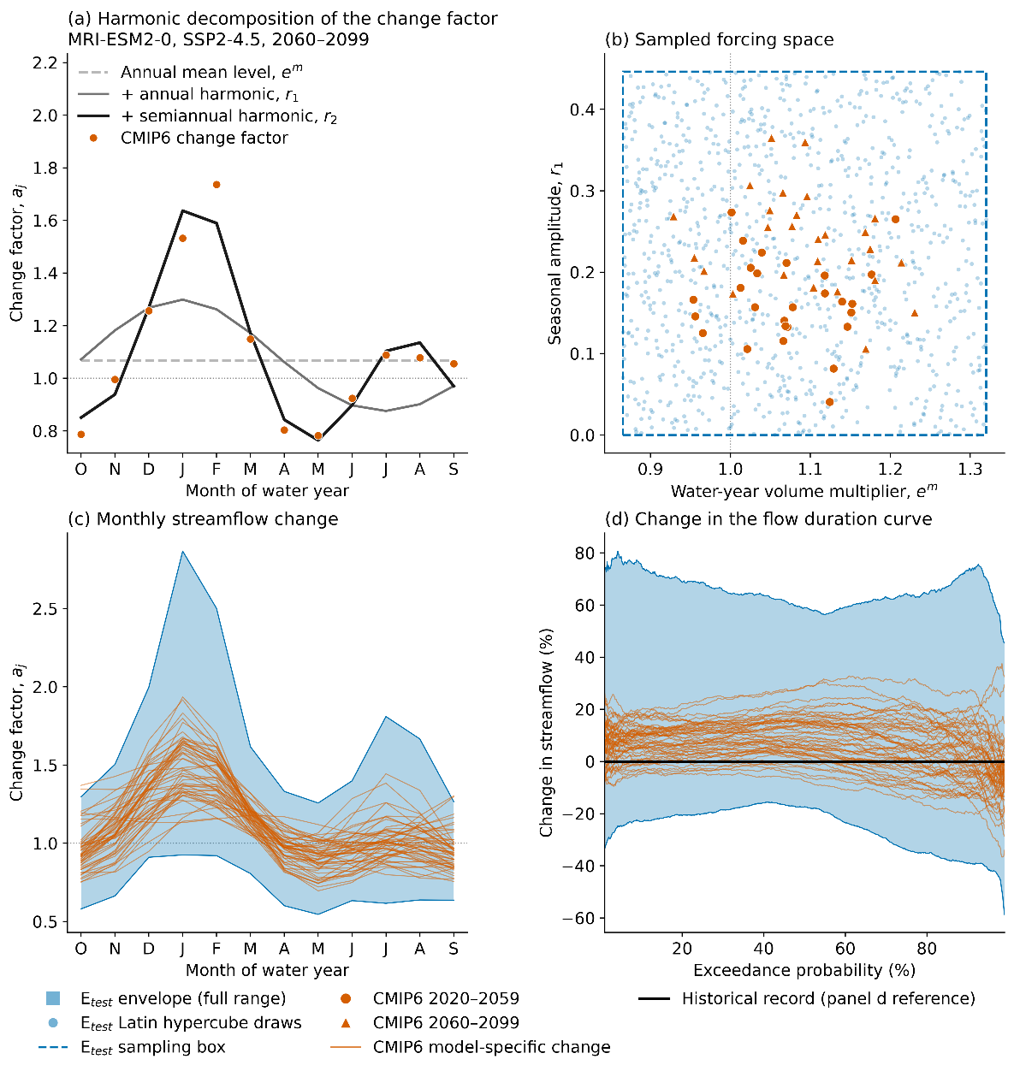
Figure 2: Construction of the uncertain future streamflow space. (a) Harmonic decomposition of one example CMIP6 monthly streamflow change-factor profile. (b) Two dimensions of the three-dimensional uncertainty space, with CMIP6-fitted parameters in orange and the Latin hypercube sampling envelope of the re-evaluation ensemble, labeled $E_{test}$ in the legend, in blue. (c) The monthly change-factor envelope implied by the sampled space against the CMIP6 model profiles. (d) The corresponding change in the flow duration curve relative to the historical record.
Each SOW is one sampled set of harmonic parameters, corresponding to one monthly profile of streamflow change. We generate 1,000 SOWs by Latin hypercube sampling across the three-dimensional parameter range, and for each SOW we generate 50 stochastic realizations of 50 years that sample natural variability within that SOW. Because the search ensembles are drawn from the unperturbed stationary generator while the re-evaluation ensemble spans a range of future streamflow changes, the re-evaluation tests whether the policies produced under each scenario design generalize to conditions absent from every search.

3.5.2 Robustness and Regret Metrics and Scenario Discovery
To answer the research questions, the eight objectives of Section 3.3.2 are recomputed for every Pareto-approximate policy from all three scenario designs in each of the 1,000 SOWs, and this per-SOW performance is used to measure satisficing robustness and regret relative to current operations.
Robustness is measured as satisficing robustness under the domain criterion of Starr (1963), the fraction of sampled SOWs in which a policy meets a set of performance thresholds,
$$S\left(x\right) = \frac{1}{N_{θ}}\sum_{θ}{\prod_{i}{1}}​\left[ J_{i}\left(x,θ\right) \text{meets} c_{i} \right],$$
where $J_{i}\left(x,θ\right)$ is objective $i$ recomputed in SOW $θ$ and $c_{i}$ is its satisficing criterion. This multivariate satisficing measure is common in the regional water planning literature (Herman et al., 2014, 2015; Trindade et al., 2017; Gold et al., 2023) and requires fewer SOWs than other measures for a stable policy ranking (Bonham et al., 2024). Because the choice of robustness measure is known to change policy rankings (Herman et al., 2015; Giuliani and Castelletti, 2016; McPhail et al., 2018), per-objective satisficing fractions, the mean across SOWs, and the worst SOW will also be reported. The placement of the satisficing criteria is not yet final.
Regret is measured for every Pareto-approximate policy relative to the current FFMP policy evaluated in the same SOW, a fixed reference in each SOW being a standard basis for regret (Savage, 1951; Herman et al., 2015; McPhail et al., 2018). Regret in a SOW means the Decree Parties would have performed better in that future by maintaining current operations. Regret is reported per objective, and the low-regret frequency of a policy summarizes it across objectives as the fraction of SOWs in which no objective is degraded beyond a specified tolerance $τ_{i}$,
$$Π_{τ}\left(x\right) = \frac{1}{N_{θ}}\sum_{θ}{\prod_{i}{1}}​\left[ D_{i}\left(x,θ\right)≥-τ_{i} \right],$$
where $D_{i}\left(x,θ\right)$ is the per-SOW difference in performance relative to the current FFMP policy. A SOW in which every objective performs as well as or better than the current FFMP policy, within the tolerance, is a low-regret SOW. The cross-objective formulation reflects the requirement that any modification of the FFMP obtain unanimous consent of the Decree Parties, which is most plausible for a policy that maintains or improves performance for every party.
Finally, we use scenario discovery to identify the uncertain streamflow conditions associated with non-satisficing and high-regret outcomes. Each SOW is classified as a success or failure for a given policy under the satisficing criteria and under the low-regret condition, and gradient-boosted tree classifiers are fitted to the labeled SOWs to partition the parameterized uncertainty space into predicted regions of success and failure.

References
Amestoy, T. J., Hamilton, A. L., & Reed, P. M. (2026). Integrated river basin assessment framework combining probabilistic streamflow reconstruction, Bayesian bias correction, and drought storyline analysis. Environmental Modelling & Software, 195, 106756.
Bartholomew, E., & Kwakkel, J. H. (2020). On considering robustness in the search phase of Robust Decision Making: A comparison of Many-Objective Robust Decision Making, multi-scenario Many-Objective Robust Decision Making, and Many Objective Robust Optimization. Environmental Modelling & Software, 127, 104699.
Bonham, N., Kasprzyk, J., Zagona, E., & Rajagopalan, B. (2024). Subsampling and space-filling metrics to test ensemble size for robustness analysis with a demonstration in the Colorado River Basin. Environmental Modelling & Software, 172, 105933.
Brodeur, Z. P., Herman, J. D., & Steinschneider, S. (2020). Bootstrap aggregation and cross-validation methods to reduce overfitting in reservoir control policy search. Water Resources Research, 56(8), e2020WR027184.
Brunner, M. I. (2023). Floods and droughts: A multivariate perspective. Hydrology and Earth System Sciences, 27(13), 2479–2497.
Brunner, M. I., & Gilleland, E. (2020). Stochastic simulation of streamflow and spatial extremes: A continuous, wavelet-based approach. Hydrology and Earth System Sciences, 24(8), 3967–3982.
Cohen, J. S., Zeff, H. B., & Herman, J. D. (2021). How do the properties of training scenarios influence the robustness of reservoir operating policies to climate uncertainty? Environmental Modelling & Software, 141, 105047.
Decree Parties. (2017). Flexible Flow Management Program, Appendix A: 2017 Operations Plan. States of Delaware, New Jersey, and New York, Commonwealth of Pennsylvania, and City of New York.
Eker, S., & Kwakkel, J. H. (2018). Including robustness considerations in the search phase of Many-Objective Robust Decision Making. Environmental Modelling & Software, 105, 201–216.
Fleig, A. K., Tallaksen, L. M., Hisdal, H., & Demuth, S. (2006). A global evaluation of streamflow drought characteristics. Hydrology and Earth System Sciences, 10(4), 535–552.
Giuliani, M., & Castelletti, A. (2016). Is robustness really robust? How different definitions of robustness impact decision-making under climate change. Climatic Change, 135(3–4), 409–424.
Giuliani, M., Castelletti, A., Pianosi, F., Mason, E., & Reed, P. M. (2016). Curses, tradeoffs, and scalable management: Advancing evolutionary multiobjective direct policy search to improve water reservoir operations. Journal of Water Resources Planning and Management, 142(2), 04015050.
Giuliani, M., Lamontagne, J. R., Reed, P. M., & Castelletti, A. (2021). A state-of-the-art review of optimal reservoir control for managing conflicting demands in a changing world. Water Resources Research, 57(12), e2021WR029927.
Gold, D. F., Reed, P. M., Gorelick, D. E., & Characklis, G. W. (2023). Advancing regional water supply management and infrastructure investment pathways that are equitable, robust, adaptive, and cooperatively stable. Water Resources Research, 59(9), e2022WR033671.
Hadjimichael, A., Quinn, J., Wilson, E., Reed, P., Basdekas, L., Yates, D., & Garrison, M. (2020). Defining robustness, vulnerabilities, and consequential scenarios for diverse stakeholder interests in institutionally complex river basins. Earth's Future, 8(7), e2020EF001503.
Hadka, D., & Reed, P. (2013). Borg: An auto-adaptive many-objective evolutionary computing framework. Evolutionary Computation, 21(2), 231–259.
Hadka, D., & Reed, P. (2015). Large-scale parallelization of the Borg multiobjective evolutionary algorithm to enhance the management of complex environmental systems. Environmental Modelling & Software, 69, 353–369.
Hamilton, A. L., Amestoy, T. J., & Reed, P. M. (2024). Pywr-DRB: An open-source Python model for water availability and drought risk assessment in the Delaware River Basin. Environmental Modelling & Software, 181, 106185.
Hashimoto, T., Stedinger, J. R., & Loucks, D. P. (1982). Reliability, resiliency, and vulnerability criteria for water resource system performance evaluation. Water Resources Research, 18(1), 14–20.
Herman, J. D., Quinn, J. D., Steinschneider, S., Giuliani, M., & Fletcher, S. (2020). Climate adaptation as a control problem: Review and perspectives on dynamic water resources planning under uncertainty. Water Resources Research, 56(2), e24389.
Herman, J. D., Reed, P. M., Zeff, H. B., & Characklis, G. W. (2015). How should robustness be defined for water systems planning under change? Journal of Water Resources Planning and Management, 141(10), 04015012.
Herman, J. D., Zeff, H. B., Lamontagne, J. R., Reed, P. M., & Characklis, G. W. (2016). Synthetic drought scenario generation to support bottom-up water supply vulnerability assessments. Journal of Water Resources Planning and Management, 142(11), 04016050.
Herman, J. D., Zeff, H. B., Reed, P. M., & Characklis, G. W. (2014). Beyond optimality: Multistakeholder robustness tradeoffs for regional water portfolio planning under deep uncertainty. Water Resources Research, 50(10), 7692–7713.
Hilbers, A. P., Brayshaw, D. J., & Gandy, A. (2019). Importance subsampling: Improving power system planning under climate-based uncertainty. Applied Energy, 251, 113114.
Hogarty, R. A. (1970). The Delaware River drought emergency (ICP Case Series No. 107). Bobbs-Merrill, Indianapolis, IN.
Kasprzyk, J. R., Nataraj, S., Reed, P. M., & Lempert, R. J. (2013). Many objective robust decision making for complex environmental systems undergoing change. Environmental Modelling & Software, 42, 55–71.
Kirsch, B. R., Characklis, G. W., & Zeff, H. B. (2013). Evaluating the impact of alternative hydro-climate scenarios on transfer agreements: Practical improvement for generating synthetic streamflows. Journal of Water Resources Planning and Management, 139(4), 396–406.
Kolesar, P., & Serio, J. (2011). Breaking the deadlock: Improving water-release policies on the Delaware River through operations research. Interfaces, 41(1), 18–34.
Lehner, F., & Deser, C. (2023). Origin, importance, and predictive limits of internal climate variability. Environmental Research: Climate, 2(2), 023001.
Leitman, S., Ahmadisharaf, E., & Brunner, M. I. (2024). Multi-reservoir system response to alternative stochastically simulated stationary hydrologic scenarios: An evaluation for the Apalachicola-Chattahoochee-Flint (ACF) Basin. Journal of Hydrology: Regional Studies, 51, 101608.
Lempert, R. J., Popper, S. W., & Bankes, S. C. (2003). Shaping the next one hundred years: New methods for quantitative, long-term policy analysis. RAND Corporation, Santa Monica, CA.
McKay, M. D., Beckman, R. J., & Conover, W. J. (2000). A comparison of three methods for selecting values of input variables in the analysis of output from a computer code. Technometrics, 42(1), 55–61.
McPhail, C., Maier, H. R., Kwakkel, J. H., Giuliani, M., Castelletti, A., & Westra, S. (2018). Robustness metrics: How are they calculated, when should they be used and why do they give different results? Earth's Future, 6(2), 169–191.
Minasny, B., & McBratney, A. B. (2006). A conditioned Latin hypercube method for sampling in the presence of ancillary information. Computers & Geosciences, 32(9), 1378–1388.
Murgatroyd, A., & Hall, J. W. (2021). Selecting indicators and optimizing decision rules for long-term water resources planning. Water Resources Research, 57(5), e2020WR028117.
New Jersey v. New York, 347 U.S. 995 (1954).
Nowak, K., Prairie, J., Rajagopalan, B., & Lall, U. (2010). A nonparametric stochastic approach for multisite disaggregation of annual to daily streamflow. Water Resources Research, 46(8), W08529.
Pederson, N., Bell, A. R., Cook, E. R., Lall, U., Devineni, N., Seager, R., Eggleston, K., & Vranes, K. P. (2013). Is an epic pluvial masking the water insecurity of the greater New York City region? Journal of Climate, 26(4), 1339–1354.
Quinn, J. D., Reed, P. M., Giuliani, M., & Castelletti, A. (2017). Rival framings: A framework for discovering how problem formulation uncertainties shape risk management trade-offs in water resources systems. Water Resources Research, 53(8), 7208–7233.
Quinn, J. D., Reed, P. M., Giuliani, M., Castelletti, A., Oyler, J. W., & Nicholas, R. E. (2018). Exploring how changing monsoonal dynamics and human pressures challenge multireservoir management for flood protection, hydropower production, and agricultural water supply. Water Resources Research, 54(7), 4638–4662.
Reed, P. M., Hadka, D., Herman, J. D., Kasprzyk, J. R., & Kollat, J. B. (2013). Evolutionary multiobjective optimization in water resources: The past, present, and future. Advances in Water Resources, 51, 438–456.
Rockafellar, R. T., & Uryasev, S. (2000). Optimization of conditional value-at-risk. The Journal of Risk, 2(3), 21–41.
Savage, L. J. (1951). The theory of statistical decision. Journal of the American Statistical Association, 46(253), 55–67.
Seager, R., Pederson, N., Kushnir, Y., Nakamura, J., & Jurburg, S. (2012). The 1960s drought and the subsequent shift to a wetter climate in the Catskill Mountains region of the New York City watershed. Journal of Climate, 25(19), 6721–6742.
Starr, M. K. (1963). Product design and decision theory. Prentice-Hall, Englewood Cliffs, NJ.
Stedinger, J. R., & Taylor, M. R. (1982). Synthetic streamflow generation: 1. Model verification and validation. Water Resources Research, 18(4), 909–918.
Taylor, W., Brodeur, Z. P., Steinschneider, S., Kucharski, J., & Herman, J. D. (2024). Variability, attributes, and drivers of optimal forecast-informed reservoir operating policies for water supply and flood control in California. Journal of Water Resources Planning and Management, 150(10), 05024010.
Tijdeman, E., Stahl, K., & Tallaksen, L. M. (2020). Drought characteristics derived based on the Standardized Streamflow Index: A large sample comparison for parametric and nonparametric methods. Water Resources Research, 56(10), e2019WR026315.
Trindade, B. C., Reed, P. M., Herman, J. D., Zeff, H. B., & Characklis, G. W. (2017). Reducing regional drought vulnerabilities and multi-city robustness conflicts using many-objective optimization under deep uncertainty. Advances in Water Resources, 104, 195–209.
Van Loon, A. F. (2015). Hydrological drought explained. WIREs Water, 2(4), 359–392.
Vicente-Serrano, S. M., López-Moreno, J. I., Beguería, S., Lorenzo-Lacruz, J., Azorin-Molina, C., & Morán-Tejeda, E. (2012). Accurate computation of a streamflow drought index. Journal of Hydrologic Engineering, 17(2), 318–332.
Walker, W. E., Lempert, R. J., & Kwakkel, J. H. (2013). Deep uncertainty. In S. I. Gass & M. C. Fu (Eds.), Encyclopedia of Operations Research and Management Science (3rd ed., pp. 395–402). Springer.
Watson, A. A., & Kasprzyk, J. R. (2017). Incorporating deeply uncertain factors into the many objective search process. Environmental Modelling & Software, 89, 159–171.
Zaniolo, M., Fletcher, S., & Mauter, M. S. (2023). Multi-scale planning model for robust urban drought response. Environmental Research Letters, 18(5), 054014.
Zaniolo, M., Fletcher, S., & Mauter, M. (2024). FIND: A synthetic weather generator to control drought frequency, intensity, and duration. Environmental Modelling & Software, 172, 105927.
Zatarain Salazar, J., Reed, P. M., Herman, J. D., Giuliani, M., & Castelletti, A. (2016). A diagnostic assessment of evolutionary algorithms for multi-objective surface water reservoir control. Advances in Water Resources, 92, 172–185.
Zatarain Salazar, J., Reed, P. M., Quinn, J. D., Giuliani, M., & Castelletti, A. (2017). Balancing exploration, uncertainty and computational demands in many objective reservoir optimization. Advances in Water Resources, 109, 196–210.
Zeff, H. B., Kasprzyk, J. R., Herman, J. D., Reed, P. M., & Characklis, G. W. (2014). Navigating financial and supply reliability tradeoffs in regional drought management portfolios. Water Resources Research, 50(6), 4906–4923.

