Hazard-Space Scenario Selection for Robust Many-Objective Re-Optimization of New York City’s Delaware Basin Reservoirs
Trevor Amestoy
Cornell University, Civil & Environmental Engineering

1.0 Introduction

1.1 Background and Motivation
Three New York City (NYC) reservoirs in the headwaters of the Delaware River Basin (DRB) supply roughly half of NYC’s drinking water while sustaining flows that protect downstream users. Operations of these reservoirs are governed by a 1954 Supreme Court Decree (New Jersey v. New York, 1954), hereafter the 1954 Decree, which sets the maximum NYC diversion allocation, entitles New Jersey (NJ) to its own diversion, and obligates NYC to make directed releases maintaining a minimum flow target at Montague, NJ. A second flow target at Trenton, NJ, established under the Delaware River Basin Commission (DRBC) Water Code, repels the salt front to protect the Philadelphia drinking water supply from salinity intrusion. The 1960s drought of record (1964 through 1967) revealed the tensions among these obligations under sustained dry conditions. The limited NYC reservoir storage could not simultaneously support both the NYC diversion and the directed releases to Montague, leading to emergency conditions, violations of the Decree requirements, environmental and economic impacts across the states, and tensions among the five parties to the 1954 Decree (the four basin states and NYC), hereafter the Decree Parties (Hogarty, 1970; Kolesar and Serio, 2011; Amestoy et al., 2026).
The emergency measures negotiated during that drought were formalized over the following decades into storage-conditioned drought rules, and since 2007 NYC releases and diversions have been managed under successive versions of the Flexible Flow Management Program (FFMP), most recently revised in 2017 (Decree Parties, 2017). The FFMP is an adaptive policy in which the allowable diversions and the flow targets are reduced in negotiated steps as combined NYC storage declines through successive drought stages (Section 2.2). The operating rules that define these staged operations are the product of decades of negotiation, and any change to them requires the unanimous consent of the Decree Parties. The FFMP’s release rules were developed with stakeholder engagement through simulation of candidate rules over the 1928 through 2000 historical streamflow record (Kolesar and Serio, 2011). To our knowledge, whether alternative operating rules could improve outcomes for multiple stakeholders at once has not been tested through formal many-objective optimization, nor against hydrologic conditions beyond the historical record.
Evaluating any candidate revision of the FFMP's operating rules requires specifying the hydrologic conditions under which its performance is measured. The observed record provides one realization of the basin's hydrology, and policies evaluated against a single sequence are prone to overfitting the particular ordering of drought and flood events it contains (Brodeur et al., 2020; Giuliani et al., 2021). The observed record also understates the range of hydrologic hazard conditions the region can plausibly experience. Tree-ring reconstructions identify droughts in the 16th and 17th centuries comparable to the 1960s drought and show that the decades since 1970 constitute an unprecedented wet period for the region (Pederson et al., 2013). Neither the 1960s drought nor the post-1970 pluvial period is attributable to radiative forcing, and both are expressions of natural variability (Seager et al., 2012). Such variability can dominate regional hydroclimate over decades (Lehner and Deser, 2023). Water resources planning therefore goes beyond the observed record with synthetic streamflow ensembles generated by stochastic models fitted to it, which sample natural variability beyond the single observed sequence (Kirsch et al., 2013; Herman et al., 2016; Leitman et al., 2024).
Synthetic streamflow ensembles enter the design of operating rules as the hydrologic conditions over which candidate rules are simulated, compared, and optimized. Simulation-based search with multiobjective evolutionary algorithms (MOEAs) is an established approach for this purpose, evaluating operational alternatives and characterizing the trade-offs they induce among competing water uses (Reed et al., 2013; Giuliani et al., 2016; Herman et al., 2020; Murgatroyd and Hall, 2021). Applications range from deterministic search over the historical record to stochastic search in which each candidate policy is evaluated by simulation over an ensemble of streamflow realizations (Giuliani et al., 2021), and this study concerns the stochastic form. In stochastic search, the ensemble is fixed before the search begins and each objective value is a statistic computed across it, so the resulting trade-offs and Pareto-approximate policies depend on the streamflow conditions the ensemble contains (Quinn et al., 2017; Giuliani et al., 2021). We refer to this ensemble of streamflow realizations, over which candidate policies are evaluated during the optimization search, as the search ensemble. Stochastic hydrology provides methods for generating realizations that are statistically consistent with an observed record (Stedinger and Taylor, 1982), and stochastic search applications commonly construct the search ensemble by sampling realizations independently from a fitted generator (Quinn et al., 2017; Zatarain Salazar et al., 2017; Murgatroyd and Hall, 2021). Evaluating candidate policies over many realizations reduces overfitting to any single sequence and reduces the sampling noise in the objective values that can misrank candidate policies during the search (Zatarain Salazar et al., 2017; Giuliani et al., 2021). Little attention has been given, however, to which realizations, among the effectively unlimited number a generator can produce, the search ensemble should contain, or to how that choice influences the robustness of the resulting policies under a broader range of hydrologic uncertainty.

1.2 Literature Review
The streamflow conditions presented during the optimization search shape the policies it returns. Reservoir policy search has been shown to overfit the sequence of floods and droughts in its training record, with out-of-sample failures documented for the flexible policy approximators of direct policy search (Brodeur et al., 2020; Giuliani et al., 2021) and for forecast-informed policies confronted with floods absent from their training records (Taylor et al., 2024). Operating rules developed on the observed record alone have likewise been shown to degrade under stationary stochastic realizations of the same hydrology (Leitman et al., 2024). The FFMP rules optimized in this study are adaptive, conditioning operations on combined storage (Section 2.2), and the search adjusts the parameters of this fixed rule structure rather than the form of a flexible policy approximator. The storage-conditioned reductions are the mechanism through which the current rules adapt to drought, so the search decides how early and how strongly that adaptation engages. The rule parameters returned by the search are those that perform best on the search ensemble, so the streamflow conditions it contains determine which storage-conditioned responses are rewarded.
Robust decision making frameworks distinguish well-characterized uncertainty, such as natural hydroclimatic variability supported by a long record, from deep uncertainty, in which experts cannot know or agree on the outcomes of a factor or their likelihoods (Lempert et al., 2003; Walker et al., 2013; Hadjimichael et al., 2020). A state of the world (SOW) is one fully specified set of values of the uncertain factors together with the streamflow realizations generated under it (Trindade et al., 2017). Many-objective robust decision making (MORDM; Kasprzyk et al., 2013) conducts the MOEA search under a single baseline SOW, in which the deeply uncertain factors are held at their reference values and the search samples only the well-characterized stochastic variability of the fitted generator, and then re-evaluates the resulting policies across a large sample of deeply uncertain SOWs to measure their robustness. Because the search itself never sees the deeply uncertain conditions, subsequent studies have moved them into the search, optimizing separately under individual stressing SOWs, identified by scenario discovery (Watson and Kasprzyk, 2017) or selected for policy relevance and outcome diversity (Eker and Kwakkel, 2018), or sampling deeply uncertain factors within every evaluation of the search (Trindade et al., 2017). Bartholomew and Kwakkel (2020) compared these forms on a stylized lake model, with the sampled form evaluating each candidate policy over a fixed sample of 50 deeply uncertain SOWs, and found that re-evaluated robustness rose with the degree to which deep uncertainty entered the search, at six to ten times the function evaluations of the separate-search form. These studies show that the conditions presented during the search affect the robustness of the resulting policies after re-evaluation. Each of them varies the deeply uncertain factors the search sees. The present study instead holds the deeply uncertain factors out of the search and asks which realizations of the well-characterized natural variability the search ensemble should contain, so that the MORDM search step, still conducted under one baseline SOW, presents a wider range of hydrologic hazard conditions.
Methods for choosing which realizations an evaluation ensemble should contain fall into three families. Zatarain Salazar et al. (2017) subsampled a large ensemble of synthetic one-year realizations by Latin hypercube sampling over the empirical distribution of annual flow, always retaining the wettest and driest realizations, to test how small a search ensemble can be within a fixed computational budget, and found that ensembles below 1,000 members produced noisier objective values, ranking errors during the search, and re-evaluated losses of up to ten percent. Because the stratification uses a single annual statistic, the drought and flood events within each realization are not considered during selection. A second family selects small decision-relevant subsets of candidate SOWs by simulating the system's response to each, whether by scoring the importance based on an assumed initial decision choice (Hilbers et al., 2019) or by the regret of the current policy relative to one perfect-foresight optimization per candidate for reservoir policy training (Cohen et al., 2021). Because the selection depends on the simulated response, the selected subset is specific to the system model, the objectives, and the policy used to score it, and must be recomputed when any of these change. A third family controls the hazard content of an ensemble at generation time, by sampling the lower tail of the inflow distribution more heavily than the record for bottom-up vulnerability assessment (Herman et al., 2016) or by prescribing the frequency, intensity, and duration of the droughts in the generated sequences (Zaniolo et al., 2023, 2024), which requires the drought characteristics of interest to be specified before generation rather than selected from the sequences the generator produces. To the best of our knowledge, no study has constructed a search ensemble to span multiple dimensions of emergent drought and flood hazard characterized from the streamflow sequences alone, and no comparison of such a construction against Monte Carlo sampling from the same generator, matched in ensemble size, realization length, and function-evaluation budget, exists for many-objective policy search on a real water system.

1.3 Research Questions and Planned Contribution
In this study, we present an alternative method for constructing the search ensemble used during stochastic many-objective optimization of water resources system operations. We refer to a rule for constructing the search ensemble as a scenario design. The proposed design selects a diverse set of realizations from a large candidate ensemble of independently generated streamflow realizations so that the selected realizations cover the range of drought and flood hazard conditions that natural variability can produce as uniformly as the candidate ensemble permits, and we refer to it as the Hazard Filling (HF) design. Hazard conditions are characterized on each streamflow sequence alone, independently of the water system's operations, response, or outcomes. The HF ensemble is therefore constructed before any simulation of the water system, and the operational consequences of each hazard are resolved by the simulation during the search. We benchmark the HF design against the standard practice of stochastic MOEA search, a Monte Carlo sampling (MC) design in which the search ensemble is drawn independently from the same stochastic generator, and we retain the long-standing practice of evaluating candidate policies over the historical record as a third, Historical (HIST) design. The comparison is performed on the re-optimization of NYC's DRB reservoir operations within the FFMP rule structure, simulated with the open-source Pywr-DRB model (Hamilton et al., 2024). The MC and HF designs are matched in ensemble size, realization length, stochastic generator, and function-evaluation budget, the number of candidate policies evaluated during the search, to isolate the effect of the construction of the search ensemble. We then compare the robustness of the resulting policies, and their regret relative to the current FFMP policy, when re-evaluated across a large ensemble spanning deeply uncertain changes in future streamflow conditions.
Two research questions guide the experimental design:
- Can many-objective search identify changes to the FFMP's operating rules that simultaneously improve outcomes for multiple basin stakeholders, spanning NYC water supply reliability, Montague and Trenton flow-target compliance, downstream flood exposure, NYC reservoir storage, and the NJ diversion, without degrading the outcomes of any party relative to the current FFMP policy evaluated under the same deeply uncertain future streamflow conditions?
- How does constructing the search ensemble to span the basin's drought and flood hazards, rather than sampling realizations independently from the same generator, affect the robustness of the resulting Pareto-approximate policies, and their regret relative to the current FFMP policy, when re-evaluated under a broad range of deeply uncertain future streamflow conditions?

2.0 The Delaware River Basin Test Case

2.1 Institutional Water Management
The DRB spans four states and supplies the drinking, agricultural, and industrial water needs of more than 14 million people. NYC's three Delaware Basin reservoirs, Cannonsville, Pepacton, and Neversink, hold a combined usable capacity of 271 billion gallons and deliver roughly half of the city's supply through the Delaware Aqueduct. The 1954 Decree caps the NYC diversion at 800 million gallons per day (MGD) as a running annual average, entitles NJ to a 100 MGD diversion, and obligates NYC to make directed releases maintaining a minimum flow of 1,750 cubic feet per second (cfs) at Montague, NJ, while the DRBC Water Code sets a 3,000 cfs flow target at Trenton, NJ (Decree Parties, 2017).
Drought drives these obligations into direct competition for the same limited storage. The emergency measures taken during the 1960s drought of record, curtailments of the NYC diversion coupled with reductions of the Montague flow target, were subsequently formalized into the storage-conditioned drought rules of the FFMP (Kolesar and Serio, 2011). The DRB's combination of Decree allocations, interstate regulation, and parties with distinct and legally protected interests makes it an institutionally complex water resources system (Hamilton et al., 2024), and because any change to the operation of NYC’s reservoirs requires unanimous consent of the Decree Parties, revisions must account for the often conflicting outcomes of multiple parties.

2.2 The Flexible Flow Management Program Operating Rules
The FFMP is an adaptive policy in which the allowable diversions and the flow-target requirements depend on combined NYC storage. Combined storage is compared daily against seasonally varying rule curves that delineate five storage zones, which, from the top of storage, are the spill mitigation zone, the normal zone, and the three drought stages Drought Watch, Drought Warning, and Drought Emergency (Decree Parties, 2017). Six rule curves are defined in all, three of them delineating the drought stages, one the boundary between the spill mitigation and normal zones, and two subdividing the spill mitigation zone into three sub-zones, in the upper two of which spill mitigation releases are made. Each rule curve follows a seasonal cycle, lower through the summer when demands exceed inflows and higher through the spring when the reservoirs capture snowmelt and spring inflows.
The two largest volumes regulated by the FFMP are the NYC diversion and the directed releases to Montague. The reservoirs also make scheduled conservation releases for habitat protection under seasonal release schedules and, while combined storage is in the spill mitigation zone, spill mitigation releases that draw storage down to avoid overtopping (Decree Parties, 2017).
Entry to each drought stage reduces the allowable diversions and the flow targets in negotiated steps. When combined storage enters Drought Emergency, for example, the allowable NYC diversion is reduced 35 percent below its decreed allocation, from 800 to 520 MGD, and the Montague flow target is lowered from 1,750 to as low as 1,100 cfs (Decree Parties, 2017). These staged reductions are the program's adaptive mechanism, trading diversion and flow-target performance against protection of the remaining drought reserve as conditions deteriorate.
The FFMP's operating rules, consisting of the rule curve placements, the staged diversion and flow-target reductions, and the release schedules, define the program’s operations within a fixed rule structure. This study explores the operational benefits and trade-offs of modest changes to these operating rules while preserving the rule structure and every constraint imposed by the 1954 Decree.

2.3 Pywr-DRB Water Systems Model
All policy evaluations use Pywr-DRB, an open-source daily water availability and drought risk model of the basin (Hamilton et al., 2024). Pywr-DRB represents the NYC reservoirs and the major lower-basin reservoirs, the FFMP rule structure of Section 2.2, the Montague and Trenton flow targets, and the NYC and NJ diversions under the Decree's running-average accounting. Basin inflows for the historical record are taken from the reconstructed 1945 through 2023 dataset of Amestoy et al. (2026). The FFMP operating rules within Pywr-DRB were parameterized so that alternative rule parameterizations can be simulated during the MOEA search. These parameters are the decision variables discussed in Section 3.3.1.

3.0 Proposed Methodology
Figure 1 summarizes the experimental design. The stochastic generator, the ensemble size, the objective formulation, and the MOEA search algorithm are held constant, and only the construction of the search ensemble is varied between the two matched designs, with the historical record retained as a reference design (Figures 1a and 1b). Each search is conducted with the multi-master Borg MOEA (MM Borg) under an equal function-evaluation budget (Figure 1c). Every Pareto-approximate policy from every search is then re-evaluated on an ensemble spanning a deeply uncertain range of future streamflow conditions (Figure 1d). The re-evaluation results are used to calculate two complementary measures for every Pareto-approximate policy (Figure 1e). Satisficing robustness measures whether a policy meets absolute performance requirements across the sampled futures, and regret relative to the current FFMP policy, evaluated in the same future, measures whether the Decree Parties would fare worse by adopting the policy than by retaining current operations, a condition that bears directly on unanimous consent. Differences in these measures are compared across the scenario designs.
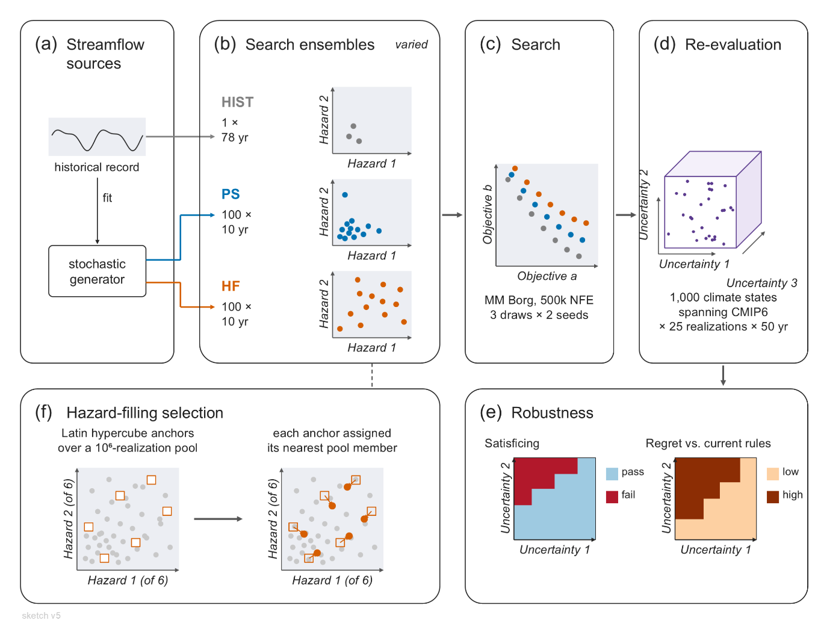
Figure 1: Graphical overview of the proposed methodology. (a) The stochastic streamflow generator fitted to the historical record. (b) The three scenario designs for the search ensemble. (c) Many-objective search with MM Borg under an equal function-evaluation budget for each design. (d) Re-evaluation of every Pareto-approximate policy on the common ensemble of deeply uncertain future streamflow conditions. (e) Satisficing robustness and regret relative to the current FFMP policy, compared across designs. (f) The hazard filling selection step.

3.1 Scenario Designs for Optimization Search
Three scenario designs for the search ensemble are compared (Table 1). The HIST design simulates the reconstructed historical record as one continuous 78-year realization, December 1945 through November 2023, and is taken from Amestoy et al. (2026). Evaluating operational alternatives over the historical record is long-standing practice (Giuliani et al., 2016; Herman et al., 2020), and the record includes the 1960s drought of record, so every candidate policy is evaluated against a multi-year drought that depletes combined NYC storage under current operations (Amestoy et al., 2026). The MC design consists of $N$ realizations of $L$ years drawn independently from a stationary stochastic generator and held fixed during the search, the standard ensemble construction of stochastic policy search (Quinn et al., 2017; Zatarain Salazar et al., 2017; Murgatroyd and Hall, 2021). The HF design selects $N$ realizations of length $L$ from a large candidate ensemble generated by the same stationary generator, chosen so that the selected realizations present diverse hydrologic conditions and span the basin’s hydrologic hazard space as uniformly as the candidate ensemble permits (Section 3.2). The MC and HF designs are constructed from the same generator, with the same $N$ and $L$, so any difference between their Pareto-approximate policy sets arises from the difference in the streamflow conditions the two ensembles present during the search.
Table 1: The three alternative designs for the search ensemble.
Design | Construction
Historical (HIST) | The reconstructed 1945 through 2023 historical record from Amestoy et al. (2026).
Monte Carlo (MC) | $N$ = 300 realizations of $L$ = 10 years drawn independently from the stationary stochastic generator.
Hazard Filling (HF) | $N$ = 300 realizations of $L$ = 10 years selected from a candidate ensemble of ${10}^{6}$ realizations generated independently by the same generator, selected for uniform coverage across six hydrologic hazard metrics (Section 3.2).

Daily, multi-site streamflow realizations are generated in two stages, with monthly flows generated using the method from Kirsch et al. (2013) and disaggregated to daily flows by nearest-neighbor resampling of historical streamflow sequences (Nowak et al., 2010). The generator is fitted to the reconstructed 1945 through 2023 record, and its fitted statistics are not perturbed to represent climate change, so the generator is stationary and all variation in hazard conditions across its output arises from natural variability.
Deeply uncertain climate or demand factors are not sampled within the search ensemble, in contrast to optimization under sampled deep uncertainties (Trindade et al., 2017; Bartholomew and Kwakkel, 2020). Holding every search ensemble to one well-characterized stationary population isolates the effect of the construction of the search ensemble. No design samples the deeply uncertain streamflow-change factors of the re-evaluation, so any difference in re-evaluated robustness arises from the hazard conditions each ensemble presented during the search rather than from exposure to the re-evaluation's streamflow-change conditions. The six hazard metrics of Section 3.2 are also computed on the re-evaluation ensemble, in consecutive 10-year windows of its realizations with the same six-month exclusion as the search ensembles, so the overlap between the hazard conditions each search ensemble presented and those the re-evaluation generates is reported on the same basis alongside the results. Deeply uncertain streamflow change is introduced only in the re-evaluation of the Pareto-approximate policies (Section 3.5).
The MC and HF designs each use $N$ = 300 realizations of $L$ = 10 years, so each function evaluation simulates 3,000 years of streamflow. The ensemble size was set by initial diagnostics that evaluated a library of fixed candidate policies over several thousand realizations and composed replicate ensembles of $N$ = 50 to 500 realizations from them, measuring for each objective the sampling noise in the objective value of a policy and in the difference between two policies. The criterion was that the noise in the difference between policies be no larger than half of the precision specified for that objective during the search, the epsilon of Table 4 below which two policies are treated as equivalent, so that policy rankings during the search reflect performance differences rather than sampling variability, following the ensemble-size reasoning of Zatarain Salazar et al. (2017). The objectives defined by the worst first-percentile year (Section 3.3.2) required the largest ensembles, and their criterion was met at $N$ = 300 and not at $N$ = 200. The replicate ensembles of the HF design are constructed from independent candidate ensembles and independent Latin hypercube targets, and the spread of each objective across these replicates is reported alongside the paired bootstrap and the seed-trial spread of Section 3.4 as an indication of how much of a difference between designs could arise from the particular ensemble draw.
We use 10-year realizations, a design choice that keeps the drought and flood hazard metrics of Section 3.2 tied to individual events. Each realization is characterized by its largest drought event, the event with the largest accumulated deficit, and by its largest flood pulse, the pulse containing the realization's maximum daily flow, so a 10-year realization is described by one drought and one flood and its position in the hazard space has a direct physical meaning. A longer realization would contain many droughts and floods, and its hazard metrics would have to aggregate across them, obscuring the differences between realizations on which the HF selection relies. A common realization length is also required for the two matched designs, since a different length would confound the construction of the ensemble with the length of its record. A 10-year realization is still long enough to contain a drought of the duration of the 1960s drought together with its onset and recovery (Amestoy et al., 2026), and the 50-year realizations of the re-evaluation ensemble expose every policy to longer sequences of consecutive droughts and floods (Section 3.5). Every realization begins on December 1 with combined NYC storage at 80 percent of capacity, and its first six months, over which the drought index of Section 3.2 accumulates, are excluded from every objective and hazard metric, so each 10-year realization contributes nine scored FFMP-years, June 1 of its first year through May 31 of its last.

3.2 Hazard Metrics and the Proposed Hazard Filling Scenario Design

3.2.1 Hazard Metrics
The HF ensemble construction method is intended to achieve diversity and coverage across the range of hydrologic drought and flood hazards plausible under natural variability. Diversity in this context refers to the variety among the streamflow characteristics across the ensemble members, so that each streamflow realization presents a unique set of hazard conditions relative to other realizations. Coverage in this context means that the selected realizations fill the hazard space along each hazard metric individually and across the metrics jointly. Each term is measured on the constructed ensemble by one metric from the design-of-experiments literature (Section 3.2.2), so that coverage is reported rather than claimed.
The stationary generator produces marginal and joint hazard distributions reflective of the historical record, so an independently sampled ensemble such as the MC design represents hydrologic conditions in proportion to their probability under the generator and concentrates near the central mass of the joint hazard distribution, whereas the HF design seeks uniform coverage across the hazard space (Figure 2). A policy's behavior under extreme conditions can influence the search only if the search ensemble contains those conditions, and the conditions presented during the search have been shown to affect the robustness of the resulting policies when they are re-evaluated on conditions not used during the search (Trindade et al., 2017; Cohen et al., 2021). We therefore hypothesize that policies that perform well across the diverse and extreme streamflow conditions of the HF ensemble will generalize better to the uncertain and unseen conditions of the re-evaluation ensemble than policies found under the MC design.
Constructing an ensemble for coverage deliberately departs from the stochastic hydrology verification and validation literature, which seeks ensembles with the same statistical properties as the record to which the generator is fitted (Stedinger and Taylor, 1982). The HF design instead over-represents extreme conditions relative to their frequency under the generator, so the marginal and joint distributions of its hazard characteristics differ by design from those of the generator. Because every objective is a statistic over the search ensemble, the reliabilities and the mean flood exceedance are, under the HF design, frequencies over the selected realizations rather than probabilities under the generator. We quantify this departure on the constructed ensemble. Each selected realization is given the share of the candidate ensemble whose nearest selected member it is, which is the redistribution rule of scenario reduction (Dupačová et al., 2003), and the effective sample size of those shares (Kish, 1965) states how far the equal-weight ensemble is from the generator's measure. The value for the HF ensemble is compared with those of the MC ensemble and of random subsets of the candidate ensemble of the same size (Section 3.2.2). This weights extreme conditions more heavily, in the same risk-averse spirit as the worst first-percentile statistics of Section 3.3.2, and the ensemble emphasis and the tail statistics compound, because those statistics are then taken over an ensemble that already emphasizes extremes. This departure is intended and confined to the search ensemble, whose role is to present diverse streamflow conditions during the optimization search, and every policy is subsequently evaluated on a common re-evaluation ensemble that preserves the generator's statistics within each SOW (Section 3.5). Deliberately over-representing drought conditions relative to a generator's native frequency has precedent in bottom-up vulnerability assessment (Herman et al., 2016), and prescribing the frequency, intensity, and duration of the droughts in the ensembles on which policies are optimized has been shown to shape the resulting policies (Zaniolo et al., 2023). Emphasizing extremes also has a counterpart in objective formulation, where risk-averse statistics such as the worst first-percentile year focus the search on a policy's performance in its most demanding years (Quinn et al., 2017). The HF design applies the emphasis at the level of the ensemble, so that extreme conditions are present to be measured by those statistics.
Hazard characteristics are calculated from the aggregate inflow to the three NYC reservoirs, because every FFMP operation is conditioned on combined NYC storage, which this inflow governs, and because the directed releases from the NYC reservoirs are the principal regulated contribution to the Montague flow. Six hazard metrics are used to define the hazard space, four characterizing each realization's largest drought event and two characterizing its largest flood pulse (Table 2, Figure 3). Rank correlations calculated on initial stationary ensembles confirm that no pair of the six metrics has a Spearman rank correlation above 0.61 in absolute value, so no metric is redundant with another, although some pairs are moderately correlated, and the six together measure distinct dimensions of the hydrologic hazards, in line with the design goal of achieving hydrologic diversity within the HF ensemble.
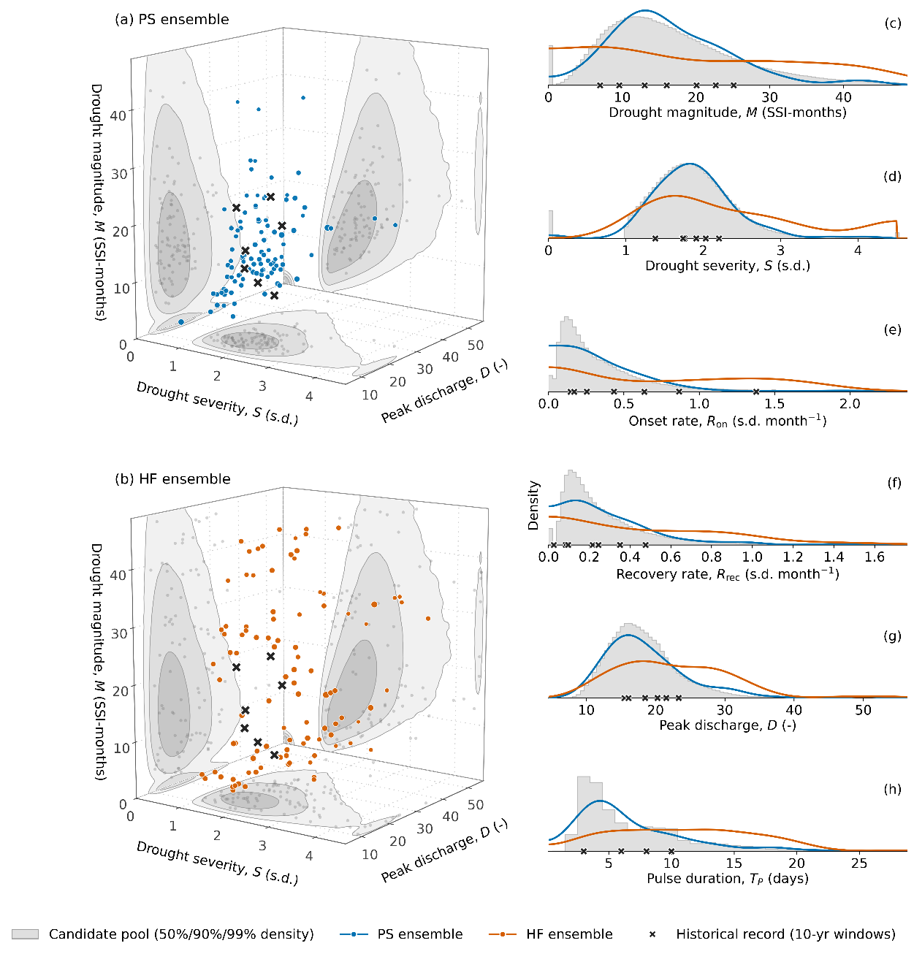
Figure 2: Hazard characteristics of an MC and an HF search ensemble from initial diagnostics at N = 100 (the campaign uses N = 300), shown as three-dimensional scatters over drought severity, drought magnitude, and flood peak discharge for the MC ensemble (a) and the HF ensemble (b), and as marginal densities along all six hazard metrics (c–h), with the candidate ensemble as the gray density and the historical 10-year windows marked. The MC ensemble concentrates where the candidate ensemble is densest, whereas the HF ensemble spreads across the range of every metric.

Table 2: Hazard metrics used to construct the HF ensemble
Metric | Description | Interpretation
Drought magnitude, M (deficit-months) | SSI-6 deficit accumulated over the deficit months of the largest drought event (Van Loon, 2015) | Accumulated deficit of the event
Drought severity, S (standard deviations) | Absolute value of the minimum SSI-6 reached during the event (Van Loon, 2015) | Largest index departure reached during the event
Drought development rate, R_{dev} (per month) | Severity divided by the elapsed months of the development phase, from the month the index crosses below zero to the month of its minimum (Parry, Wilby, et al., 2016) | How rapidly the deficit develops
Drought termination rate, R_{term} (per month) | Severity divided by the elapsed months of the termination phase, from the month of the minimum to the month the index returns above zero (Parry, Wilby, et al., 2016) | How rapidly the deficit terminates
Flood peak discharge, D (dimensionless) | Maximum daily aggregate NYC inflow, normalized by the historical mean daily flow (Brunner and Gilleland, 2020; Brunner, 2023) | Peak of the largest flood pulse
Flood pulse duration, T_{P} (days) | Consecutive days above the historical 95th percentile daily flow in the pulse containing the maximum (Brunner, 2023) | Duration of the largest flood pulse

Drought events are characterized using a 6-month Standardized Streamflow Index (SSI-6) of aggregate NYC inflow (Vicente-Serrano et al., 2012; Tijdeman et al., 2020). The SSI measures accumulated streamflow anomalies in units of standard deviations by fitting a gamma distribution to six-month accumulated flows, separately for each calendar month, and mapping the fitted probabilities to a standard normal distribution. The distributions are fitted to the 1945 through 2023 historical record and held fixed, so a given index value corresponds to the same departure from historical conditions in every realization. Drought events are identified from the monthly index series by a threshold-based definition in which an event begins when the index falls below zero, qualifies as a drought only if the index reaches -1.0, and ends after three consecutive non-negative months (Fleig et al., 2006; Van Loon, 2015). When a realization contains more than one event, the event with the largest accumulated SSI-6 deficit defines its drought hazard.
The four drought metrics (Table 2) are the drought magnitude, the drought severity, and the development and termination rates. Magnitude and severity quantify the accumulated deficit and the largest index departure of an event, and the two rates quantify how rapidly the deficit develops and how rapidly it terminates, aspects of drought behavior to which storage-conditioned rules respond differently. The two rates follow the division of a drought event at its minimum into a development phase and a termination phase (Parry, Prudhomme, et al., 2016; Parry, Wilby, et al., 2016), each rate being the severity divided by the duration of its phase in months. A drought that develops rapidly moves combined storage through successive drought stages within a single season, whereas a drought that terminates slowly prolongs the period over which the reduced diversions and flow targets remain in force, so the placement of the rule curves and the size of the staged reductions are tested differently by the two.
Flood hazards are characterized by a peaks-over-threshold approach calculated using the aggregate NYC inflow against a threshold fixed at the 95th percentile of the historical record's daily flow. This threshold-exceedance approach for characterizing flood peak discharge and duration has been applied to stochastic streamflow ensembles (Brunner and Gilleland, 2020; Brunner, 2023). The flood pulse containing the realization’s maximum daily flow is scored for its peak discharge and its pulse duration (Table 2).
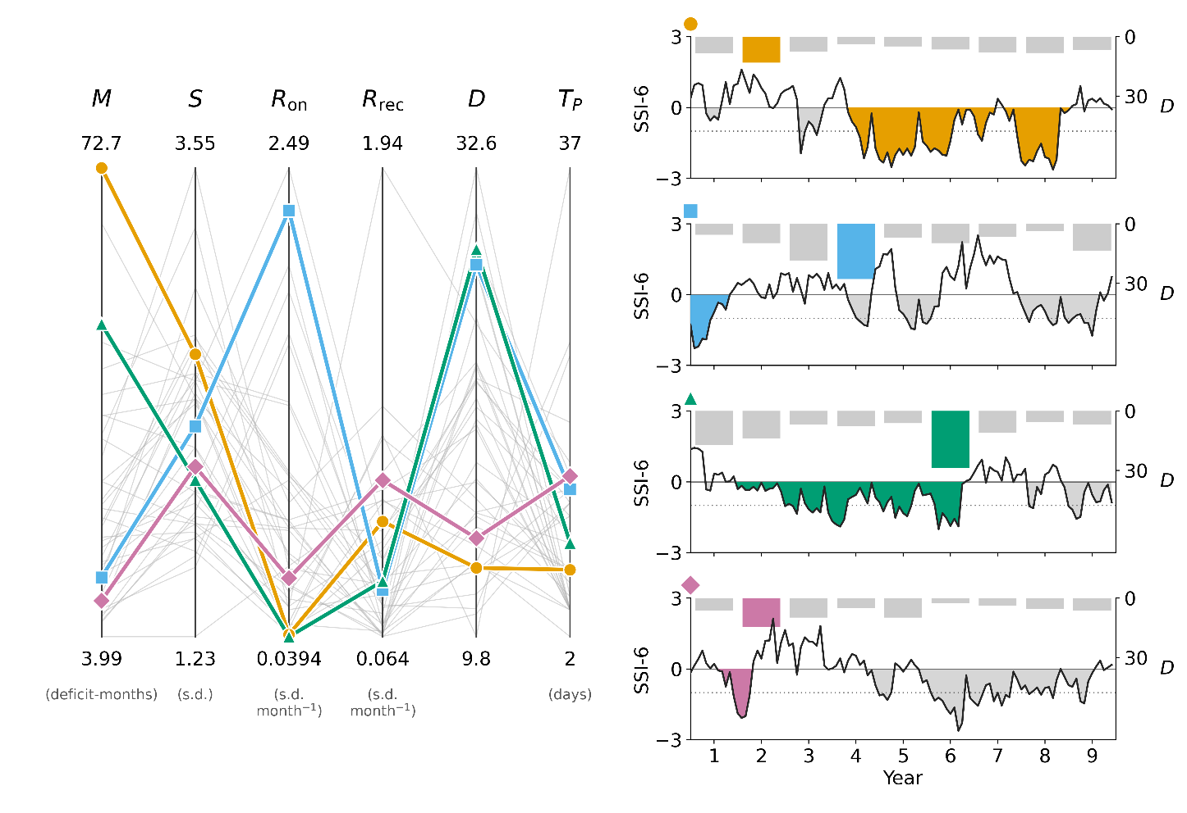
Figure 3: The six hazard metrics illustrated on four example realizations of an HF ensemble. Left, the hazard characteristics of every ensemble member (gray) and of the four examples (color) on parallel axes, one per metric. Right, for each example, the SSI-6 series of aggregate NYC inflow with the largest drought event shaded and the annual peak discharge as bars from the top axis. The drought metrics are computed from the shaded event and the flood metrics from the largest pulse.

3.2.2 Hazard Filling Ensemble Construction
The HF ensemble construction follows four steps (Figure 1f).
First, a candidate ensemble of one million streamflow realizations is generated with the stationary stochastic generator of Section 3.1, an ensemble large enough that the empirical distribution of each hazard metric, including the 1st and 99th percentile bounds used in the third step, is stable with respect to further generation, which is verified over a nested sequence of candidate ensemble sizes.
Second, the six hazard metrics (Table 2) are calculated for each realization in the candidate ensemble.
Third, each hazard metric is scaled by its 1st and 99th percentile bounds across the candidate ensemble, so that no single metric dominates the selection distance.
Fourth, $N$ target hazard characteristics $u_{1},…,u_{N}$ are drawn as a Latin hypercube sample in the scaled space (McKay et al., 2000), and each target is assigned to the nearest unselected streamflow realization in Euclidean distance,
$$x_{\left(i\right)} =\underset{x ∈ C∖\left\{x_{\left(1\right)},…,x_{\left(i-1\right)}\right\}}{\arg{min}} {\left\|\overset{˜}{h}\left(x\right)-u_{i}\right\|}_{2}, i=1,…,N,$$
where $C$ is the candidate ensemble, $\overset{˜}{h}\left(x\right)$ is the vector of scaled hazard characteristics of realization $x$, and $u_{i}$ is the $i$th vector of target hazard characteristics.
The selected realizations form the HF search ensemble (Figure 2). The assignment above is the sequential heuristic for a defined problem. The construction seeks the one-to-one assignment of targets to candidate realizations that minimizes the total target displacement, D(σ)=∑_(i=1)^N ‖u_i-h̃(σ(i))‖, a linear assignment problem (Kuhn, 1955), and the exact assignment is computed for every constructed ensemble so that the displacement of each target under the sequential rule, its gap to the optimum, and the overlap of the two selected sets are reported rather than assumed. Selecting streamflow realizations whose measured attributes approximate a Latin hypercube design follows conditioned Latin hypercube sampling (Minasny and McBratney, 2006).
The design's goal terms are measured on every constructed ensemble in the scaled hazard space and reported against random subsets of the candidate ensemble of the same size, because the uniform cube is not attainable by a correlated candidate ensemble. Coverage is the minimax distance of the selected set relative to the candidate ensemble, the largest distance from any candidate realization to its nearest selected member (Johnson et al., 1990; Pronzato and Müller, 2012), together with the Kolmogorov–Smirnov distance of each scaled marginal from the uniform distribution. Diversity is measured by the edge lengths of the minimum spanning tree of the selected set, whose mean summarizes the spacing of the members and whose minimum is the closest pair (Franco et al., 2009; Bonham et al., 2024). Range is the span attained on each axis as a fraction of the candidate ensemble's 1st to 99th percentile interval, with the number of members beyond the largest historical value on that axis. The same statistics for the Latin hypercube targets themselves show what the assignment to real realizations costs, and the stability of the 1st and 99th percentile bounds is verified over nested subsets of the candidate ensemble.

3.3 Many-Objective Problem Formulation
The re-optimization is formulated as an eight-objective problem with 36 decision variables that parameterize the 2017 FFMP operating rules. Section 3.3.1 defines the decision variables and Section 3.3.2 defines the objectives.

3.3.1 Decision Variables
The decision variables parameterize the FFMP's operating rules while preserving the rule structure, including the storage-conditioned zones, the seasonal form of the rule curves, and the running-average accounting of the NYC and NJ diversions. They fall into six groups (Table 3), acting on the six rule curves of Section 2.2, the staged reductions of the three drought stages, the spill mitigation releases, and the conservation release schedules.

Table 3: Decision variables used for the FFMP operational formulation.
Decision Variable Group | No. DVs | Description
Rule curve vertical shifts | 9 | Vertical shifts of the lower seasonal plateau of each of the six rule curves and of the upper plateau of the three drought-stage curves, within 10 percent of combined capacity.
Rule curve temporal shifts | 6 | Shifts the seasonal timing of each of the six rule curves by up to 30 days.
Drought zone staged NYC & NJ diversion reductions | 5 | Fractional reduction of the NYC diversion allowance in each of the three drought stages and of the NJ allowance in Drought Warning and Drought Emergency, each bounded around its 2017 value.
Montague & Trenton flow target reductions | 6 | Multiplier on the FFMP's drought-stage reduction of the Montague and Trenton flow targets in each of the three drought stages, capped so that a target never exceeds its normal-zone value.
Spill mitigation releases | 6 | Scale on the prescribed spill mitigation release of each of the three reservoirs in each of the two sub-zones of the spill mitigation zone in which such releases are made.
Conservation release seasonal scales | 4 | Seasonal multipliers on the reservoirs’ conservation release schedules for winter, spring, summer, and fall, bounded by the range of release rates that the FFMP's own schedules span.

The problem formulation maintains the constraints established by the 1954 Decree and the DRBC Water Code. The 800 MGD NYC and 100 MGD NJ diversion allocations, the 1,750 cfs Montague flow target, and the 3,000 cfs Trenton flow target are preserved in the normal zone, and these allocations and targets are altered only through the negotiated drought-stage reductions that the FFMP applies as storage declines. The reservoirs’ maximum discharges are fixed, and the conservation release schedules are varied only through the seasonal scales of Table 3. Every decision variable is bounded to a limited range around its 2017 FFMP value, so the search explores modest modifications of the current operating rules.

3.3.2 Objectives
We define eight objectives that cover a range of stakeholder priorities encoded in the basin's governance (Table 4). The objectives reflect interest in NYC water supply (diversion reliability and diversion deficit), the Decree flow obligation at Montague (flow reliability and flow deficit), the Trenton flow target, downstream flood exposure, NYC reservoir storage, and the NJ diversion. The Trenton flow target is represented by a reliability objective alone. The Trenton flow is supported by DRBC-directed releases from the lower-basin reservoirs as well as by the NYC releases, and initial diagnostics showed that the depth of Trenton shortfalls varies little across candidate FFMP policies, so a Trenton deficit objective would not discriminate among them.
Every diversion and flow objective is scored against the obligations of the 1954 Decree and the Water Code rather than against the FFMP's drought-reduced targets, so that a policy's own drought curtailments cannot lower the standard against which it is scored. For the diversions, the obligation on a given day is not a fixed quantity, because the Decree limits the running average of each diversion rather than any single day's withdrawal. NYC's allowance accrues under an annual running average that resets each June 1 and NJ's under a monthly running average, so the volume a party is entitled to on a given day depends on the allowance accrued through its prior diversions. Each day's diversion obligation is therefore the entitlement reconstructed at the full 800 MGD or 100 MGD allocation and taken as the smaller of that day's demand and the accrued allowance. Unsatisfied demand above the Decree allocation is never counted as a shortfall.
Every objective is computed from the daily simulation output through the same two-stage aggregation over FFMP-years, each running from June 1 through May 31. A within-year operator $Φ$ reduces each FFMP-year of each realization to one annual value, and an across-year statistic $Ψ$ summarizes the annual values across all realizations of the ensemble,
$$J_{d} = Ψ_{\left(r,y\right)}\left[ Φ_{t∈y}\left[ g_{d}\left(t,r\right) \right] \right],$$
where $g_{d}\left(t,r\right)$ is the daily quantity underlying objective $d$ on day $t$ of realization $r$. This operator composition follows the aggregation formalism of the many-objective reservoir literature, in which $Ψ$ is a statistic used to filter the noise across ensemble members (Quinn et al., 2017, 2018; Zatarain Salazar et al., 2017).
The four reliability objectives measure the frequency with which an obligation is met (Hashimoto et al., 1982; Zeff et al., 2014). The obligation is the diversion entitlement defined above for the NYC and NJ diversions and the flow target for the Montague and Trenton flows. A week meets its obligation when the delivered diversion or the weekly mean flow is at least 99 percent of the obligation. For each reliability objective, $Φ$ is an annual failure indicator that registers a failure when the number of weeks in the year that fail to meet the obligation reaches $k$, and $Ψ$ is the frequency of non-failure years across the pooled years of all realizations (Zeff et al., 2014; Trindade et al., 2017). NYC diversion reliability and Montague flow reliability use $k=3$ failure weeks, and Trenton flow reliability and NJ diversion reliability use $k=1$.
The two deficit objectives measure the depth of the failures that the corresponding reliability objectives count, a vulnerability measure in the sense of Hashimoto et al. (1982). The weekly deficit is the shortfall below the obligation value. Within each year, $Φ$ is the conditional value-at-risk of the weekly deficits at the 90 percent level (${\text{CvaR}}_{90}$), the mean of the worst 10 percent of weeks in that year (Rockafellar and Uryasev, 2000). This statistic characterizes the depth of a year’s worst shortfalls while averaging over several weeks, so the annual value is less sensitive to a single week than the annual maximum would be. Across years, $Ψ$ is the worst first-percentile year across the pooled years of all realizations, a tail statistic that is more stable than the single worst year (Quinn et al., 2017, 2018). For the HIST design, whose single realization provides 77 scored FFMP-years, this percentile reduces to the worst year.
The downstream flood exceedance objective is the mean annual accumulation of river stage above the National Weather Service minor flood stage at three reservoir tailwater gauges, taking the maximum across gauges each day so that one basin-wide flood event is not counted three times. The NYC minimum storage objective is the worst first-percentile year of the annual minimum of combined NYC storage, which protects the drought reserve.

Table 4: The eight objectives used during MOEA search of NYC reservoir operational rules.
Objective (preference) | $g_{d}$  (Value of interest) | $Φ$  (Annual performance metric) | $Ψ$  (Multi-year aggregation metric) | $$ε$$
NYC diversion reliability (max) | NYC diversion relative to the running-average entitlement, weekly | failure indicator (3 or more failure weeks) | frequency of non-failure years | 0.05
NYC diversion deficit (min) | NYC diversion shortfall in percent of entitlement, weekly | within-year CVaR${}_{90}^{​}​$ of weekly deficit | worst first-percentile year | 10.0
Montague flow reliability (max) | mean flow at Montague relative to the 1,750 cfs target, weekly | failure indicator (3 or more failure weeks) | frequency of non-failure years | 0.05
Montague flow deficit (min) | Montague flow shortfall in percent of target, weekly | within-year CVaR${}_{90}^{​}​$ of weekly deficit | worst first-percentile year | 10.0
Trenton flow reliability (max) | mean flow at Trenton relative to the 3,000 cfs target, weekly | failure indicator (1 or more failure weeks) | frequency of non-failure years | 0.05
Downstream flood exceedance (min) | maximum across three tailwater gauges of stage above the minor flood stage, daily | annual ft-day exceedance | mean across years | 0.3
NYC minimum storage (max) | combined NYC storage in percent of capacity, daily | annual minimum daily storage | worst first-percentile year | 5.0
NJ diversion reliability (max) | NJ diversion relative to the running-average entitlement, weekly | failure indicator (1 or more failure weeks) | frequency of non-failure years | 0.05

3.4 Search Configuration
All searches use MM Borg (Hadka and Reed, 2013, 2015), a self-adaptive MOEA that combines an $ε$-dominance archive, $ε$-progress triggered restarts with adaptive population sizing, and auto-adaptive multi-operator search in which the selection probabilities of the search operators adapt to the operators that contribute new Pareto-approximate solutions. Borg's search has proven reliable across many-objective water resources applications (Reed et al., 2013; Zatarain Salazar et al., 2016, 2017). The multi-master implementation is a hierarchical parallelization in which several islands, each a master-worker instance of the Borg MOEA, co-evolve through a controller that maintains a global $ε$-dominance archive and global operator probabilities and provides guidance to an island whose local restarts fail to escape stagnation (Hadka and Reed, 2015).
The FFMP re-optimization is performed for each scenario design as two random seed trials, to account for variability in initial populations and operator probabilities (Zatarain Salazar et al., 2017), a seed count set by the cost of each evaluation and following the precedent of Bartholomew and Kwakkel (2020) and Gold et al. (2023). Each seed trial uses a four-island configuration of MM Borg on twelve nodes of the Purdue Anvil system, with MM Borg’s default parameterization and a budget of 500,000 function evaluations (NFE), 125,000 per island. The first seed trial of each design is extended to 187,500 function evaluations per island, and its runtime hypervolume is tracked to verify that the Pareto-approximate set has reached diminishing returns by 125,000 function evaluations per island. The archives of the two seed trials at the equal budget of 125,000 function evaluations per island are combined and re-sorted into a best known Pareto-approximate set for each scenario design. Objective values attained during the search are specific to the search ensemble on which they were computed, so the Pareto-approximate sets are not compared across designs on their search objective values, and every cross-design comparison is made on the common re-evaluation ensemble of Section 3.5. Differences between designs in re-evaluated robustness and regret are judged against a paired bootstrap over the SOWs of the re-evaluation ensemble, with the spread between the two seed trials of each design as a further indication of search variability. Whether the performance of each matched design's Pareto-approximate set is sensitive to the particular draw of its search ensemble is tested by re-evaluating the set on two further draws of the same design.

3.5 Robustness and Regret Under Uncertain Future Hydroclimate Conditions

3.5.1 Re-Evaluation Under Uncertainty
The basin's natural hydroclimatic variability is well characterized, with the reconstructed 1945 through 2023 record supporting the fitted stochastic streamflow generator, whereas the size and seasonal structure of future streamflow change are deeply uncertain, because climate model projections for the basin disagree across a wide range of conditions. Demand growth is not included as an uncertainty, because the 1954 Decree establishes a legally binding upper bound on the NYC diversion, the dominant demand on the reservoirs, so the deeply uncertain factors sampled in this study are limited to changes in streamflow conditions.
Following the deep uncertainty re-evaluation step of MORDM (Kasprzyk et al., 2013; Herman et al., 2014; Trindade et al., 2017; Gold et al., 2023), every design's Pareto-approximate set is re-evaluated on an ensemble constructed to span a range of streamflow change inferred from an ensemble of downscaled and bias-corrected climate model projections (Coupled Model Intercomparison Project Phase 6; CMIP6). For each CMIP6 ensemble member, we calculate the relative change in monthly mean streamflow and represent the resulting seasonal profile of change factors by a two-harmonic function (Figure 4). The phases of both harmonics are fixed at the seasonal shape common to the CMIP6 profiles, so three amplitude parameters govern annual flow volume, seasonal amplitude, and the shape of the snowmelt shoulder. The two-harmonic form captures the 54 CMIP6 profiles with a median coefficient of determination of 0.85. The sampled range of each parameter is the full range of the CMIP6-fitted values widened by one quarter of that range at each end, so the re-evaluation ensemble envelops every projection and extends beyond the driest and the wettest of them, spanning mean annual flow volumes from roughly 13 percent below to 32 percent above the historical mean.
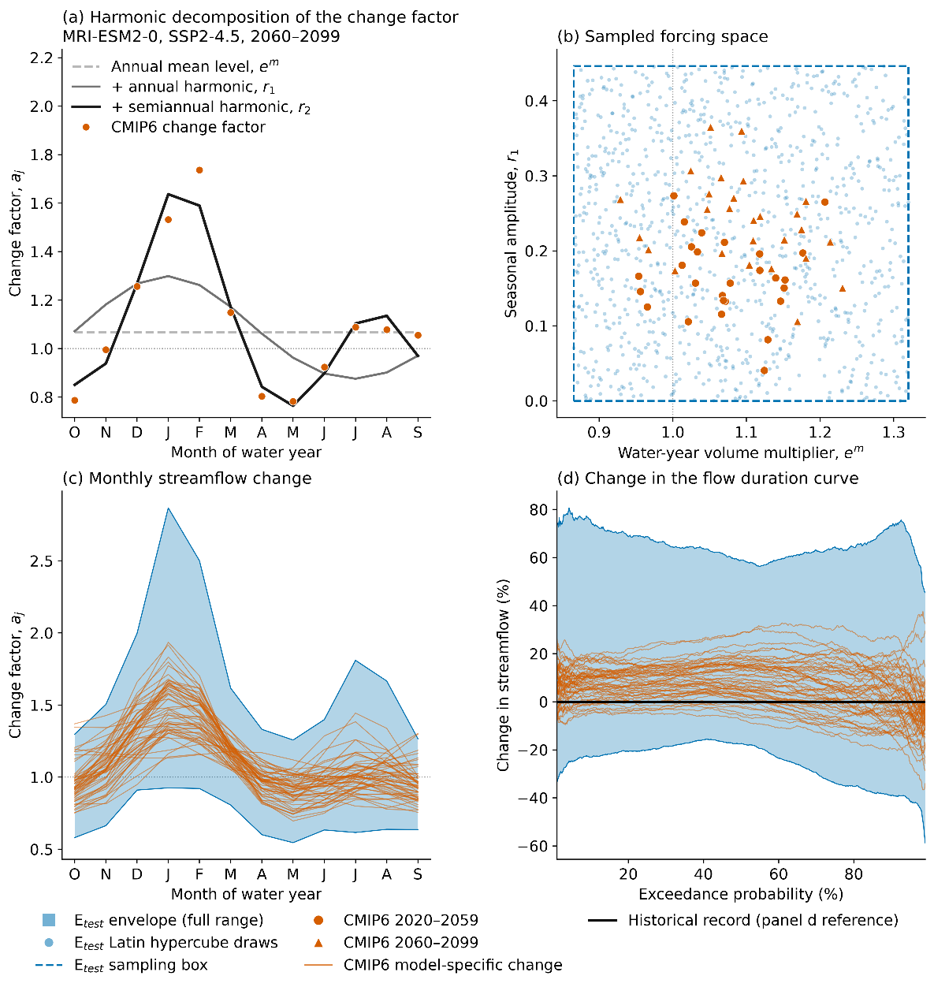
Figure 4: Construction of the uncertain future streamflow space. (a) Harmonic decomposition of one example CMIP6 monthly streamflow change-factor profile. (b) Two dimensions of the three-dimensional uncertainty space, with CMIP6-fitted parameters in orange and the Latin hypercube sampling envelope of the re-evaluation ensemble, labeled $E_{test}$ in the legend, in blue. (c) The monthly change-factor envelope implied by the sampled space against the CMIP6 model profiles. (d) The corresponding change in the flow duration curve relative to the historical record.
Each SOW is one sampled set of harmonic parameters, corresponding to one monthly profile of streamflow change. We generate 500 SOWs by Latin hypercube sampling across the three-dimensional parameter range, and for each SOW we generate 50 stochastic realizations of 50 years that sample natural variability within that SOW, 25,000 realizations and 1,250,000 years of simulated streamflow in all. The number of SOWs follows Bonham et al. (2024), who found that policy rankings under satisficing metrics were accurate with 50 to 300 sampled SOWs and under a regret metric with 400 or more. Initial diagnostics on the re-evaluation ensemble indicate that natural variability across the 50 realizations of a SOW produces droughts beyond any in the historical record and that the driest SOWs extend the drought hazard beyond the range of the stationary candidate ensemble, and the overlap between the search and re-evaluation hazard conditions is reported with the hazard-metric computation of Section 3.1. Because the search ensembles are drawn from the unperturbed stationary generator while the re-evaluation ensemble spans a range of future streamflow changes, the re-evaluation tests whether the policies produced under each scenario design generalize to streamflow conditions absent from every search.

3.5.2 Robustness and Regret Metrics and Scenario Discovery
To answer the research questions, the eight objectives of Section 3.3.2 are recomputed for every Pareto-approximate policy from all three scenario designs in each of the 500 SOWs, and this per-SOW performance is used to measure satisficing robustness and regret relative to the current FFMP policy.
Robustness is measured as satisficing robustness under the domain criterion of Starr (1963), the fraction of sampled SOWs in which a policy meets a set of performance thresholds,
$$S\left(x\right) = \frac{1}{N_{θ}}\sum_{θ}{\prod_{i}{1}}​\left[ J_{i}\left(x,θ\right) \text{meets} c_{i} \right],$$
where $J_{i}\left(x,θ\right)$ is objective $i$ recomputed in SOW $θ$ and $c_{i}$ is its satisficing criterion. The fraction is computed jointly across the objectives that carry a criterion, so a SOW counts only when every criterion is met. This multivariate satisficing measure is common in the regional water planning literature (Herman et al., 2014, 2015; Trindade et al., 2017; Gold et al., 2023) and requires fewer SOWs than other measures for a stable policy ranking (Bonham et al., 2024). Because the choice of robustness measure is known to change policy rankings (Herman et al., 2015; Giuliani and Castelletti, 2016; McPhail et al., 2018), per-objective satisficing fractions, the mean across SOWs, and the worst SOW will also be reported. Each criterion is placed at the Decree or FFMP quantity that defines acceptable performance where one exists, such as the Drought Emergency storage boundary for minimum storage, and otherwise at the performance the current FFMP policy attains on the re-evaluation ensemble. The final placements will be set from the re-evaluation of the current FFMP policy.
Regret is measured for every Pareto-approximate policy relative to the current FFMP policy evaluated in the same SOW. The current FFMP policy therefore serves as a fixed reference in each SOW, the form of regret measured against a prespecified status quo rather than against the best policy in each SOW (Herman et al., 2015; McPhail et al., 2018). Regret in a SOW means that at least one Decree Party would have fared better in that future by maintaining current operations. Regret is reported per objective, and the low-regret frequency of a policy summarizes it across objectives as the fraction of SOWs in which no objective is degraded beyond a specified tolerance $τ_{i}$,
$$Π_{τ}\left(x\right) = \frac{1}{N_{θ}}\sum_{θ}{\prod_{i}{1}}​\left[ D_{i}\left(x,θ\right)≥-τ_{i} \right],$$
where $D_{i}\left(x,θ\right)$ is the per-SOW difference in performance relative to the current FFMP policy. A SOW in which every objective performs as well as or better than the current FFMP policy, within the tolerance, is a low-regret SOW, so the frequency is computed jointly across the objectives, and per-objective regret frequencies are also reported. The tolerance for each objective is set from initial diagnostics of the sampling variability of the current FFMP policy's own re-evaluated objective values across the realizations within a SOW, at a level that limits spurious regret arising from that variability alone to 5 percent of SOWs. The adopted tolerances are 0.02 for the reliability objectives, 2 percentage points for the deficit objectives, 0.25 ft-days per year for flood exceedance, and 5 percentage points for minimum storage. The cross-objective formulation reflects the requirement that any modification of the FFMP obtain unanimous consent of the Decree Parties, which is most plausible for a policy that maintains or improves performance for every party.
Finally, we use scenario discovery to identify the uncertain streamflow conditions associated with non-satisficing outcomes and with SOWs that are not low-regret. Each SOW is classified as a success or failure for a given policy under the satisficing criteria and under the low-regret condition, and gradient-boosted tree classifiers are fitted to the labeled SOWs to partition the parameterized uncertainty space into predicted regions of success and failure.

References
Amestoy, T. J., Hamilton, A. L., & Reed, P. M. (2026). Integrated river basin assessment framework combining probabilistic streamflow reconstruction, Bayesian bias correction, and drought storyline analysis. Environmental Modelling & Software, 195, 106756.
Bartholomew, E., & Kwakkel, J. H. (2020). On considering robustness in the search phase of Robust Decision Making: A comparison of Many-Objective Robust Decision Making, multi-scenario Many-Objective Robust Decision Making, and Many Objective Robust Optimization. Environmental Modelling & Software, 127, 104699.
Bonham, N., Kasprzyk, J., Zagona, E., & Rajagopalan, B. (2024). Subsampling and space-filling metrics to test ensemble size for robustness analysis with a demonstration in the Colorado River Basin. Environmental Modelling & Software, 172, 105933.
Brodeur, Z. P., Herman, J. D., & Steinschneider, S. (2020). Bootstrap aggregation and cross-validation methods to reduce overfitting in reservoir control policy search. Water Resources Research, 56(8), e2020WR027184.
Brunner, M. I. (2023). Floods and droughts: A multivariate perspective. Hydrology and Earth System Sciences, 27(13), 2479–2497.
Brunner, M. I., & Gilleland, E. (2020). Stochastic simulation of streamflow and spatial extremes: A continuous, wavelet-based approach. Hydrology and Earth System Sciences, 24(8), 3967–3982.
Cohen, J. S., Zeff, H. B., & Herman, J. D. (2021). How do the properties of training scenarios influence the robustness of reservoir operating policies to climate uncertainty? Environmental Modelling & Software, 141, 105047.
Decree Parties. (2017). Flexible Flow Management Program, Appendix A: 2017 Operations Plan. States of Delaware, New Jersey, and New York, Commonwealth of Pennsylvania, and City of New York.
Dupačová, J., Gröwe-Kuska, N., & Römisch, W. (2003). Scenario reduction in stochastic programming: an approach using probability metrics. Mathematical Programming, 95(3), 493–511.
Eker, S., & Kwakkel, J. H. (2018). Including robustness considerations in the search phase of Many-Objective Robust Decision Making. Environmental Modelling & Software, 105, 201–216.
Fleig, A. K., Tallaksen, L. M., Hisdal, H., & Demuth, S. (2006). A global evaluation of streamflow drought characteristics. Hydrology and Earth System Sciences, 10(4), 535–552.
Franco, J., Vasseur, O., Corre, B., & Sergent, M. (2009). Minimum spanning tree: a new approach to assess the quality of the design of computer experiments. Chemometrics and Intelligent Laboratory Systems, 97(2), 164–169.
Giuliani, M., & Castelletti, A. (2016). Is robustness really robust? How different definitions of robustness impact decision-making under climate change. Climatic Change, 135(3–4), 409–424.
Giuliani, M., Castelletti, A., Pianosi, F., Mason, E., & Reed, P. M. (2016). Curses, tradeoffs, and scalable management: Advancing evolutionary multiobjective direct policy search to improve water reservoir operations. Journal of Water Resources Planning and Management, 142(2), 04015050.
Giuliani, M., Lamontagne, J. R., Reed, P. M., & Castelletti, A. (2021). A state-of-the-art review of optimal reservoir control for managing conflicting demands in a changing world. Water Resources Research, 57(12), e2021WR029927.
Gold, D. F., Reed, P. M., Gorelick, D. E., & Characklis, G. W. (2023). Advancing regional water supply management and infrastructure investment pathways that are equitable, robust, adaptive, and cooperatively stable. Water Resources Research, 59(9), e2022WR033671.
Hadjimichael, A., Quinn, J., Wilson, E., Reed, P., Basdekas, L., Yates, D., & Garrison, M. (2020). Defining robustness, vulnerabilities, and consequential scenarios for diverse stakeholder interests in institutionally complex river basins. Earth's Future, 8(7), e2020EF001503.
Hadka, D., & Reed, P. (2013). Borg: An auto-adaptive many-objective evolutionary computing framework. Evolutionary Computation, 21(2), 231–259.
Hadka, D., & Reed, P. (2015). Large-scale parallelization of the Borg multiobjective evolutionary algorithm to enhance the management of complex environmental systems. Environmental Modelling & Software, 69, 353–369.
Hamilton, A. L., Amestoy, T. J., & Reed, P. M. (2024). Pywr-DRB: An open-source Python model for water availability and drought risk assessment in the Delaware River Basin. Environmental Modelling & Software, 181, 106185.
Hashimoto, T., Stedinger, J. R., & Loucks, D. P. (1982). Reliability, resiliency, and vulnerability criteria for water resource system performance evaluation. Water Resources Research, 18(1), 14–20.
Herman, J. D., Quinn, J. D., Steinschneider, S., Giuliani, M., & Fletcher, S. (2020). Climate adaptation as a control problem: Review and perspectives on dynamic water resources planning under uncertainty. Water Resources Research, 56(2), e24389.
Herman, J. D., Reed, P. M., Zeff, H. B., & Characklis, G. W. (2015). How should robustness be defined for water systems planning under change? Journal of Water Resources Planning and Management, 141(10), 04015012.
Herman, J. D., Zeff, H. B., Lamontagne, J. R., Reed, P. M., & Characklis, G. W. (2016). Synthetic drought scenario generation to support bottom-up water supply vulnerability assessments. Journal of Water Resources Planning and Management, 142(11), 04016050.
Herman, J. D., Zeff, H. B., Reed, P. M., & Characklis, G. W. (2014). Beyond optimality: Multistakeholder robustness tradeoffs for regional water portfolio planning under deep uncertainty. Water Resources Research, 50(10), 7692–7713.
Hilbers, A. P., Brayshaw, D. J., & Gandy, A. (2019). Importance subsampling: Improving power system planning under climate-based uncertainty. Applied Energy, 251, 113114.
Hogarty, R. A. (1970). The Delaware River drought emergency (ICP Case Series No. 107). Bobbs-Merrill, Indianapolis, IN.
Johnson, M. E., Moore, L. M., & Ylvisaker, D. (1990). Minimax and maximin distance designs. Journal of Statistical Planning and Inference, 26(2), 131–148.
Kasprzyk, J. R., Nataraj, S., Reed, P. M., & Lempert, R. J. (2013). Many objective robust decision making for complex environmental systems undergoing change. Environmental Modelling & Software, 42, 55–71.
Kirsch, B. R., Characklis, G. W., & Zeff, H. B. (2013). Evaluating the impact of alternative hydro-climate scenarios on transfer agreements: Practical improvement for generating synthetic streamflows. Journal of Water Resources Planning and Management, 139(4), 396–406.
Kish, L. (1965). Survey sampling. John Wiley & Sons, New York.
Kolesar, P., & Serio, J. (2011). Breaking the deadlock: Improving water-release policies on the Delaware River through operations research. Interfaces, 41(1), 18–34.
Kuhn, H. W. (1955). The Hungarian method for the assignment problem. Naval Research Logistics Quarterly, 2(1–2), 83–97.
Lehner, F., & Deser, C. (2023). Origin, importance, and predictive limits of internal climate variability. Environmental Research: Climate, 2(2), 023001.
Leitman, S., Ahmadisharaf, E., & Brunner, M. I. (2024). Multi-reservoir system response to alternative stochastically simulated stationary hydrologic scenarios: An evaluation for the Apalachicola-Chattahoochee-Flint (ACF) Basin. Journal of Hydrology: Regional Studies, 51, 101608.
Lempert, R. J., Popper, S. W., & Bankes, S. C. (2003). Shaping the next one hundred years: New methods for quantitative, long-term policy analysis. RAND Corporation, Santa Monica, CA.
McKay, M. D., Beckman, R. J., & Conover, W. J. (2000). A comparison of three methods for selecting values of input variables in the analysis of output from a computer code. Technometrics, 42(1), 55–61.
McPhail, C., Maier, H. R., Kwakkel, J. H., Giuliani, M., Castelletti, A., & Westra, S. (2018). Robustness metrics: How are they calculated, when should they be used and why do they give different results? Earth's Future, 6(2), 169–191.
Minasny, B., & McBratney, A. B. (2006). A conditioned Latin hypercube method for sampling in the presence of ancillary information. Computers & Geosciences, 32(9), 1378–1388.
Murgatroyd, A., & Hall, J. W. (2021). Selecting indicators and optimizing decision rules for long-term water resources planning. Water Resources Research, 57(5), e2020WR028117.
New Jersey v. New York, 347 U.S. 995 (1954).
Nowak, K., Prairie, J., Rajagopalan, B., & Lall, U. (2010). A nonparametric stochastic approach for multisite disaggregation of annual to daily streamflow. Water Resources Research, 46(8), W08529.
Parry, S., Prudhomme, C., Wilby, R. L., & Wood, P. J. (2016). Drought termination: concept and characterisation. Progress in Physical Geography, 40(6), 743–767.
Parry, S., Wilby, R. L., Prudhomme, C., & Wood, P. J. (2016). A systematic assessment of drought termination in the United Kingdom. Hydrology and Earth System Sciences, 20(10), 4265–4281.
Pederson, N., Bell, A. R., Cook, E. R., Lall, U., Devineni, N., Seager, R., Eggleston, K., & Vranes, K. P. (2013). Is an epic pluvial masking the water insecurity of the greater New York City region? Journal of Climate, 26(4), 1339–1354.
Pronzato, L., & Müller, W. G. (2012). Design of computer experiments: space filling and beyond. Statistics and Computing, 22(3), 681–701.
Quinn, J. D., Reed, P. M., Giuliani, M., & Castelletti, A. (2017). Rival framings: A framework for discovering how problem formulation uncertainties shape risk management trade-offs in water resources systems. Water Resources Research, 53(8), 7208–7233.
Quinn, J. D., Reed, P. M., Giuliani, M., Castelletti, A., Oyler, J. W., & Nicholas, R. E. (2018). Exploring how changing monsoonal dynamics and human pressures challenge multireservoir management for flood protection, hydropower production, and agricultural water supply. Water Resources Research, 54(7), 4638–4662.
Reed, P. M., Hadka, D., Herman, J. D., Kasprzyk, J. R., & Kollat, J. B. (2013). Evolutionary multiobjective optimization in water resources: The past, present, and future. Advances in Water Resources, 51, 438–456.
Rockafellar, R. T., & Uryasev, S. (2000). Optimization of conditional value-at-risk. The Journal of Risk, 2(3), 21–41.
Seager, R., Pederson, N., Kushnir, Y., Nakamura, J., & Jurburg, S. (2012). The 1960s drought and the subsequent shift to a wetter climate in the Catskill Mountains region of the New York City watershed. Journal of Climate, 25(19), 6721–6742.
Starr, M. K. (1963). Product design and decision theory. Prentice-Hall, Englewood Cliffs, NJ.
Stedinger, J. R., & Taylor, M. R. (1982). Synthetic streamflow generation: 1. Model verification and validation. Water Resources Research, 18(4), 909–918.
Taylor, W., Brodeur, Z. P., Steinschneider, S., Kucharski, J., & Herman, J. D. (2024). Variability, attributes, and drivers of optimal forecast-informed reservoir operating policies for water supply and flood control in California. Journal of Water Resources Planning and Management, 150(10), 05024010.
Tijdeman, E., Stahl, K., & Tallaksen, L. M. (2020). Drought characteristics derived based on the Standardized Streamflow Index: A large sample comparison for parametric and nonparametric methods. Water Resources Research, 56(10), e2019WR026315.
Trindade, B. C., Reed, P. M., Herman, J. D., Zeff, H. B., & Characklis, G. W. (2017). Reducing regional drought vulnerabilities and multi-city robustness conflicts using many-objective optimization under deep uncertainty. Advances in Water Resources, 104, 195–209.
Van Loon, A. F. (2015). Hydrological drought explained. WIREs Water, 2(4), 359–392.
Vicente-Serrano, S. M., López-Moreno, J. I., Beguería, S., Lorenzo-Lacruz, J., Azorin-Molina, C., & Morán-Tejeda, E. (2012). Accurate computation of a streamflow drought index. Journal of Hydrologic Engineering, 17(2), 318–332.
Walker, W. E., Lempert, R. J., & Kwakkel, J. H. (2013). Deep uncertainty. In S. I. Gass & M. C. Fu (Eds.), Encyclopedia of Operations Research and Management Science (3rd ed., pp. 395–402). Springer.
Watson, A. A., & Kasprzyk, J. R. (2017). Incorporating deeply uncertain factors into the many objective search process. Environmental Modelling & Software, 89, 159–171.
Zaniolo, M., Fletcher, S., & Mauter, M. S. (2023). Multi-scale planning model for robust urban drought response. Environmental Research Letters, 18(5), 054014.
Zaniolo, M., Fletcher, S., & Mauter, M. (2024). FIND: A synthetic weather generator to control drought frequency, intensity, and duration. Environmental Modelling & Software, 172, 105927.
Zatarain Salazar, J., Reed, P. M., Herman, J. D., Giuliani, M., & Castelletti, A. (2016). A diagnostic assessment of evolutionary algorithms for multi-objective surface water reservoir control. Advances in Water Resources, 92, 172–185.
Zatarain Salazar, J., Reed, P. M., Quinn, J. D., Giuliani, M., & Castelletti, A. (2017). Balancing exploration, uncertainty and computational demands in many objective reservoir optimization. Advances in Water Resources, 109, 196–210.
Zeff, H. B., Kasprzyk, J. R., Herman, J. D., Reed, P. M., & Characklis, G. W. (2014). Navigating financial and supply reliability tradeoffs in regional drought management portfolios. Water Resources Research, 50(6), 4906–4923.

