Talking word puzzles

User Manual

*Document type :*

🗹 draft

🞎 to be validated

🞎 validated

* Talking Word Puzzles
* User Manual
* JJ Abbott, Mitch Brooks, Trevor Jackson
* This user manual is to be used as a guide for operating and implementing the Talking Word Puzzles application.

Purpose of the document

This document is a user manual for the Talking Word Puzzles application. Talking Word Puzzles is an online application that allows users to create and play crossword puzzles. This application focuses on accessibility for blind and impaired users. This document will provide guidelines for implementing, operating, and navigating the application.

This document is the property of the American Printing House for the Blind

It may not be reproduced or communicated without the author's prior agreement.

Document history

|  |  |  |  |
| --- | --- | --- | --- |
| **Version** | **Date** | **Drafter** | **Description** |
|  |  |  |  |
| 1.0 | 4/12/17 | Mitchell Brooks | Began drafting the document |
|  |  |  |  |
|  |  |  |  |

* 1. 4/12/17 JJ Abbott Added to and revised the document

Distribution

|  |  |  |  |
| --- | --- | --- | --- |
| **Receiver** | | **For**  **validation** | **For**  **information** |
|  |  |  |  |
|  |  |  |  |
|  |  |  |  |

Validation

|  |  |  |
| --- | --- | --- |
| **Representative** | **Validator** | **Date** |
|  |  |  |
|  |  |  |

Contents

Purpose of the document 1

Document history 2

Distribution 2

Validation 2

1. Icons Used in the Manuel 4

2. Presentation of the Solution 4

2.1 Brief description 4

2.2 Descriptives Icons 4

2.3 Project players 4

2.4 Support 4

3. Connecting to the Application 5

3.1 Address 5

3.2 Authentication 5

4. Structuring of the Application 5

4.1 Layout 5

4.2 Menus 7

4.3 Icons / Shortcuts 7

4.4 Functionalities 7

4.4.1 Functionalities Presented/Described 7

4.4.2 Functionalities not Presented/not Described 7

5. puzzle creation screen 8

5.1 Screenshot 8

5.2 Descriptions of fields, content 9

5.3 Description of actions 9

5.4 Sequence of screens 9

6. Puzzle Generation screen 11

6.1 Screenshot 11

6.2 Descriptions of fields, content 11

6.3 Description of actions 11

# Icons Used in the Manuel

These icons are kept here to be used as notifications or points of interest for future versions of documentation. They may or may not be required as the application is updated to future versions.

|  |  |
| --- | --- |
| icono2 | Important information |
| Light Bulb On 32 h g | Good to know - Tricks |
| icono3 | **Risk** in front of a parameter setting or of a specific action |
| icono1 | Action to be avoided |
| icono5 | Mandatory action |
| icono4 | Sensitive or difficult procedure. To take into account necessarily |

# Presentation of the Solution

## Brief description

* The application was designed to be played by the blind and vision impaired. Because of this, comfortable navigation

## Descriptive Icons

* This section is left blank in the current version but is left in case descriptive icons should be added.

## Project players

* American Printing House and affiliates

## Support

*You agree to not modify, reverse engineer, decompile or disassemble the Software or create derivative works from the Software. APH may provide you with support services related to the Software ("Support Services"). Use of Support Services is governed by APH policies and programs, which may change from time to time. Any supplemental software code provided to you as part of the Support Services will be considered part of the Software and subject to the terms and conditions of this Agreement. With respect to technical information you provide to APH [as part of the registration of your license to the Software or] in connection with the Support Services, APH may use such information for its business purposes, including for product support and development.*

# Connecting to the Application

## Address

* The application can be found [here](http://wordpuzzles.aphtech.org/).

## Authentication

* In the current version, no authentication is required to access the application. However, this may be implemented in future versions.

# Structuring of the Application

## Layout

* The general layout of the application is as follows.
* The first screen is the main menu. This page has buttons that will redirect you to the other two screens of the application.

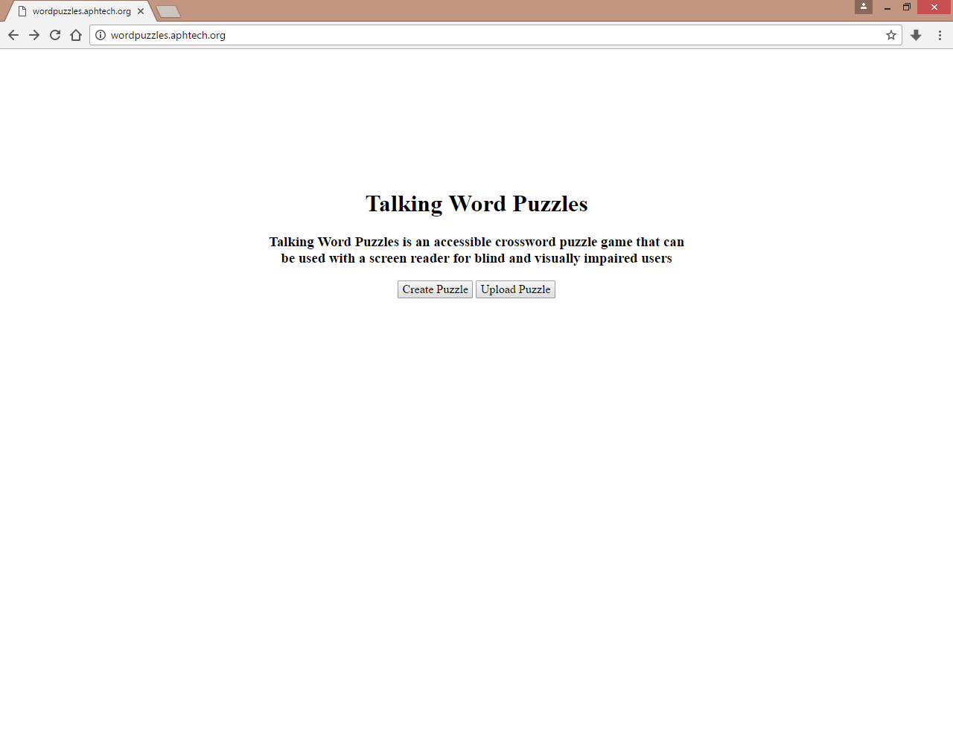

* The next screen is the puzzle creation screen. Using this page allows you to create a crossword puzzle which is used to create an .xwc file which can be uploaded to the final screen of the application.
* 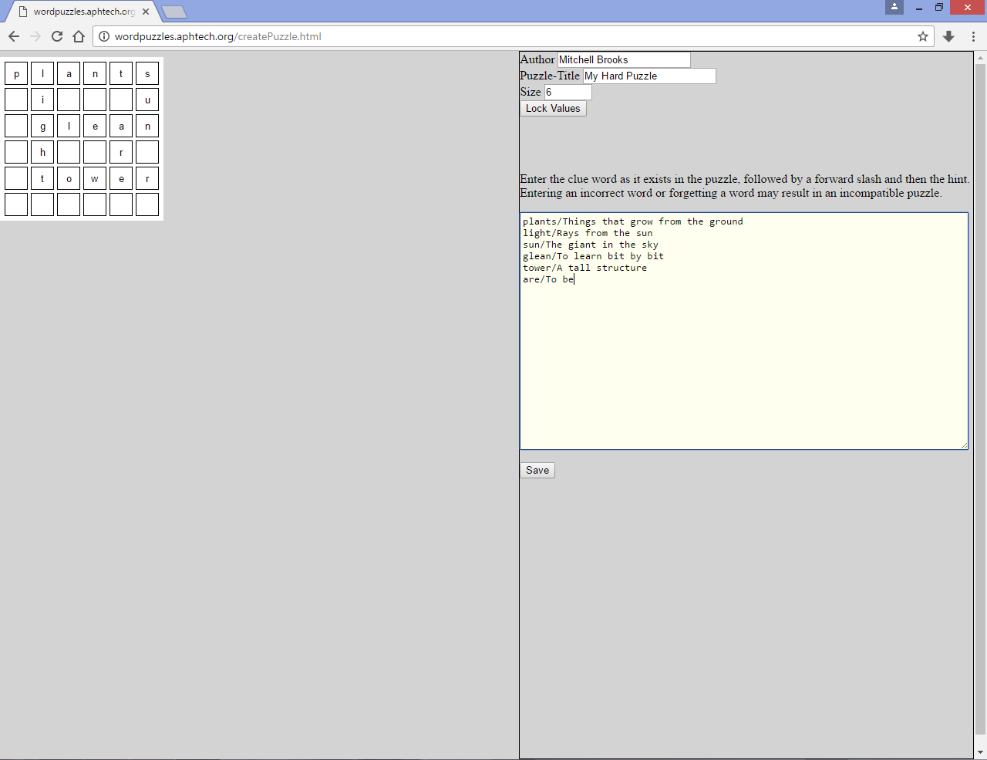
* Lastly, we have the puzzle generation screen. You must upload an .xwc file which this page will use to generate a crossword puzzle with all intended functionality.
* 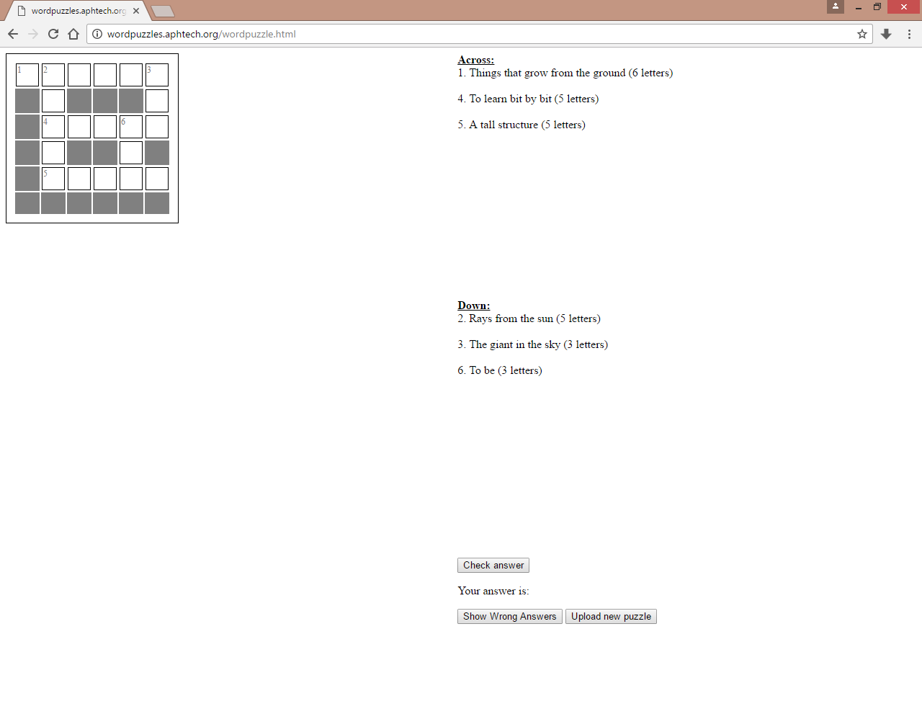

## Menus

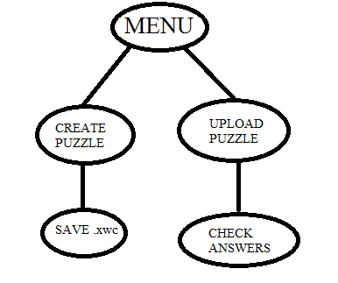

## Icons / Shortcuts

-

## Functionalities

### Functionalities Presented/Described

* Implementation of Puzzle Creation
* Implementation of Gameplay

### Functionalities not Presented/not Described

* Specifications for .xwc file guidelines. A description of using this file type for crossword puzzles can be found at https://github.com/Tw1ddle/Blind-Crossword-3D/wiki/Spoonbill-Crossword-Compiler-(.xwc)-Format-Specification

# Puzzle Creation Screen

* The Puzzle Creation was originally designed to aid in testing the actual game by creating a variety of puzzles differing in size and context. However, this part of the application is healthy enough to be used alongside the actual game for end users. Still, while accessible, the navigation may not be as comfortable as the game itself.
* The Puzzle Creation abstracts the attributes of the .xwc file and allows users to create puzzles in a conventional way.

## Screenshot

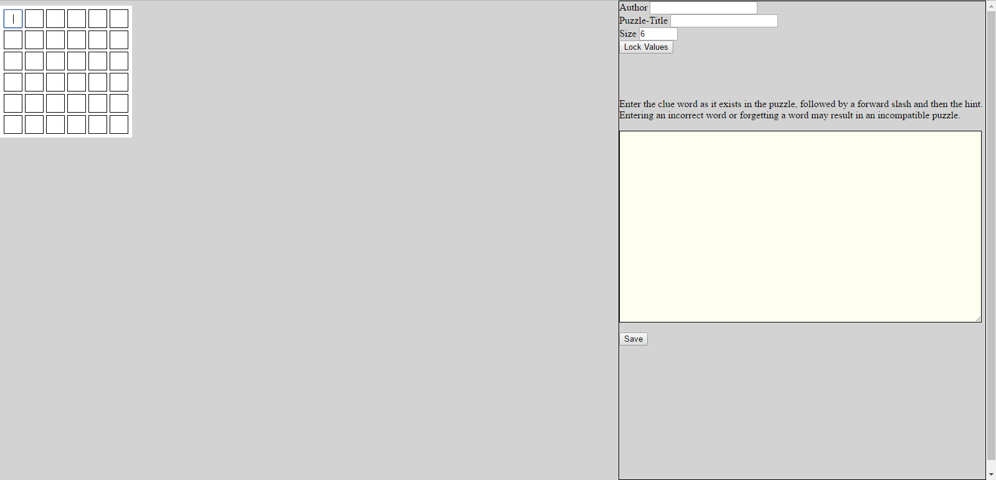

## Descriptions of fields, content

* The Author field is optional and is where the user puts the name of the puzzle creator.
* The Puzzle Title field is where the user puts the name of the puzzle.
* The size field allows the user to change the size of the puzzle. The minimum size allowed is 6 (6X6 grid) and the maximum size allowed is 35 (35X35 grid)
* The Lock Values buttons simply makes the size field read only. This ensures a user wont change the size while values are in the grid.
* The puzzle grid is where the user inputs values to create a crossword puzzle. Blank values will turn solid during the upload of the puzzle.
* The Clues text area is where the user writes the words inputted in the graph along with the corresponding clues.

## Description of actions

* The user should enter their name in the Author field (optional)
* The user should enter the puzzle title in the Puzzle Title field. If nothing is entered, a default name will be given to the puzzle.
* The user should enter the size of the puzzle in the size field. The size should be between 6 and 35. A size less than 6 will result in a grid size of 6. Likewise, a size greater than 35 will result in a grid size of 35.
* The user should click lock values to ensure their grid size doesn’t change as they create their puzzle. This is optional, but changing a grid size eliminates all current values in the puzzle field.
* The user should fill out the puzzle grid to match that of a crossword puzzle.
* The user needs to input clue words immediately followed by a forward slash and then the corresponding clue. Each clue should be entered on a new line.

icono2 Failure to input the clue words as they exist in the puzzle will result in an error. Because of this, a good strategy is to have all the clue words you will use on a separate document to refer back to when entering the clues and clue words.

* Once the puzzle has been created, and all fields have been filled, the user should click the save button to download the generated .xwc file.

## Sequence of screens

*Example of input fields*

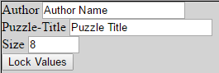

*Example of filled grid*

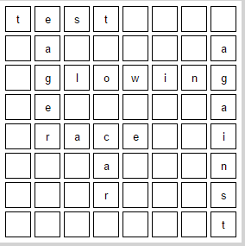

*Example of clue input*

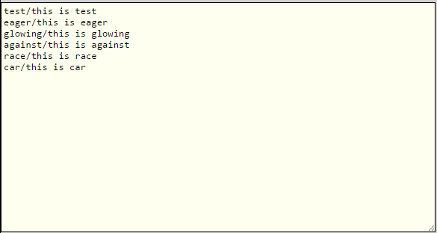

*Example of save screen*



# Puzzle Generation Screen

* The puzzle generation screen is the screen that allows a user to upload an .xwc file and play the corresponding puzzle.

## Screenshot

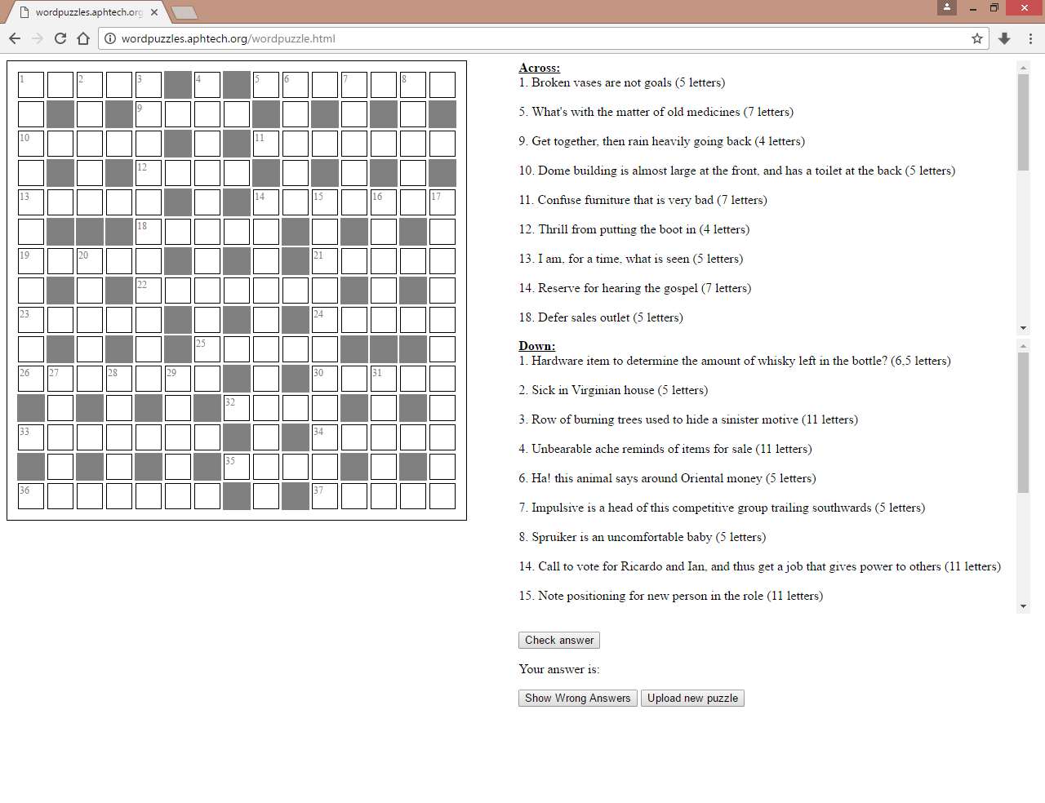

## Descriptions of fields, content

* There are four main areas of the screen. There is the crossword puzzle, across hints, down hints and the button section. The crossword puzzle section is for entering your answers to the hints. The across hints section and down hints section contain their respective clues. The button section allows a user to check their answer, show wrong answers and scrap the current puzzle to upload a new one.

## Description of actions

* This page was created with accessibility in mind so there are several functions we added to hopefully facilitate ease of use for blind and visually impaired users.

### Page Tab Order

* The tab order for the page is set as the following:

1. Puzzle (focuses the last selected entry element)
2. Across hints (focuses the last selected across hint)
3. Down hints (focuses the last selected down hint)
4. Check answer button
5. “Your answer is” area
6. Show wrong answers button
7. Upload new puzzle button
8. Body
9. URL

* The final two members of the tab order list are undesirable but it is not possible to exclude these two from the tab order.

### puzzle entry section

* When visiting this section via a tab or shift+tab, the last focused element will be selected. If you have not yet visited the grid, the puzzle will try to find the first input area of the puzzle.
* For entering clue answers into the puzzle, we have ARIA labels attached to the beginning of clue answers that specify which clue (e.g. 5 across) they are answering and the length of the answer (e.g. 6 letters).
* The application allows users to navigate through the puzzle by using the arrow keys. When trying to move into a non-entry element (the gray squares), nothing will happen.
* When selecting an input field, the current value that has been entered into that element will be highlighted. This allows for easier overtyping of an answer that the user feels is incorrect.
* There is also an auto movement feature. This allows a user to type the answer to a clue without having the press an arrow key between each keystroke. For example, a user focused on the first entry element of the puzzle will move to the right after entering a value. The auto movement value is set based on which hint section (across or down) was last focused. When the across hint section was last focused, the puzzle will automatically move users to the right after a keystroke. When the down hint section was last focused, the puzzle will automatically move users down after a keystroke.
* The application also has a functionality built in that allows a user to navigate from the puzzle to any associated hint(s) by pressing the CTRL button. For example, a user on the first input of the puzzle in the screenshot could press CTRL and go to “1 across”. Another CTRL press would take the user to “1 down”. A third CTRL press would take the user back to the beginning of the “1 down” hint. This functionality works on all inputs of the puzzle with one caveat: when focused on an input that is at the cross section of an across and down hint (e.g. the cross section of “2 down” and “10 across”), the third CTRL press will move the user to the beginning of that down hint. In this example, you would be moved to the beginning of “2 down” instead of where the user was last focused.

### hint section

* When visiting either the across or down hints section, the last selected clue will be focused. If no clue has been selected yet, the page will try to find the first clue element in that section.
* Users can navigate to different clues in the section by using the up and down arrow keys.
* The application allows for a user to go from a hint to the beginning of that hint’s answer section by pressing CTRL.

End of document