Observations

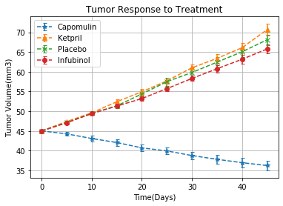

1. Campomulin is the most effect drug in reducing tumor volume
2. Campomulin work best over time

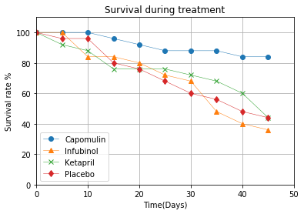

1. Campomulin has the highest survival rate

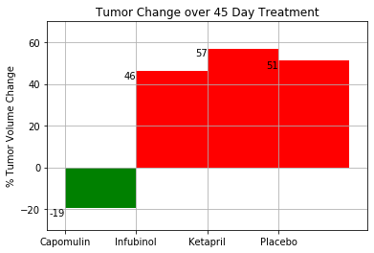

1. Campomulin reduces tumor volume on average about 20%
2. Other drugs have similar performance as the placebo