Weather observations

1. Temperature vs. Latitude

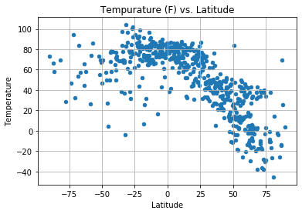

Weather tends to be warmer at latitude 0, the equator.

1. Wind speed vs. latitude

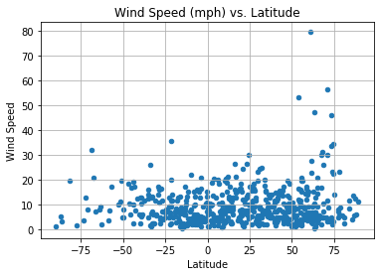

Wind speed range tends to be the same for most latitudes

1. Humidity and Cloudiness vs. latitude

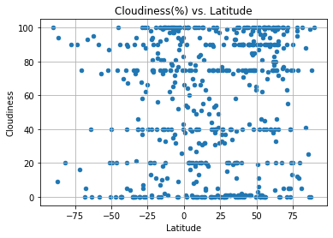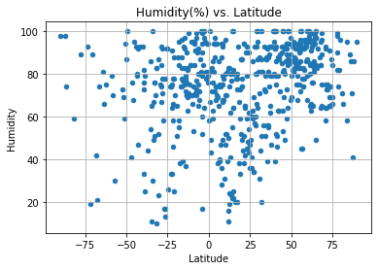

Humidity and cloudiness don’t appear to vary by latitude.