

design document

Group 12



Mark Mcculloh

Trevor Minnix

Omar Mohammed

Kalvin Miller

# 1 Introduction

This document serves to explain the design approach that was taken in the implementation of the GTA Management System (GTAMS). The objective of the system is to provide an interface for faculty, staff, and students to improve the process of Graduate Teaching Assistantship (GTA) nominations. The system will allow the faculty members to nominate PhD students for GTA positions, as well as allow the nominated students to provide the necessary data. Graduate Committees (GC) consist of several professors in the department and will be reviewing the students that were nominated by the professors, and will make the selection based on the score that was attributed to the student.

# 2 Entity Relationship Diagram

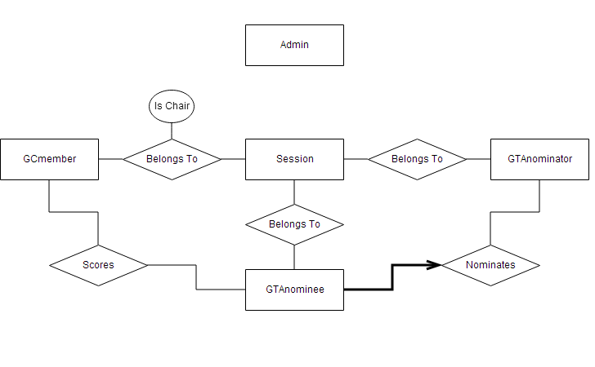

Figure : Entity Relationship Diagram

The Entity Relationship Diagram provides a visualization for the entities that take part in the GTA nomination process as well as how these entities are related to each other. The first entity in the diagram is the GC member which will be representative of the professors that are in the GC. Each GC member will have a relationship with the current session. Only one of the GC members can be a chair of the committee, and there can only be one chair per session. Therefore, whether a member is the chair or not will be implemented as an attribute of the relationship between the session and GC members. The session will be implemented as an entity in order to keep track of older sessions, as well as the current session. The session will be started and kept track of by the system administrator. However, this will not be represented in the diagram because there is no need to keep track of who started the session.

The session will also have a relationship with the nominators, and a relationship with the nominees, because both of the entities will be a part of a specific session that the system administrator has started. The nominator will have a relationship with a nominee because the nominator will nominate the PhD student. Each of these entities will have attributes that are shown in the diagram, and are implemented in the database. The entities will also have primary keys, and foreign keys in order to keep track of the data, and the relationships between different entities.

# 4 Use Case Diagram

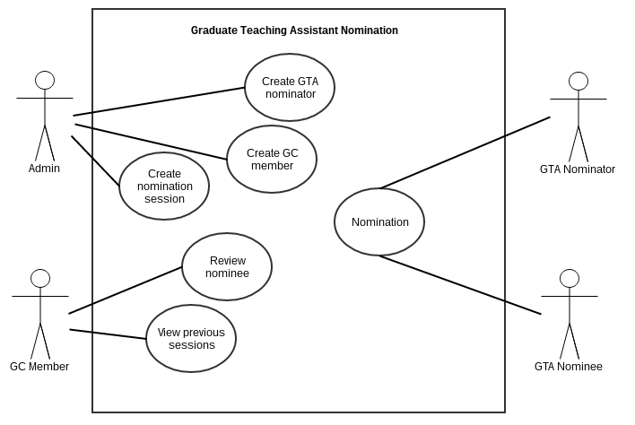

Figure : Use Case Diagram

The use case diagram was designed to display how the different users can take different actions. The system administrator will be have the ability to create and start a session, as well as create the corresponding GC members and nominators to that session. The GC member will have the ability to review the nominees, and view data from previous sessions. The nominator will have the ability to log in and create a nomination in order to nominate a PhD student. The nominee will have the ability to open the specific link that will allow the nominee to fill in the necessary data.

# 3 Development Tools

While developing this application, the EasyPHP DevServer, which included a setup MySQL server, and an Apache server. The user interface of the application was implemented using HTML and CSS, as well as JavaScript. The data from the front end will be sent to the PHP files using the HTML form actions and methods. The PHP files will then execute, while using the data to query the MySQL database. Once the query results are returned, the PHP files will continue executing, and parsing the results. The data will then be sent back to the front end will the user interface will be populated with this data using JavaScript.