Mark McCulloh, Kalvin Miller, Trevor Minnix, Omar Mohammed

Dr. Kien Hua

COP 4710

1 April 2016

Team 12 Progress Report

Our team has met twice so far to discuss the project. We have discussed the scope of the project goals in order to ensure all of the necessary features are implemented without exceeding those bounds. The workload has been divided between front end and back end development. The back end has been further divided into database and server components.

We have created some basic visuals to help our understanding of the project structure and ensure that all team members have a unified vision of the final product. Our database is represented in a basic entity-relationship diagram.

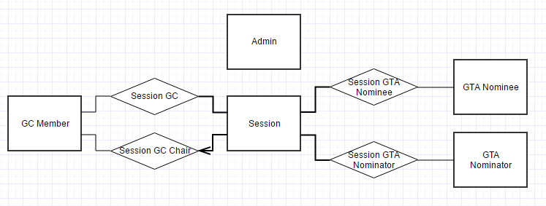

A high-level design diagram shows how the users’ web browser interacts with the server and database.

