Trevor Sharnick

11/6/2022

CS-330-T2831

Module Two Milestone

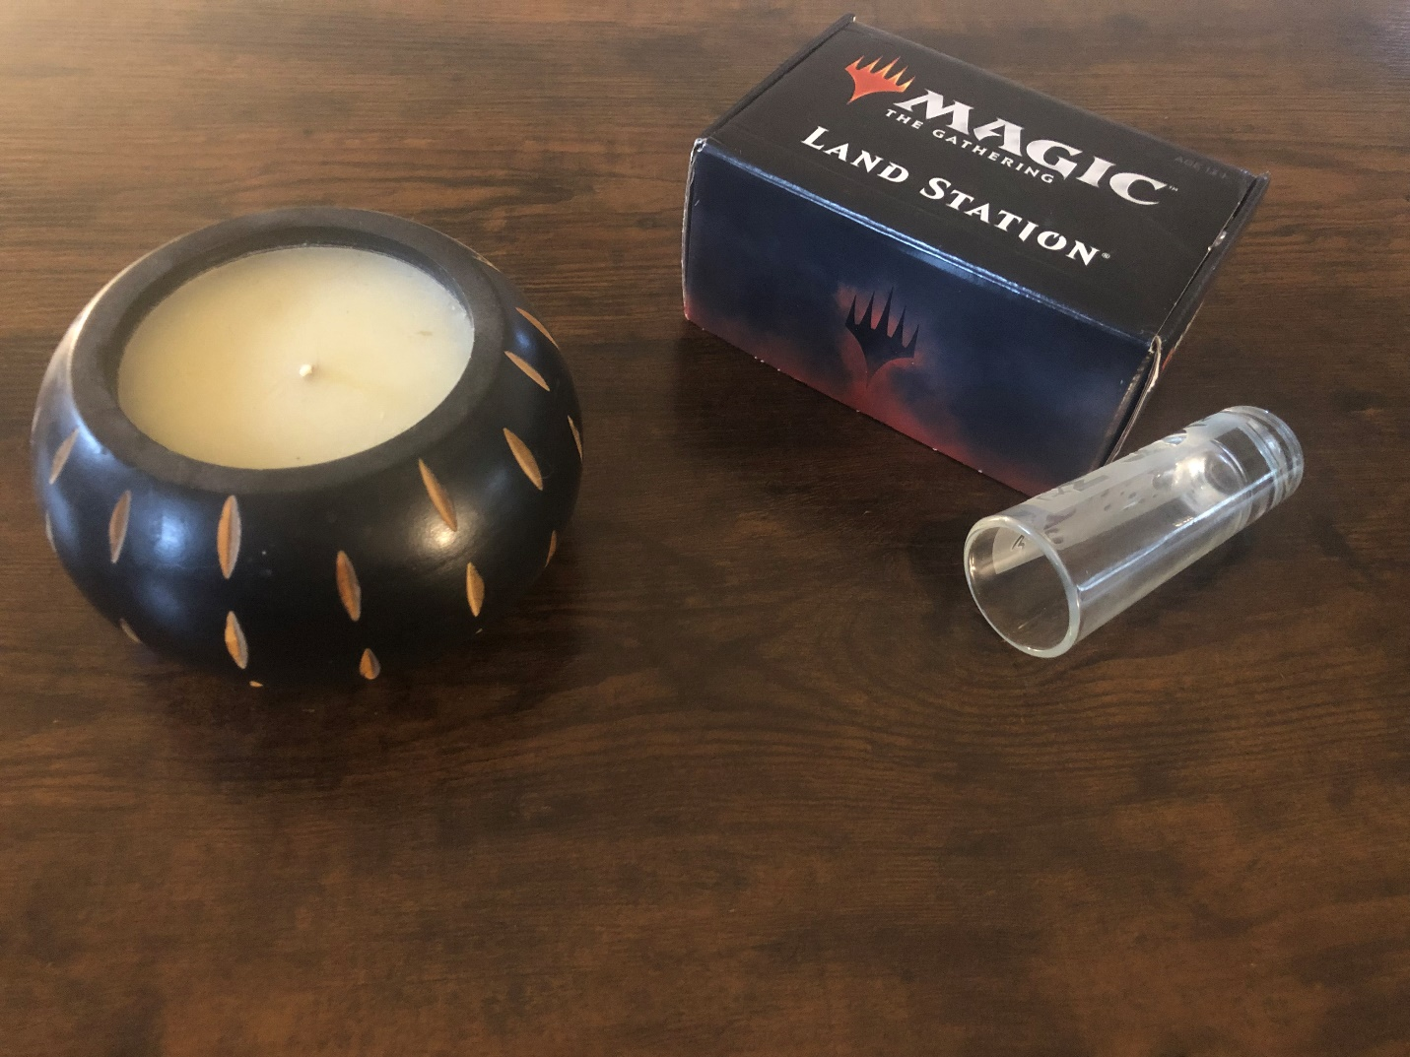

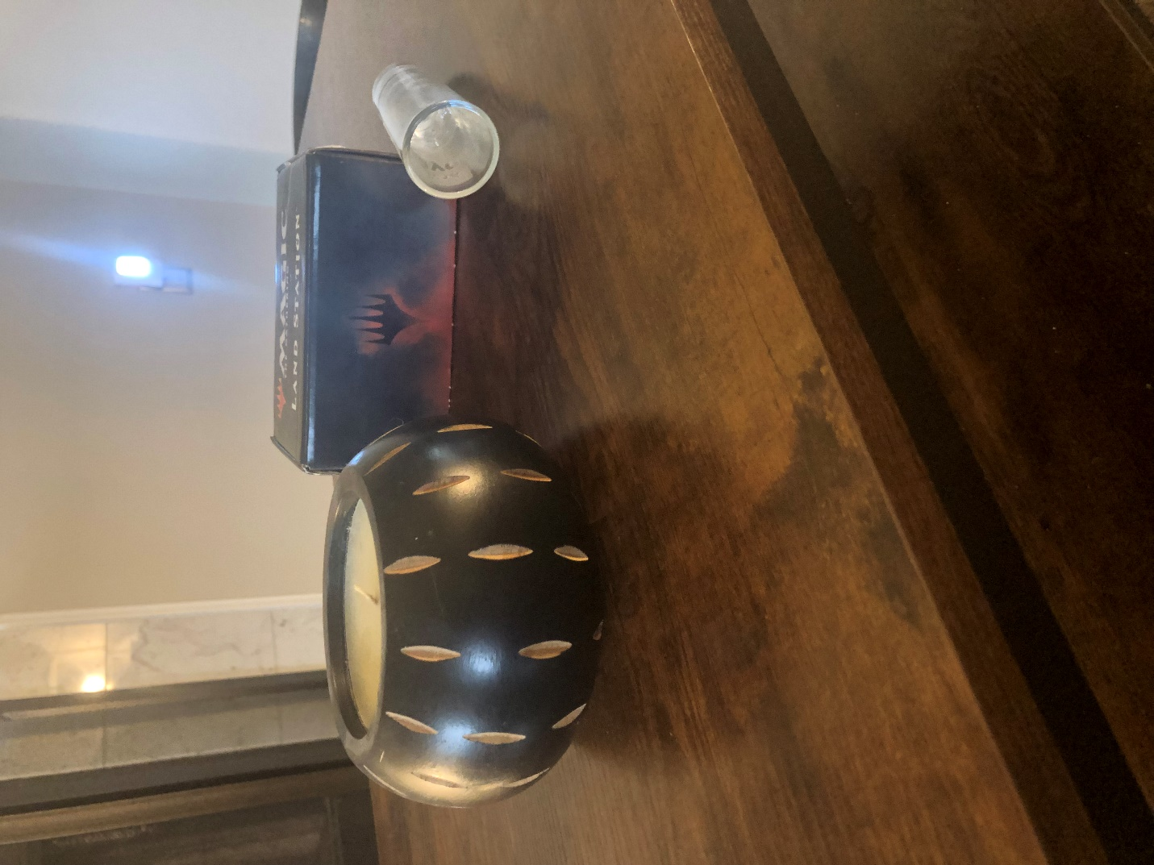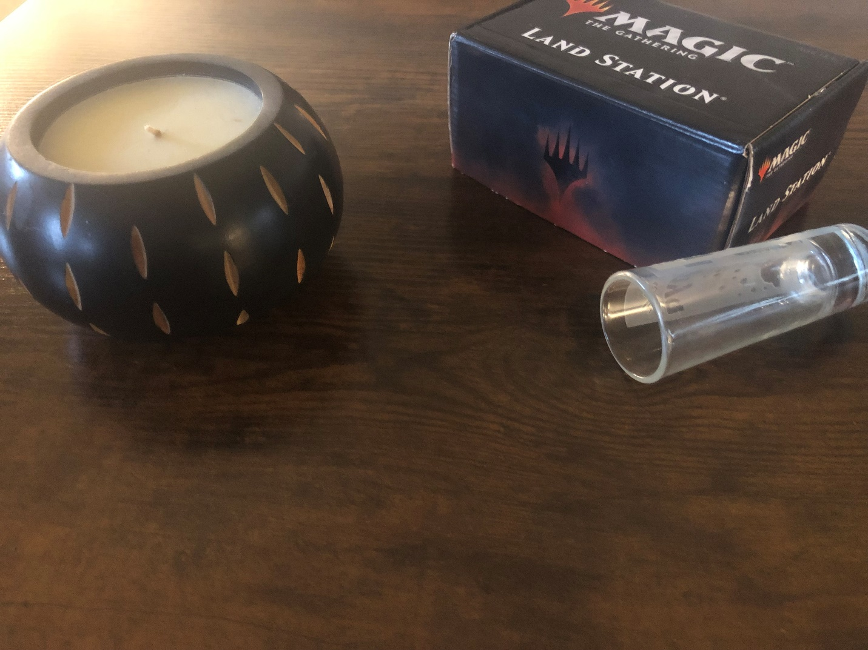

For my 2D image, I chose to assemble a series of primitive shapes along a table. The image consists of four objects: a candle, a shot glass, a box of cards, and the table itself. I will be creating each of these objects in 3D, and I think they represent a good balance of the different primitive shapes that fulfill the project requirements. The box of cards can be created using a simple rectangular cube shape. The shot glass can be created using a cylinder, which will need to narrow at its base. The table object will be represented by a plane, which the three other objects will be positioned upon. Lastly, the candle is a complex object that will require the use of two primitive shapes: a torus will represent the outer shell of the candle, while a sphere flattened into a circle will represent the candle within. When positioning the objects on the table for the picture, I tried to position them at varying angles to make for a challenging yet achievable project.