**Lecture 1**

1. Difficulties of point cloud processing: (1) sparsity; (2) irregular – difficulty in neighbor searching; (3) lack of texture information; (4) unordered – difficulty in deep learning; (5) rotation equivariance / invariance.
2. Method comparison:

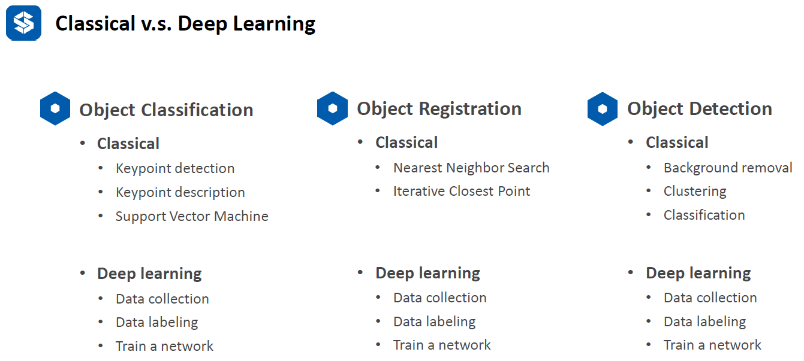

1. Principle Component Analysis (PCA): find the dominant directions of the point cloud
2. Application of PCA: (1) dimensionality reduce; (2) surface normal estimation; (3) key-point detection; (4) feature description; (5) canonical orientation.

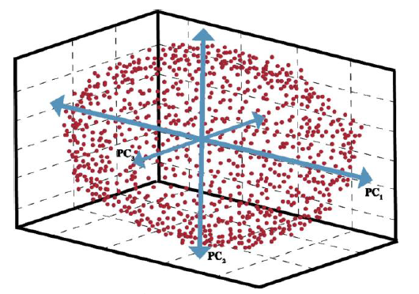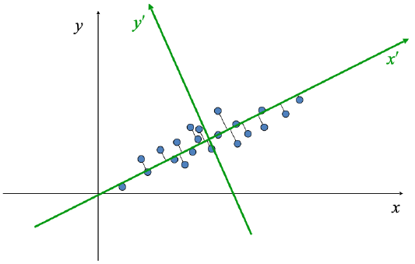

1. PCA and kPCA can be used for classification as well.
2. Vector dot product is just the projection of one vector to the other. 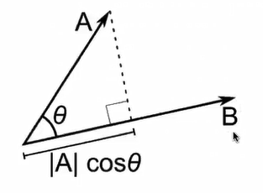
3. Matrix-vector multiplication is a linear combination of vectors. 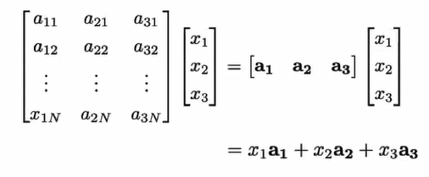
4. Singular value decomposition (SVD) is deformation and rotation of the geometry.

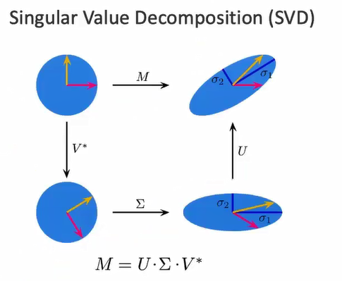i.e., (1) use V* to rotate coordinate system; (2) use Σ to scale the shape; (3) use U to rotate another direction. U and V is orthogonal matrix, they have rotation function; Σ is diagonal matrix, it has scaling function.

9. spectral theorem:

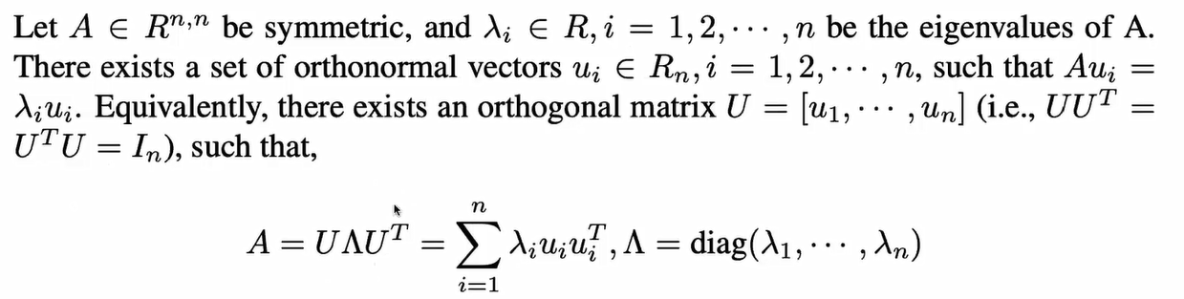

10. Rayleigh Quotients:

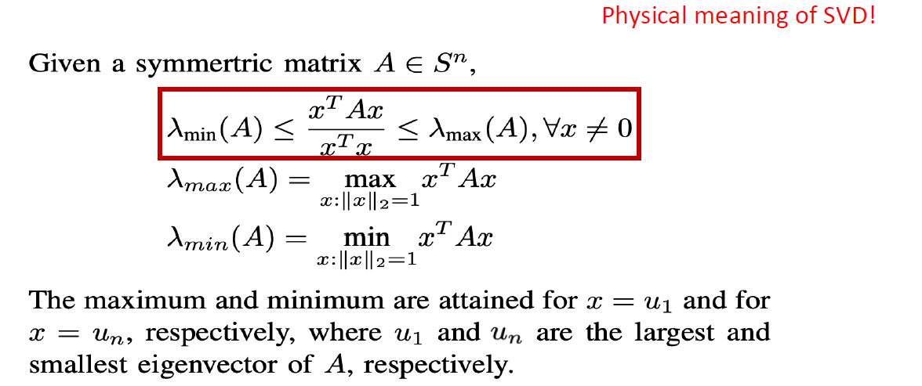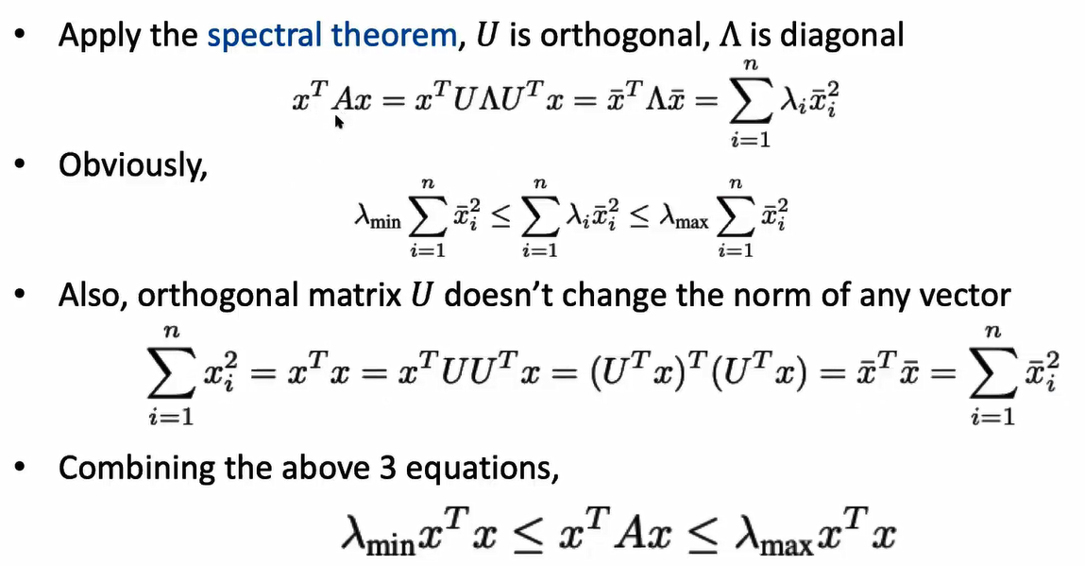

12. PCA: (1) input: a set of points; (2) output: principal vectors; (3) most significant principal component: maximal variance of projected data points on that direction; (2) get remaining significant components: deflation, that is, remove the higher priority component from the points, i.e., data point minus projection. Repeat for the rest.

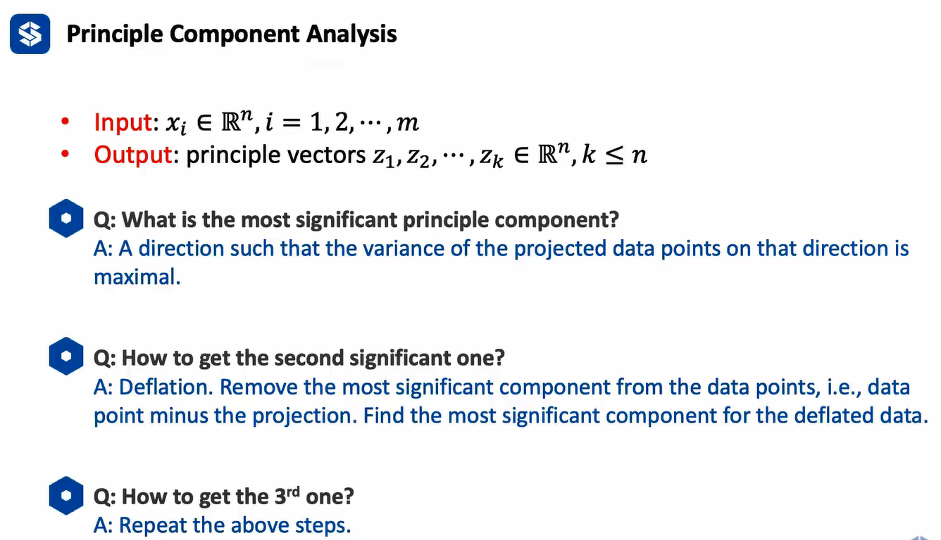

13. PCA proof: (1) normalize the data to be zero mean; (2) PCA purpose: get largest variance when projected to a direction, that is, vector *x* is projected to direction *z* (mod is 1), the result is their inner product which is the projection. (3) compute the mean variance of the projection. (4) compute the maximal variance; (4) H is covariance matrix, since X is already normalized and zero mean, so it is symmetric (think about normalization distribution), it can be applied to Spectral Theorem, which is XXT=UΣUT UΣUT=UΣ2UT, where UUT=1.(5) since U is orthogonal, the product of u1 and ui (i=2~m) will be zero, so only when i=1 there exists the result. (6) how to deflate: project all the data points to z1 direction, and use all the data points to minus this projected result.

14. physical meaning of PCA: for high dimensional data, we want to find a base which can be used to well present our data after projecting the high dimensional data to this base.

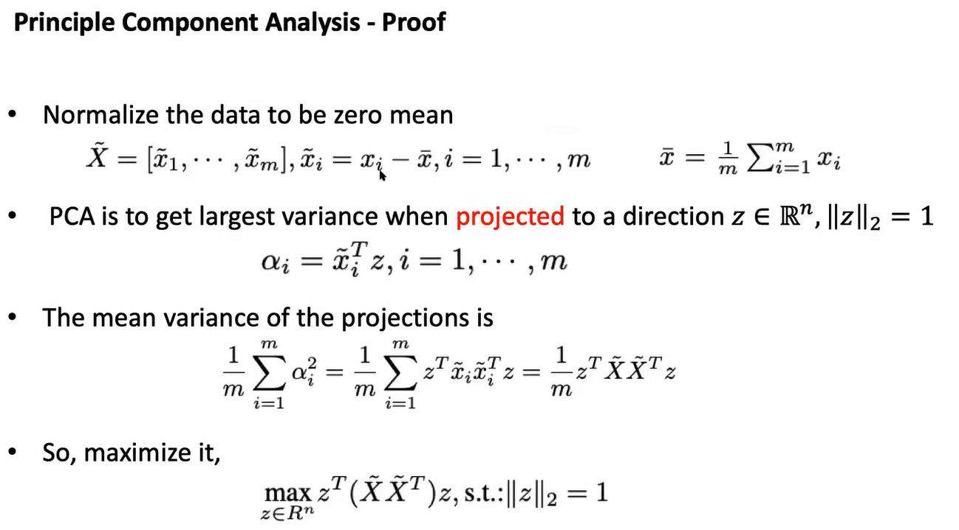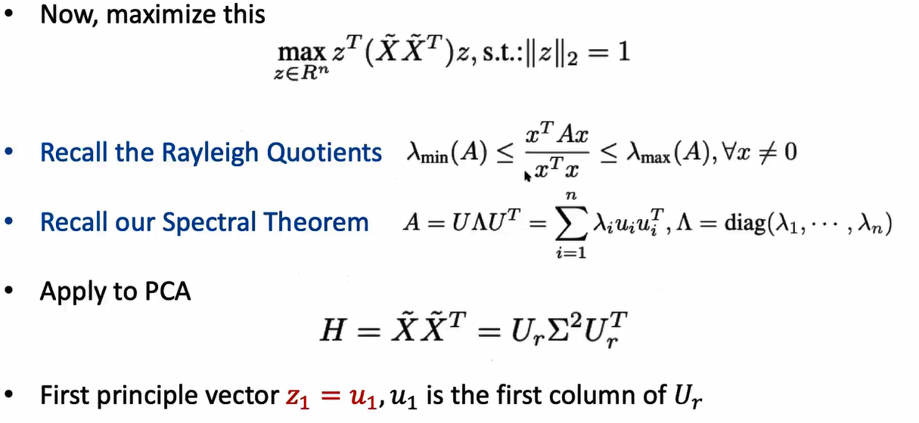

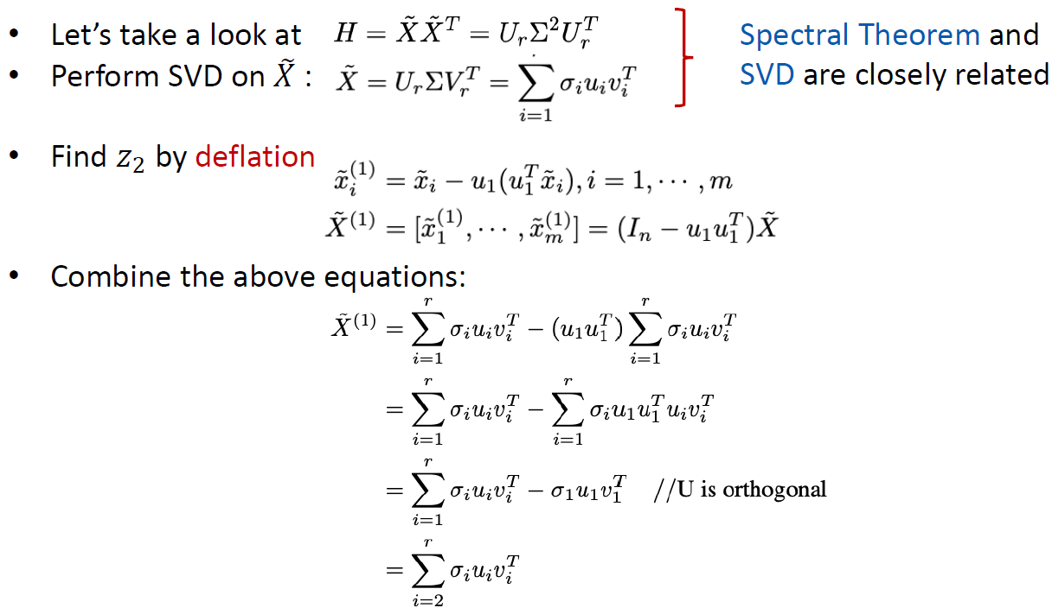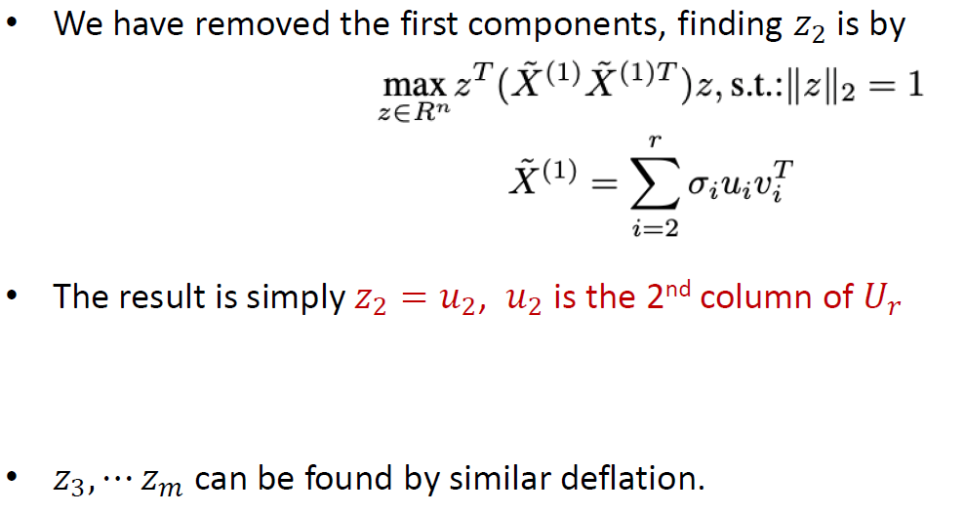

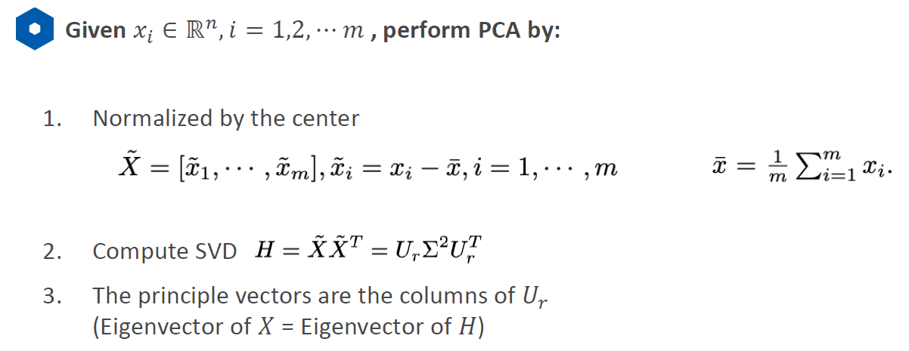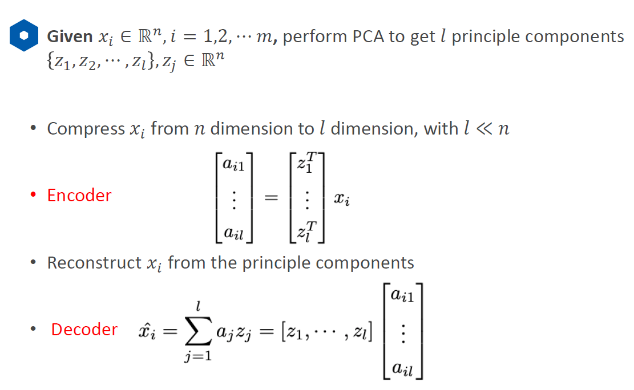

15. PCA application: dimensionality reduction. i.e., we have 100 dimensions, we want to project the data points to 10 principal components direction. For each data point, we will project that point to the 10 directions, the result matrix will be 10*100. As long as the number of the projected directions is smaller than the original dimension, it will loss some data point information.