Twitch

User Manual

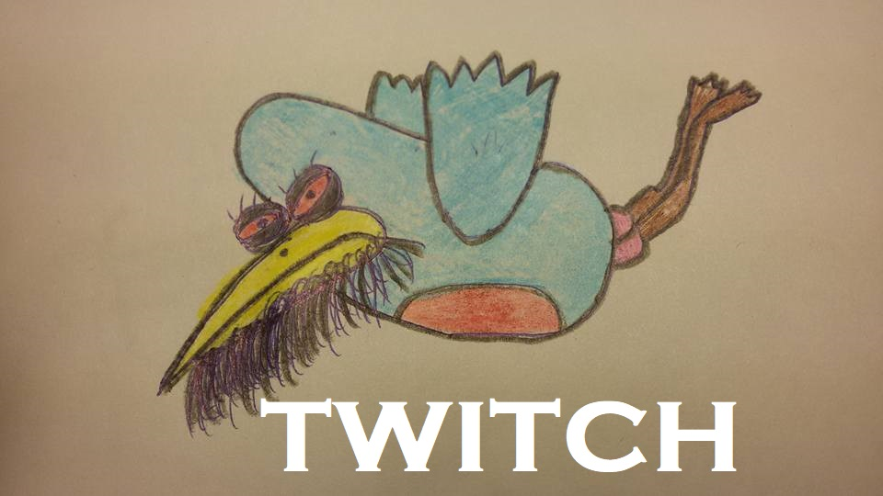

06/02/2019

Program Version: 1.0.0

Document version: 1.0.0

Author: Trevor Garrity

trevsstuff@hotmail.com

License: Free to use and distribute

**Table of Contents**

1. **Purpose of this document**
2. **About the program**
   1. **Players goal.**
3. **Selection Menu**
   1. **Adding a new Bird**
   2. **Deleting a bird**
   3. **Sorting the birds**
   4. **Selecting a bird**
   5. **Quitting game**
4. **Playing the game**
   1. **Move**
   2. **Accelerate**
   3. **Brake**
   4. **Home**
   5. **Turn around**
   6. **Get angry**
   7. **Flight**
   8. **Quit**
5. **System Requirements**

**6.0 Running the program**

**6.1 Setting up Java**

**6.2 Running the program in Windows command**

**7.0 Trouble shooting**

**8.0 More Information**

1. **Purpose of this document**

The aim of this document is to assist users of the Twitch program. This document will guide users through setting up and playing the twitch game.

1. **About the program**

The program runs a console game in Java programming language. Users interact with the program and play the game by entering commands upon being prompted by the program.

* 1. **Players goal**

The aim of the player is to find a randomly selected range on a linear scale by finishing each turn and hoping to be placed within the range that is unknown to the player during play. The player must do this by “Moving” around on a linear scale to find the unknown point.

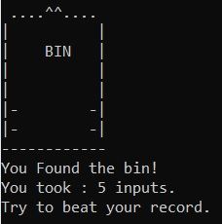Upon landing within the correct range, a victory message will show, the number of inputs the player took will be shown and the game exits. The smaller the number of inputs taken to find the goal the better the player has done.

There are two main game modes the player must be aware of, selection mode and game mode.

* 1. **How to play**

During game play the user must be aware of the speed that they are travelling in order to not move past the point they must finish the move on.

The higher the speed the user sets the further the bird moves each time.

The angrier a bird is the smaller the range is that they must find.

1. **Selection mode**

Selection mode enables the user to select, add, remove and sort the birds before starting the adventure.

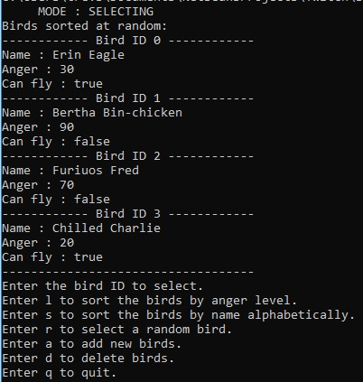

**3.1 Adding a new Bird**

Players can create their own birds by entering ‘a’ in the selection menu. Upon entering the appropriate command, they are prompted to add the parameters for their own bird. After completion the program returns to the selection menu and the new bird will be shown.

**3.2 Deleting a bird**

Should a player want to remove birds press ‘d’ in the selection menu. A list of birds with their ID numbers will be shown and user will be prompted to enter the id of the bird the wish to delete. After deletion the console will show the name of the bird deleted, a modified list will be shown, and the program returns to the selection menu.

**3.3 Sorting the birds**

The program contains two ways a user can sort the list of birds.

By entering ‘l’ (that is; lower case ‘L’) the user re-arranges the list of birds by their anger levels, least angry to most angry.

By entering ‘s’ the user sorts the list alphabetically a to z.

In both instances the modified list is shown after user’s input and the program returns to the selection menu.

**3.4 Selecting a bird**

In the selection menu the user can see the birds numeric ID. To select a bird, enter the corresponding ID number.

By entering ‘r’ the program selects a bird at random for the user.

After a selection is made the name of the bird that was selected is shown and the program enters game mode.

**3.5 Quitting game**

Entering ‘q’ in the selection mode causes the program to exit.

1. **Game mode**

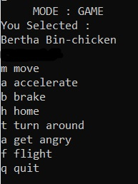

After selecting the bird, the user enters the main mode of the game where the user must move his bird around with commands from the game mode menu. The main aim is to find the randomly generated positional range with the smallest amount of input commands.

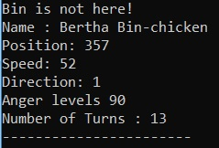Upon entering the first command the game parameters will be shown and continue to update as the user makes selections from the game mode menu until the game is complete or the user enters the quit command.

* 1. **Move**

When the user enters the ‘m’ command the bird moves along the plane updating the position according to its speed and direction.

* 1. **Accelerate**

When the user enters the ‘a’ command this causes the speed of the selected bird to increase by 10.

* 1. **Brake**

When the user enters the ‘b’ command the speed of the selected bird decreases by 10.

* 1. **Home**

The ‘h’ command returns the bird to its initial position.

* 1. **Turn around**

The ‘t’ command causes the bird to turn and go back the other way, thus reducing the position number as indicated in the game parameters.

* 1. **Get angry**

**This feature is currently in development.**

In Twitch version 2.0 the user will have the ability to modify their anger levels.

* 1. **Flight**

**This feature is currently in development.**

In Twitch version 2.0 birds that can fly will have a greater “line of sight” and be able to have a larger range with which they must find.

**4.8 Quit**

Entering ‘q’ in the game mode causes the program to exit.

**5.0 System Requirements**

To run Twitch, you need a computer with an operating system and JavaSE Runtime Environment (build 1.7.0_80-b15) or later installed.

**6.0 Running the program**

There are many operating systems that the program can be ran on, but this guide pertains to setup and execution on Windows 10.

**6.1 Setting up Java**

1) Check and update java runtime environment on your system.

Open your windows terminal and type java -version. If the java command is not recognised, then go to: <https://www.java.com/en/download/help/index_installing.xml>

Then download and install from the .exe file.

If the version is older than build 1.7.0_80 then:

In the Java Control Panel, click on the Java tab.

Click View to display the Java Runtime Environment Settings

Verify that the latest Java Runtime version is enabled by checking the Enabled box.

Click OK to save settings

Click OK in Java Control Panel window to confirm changes and close the window.

Check the version again in the windows console.

**6.2 Running the program in Windows 10 command**

a)Press windows key. Type ‘cmd’ open the windows command console.

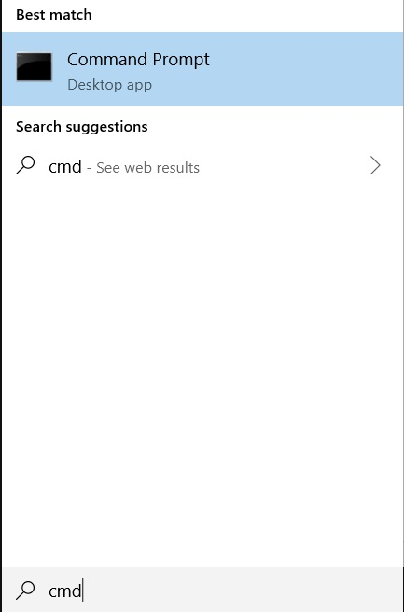

b) Change directory to the one containing the twitch folder. In the example the twitch folder is in my desktop folder.

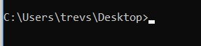

c) Enter java twitch.Twitch to start the game.



**8.0 Trouble Shooting**

**If you cannot run the game.**

Go through parts 6.0 to 6.2 of this document and retry.

**If this fails do the following:**

Windows 10 and Windows 8

In Search, search for and then select: System (Control Panel)

Click the Advanced system settings link.

Click Environment Variables. In the section System Variables, find the PATH environment variable and select it. Click Edit. If the PATH environment variable does not exist, click New.

In the Edit System Variable (or New System Variable) window, specify the value of the PATH environment variable. Click OK. Close all remaining windows by clicking OK.

Reopen Command prompt window and run your java code.

**If you find any errors whilst playing.**

Contact the developer, see section 7 of this document.

**7.0 More information**

Report any errors or get help.

Please contact Trevor:

trevsstuff@hotmail.com