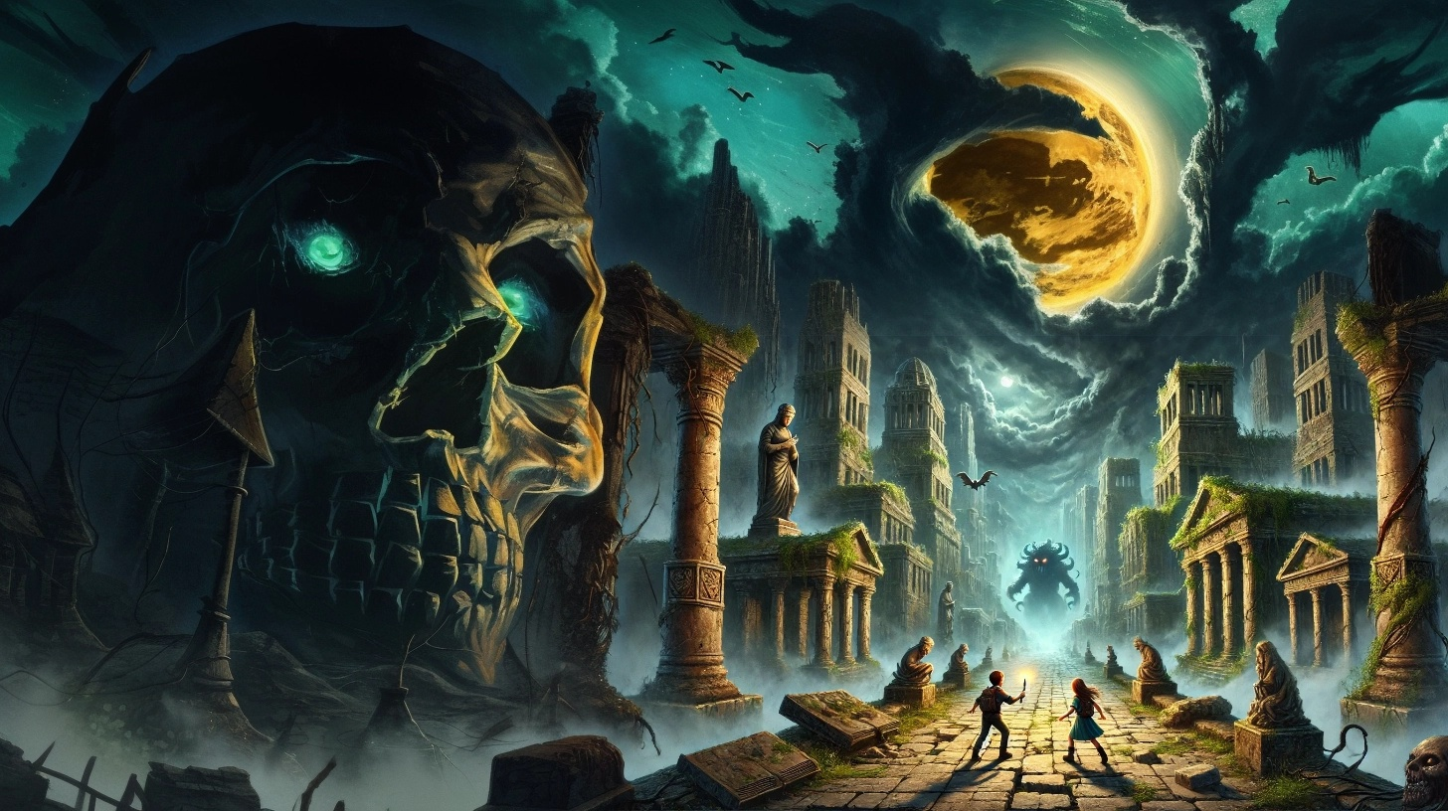

**There is such a thing as  
Forbidden Knowledge**

**Luke is your average teenager, except he is the last child born on Earth.**

**Shortly before his conception, scientists discovered that the laws of reality could be overwritten.**

**Unfortunately, that knowledge threatened the existence of the Universe – forcing an intervention.**

**The good news – Humanity was given time to prepare.**

**The bad news – The old world is unrecoverable, forcing humanity to enter the new world with only the things on their backs.**

**The ugly news – There are monsters…**

|  |
| --- |
| **The Princess and the Apocalypse - By Trevy Burgess** |