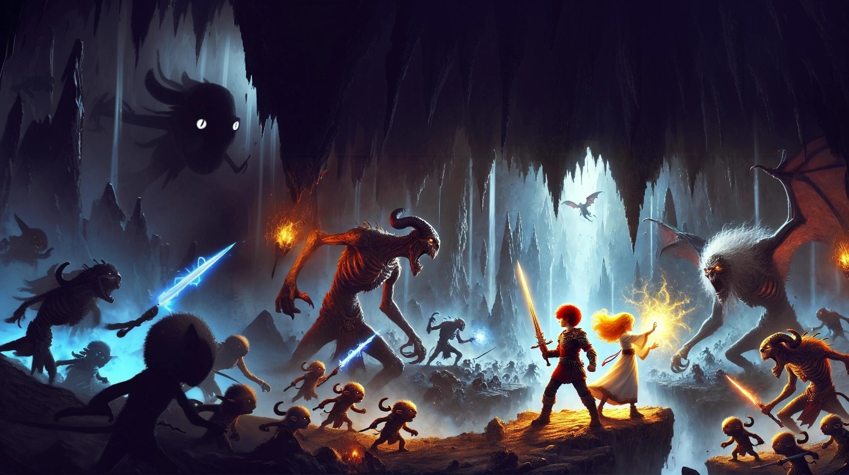

**Not all Monsters are Metaphorical  
Sometimes they are real,   
With big teeth**

**Luke Sunderland is a war veteran forced to live in the streets.**

**It's hard to keep a job when your coworkers fear you might kill them. For the record, no one died in that office incident. However, one nose was broken and a few pieces of office equipment were sent to the afterlife.**

**It's also hard to live on the streets of London, where pickpockets, rapists and murderers abound - Unless you get a reputation by accidentally killing a rapist.**

**All that changed when confronted by rats. Yes rats. Big ones. The size of alley cats? No bigger. The size of Dobermans? You're getting close. And the boss is the size of an elephant.**

**The good news - Overcoming monsters always makes you stronger.**

|  |
| --- |
| **The Princess and the Murder Hobo - By Trevy Burgess** |