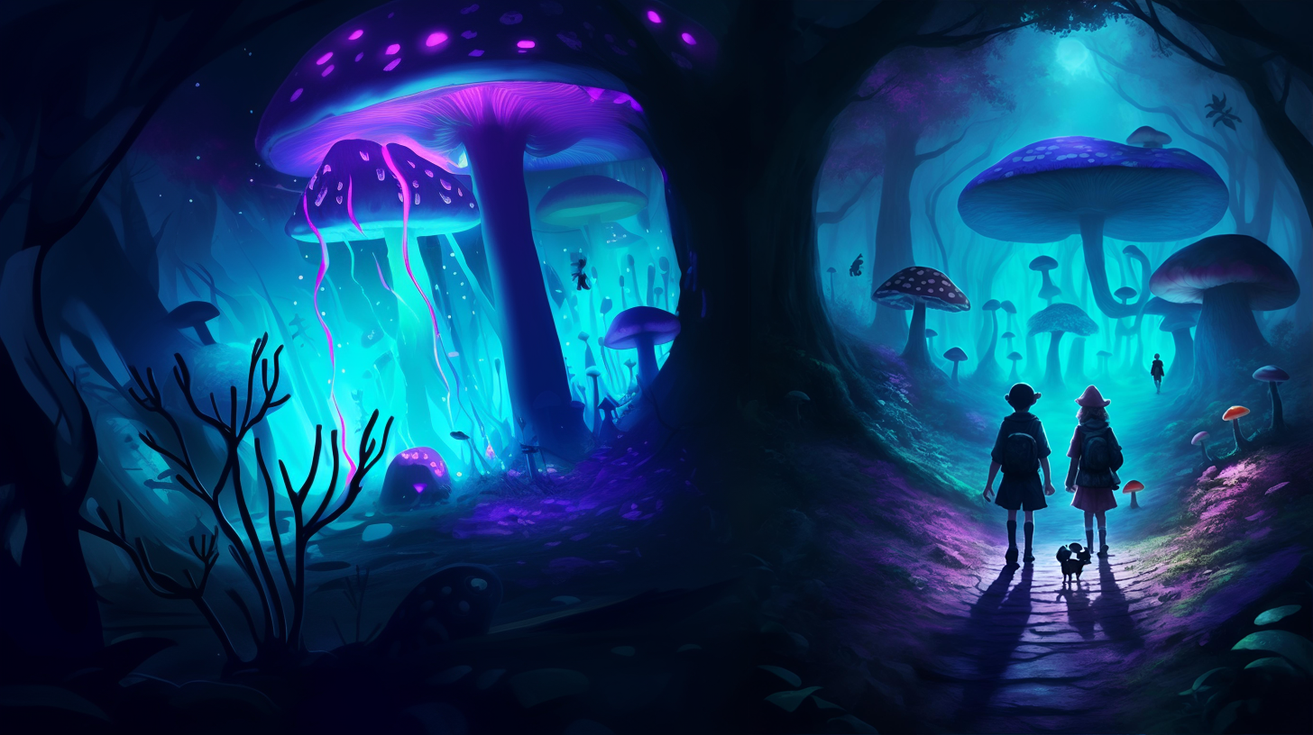

**Video Games are fun -  
until they come to life.**

**Luke Solarsmith is your average teenager, spending his life going to school, playing video games and growing his channel.**

**Then a revolutionary theme park opened up, turning a video game to real life.**

**But what happens when the game isn’t a game? What if Dark Matter is not the harmless thing physicists think it is?**

**What if it is the source of life?**

**What would happen if Earth were to plow into a huge chunk of Dark Matter? What will happen to the people of Earth as the laws of physics prove to be incomplete?**

**Join Luke as his world turns upside down, fighting monsters, making new friends, rescuing people and having fun in a world that has gone mad.**

|  |
| --- |
| **The Princess and the Player - By Trevy Burgess** |