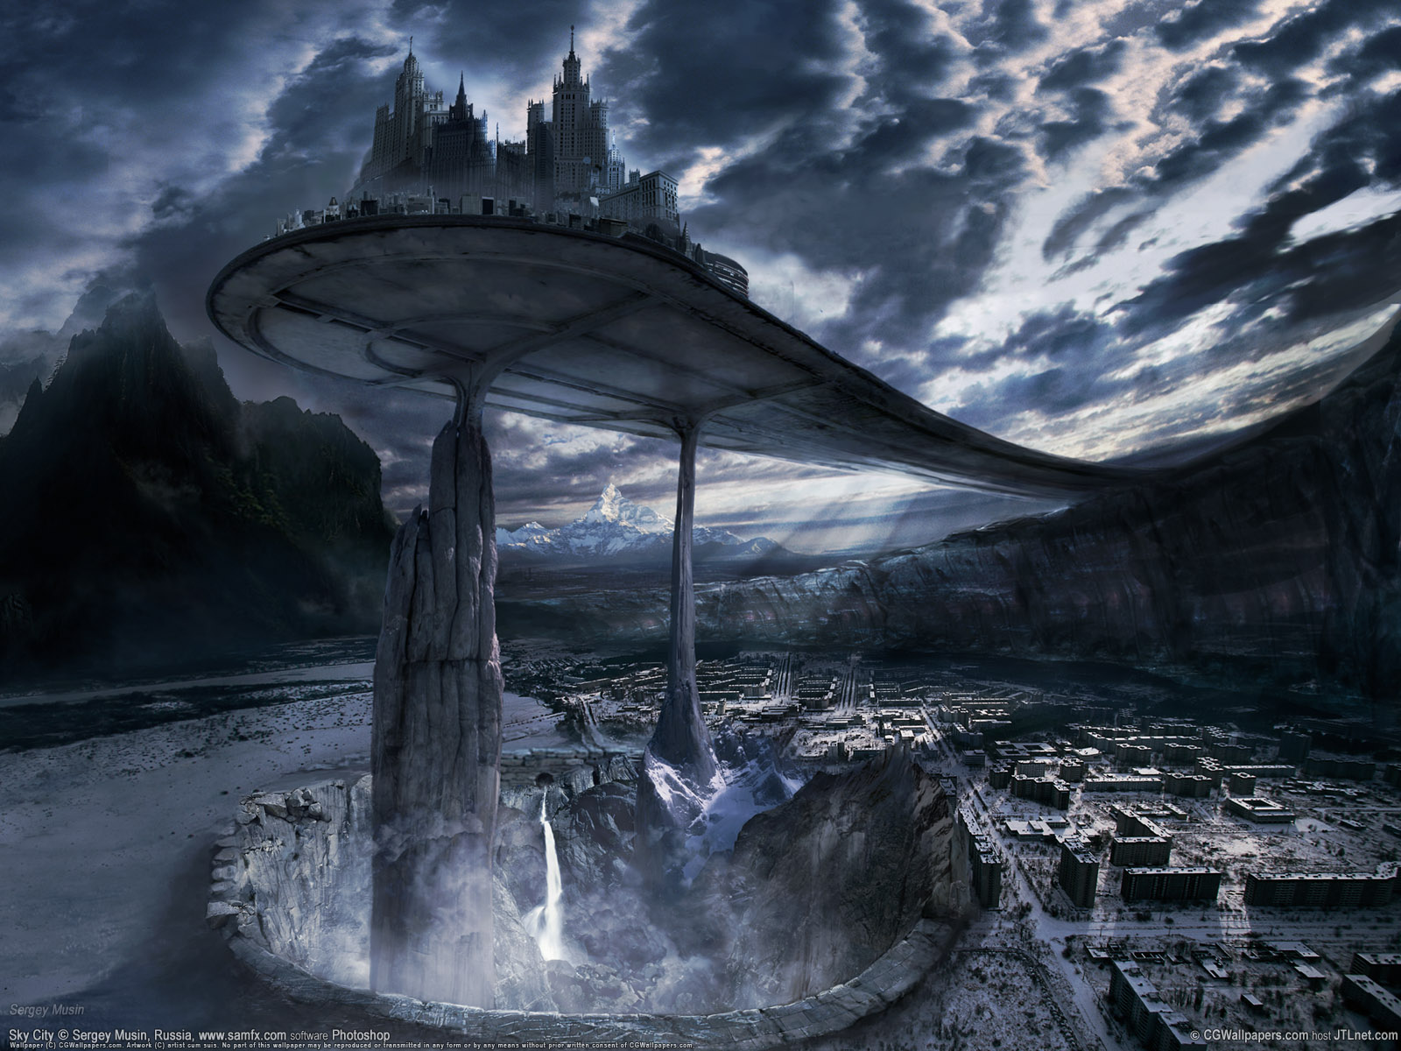

|  |
| --- |
| **The Princess and the Stellar Warrior - By Trevy Burgess** |