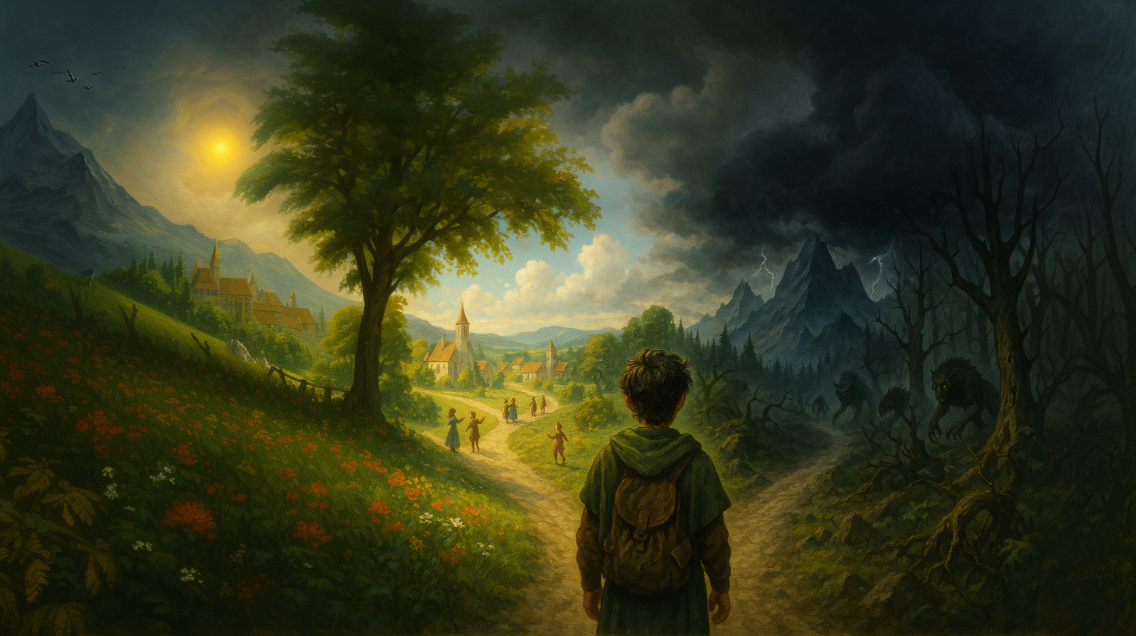

**Have you ever wondered if magic exists?**

**Is there more to life than material existence?**

**Luke Russell discovered magic does exist, when he stumbled onto the Unknown Road.**

**Unfortunately, the price for being a wizard is living in a world filled with unknowable and sometimes terrifying forces**

**Can you give up everything you hold true? Can you live in a world of psychedelic craziness?**

|  |
| --- |
|  |