People have been trying to
create a perfect society
since the
dawn of
time.
Each time it has
failed for one
important reason:
The principles of
good government were
never applied in full.

The best purpose of Government is to:
- Manage scarce resources
- Cultivate human potential
- Negotiate with other sovereign countries

Principles:
- All political power comes from the people and to the people it must sooner or later return.
- ‘Accountable government’ can only be achieved when the individual, not the group, is assigned the accountability and responsibility of performing tasks.
- Only when every citizen actively participates in community can true freedom be achieved.
- It is the duty of every citizen to question authority when they think that those in authority are wrong.
- Beware the barbarians howling at your gate.
Share with them the bounty the bounty of the land or be destroyed by them.
- Law of Freedom
- Law of Balance
- Law of Reason
- Correct your mistakes, welcome critism criticism, tackle challenges slightly beyond your abilities, and there’s nothing you can’t do.
- Only in Silence can you find your true Self --
and make the world new again.
It’s so simple, only a genius could have figured it out.
-- Doctor Slip Cam --
One hundred thousand lemmings can't be wrong.
-- Graffito --
If we don't succeed, we run the risk of failure.
-- George W. Bush --
The Truth shall set you free...
But first it will piss you off!
-- Anon --




Aipotu - The land of personal power Trevy Burgess

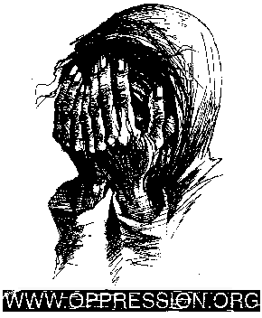


Aipotu
The land of personal power

It Is Possible
To Create A
Perfect Society
- Not despite Human Nature -
But Because Of It

Credendo Vides
(by believing one sees)

TREVY
BURGESS

