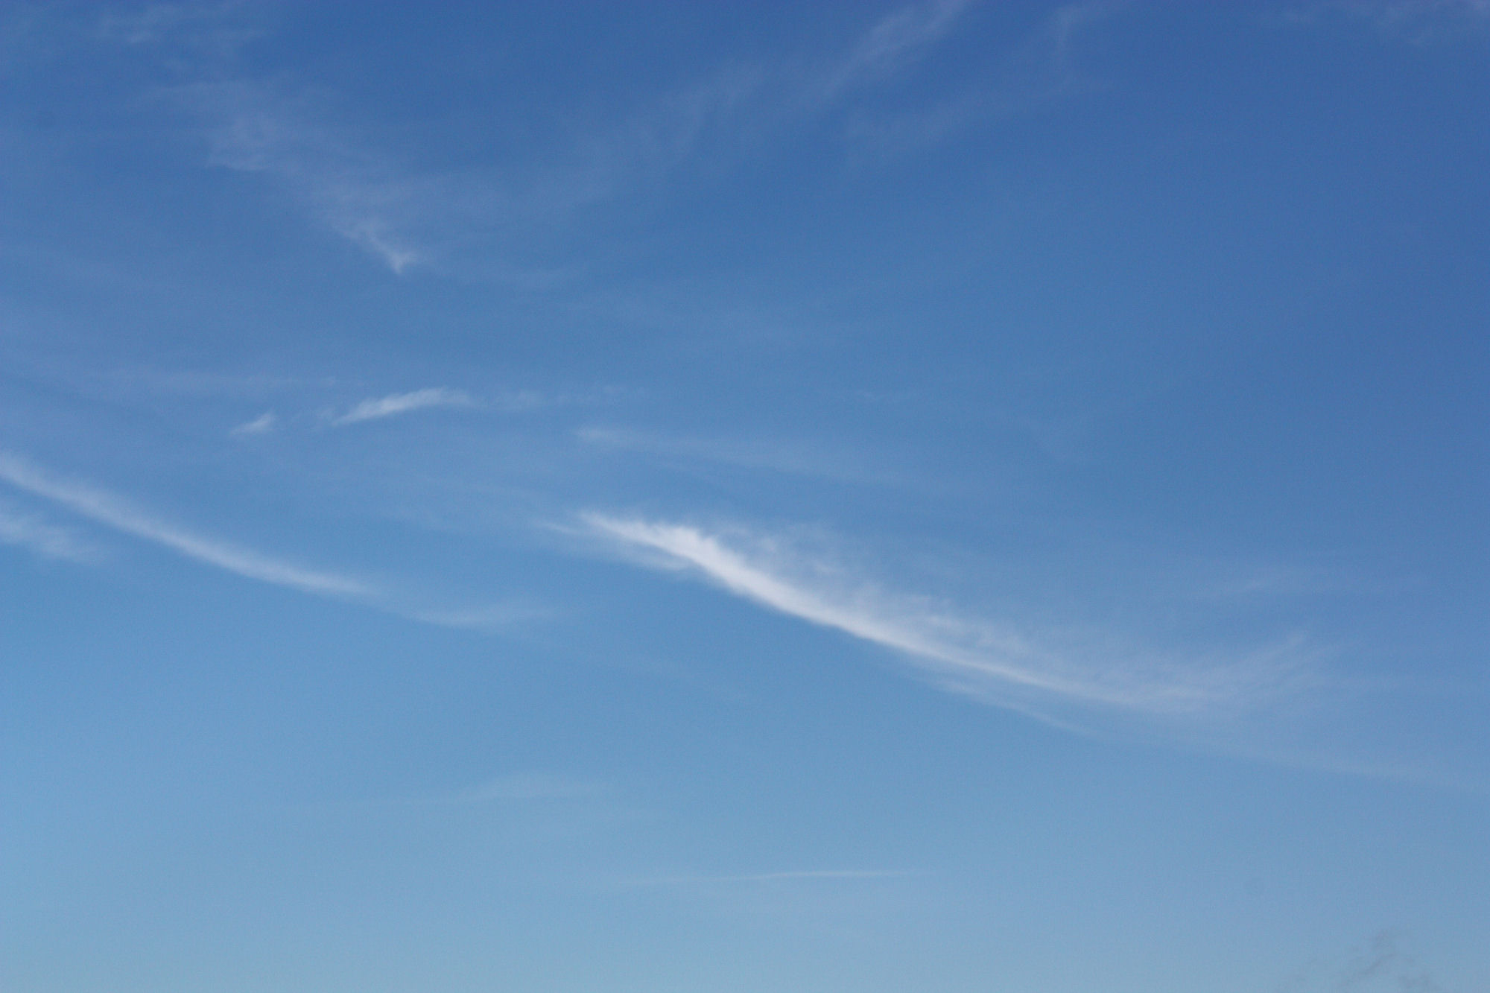
Only by passing the Princess Challenge  may a regular guy gain the right  to marry a princess  --  Marcus Lucas Draco is your typical student wizard from a (naturalist) clan of dragon masters, obsessed with women, food, magic and adventure.  Annie is an underage princess who thinks Mark is the coolest guy in the universe and is bound and determined to marry him when she becomes a full adult at the age of twenty-one.  To that end, Annie has issued the Princess Challenge to Mark.  If Mark fails the challenge, the entire country will be destroyed – and possibly the planet.  If he succeeds, Annie will be cursed.  And of course,  Mark can't refuse the challenge,  no matter how much he wants to.  Did I mention that he will be turned into a sludge monster as part of the challenge?  If you liked, “Stranger in a Strange Land”,  You'll love this…  Warning: Contains nudity and violence. Part of the story is in a nudist colony, filled with both children and adults.  This is a necessary part of the story.  It also contains a retelling of the Genesis story of the Old Testament of the Bible | The Princess and the Dragon - Trevy Burgess | The Princess  And  The Dragon  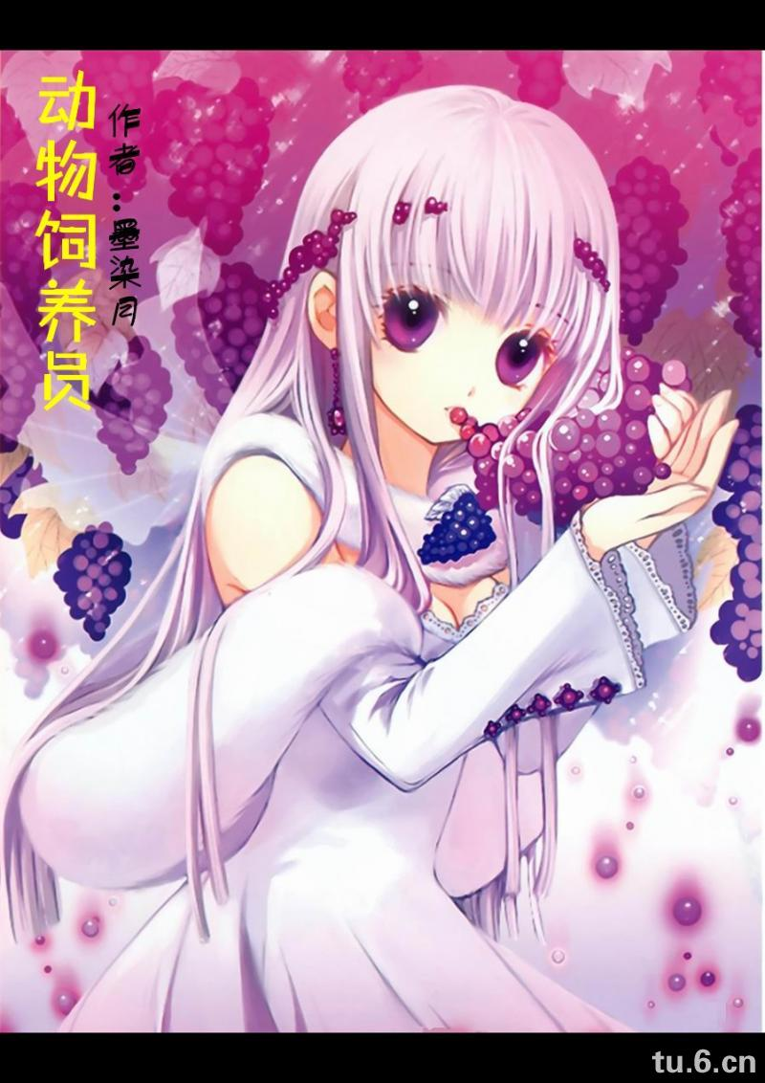  By  Trevy Burgess

