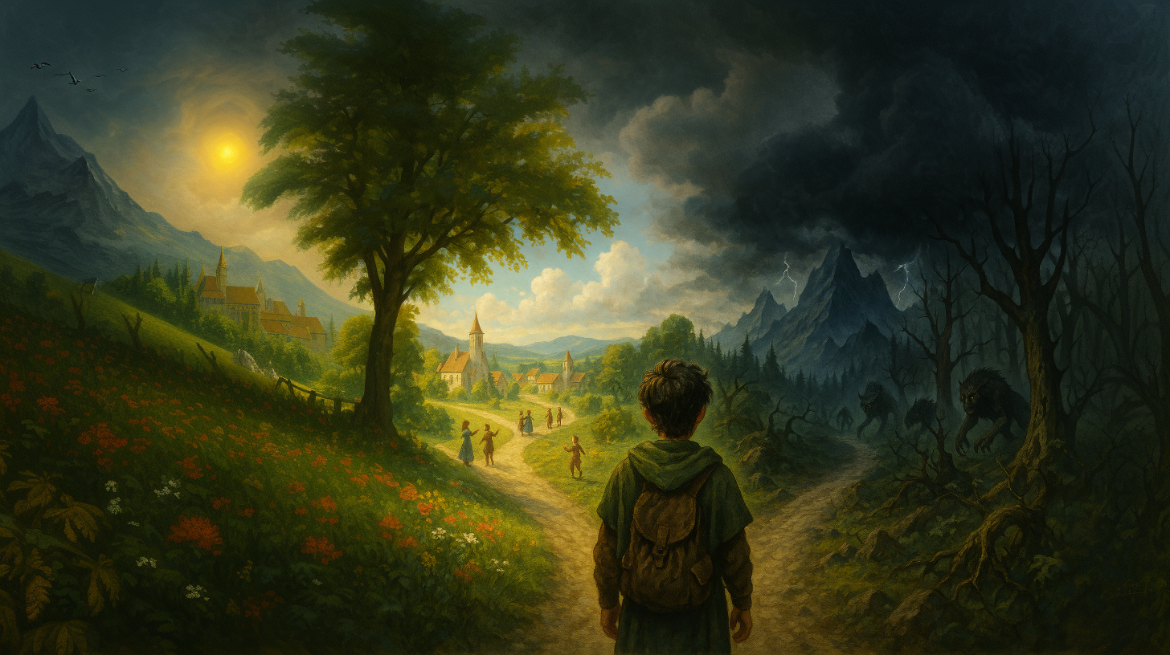

-----------------------------------
Have you ever wondered if magic exists?
Is there more to life than material existence?
Luke Russell discovered magic does exist, when he stumbled onto the Unknown Road.
Unfortunately, the price for being a wizard is living in a world filled with unknowable and sometimes terrifying forces
Can you give up everything you hold true? Can you live in a world of psychedelic craziness?

