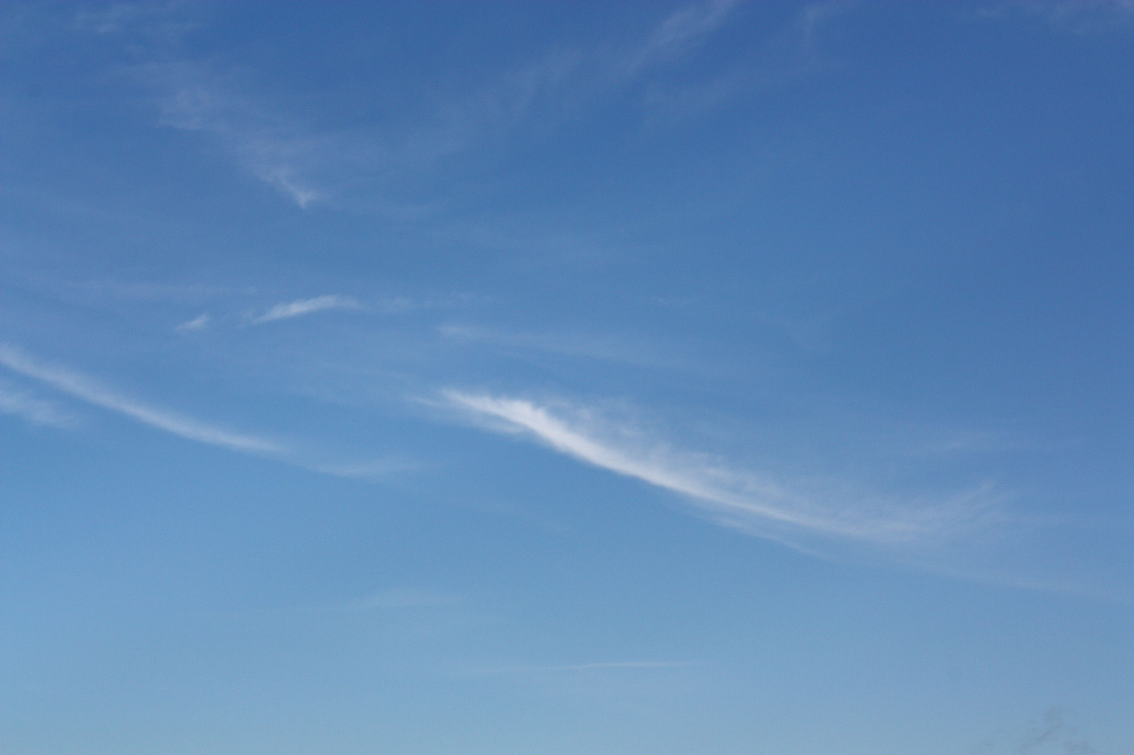

|  |  |  |
| --- | --- | --- |
| **Only by passing the Princess Challenge may a regular guy gain the right to marry a princess**  **--**  **Marcus Lucas Draco is your typical student wizard from a (naturalist) clan of dragon masters, obsessed with women, food, magic and adventure.**  **Annie is an underage princess who thinks Mark is the coolest guy in the universe and is bound and determined to marry him when she becomes a full adult at the age of twenty-one.**  **To that end, Annie has issued the *Princess Challenge* to Mark.**  **If Mark fails the challenge, the entire country will be destroyed.**  **If he succeeds, Annie will be cursed.**  **And of course, Mark can't refuse the challenge, no matter how much he wants to.**  **Did I mention that he will be turned into a sludge monster as part of the challenge?   “Look at that cute red-hair boy with that mustache,” one high school girl said to another.**  **Mark, on overhearing the conversation, walks up to the girl who spoke and kisses her hand. “Hi, my name is Mark. How would you like to go out with me?”**  **The girl replies, “I’d love to go out with…” She does a double-take.**  **She covered her mouth in shock and says,**  **“What the hell am I saying? You’re just a ten year old boy.”**  **...**  **As he left, he overheard the women whisper to her friend,**  **“He’s such a hottie. Maybe we should visit him in the student council hall.”**  **And so began a typical day in the life of Marcus Lucas Draco,**  **Wizard in training...**  **If you liked, “Stranger in a Strange Land”,**  **You'll love this…** | **The Princess and the Dragon - Trevy Burgess** | The Princess  And  The Dragon    By  **Trevy Burgess** |