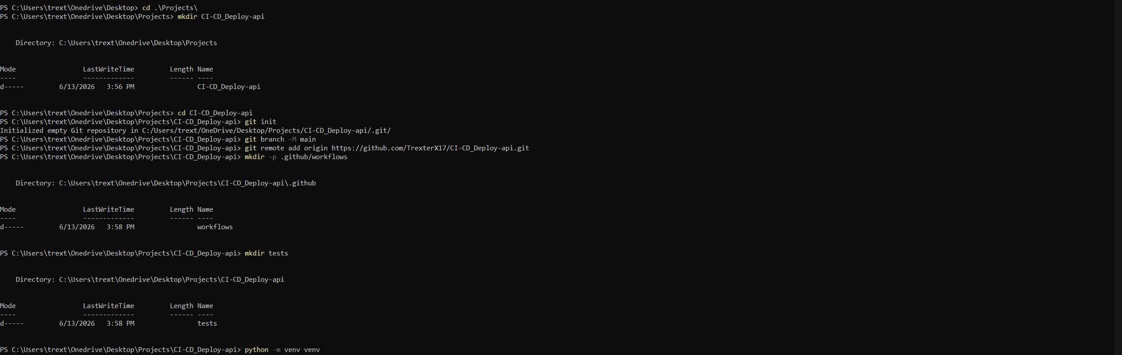
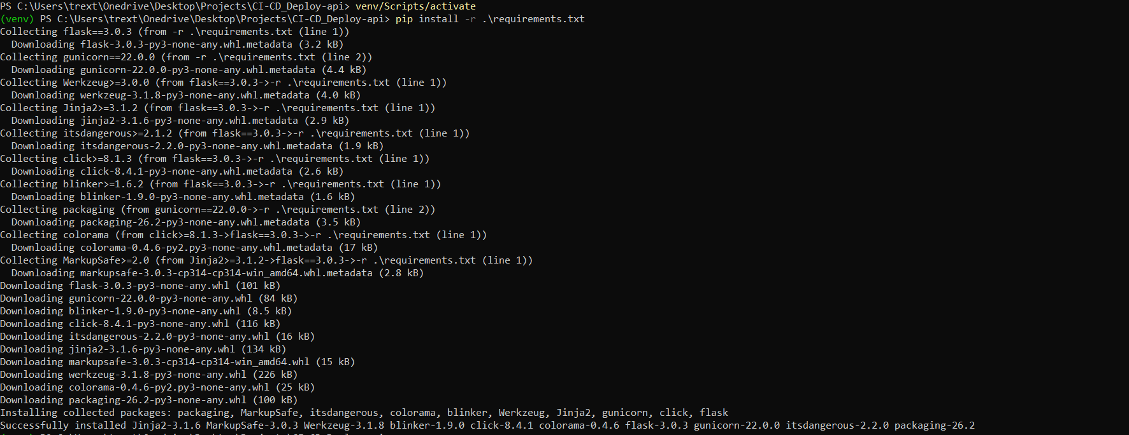
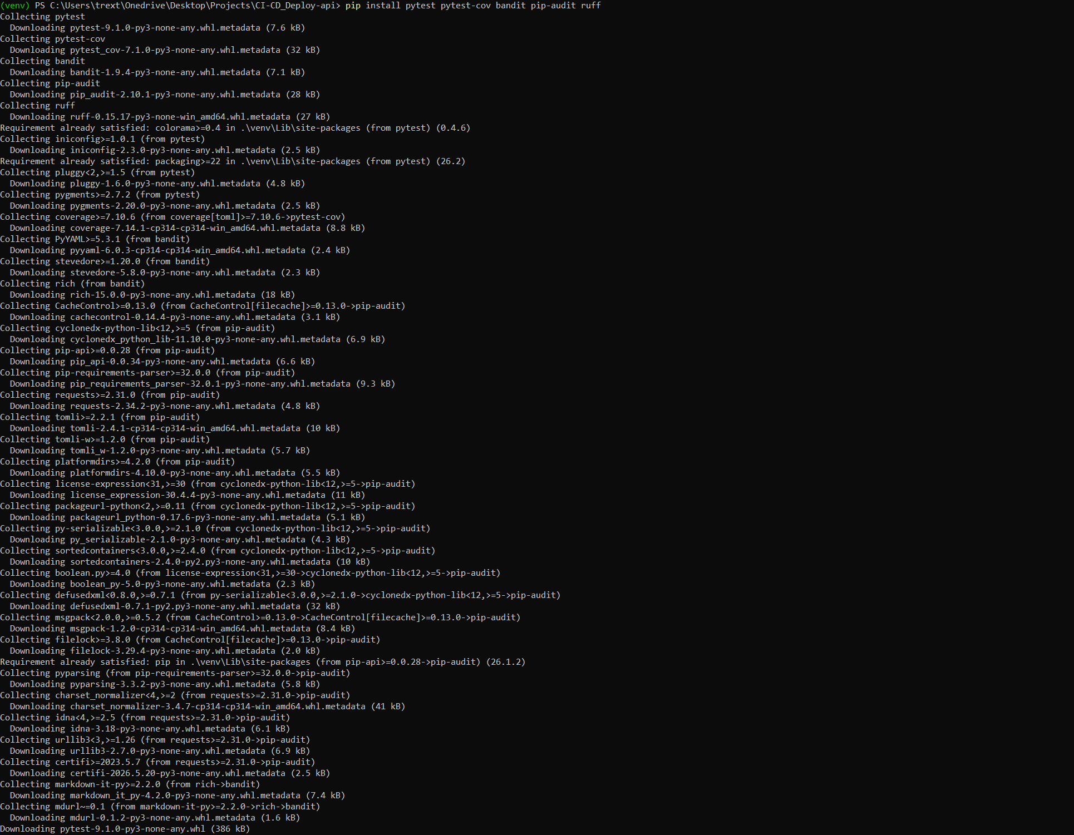
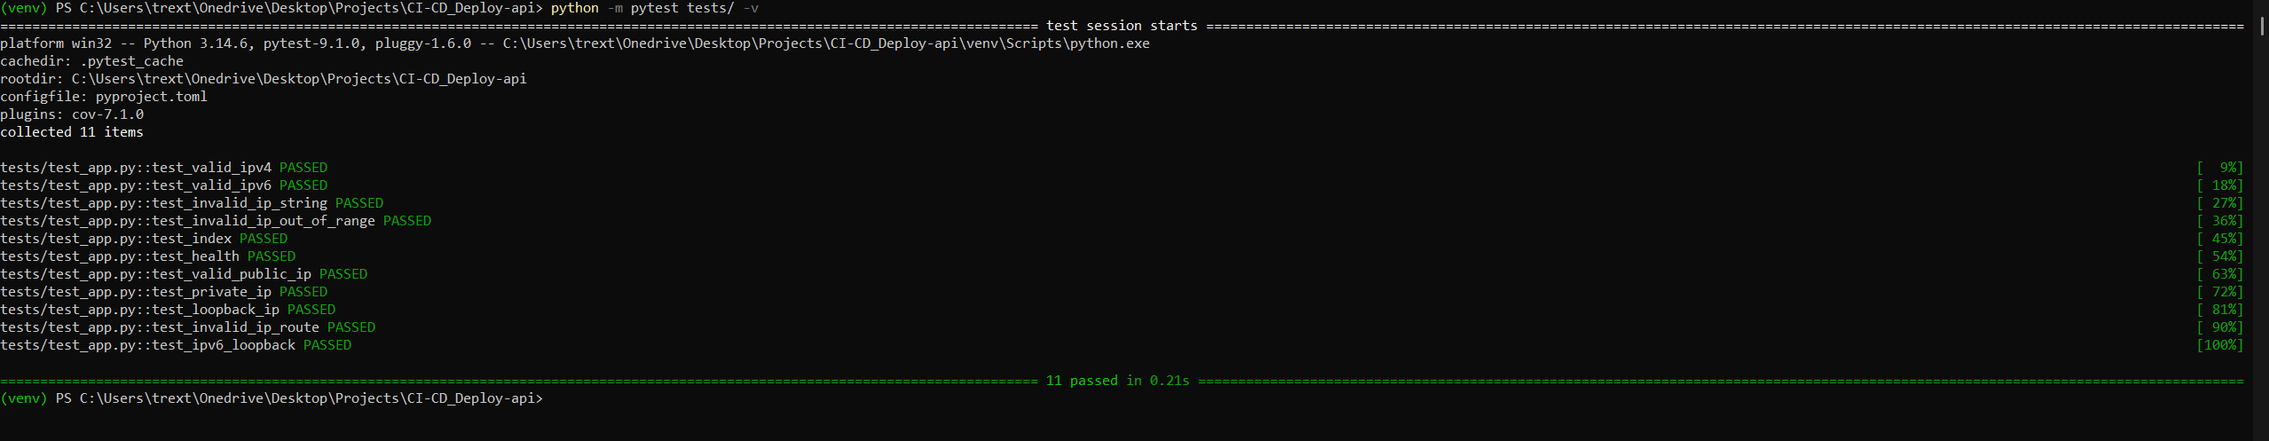
This is actually great news for your submission — not a problem at all.
pip-audit found a real vulnerability: Flask 3.0.3 has a known CVE (CVE-2026-27205), and the fix is to upgrade to Flask 3.1.3.
This is exactly what this tool is supposed to do — catch outdated dependencies with known security issues. Now you get to fix it, which is a great talking point in your interview ("my pipeline caught a real vulnerability and I patched it").

Fix it:
- Open requirements.txt and change:
flask==3.0.3
gunicorn==22.0.0
to:
flask==3.1.3
gunicorn==22.0.0

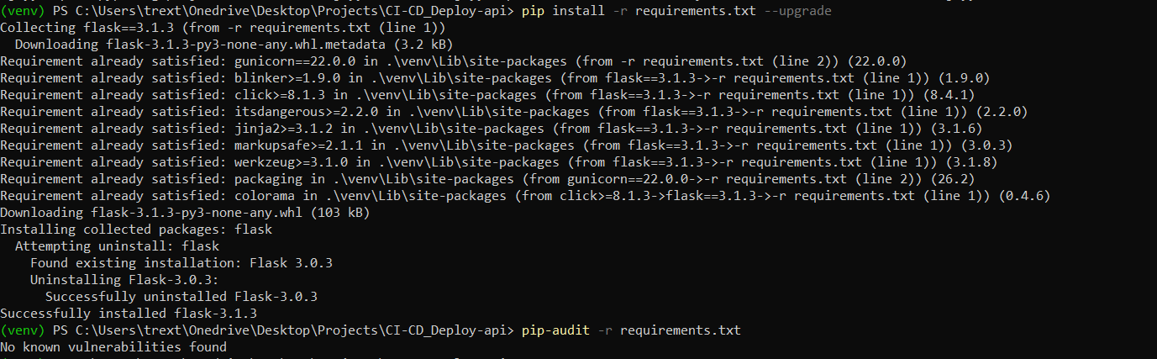
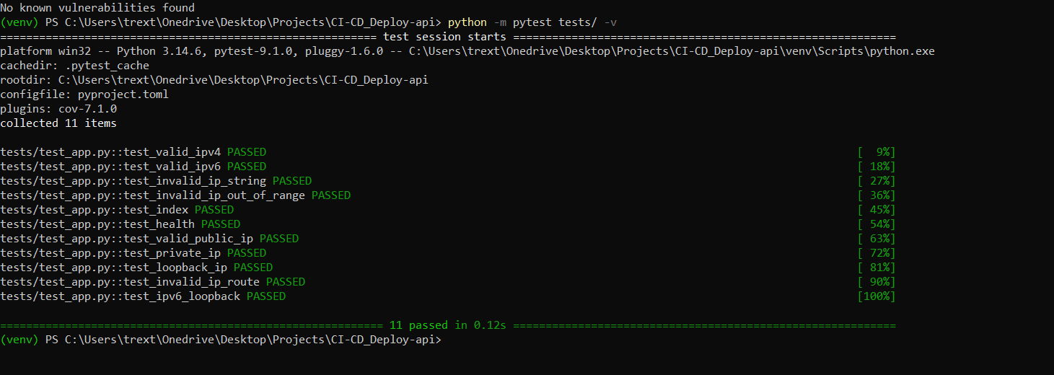
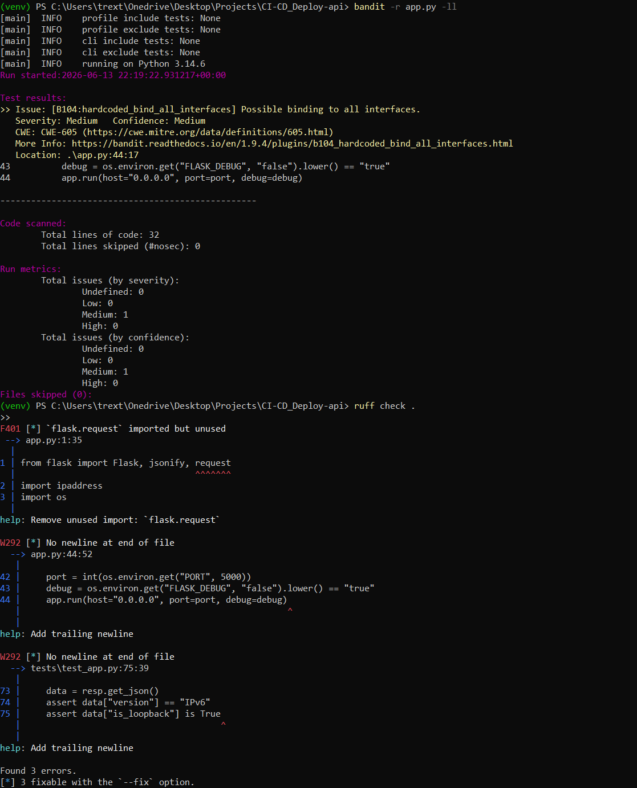
Good — these are real findings and easy fixes. Let's go through each one.

Bandit found 1 issue (Medium severity)
B104: Possible binding to all interfaces — this is about host="0.0.0.0" in app.py line 44. Bandit flags this because binding to 0.0.0.0 means the app accepts connections from any network interface, not just localhost — which is correct for a containerized app, but bandit flags it as worth a second look.
This is actually fine to keep — for a Dockerized app, 0.0.0.0 is required (otherwise the app won't be reachable from outside the container). But since bandit flags it, we should acknowledge it explicitly using a # nosec comment, which tells bandit "I've reviewed this and it's intentional."
app.run(host="0.0.0.0", port=port, debug=debug) # nosec B104 - required for containerized deployment
ruff check . –fix
