Creating a skill/scriptable object:

1.Import package into unity project

2.inside assets tab right click > create > SkillObjects > ScriptablePhysicalSkills/ScriptableRangeSkills

3.assign values to skill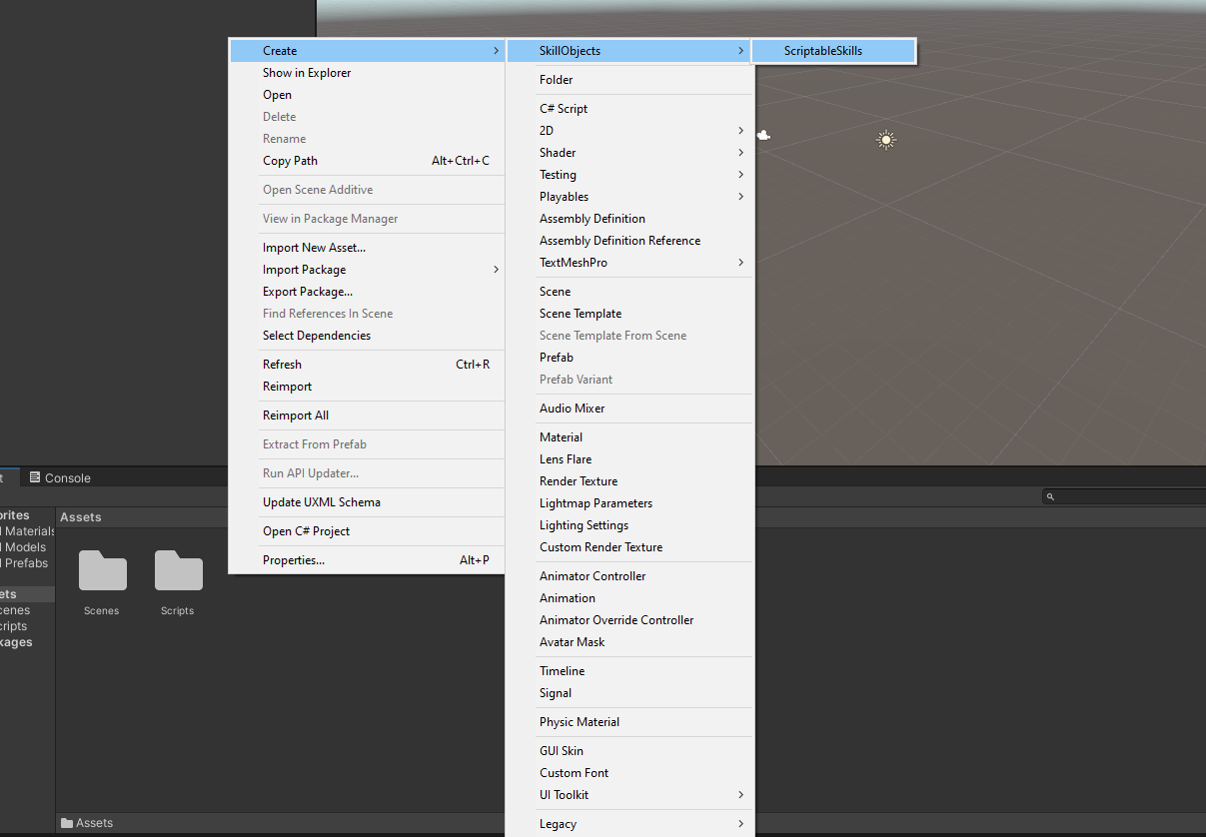

-make sure Character Tag uses the same tag your Player is using

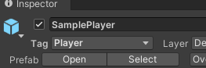

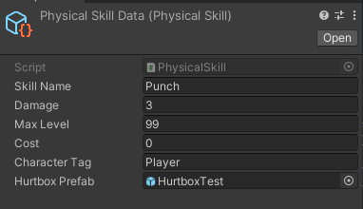

Use skill in code:

1. Get reference to SkillProgress and call AddSkill() to grab skill data. call the Use() function on Input to execute the skill. AddExp(int) will increase skill experience points by a certain amount
2. Assign a tag to the player(make sure Character Tag uses the same tag your Player is using)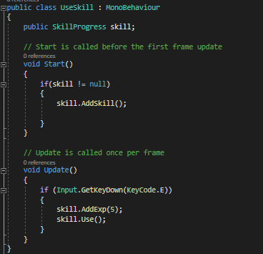



1. Drag and drop scriptable objects into Skill Data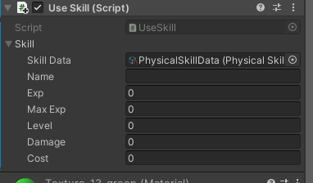
2. create a enemy gameobject and attach the health script to it and create a Enemy layer on **Layer 6.** Also add a rigidbody.

