Are Leveraged ETFs Worth It For Young Investor’s

Trey Davidson

2024-12-23

I am a young investor who is currently interested in saving for retirement. As a young investor traditional investment advise would say I can afford to take on risk as I have a long time horizon to make up losses through income generation and other methods. If I lose all of my investment at the age of 30, I am essentially equal in position to someone who starts saving money in there 30’s. [Considering the fact that 31 is the average age to start saving for retirement I wouldn’t be alone](https://news.nationwide.com/americas-retirement-voice-reveals-how-much-it-costs-to-delay-retirement/).

Since, I am less concerned about risk I have two choices when it comes to magnifying gains. I can either concentrate a portfolio or take on leverage. The issue with concentration is that many biases can come at play that make stock picking hard unlike leverage, which would allow me to keep the diversity of the S&P 500 or QQQ, while also magnifying returns.

index_data <- read.csv("index_data.csv")  
  
plot(index_data$Decimal_Year, index_data$Volume,  
 col = "gray",   
 pch = 16,   
 xlab = "Year",   
 ylab = "Volume",   
 main = "Year vs Volume")

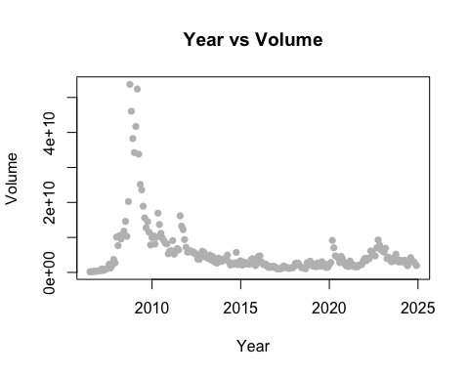

plot(tail(index_data$Decimal_Year, 150), tail(index_data$Volume,150),   
 col = "gray",   
 pch = 16,   
 xlab = "Year",   
 ylab = "Volume",   
 main = "Year vs Volume")

