Assignment 2-Multiple Linear Regression

Trey Howard

February 4, 2019

library(tidyverse)

## -- Attaching packages ------- tidyverse 1.2.1 --

## v ggplot2 3.1.0 v purrr 0.2.5  
## v tibble 1.4.2 v dplyr 0.7.7  
## v tidyr 0.8.2 v stringr 1.3.1  
## v readr 1.1.1 v forcats 0.3.0

## -- Conflicts ---------- tidyverse_conflicts() --  
## x dplyr::filter() masks stats::filter()  
## x dplyr::lag() masks stats::lag()

library(GGally)

## Warning: package 'GGally' was built under R version 3.5.2

##   
## Attaching package: 'GGally'

## The following object is masked from 'package:dplyr':  
##   
## nasa

library(MASS)

##   
## Attaching package: 'MASS'

## The following object is masked from 'package:dplyr':  
##   
## select

library(readr)  
hour <- read_csv("hour.csv")

## Parsed with column specification:  
## cols(  
## instant = col_integer(),  
## dteday = col_date(format = ""),  
## season = col_integer(),  
## yr = col_integer(),  
## mnth = col_integer(),  
## hr = col_integer(),  
## holiday = col_integer(),  
## weekday = col_integer(),  
## workingday = col_integer(),  
## weathersit = col_integer(),  
## temp = col_double(),  
## atemp = col_double(),  
## hum = col_double(),  
## windspeed = col_double(),  
## casual = col_integer(),  
## registered = col_integer(),  
## count = col_integer()  
## )

Bike <- hour

Bike = Bike %>% mutate(season = as_factor(as.character(season))) %>%  
mutate(season = fct_recode(season,  
"Spring" = "1" ,  
"Summer" = "2" ,  
"Fall" = "3" ,  
"Winter" = "4"))

Bike = Bike %>% mutate(holiday = as_factor(as.character(holiday))) %>%  
mutate(holiday = fct_recode(holiday,  
"0" = "NotHoliday", "1" = "Holiday"))

## Warning: Unknown levels in `f`: NotHoliday, Holiday

ggpairs(Bike)

## `stat_bin()` using `bins = 30`. Pick better value with `binwidth`.  
## `stat_bin()` using `bins = 30`. Pick better value with `binwidth`.  
## `stat_bin()` using `bins = 30`. Pick better value with `binwidth`.  
## `stat_bin()` using `bins = 30`. Pick better value with `binwidth`.  
## `stat_bin()` using `bins = 30`. Pick better value with `binwidth`.  
## `stat_bin()` using `bins = 30`. Pick better value with `binwidth`.  
## `stat_bin()` using `bins = 30`. Pick better value with `binwidth`.  
## `stat_bin()` using `bins = 30`. Pick better value with `binwidth`.  
## `stat_bin()` using `bins = 30`. Pick better value with `binwidth`.  
## `stat_bin()` using `bins = 30`. Pick better value with `binwidth`.  
## `stat_bin()` using `bins = 30`. Pick better value with `binwidth`.  
## `stat_bin()` using `bins = 30`. Pick better value with `binwidth`.  
## `stat_bin()` using `bins = 30`. Pick better value with `binwidth`.  
## `stat_bin()` using `bins = 30`. Pick better value with `binwidth`.  
## `stat_bin()` using `bins = 30`. Pick better value with `binwidth`.  
## `stat_bin()` using `bins = 30`. Pick better value with `binwidth`.  
## `stat_bin()` using `bins = 30`. Pick better value with `binwidth`.  
## `stat_bin()` using `bins = 30`. Pick better value with `binwidth`.  
## `stat_bin()` using `bins = 30`. Pick better value with `binwidth`.  
## `stat_bin()` using `bins = 30`. Pick better value with `binwidth`.  
## `stat_bin()` using `bins = 30`. Pick better value with `binwidth`.  
## `stat_bin()` using `bins = 30`. Pick better value with `binwidth`.  
## `stat_bin()` using `bins = 30`. Pick better value with `binwidth`.  
## `stat_bin()` using `bins = 30`. Pick better value with `binwidth`.  
## `stat_bin()` using `bins = 30`. Pick better value with `binwidth`.  
## `stat_bin()` using `bins = 30`. Pick better value with `binwidth`.  
## `stat_bin()` using `bins = 30`. Pick better value with `binwidth`.  
## `stat_bin()` using `bins = 30`. Pick better value with `binwidth`.  
## `stat_bin()` using `bins = 30`. Pick better value with `binwidth`.  
## `stat_bin()` using `bins = 30`. Pick better value with `binwidth`.

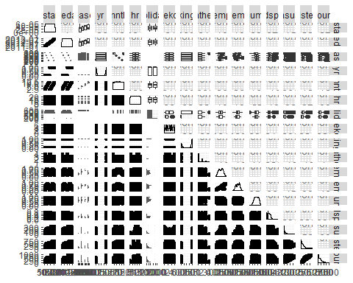

ggcorr(Bike, label = TRUE)

## Warning in ggcorr(Bike, label = TRUE): data in column(s) 'dteday',  
## 'season', 'holiday' are not numeric and were ignored

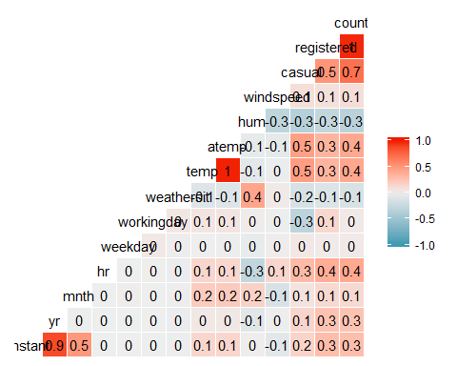

ggplot(Bike, aes(x=hr,y=count)) + geom_boxplot()

## Warning: Continuous x aesthetic -- did you forget aes(group=...)?

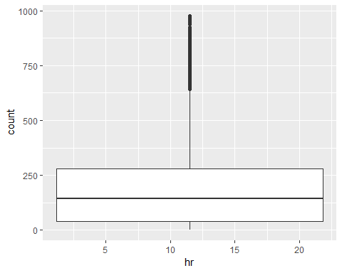

Bike = Bike %>% mutate(yr = as.integer(yr)-1)